An Analysis of a Technology Supported Learning Environment (TSLE): EdHeads
Helen “Holly” Fake, Janet Athanasiou, and Dr. Nada Dabbagh
George Mason University

Abstract
The researchers conducted an analytical review on the Technology Supported Learning Environment (TLSE) EdHeads, specifically the Sickle Cell DNA course. This interactive tool was designed to motivate students to study STEM based curriculums and connect their lessons to actual careers. Using the Learning Affordance Design Criteria (LADC) scale, an analysis of the TSLE revealed that the Sickle Cell DNA course supported Engage-ability and Experiential Learning at a high rate. Personalization, Assessment, and Learning Community were not supported according to our scale, but reasons for why these factors may not have been included are explored.
Keywords: learning affordance, education, technology supported learning environments

Introduction
EdHeads is an interactive tool designed to motivate students of all ages to study STEM curriculums by providing applications to real world jobs. This Technology Supported Learning Environment (TSLE) was the subject of an analytical review to gain a better understanding of this tool. To conduct the review, a Learning Affordance Design Criteria (LADC) scale was created examining 5 categories of Learning Community, Personalization, Experiential Learning, Assessment, and Engage-ability. Two researchers partnered together to assess and evaluate EdHeads by completing a simulation of a genetic counsellor. While the simulations were completed individually, the researchers met to discuss their results, and completion the evaluation. As EdHeads is a popular tool to aid students in their application of their STEM education, assessing the learning affordances can help educators decide if it is the right tool for their classes. This evaluation will review details on the TSLE, the scale used for the evaluation, and the process by which we evaluated EdHeads.
About EdHeads
EdHeads is a non-profit organization which offers unique and interactive online learning opportunities. EdHeads seeks to engage learners in authentic math and science learning experiences and simulations which echo the challenges STEM practitioners face in their day to day operations.
Since the early 2000s, EdHeads has provided over 12 million learners the opportunity to explore careers in the STEM fields. Funded by memberships, partnerships and grants, all of the instructional materials within EdHeads are connected to national and state educational standards.
For the purposes of the evaluation, the two researchers investigated the EdHeads Sickle Cell DNA course sponsored by the National Science Foundation. The course documentation recommends the Sickle Cell DNA course for students in the 7th to 12th grades. The learning objectives tied to this particular unit are based on curricular standards to include the ability to:
- Express how DNA is related to protein creation and ultimately genetic expression.
- Explain the interrelationships between DNA, chromosomes, and the genetic code.
- Apply statistics and probability to explain genetic variation.
- Calculate the probability that genetic traits will be passed along to offspring.
- Weigh the costs and benefits of research that alters the genetic code of organisms.
- Explore future STEM career possibilities in the biomedical field
Please see the DNA Teacher’s Guide for the actual learning objectives associated with the course (Sickle Cell DNA, 2014).
Course Set-up
The initial course screen for the Sickle Cell DNA course (figure 1) describes the challenge to “help determine if a family might carry a genetic mutation!”. Upon clicking “start”, learners are taken through a realistic animation of walking into a hospital entrance and being greeted by an animated character who introduces herself as a genetic counselor. Explaining she is swamped, the genetic counselor enlists your help counseling a couple who are concerned that they carry the gene for sickle cell anemia. As future parents, the couple is concerned about how their genes may impact their potential offspring and want to make an informed decision about the risk of transferring this mutation to their children. This character continues by defining what sickle cell anemia is and how it can negatively impact people who suffer from the disease. Following this information, she asks the participant’s opinion on what might be the best way to proceed.
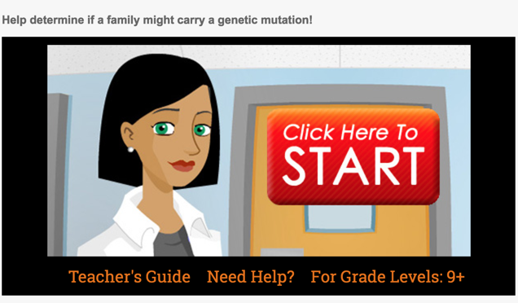
Figure 1: Initial Course Screen
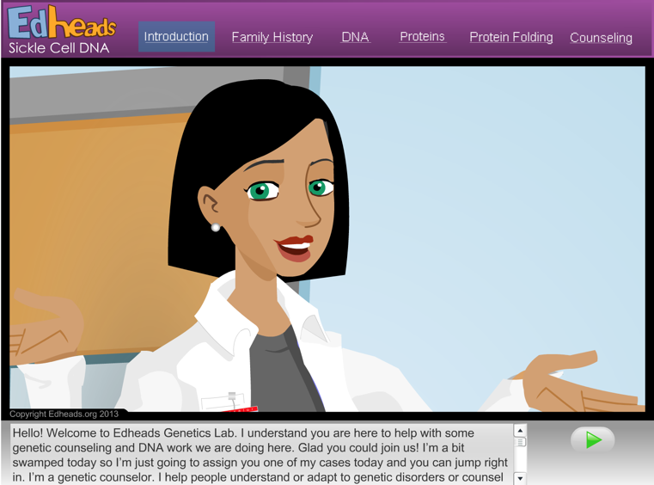
Figure 2: Challenge Description and Debrief
Once you correctly select the appropriate next step, the animated figure shows the results of a genogram (figure 3). The learner is offered an opportunity to look at the patient files to determine what the potential risks may be for these future parents and whether or not additional testing is warranted.

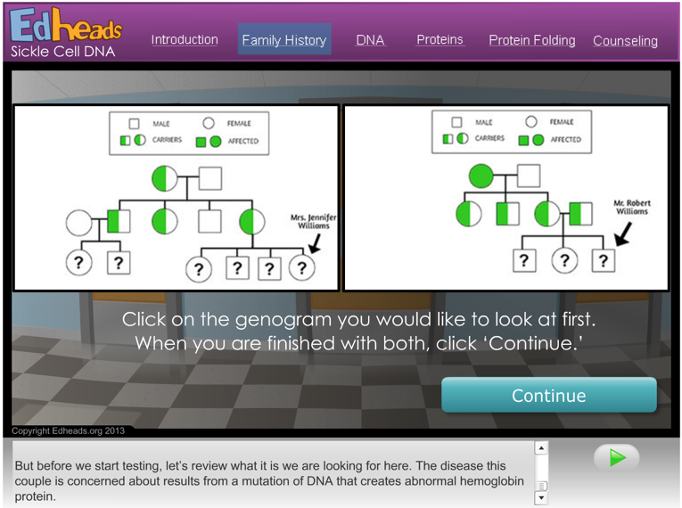
Figure 3: Artifacts to Review
After the learner determines that each parent may carry recessive genes that could pass along the genetic mutation that perpetuates sickle cell anemia, the online course continues with a walk through of how sickle cell anemia occurs in the genetic code. The genetic counselor explains how DNA, amino acids, and protein folding can impact the hemoglobin of red blood cells thus affecting an individual’s ability to carry oxygen in their blood. Throughout this, learners are asked to pair DNA sequences, create amino acids, and ultimately diagnose the probability associated with passing along the sickle cell mutation.
In addition to the online module, the course additionally provides supplemental teacher materials that include information on how to extend student learning past the 25 - 30 minute online simulation. Additional materials include a quiz, reflection questions about the STEM careers highlighted in the tutorial, supplemental resources, as well as documentation on how the activities in the tutorial map to curricular standards.
Method
Observational Scale Development
Following an affordance analysis of digital technologies referencing the Bowers (2008) and Hartson and Pyla (2012) affordance frameworks, fourteen doctoral students and a professor of a Learning Technologies Design Research program at a Mid-Atlantic University were split into two groups to analyze, synthesize, and deliberate upon what criteria should be considered in evaluating the effectiveness of a Technology Supported Learning Environment (TSLE). Each group generated key evaluation criteria and worked to define key concepts and subcategories. After each group had defined and categorized their TSLE criteria, the teams met to reconcile the results. Following several classroom sessions, the group identified the following as key criteria for evaluating a TSLE: (1) Learning Community, (2) Personalization, (3) Assessment, (4) Experimentation, and (5) Engage-ability.
After the TSLE criteria were agreed upon, the doctoral students further defined and developed measurable and observable items that would indicate the existence of the aforementioned factors within a Technology Supported Learning Environment. The scope of this project did not support collection of data beyond individual system observation, so it is important to note that certain learner data was not collected (i.e. a student’s self-report or use of the technology in real classroom environments). The analysis within this paper will therefore focus on the tangible elements that could be observed from an expert review of the TSLE (Usability.gov, 2016).
To observe the TSLE, two researchers individually launched and participated in the online training three times for a total of 1 hour and thirty minutes. Due to time constraints and lack of access to a population using this course asset, the researchers were unable to view student involvement with the site. They were able to view student assignments through completing the material, as all students must complete the same assignments for the individual modules.
Following the observation, each researcher referenced the scale and marked what was individually observed. After completing this initial analysis individually, the researchers met to reconcile where their finding different. When it came to discrepancies in the analysis, they discussed the reasons why an item was marked as present on the scale, or why it was missing, and came to a consensus. Through these discussions they found that they had different ideas about what was included in the TSLE. The researchers eventually agreed that the supplemental teacher materials, optional quizzes as well as discussion and reflection questions should be included in the TSLE analysis despite the fact they weren’t immediately embedded into the modular presentation format. Following this period of reconciliation, they added in examples of the features into the LADC scale and calculated a percentage for each category and subcategory.
Since one of the researchers had previous experience with EdHeads, there was an assumption that the materials of the course would be less directed than this particular module. Previous modules of EdHeads seemed to encourage an investigative mindset where learners would have to decide where to pull information and how to apply it to their situation. The Sickle Cell DNA course, however was much more linear in design, only providing learners a single path.
For the other researcher, having no previous experience with EdHeads, the expectation and assumptions were that it would be a self-paced, supplemental instructional asset to support a high school unit on sickle cell anemia. EdHeads exceed expectations as the depth of material was more advanced than expected, but met the assumptions about how learners would access and use the TSLE.
Results
A detailed view of our analysis of the EdHeads Sickle Cell DNA course is in the appendix of this paper. For more information regarding our analysis of the Learning Affordances Design Criteria Scale we’ve provided a link to the appendix for your review.
Based on our analysis, the Sickle Cell Anemia course supports engage-ability (79% of available factors represented) and experiential learning (69% of available factors represented) at the highest rates compared across all the main categories. The TSLE also is moderately supportive of assessment (44%), however, the TSLE falls short in the learning communities (17%) and personalization (31%) categories.
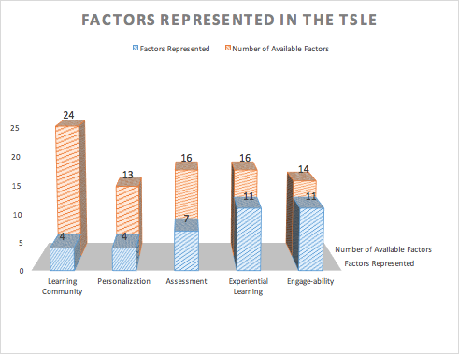
Table 1. Scale Factors represented in the TSLE
Since this particular course asset is intended to be used as a supplemental resource for a unit within an existing middle or high school, the lack of an embedded learning community may not be a critical issue. If this course is used in another context, however, it may be useful to incorporate the elements of a learning community in future iterations of the course. Based on our scale development research, a focus on learning communities could support learners in developing critical social skills to include collaboration, knowledge construction, communication, and dialogic learning (Gauthier, 2016; Kitsantas & Dabbagh, 2010). Please see the appendix of this paper for a full analysis of the Sickle Cell DNA course along with examples of the factors represented in our chosen TSLE.
Discussion
As mentioned in the results section, the experiential learning and engage-ability sections were the ones that scored highest on the LADC scale. The scenario of working with a couple seeking genetic counseling and the activities involved in projecting the couple’s risks supported the experiential learning affordances of the scale. Figure 2 is an example of the course’s embedded learning activities. This particular activity asks students to demonstrate their understanding of how base pieces of DNA naturally pair.
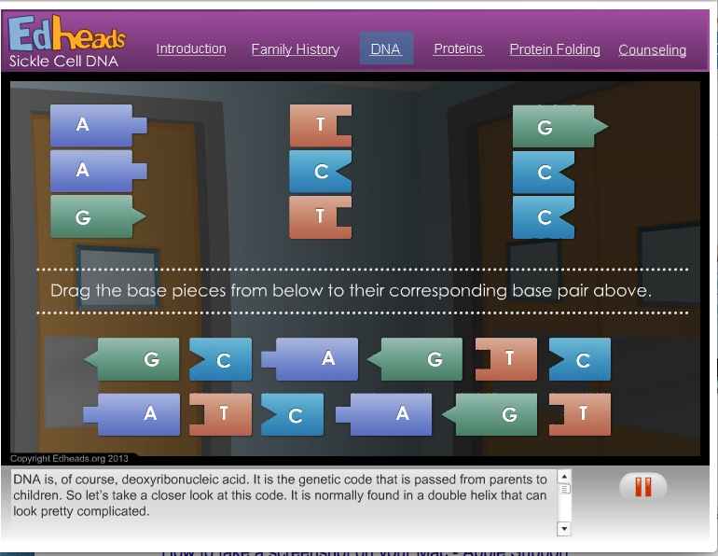
Figure 4: Learning Activity from the Sickle Cell DNA
The experiential learning section introduces learners to the different responsibilities associated with being a genetic counselor. It additionally introduces students to the range of disciplines, from biology and psychology that will be necessary to be successful in a genetic counseling role. The career animations for a genetic counselor and a chemical/biomolecular engineer support the learner’s experience of applying real-world experiences to the science the module is teaching. Learners gain an understanding of the education needed to pursue a career in genetic counselling or biomolecular engineering.
The engage-ability section is a combination of engagement and usability and measured the observable practices that supported the learners ability to interact with and use the TSLE. Combining the aesthetics, perceived utility and focused attention of the TSLE, this section examined how learners engage with the environment, and use it to demonstrate their knowledge. To assess the engage-ability of the TSLE researchers modified the User Engagement Scale (O’Brien & Cairns, 2015; O’Brien & Toms, 2013; Wiebe, Lamb, Hardy, & Sharek, 2014) in order to best examine if there are features within the module that would support engage-ability. Figures 5 and 6 are examples of the engage-ability of the EdHeads TSLE. The general instructions screens are clear and easy to follow, and while the TSLE includes an audio component, the text is also written at the bottom of the screen so that hearing impaired learners can also participate.
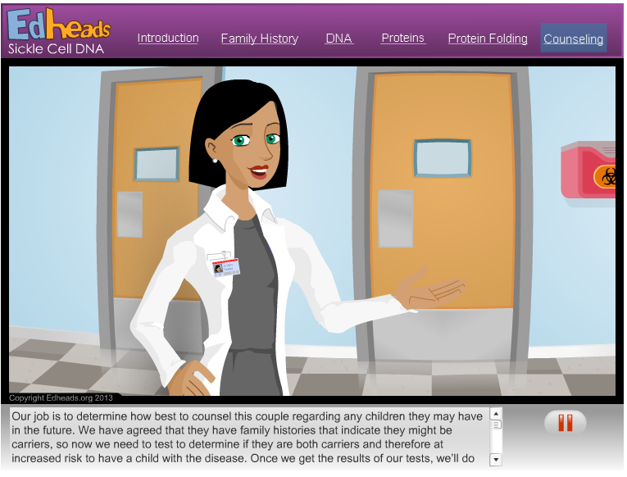
Figure 5: Instruction Screen of the Sickle Cell DNA Course from EdHeads.
Figure 6 shows a clear demarcation of which multiple choice option was selected in the assessment. As you can see, the blue box clearly highlights the selected which ultimately minimizes learner confusion since there is a visual clue to indicate how they are answering the question.
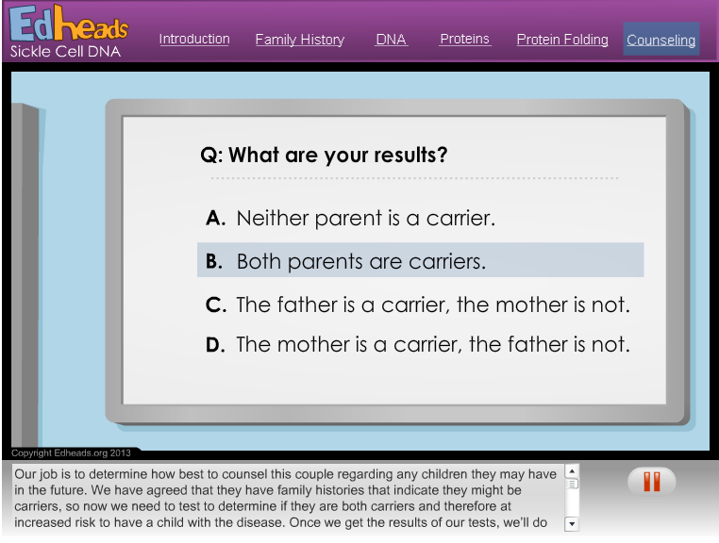
Figure 6: Multiple Choice Options in the Sickle Cell DNA EdHeads.
The engage-ability of the TSLE allowed learners to understand the tasks required of them, the outcomes of the module, and when they were answering a question or activity correctly.
Learning Community, Assessment, and Personalization affordances were present in scale, but these sections did not score very highly. The Assessment category scored slightly higher than the other affordances since the module also linked to supplemental materials to include a teacher guide, worksheets, additional resources, and a 10-question quiz. The 10-question quiz was designed to be used as an optional summative assessment. These materials, while not part of the student view of the module, are important additions to allowing an instructor to assess the knowledge students are gaining as part of completing the game. The individualized nature of the TSLE made it difficult to observe the assessment, personalization, or learning community categories. The researchers could share experiences and discuss the different activities, however, the TSLE was not designed to promote collaboration or encourage active reflection. The TSLE also did not track the learner’s progress through the experience. This TSLE is intended to supplement other classroom teaching so these underrepresented factors may not be a concern, but as a stand-alone teaching tool they may limit the learner’s understanding of the material.
As mentioned earlier, the TSLE also allowed the learner to proceed at their own pace. According to some definitions of personalization, having the ability to advance according to one’s own pace is considered a factor of personalized learning (Department of Education, 2016). While this is an important aspect of personalization to note, it was not captured in our existing scale.
Conclusion
The EdHeads TLSE on Sickle Cell DNA was an informative, fun, and engaging simulation aimed at giving students in grades seven through twelve a better understanding into the biology and psychology of being a genetic counselor, or biomolecular engineer. EdHeads did an effective job integrating the Experiential Learning and Engage-ability learning affordances, creating an engaging, informative, hands-on learning experience. As another benefit, the course showed students ways they could apply knowledge from their science classes to a real-world career. Where EdHeads fell short in learning affordances was in the Assessment, Personalization, and Learning Community categories. Assessment had a higher rating due to some supplemental materials for the module. Personalization and Learning Community did not have a substantial presence in the learning affordances at all, as they were not included in the EdHeads design. The TSLE met the learning outcomes outlined in the teacher’s guide for the module, but would only be recommended for supplemental instruction (as it is intended to be) rather than a primary source of learning.

References

Bower, M. (2008). Affordance analysis - matching learning tasks with learning technologies. Educational Media International, 45, 1, 3-15.
Department of Education. (2016). National Educational Technology Plan (pdf document). Retrieved from http://tech.ed.gov/netp/.
EdHeads (2014). Sickle Cell DNA. Retrieved from http://edheads.org/page/DNA.
Hartson, R., & Pyla, P. (2012). The UX book: Process and guidelines for ensuring a quality user experience. Waltham, MA: Elsevier.
Kitsantas, A., & Dabbagh, N. (2010). Learning to learn with Integrative Learning Technologies (ILT): A practical Guide for academic success. Greenwich, CT: Information Age Publishing.
O’Brien, H., & Cairns, P. (2015). An empirical evaluation of the User Engagement Scale (UES) in online news environments. Information Processing & Management 51(4), 413-427.
O’Brien, H.L., & Toms, E.G. (2013). Examining the generalizability of the User Engagement Scale (UES) in exploratory search. Information Processing & Management 49(5), 1092-1107.
Gauthier, L. (2016). Redesigning for student success: Cultivating communities of practice in a higher education classroom. Journal of the Scholarship of Teaching & Learning 16(2), 1-13.
Wiebe, E. N., Lamb, A., Hardy, M., & Sharek, D. (2014). Measuring engagement in video game-based environments: Investigation of the User Engagement Scale. Computers in Human Behavior, 32, 123 - 132.
Usability.gov (2016). Heuristic Evaluations and Expert Reviews. Retrieved from https://www.usability.gov/how-to-and-tools/methods/heuristic-evaluation.html.

Appendix

Learning Affordances Design Criteria (LADC) Scale

Technology Supported Learning Environment (TSLE) being evaluated: EdHeads Sickle Cell DNA Course

Learning Community  Definition: A learning community is a group of people with similar interests, concerns and objectives who collaborate to learn from each other and generate shared values. They use common artifacts and language to initiate their own practice and direction for learning. They learn in an authentic environment to negotiate and create relevant meaning of the world through regular social communication. Learners engage in dialogic learning tasks that result in collective sociocultural experiences and deep-level cognitive processing knowledge (Ostermann, 2015; Gauthier, 2016; Kitsantas & Dabbagh, 2010). |  | Average Percentage that the TSLE supports Learning Community:
Subcategory | Identifiers |  | Identifier present? (place an X in the box if it is) |  | Evidence: List examples of evidence
Collaboration:  A process in which autonomous actors interact through negotiation, jointly creating rules and structures governing their relationships and ways to act or decide on the issues that brought them together; it is a process involving shared norms and mutually beneﬁcial interactions. (Thomson, et al 2006) | Does the TSLE support working in groups? |  | N/A
 | Does the TSLE support learner selection of learning tasks or topics as a group? |  | N/A
 | Does the TSLE allow learners to be grouped based on shared goals? |  | N/A
 | Does the TSLE support group negotiation of tasks they are doing? Or Does the TSLE support group negotiation to solve a problem or conduct a project? |  | N/A
 | Does the TSLE support joint creation of rules on how groups are completing the assigned tasks? |  | N/A
 | Does the TSLE support active generation of norms by groups? |  | N/A
 | Does the TSLE allow learners to take different roles of leadership and mentors within groups? |  | N/A
 | Does the TSLE enable learners’ awareness of the mutual benefits of working together? |  | N/A
 | Total number of identifiers from this subcategory present in this TSLE |  | 0
 | Total number of identifiers in this subcategory |  | 8
 | Percentage of this subcategory supported by the TSLE |  | 0%
Knowledge construction:  “The production and continual improvement of ideas of value to a community, through means that increase the likelihood that what the community accomplishes will be greater than the sum of individual contributions and part of broader cultural efforts”(Scardamalia & Bereiter, 2003, as cited in Li, 2009) | Does the TSLE allow learners to exchange ideas, opinions and knowledge to learn from each other? |  | N/A
 | Does the TSLE allow learners to work on improving ideas? |  | X |  | The embedded course activities allow learners to select the wrong answer, but offer feedback about why the answer is wrong. This allows students the opportunity to see the reasoning behind the correct answer
 | Does the TSLE support learners to aggregate knowledge from sources with different perspectives? |  | N/A
 | Does the TSLE support learner analysis and synthesis of their combined knowledge? |  | N/A
 | Does the TSLE support learner creation of meaningful knowledge or a valued product? |  | X |  | The TSLE models a challenge a Genetic Counselor might face. By the end of the tutorial a learner would be able to ascribe why it would be important to know about DNA, genes, genetic counseling, and the dangers of genetic mutations.
 | Total number of identifiers from this subcategory present in this TSLE |  | 2
 | Total number of identifiers in this subcategory |  | 5
 | Percentage of this subcategory supported by the TSLE |  | 40%
Communication:  The methods of interaction by which people transfer information to create and manage social, intellectual, and emotional knowledge and shared meaning (Heath and Bryant, 2000). | Does the TSLE afford learners to communicate using multiple methods of interaction, such as visual, verbal, or written? |  | N/A
 | Does the TSLE allow learners to communicate with peers using explicit intellectual connections such as asking questions related to learning content? |  | N/A
 | Does the TSLE allow learners to communicate with peers using explicit emotional connections such as sharing excitements or worries about learning? |  | N/A
 | Does the TSLE allow learners to communicate with the instructor using explicit intellectual connections such as asking questions related to learning content? |  | N/A
 | Does the TSLE allow learners to communicate with the instructor using explicit emotional connections such as sharing excitements or worries about learning? |  | N/A
 | Does the TSLE allow learners to communicate with the instructor using explicit social connections such as resolving group issues or negotiating responsibilities? |  | N/A
 | Does the TSLE allow learners to communicate with experts in the field or content area? |  | N/A
 | Total number of identifiers from this subcategory present in this TSLE |  | 0
 | Total number of identifiers in this subcategory |  | 7
 | Percentage of this subcategory supported by the TSLE |  | 0%
Dialogic learning:  Tasks such as articulation, reflection and negotiation motivate learners in learning communities (Dabbagh & Bannan-Ritland, 2005; Gauthier, 2016) | Does the TSLE allow learners to articulate their learning and understanding through explicit verbal or written conversation? |  | X |  | Supplemental activities and teacher materials associated with the TSLE offer prompts to encourage discussion and further research about personalized medicine as well as careers in a genetic counseling profession.
 | Does the TSLE allow learners to reflect on the learning process? |  | X |  | Supplemental activities and teacher materials associated with the TSLE include reflective questions about the genetic counseling profession and ethics surrounding the practice.
 | Does the TSLE allow learners to reflect on the learning outcome? |  | X |  | Embedded and supplemental teacher materials support student reflection on STEM careers, the genetic counseling profession, and the ethics of personalized medicine.
 | Does the TSLE allow learners to negotiate multiple perspectives? |  | N/A
 | Total number of identifiers from this subcategory present in this TSLE |  | 2
 | Total number of identifiers in this subcategory |  | 4
 | Percentage of this subcategory supported by the TSLE |  | 50%
Personalization
Definition: Personalization is a strategy to drive learning, and connect with an individual’s needs, interests, passions and preferences (Basye, 2014; Bray & McClaskey, 2014; Fruhmann, Nussbaumer, & Albert, 2010; Essalmi, Ayed, Jemni, Kinshuk, & Graf, 2010). Personalization can take on different forms, such as formal and informal learning (Mikroyannidis, Kroop, & Wolpers, 2015). Personalization presents itself in many forms along a spectrum. On one end of the spectrum it can mean allowing a user to personalize aspects of their learning which require self-directed and self-regulated learning skills (Dabbagh & Kitsantas, 2012). On the other end of the spectrum, personalization can involve a system that makes learning decisions based on user behaviors. This systems based personalization is supported by adaptive technologies. (Dabbagh & Kitsantas, 2012; Dagienė, Ignatova, & Kubilinskienė, 2015; Gallagher, 2013; McRae, 2010; Bray & McClaskey, 2014).
Subcategory | Identifiers |  | Identifier present? (place an X in the box if it is) |  | Evidence: List examples of evidence
Self- Regulated Learning  Self-directed learning (SDL) and self-regulated learning (SRL) are used interchangeably in learning contexts. They are considered as vital tools for lifelong learning. SDL is often characterized as a voluntary process that requires initiative on the part of the learner to organize, plan, and execute on each part of the learning process. (Saks & Leijen, 2014; Skiff, 2009; Rashid & Asghar, 2016). On the other hand, SRL requires learners to manage and direct the metacognitive aspects of learning (which are not necessarily voluntary) to include setting learning goals, time management, and self-evaluation (Rashid & Asghar, 2016; Zimmerman, 2008). We have combined these two terms in consideration of their tremendous overlap. | Does the TSLE support learners to identify and formulate the goals of units of study? And the goals of learning activities? |  | N/A
 | Does the TSLE enable learners to identify the resources materials for each goal? |  | N/A
 | Does the TSLE enable learners to determine and manage the timeline for completing the learning activities? |  | X |  | The teacher guide for the module states that students in the target grade-range will take approximately 25-30 minutes to complete the module
 | Does the TSLE support learners to identify the structure and sequence of learning activities? |  | X |  | As a part of the tutorial, students must sequence DNA and create proteins using the knowledge they’ve gained as a result of the tutorial.
 | Does the TSLE support learners to engage in self-reflection and evaluate their learning progress? |  | X |  | Learning activities throughout the course provide feedback when students answer questions incorrectly and offer explanations why the tutorial believes the answers that have been given are wrong.
 | Does the TSLE allow learners to seek the feedback and ideas from the instructors and other available resources? |  | N/A
 | Does the TSLE support learners in being involved in directing and measuring their own learning in meaningful ways? |  | N/A
 | Total number of identifiers from this subcategory present in this TSLE |  | 3
 | Total number of identifiers in this subcategory |  | 7
 | Percentage of this subcategory supported by the TSLE |  | 43%
Adaptive learning:  A system that continuously adjusts to each individual’s performance on a task or activity to achieve preset learning objectives. Adaptive learning assessments automatically collect information about a learner’s mastery, so that learners receive material that is simplified or advanced depending on their individual needs. Learning technologies begin adapting early with an assessment that places students at the point where their skills and the curriculum meet (Larkin 2002; Diaz-Rico & Weed, 2010).. | Does the TSLE provide adaptive differentiated assessments to learners to determine their instructional needs? |  | N/A
 | Does the TSLE provide individualized learning paths? |  | N/A
 | Does TSLE afford to provide different levels of instruction of the same skill? |  | N/A
 | Does the TSLE provide learners with summative and formative assessments? |  | X |  | In each section of the Sickle Cell DNA module learners are tested on the knowledge that has been presented to them. Following the tutorial, there is an optional quiz for learners included in the supplemental teacher materials.
 | Does the TSLE provide learners with an initial adaptive placement assessment? |  | N/A
 | Does the TSLE have built-in adaptive ongoing assessments? (Assessments to override the initial placement assessments). |  | N/A
 | Total number of identifiers from this subcategory present in this TSLE |  | 1
 | Total number of identifiers in this subcategory |  | 6
 | Percentage of this subcategory supported by the TSLE |  | 17%
Assessment
Definition: Assessment involves, collecting, reviewing and using information to improve learning. (Polomba & Banta, 1999) Assessment is the evaluation process of learners based on learning outcomes and can include traditional and authentic approaches of evaluation to assess a predetermined curriculum or ability to solve real world problems, respectively. Formative assessment is done during learning to find ways to enhance and modify the learning (Cowie & Bell, 2010) while summative methods are used after learning has taken place (Dixson & Worrell, 2016)
Subcategory | Identifiers |  | Identifier present? (place an X in the box if it is) |  | Evidence: List examples of evidence
Formative Assessment:  Instructors/systems find ways to recognize understanding in order to modify and enhance the learning. (Cowie & Bell, 2010) | Does the TSLE support the ability to check for understanding throughout the learning? |  | X |  | Learners can repeat sections of the module, or complete the whole module again.
 | Does the TSLE formatively assess the learner in a variety of formats? (i.e. knowledge checks, discussions, questioning, peer assessment, etc.) |  | X |  | Throughout the tutorial learners are challenged to read a geneogram, pair DNA sequences, create proteins, identify problematic DNA sequences, calculate the probabilities associated with passing along sickle cell anemia, and counsel a couple about the probabilities of passing along the sickle cell anemia mutation.
 | Does the TSLE offer at least one or more way(s) for the instructor/system to modify instruction based on the level of understanding of the learner? |  | N/A
 | Total number of identifiers from this subcategory present in this TSLE |  | 2
 | Total number of identifiers in this subcategory |  | 3
 | Percentage of this subcategory supported by the TSLE |  | 67%
Summative Assessment:  Determines how much a learner knows at the end of a learning sequence (Dixson & Worrell, 2016) | Does the TSLE support assessment at end of the content? |  | X |  | The teacher materials include an optional quiz to support a summative assessment.
 | Does the TSLE have an assessment at the end of each learning sequence? |  | X |  | Each learning sequence includes an activity that challenges learners to apply their knowledge. For example, after the explanation of DNA, learners are challenged to create base pairs of adenine (A), guanine (G), cytosine (C), and thymine (T) with their natural partners.
 | Does the TSLE provide evidence of learner achievement of the learning outcome? |  | N/A
 | Does the TSLE summatively assess the learner in a variety of ways? |  | N/A
 | Total number of identifiers from this subcategory present in this TSLE |  | 2
 | Total number of identifiers in this subcategory |  | 4
 | Percentage of this subcategory supported by the TSLE |  | 50%
Authentic Approaches:  Assessments strategies that ask learners to perform tasks that replicate real-world problems. (Mueller, 2016) | Does the TSLE support the ability for the learner to self-assess? |  | N/A
 | Does the TSLE support peer assessment? |  | N/A
 | Does the TSLE support group assessment? |  | N/A
 | Does the TSLE support expert assessment? |  | X |  | The optional quiz at the end of the module serves as an expert assessment
 | Does the TSLE utilize rubrics that assess real world knowledge? |  | N/A
 | Total number of identifiers from this subcategory present in this TSLE |  | 1
 | Total number of identifiers in this subcategory |  | 5
 | Percentage of this subcategory supported by the TSLE |  | 20%
Traditional Approaches:  Assessment techniques that use forced-choice measures to determine if the predetermined acquisition of knowledge occurred. (Mueller, 2016) | Does the TSLE utilize tests/quizzes for assessment? |  | X |  | The TSLE provides an optional quiz for the assessment.
 | Does the TSLE utilize criterion based assessment? |  | N/A
 | Does the TSLE use a pre-determined curriculum (body of knowledge) to assess learners? |  | X |  | The TSLE is supported by High School curricular standards for Life Science and the Ohio Revised Standards and Model Curriculum for High School. Specific curricula standards from this unit supports can be found here: http://edheads.org/page/DNATeachersGuide
 | Does the TSLE utilize rubrics that assess conventional learning? |  | N/A
 | Total number of identifiers from this subcategory present in this TSLE |  | 2
 | Total number of identifiers in this subcategory |  | 4
 | Percentage of this subcategory supported by the TSLE |  | 50%
Experiential Learning
Definition: Experiential learning is a process that create knowledge through experiences (Kolb, 1984). It supports learners in applying their knowledge and conceptual understanding to real-world problems/situations. This type of authentic learning involves thought and reflection in the areas of Critical Thinking, Problem Solving and Decision Making. It also includes Computational Thinking which includes mathematical and engineering thinking (Voskoglou & Buckley, 2012).
Subcategory | Identifiers |  | Identifier present? (place an X in the box if it is) |  | Evidence: List examples of evidence
Problem Solving:  A goal-directed sequence of cognitive operations which allows learners to search for solutions, as well as monitor and implement solutions (Gick & Holyoak, 1980). | Does the TSLE utilize real world problems that have multiple interpretations and outcomes? |  | X |  | Learners are asked to perform the analysis and genetic counselling for a couple who are carriers of the sickle cell anemia genome.
 | Does the TSLE support learners’ ability to demonstrate their conceptual understanding of problems? |  | X |  | Embedded activities require that learners complete activities that demonstrate their knowledge. More information about these activities is included in the formative assessment subcategory.
 | Does the TSLE provide clear and detailed goals for the problems presented? |  | X |  | Activities have clear instructions. Learners know what will be expected of them to complete the module.
 | Does the TSLE provide opportunities for learners to implement solutions to problems? |  | X |  | Learners are presented with the problem of determining whether or not a couple is at risk for carrying and passing on a specific gene to their children
 | Does the TSLE allow learners to perform complex tasks by using intellectual resources with sustained amount of time to investigate problems? |  | N/A
 | Total number of identifiers from this subcategory present in this TSLE |  | 4
 | Total number of identifiers in this subcategory |  | 5
 | Percentage of this subcategory supported by the TSLE |  | 80%
Decision Making:  A learning process in which learners precede the actual decision, including gathering information and generating, contemplating, and evaluating alternative courses of action (Fitzgerald, 2002). | Does the TSLE offer learners information about their available and applicable choices to support their decision-making about a course of action? |  | X |  | Learners are presented with multiple choice options for courses of action to advise the couple in the course scenario
 | Does the TSLE allow learners to generate multiple courses of action? |  | N/A
 | Does the TSLE support learner’s ability to evaluate their course of action based on feedback from the TSLE? |  | X |  | Learners receive audio responses when they select choices, and feedback on why a choice may be incorrect
 | Total number of identifiers from this subcategory present in this TSLE |  | 2
 | Total number of identifiers in this subcategory |  | 3
 | Percentage of this subcategory supported by the TSLE |  | 67%
Critical Thinking:  A reasonable reflective thinking that is focused on deciding what to believe or what to do (Halpern, 2003). | Does the TSLE support the learners’ ability to formulate inferences? |  | X |  | Certain vocabulary is embedded in the tutorial. For instance, if you do not know the definition of “genogram” you learn what it is when the doctor asks you to review one for the patients.
 | Does the TSLE allow learners to monitor what they are doing and correct their thinking based on evidence? |  | X |  | In the course, students are not allowed to advance to the next item until they complete the learning activity correctly.
 | Does the TSLE support learner’s ability to reflect on their thinking process? |  | N/A
 | Does the TSLE contain activities that are open to multiple interpretations so that learners can identify their own tasks to complete learning goals? |  | N/A
 | Total number of identifiers from this subcategory present in this TSLE |  | 2
 | Total number of identifiers in this subcategory |  | 4
 | Percentage of the subcategory supported by the TSLE |  | 50%
Computational Thinking:  A type of analytical thinking that employs mathematical and engineering thinking to understand and solve complex problems within the constraints of the real world (Voskoglou & Buckley, 2012). | Does the TSLE support analytical thinking such as logic type thinking or mathematical reasoning type thinking to solve problems? |  | X |  | Learners are required to sequence base pairs, create proteins, and identify problematic proteins throughout the tutorial.
 | Does the TSLE provide learners with the capability to analyze and organize data? |  | X |  | Learners are required to look at a DNA sequence to identify whether or not there is a potential issue with the proteins on Chromosome 11.
 | Does the TSLE allow learners to break a problem into smaller pieces and develop a list of steps learners can follow to finish a task? |  | N/A
 | Does the TSLE provide opportunities for learners to use computation in real world problems? |  | X |  | Learners are required to calculate the probability of the couple transmitting a genetic disorder to their potential offspring.
 | Total number of identifiers from this subcategory present in this TSLE |  | 3
 | Total number of identifiers in this subcategory |  | 4
 | Percentage of this subcategory supported by the TSLE |  | 75%
Engage-ability
Definition: Engagement is often associated with curiosity, attention, interest, and passion associated with learning (Hidden Curriculum, 2014). Since measuring engagement often requires self-report to identify the presence of these factors, we have used the term Engage-ability to refer to observable practices support the learner’s ability to interact and use a TSLE. To help guide our measurement of engage-ability we referenced The User Engagement Scale which is based on a self-report index that has been adjusted for a variety of contexts and use cases (O’Brien & Cairns, 2015; O’Brien & Toms, 2013; Wiebe, Lamb, Hardy, & Sharek, 2014). Using a Factor Analysis, this index found that in a multitude of online scenarios (eCommerce, search, video games, news, etc.) aesthetics, perceived usability, and focused attention were shown to be statistically significant variables in engage-ability levels (O’Brien & Cairns, 2015). Three additional constructs: felt involvement, endurability, and novelty were shown to be significant in different use cases.
Subcategory | Identifiers |  | Identifier present? (place an X in the box if it is) |  | Evidence: List examples of evidence
Aesthetics:  “User’s perception of the visual appearance of a computer application interface” (O’Brien & Toms, 2013) | Does the TSLE incorporate graphic elements? |  | X |  | The TSLE is animated and presents information using graphics, audio, and text.
 | Does the TSLE follow color theory? (Colors complement each other) |  | X |  | The main colors for the tutorial are orange and blue. Orange and blue are compatible colors on the color wheel.
 | Does the TSLE follow grid theory? (Parts are well-aligned) |  | X |  | Many of the screens present visuals in thirds -- a common feature of grid theory.
 | Does the TSLE embrace a minimalist design? |  | X |  | The tutorial is not cluttered and strikes a sufficient balance between encouraging visual interest and minimizing cognitive load.
 | Does the TSLE include a visual hierarchy?  (Eyes easily focus on important sections) |  | X |  | It is clear throughout the tutorial what you should be looking at. For example, when the character speaks about how sickle cell anemia impacts red blood cells, the only viewable objects include diagrams of the red blood cells.
 | Total number of identifiers from this subcategory present in this TSLE |  | 5
 | Total number of identifiers in this subcategory |  | 5
 | Percentage of this subcategory supported by the TSLE |  | 100%
Perceived Utility:  “User’s affective (e.g. frustration) and cognitive (e.g. effort) responses to the system” (O’Brien & Toms, 2013) | Does the TSLE incorporate clear word choice, symbols, and follow conventions regarding how to perform important actions and tasks? (Nielsen, 2005) |  | X |  | The navigational items in the tutorial are logical and well presented. There is an issue with the pause button because learners must press it three times to get the tutorial to pause, however, everything else is well placed and logical.
 | Does the TSLE keep learners informed about what is going on through appropriate system feedback within a reasonable timeframe (less than 10 seconds)? (Nielsen, 2005) |  | X |  | Feedback occurs in less than a second making the information seem instantaneous and seamless.
 | Does the TSLE allow learners to tailor frequent actions? (Nielsen, 2005) |  | N/A
 | Does the TSLE provide feedback that is visible and apparent? |  | X |  | Feedback for embedded learning activities is given using both visual and auditory means.
 | Does the TSLE make it easy to correct mistakes? (Nielsen, 2005) |  | X |  | If you get a question wrong within the tutorial, you are not penalized and can reanswer.
 | Does the TSLE provide 3 or more ways to request help? (For example, does the TSLE allow learners to search for documentation and help easily, focused on the learner’s task, list concrete steps to be carried out, and not too large?) Nielsen, 2005 |  | N/A
 | Total number of identifiers from this subcategory present in this TSLE |  | 4
 | Total number of identifiers in this subcategory |  | 6
 | Percentage of this subcategory supported by the TSLE |  | 67%
Focused Attention:  “The concentration of mental activity contained some elements of Flow, specifically focused concentration, absorption, and temporal dissociation” (O’Brien & Toms, 2013) | Does the TSLE support minimized cognitive load (ex. Auto-correcting text, filling in blank information, etc.) |  | N/A
 | Does the TSLE minimize distractions? (i.e. ads, flashing banners, etc.) |  | X |  | It is clear throughout the tutorial what information you should be looking at. There are no banners or flashing ads within the tutorial.
 | Does the TSLE have evidence of three or more instances of content chunking? (Splitting sections into digestible bits) |  | X |  | The tutorial is split into sections (Introduction, Family History, DNA, Proteins, Protein Folding, and Counseling). Each of these sections take 3 to 5 minutes to complete.
 | Total number of identifiers from this subcategory present in this TSLE |  | 2
 | Total number of identifiers in this subcategory |  | 3
 | Percentage of this subcategory supported by the TSLE |  | 67%

