Deli Assembly Instructions
Model/Type
  Bromic P/N | Bromic Model
  3335630 | DD1000SG-NR
  3335631 | DD1250SG-NR
  3335632 | DD1875SG-NR
  3335633 | DD2500SG-NR
  3335635 | DD1000CG-NR
  3335636 | DD1250CG-NR
  3335637 | DD1875CG-NR
  3335638 | DD2500CG-NR
Description | Deli Displays
Brand | Bromic
Contact | Bromic Service  T: 1300 276 642 E: service@bromic.com.au
Tools | Phillips Screwdriver  Cordless impact driver  Metric Allen’s key set

Panelling Assembly
Skirting assembly | 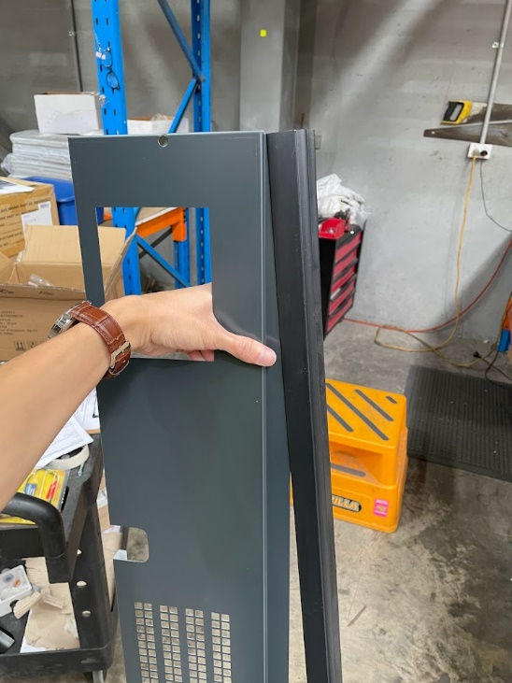  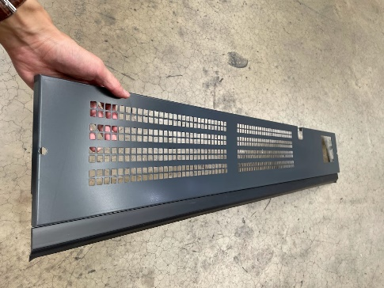

Attach front panels | 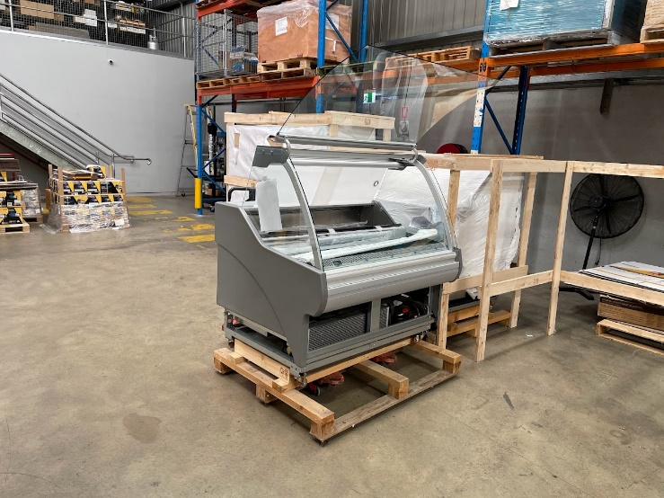  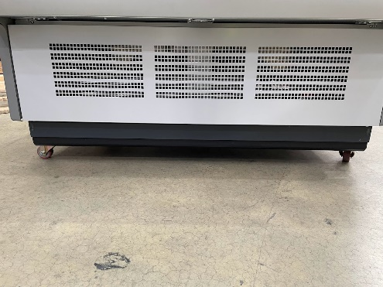  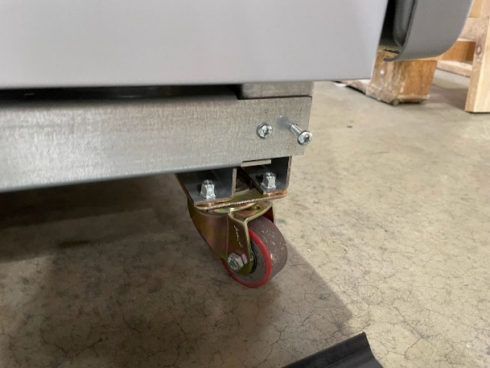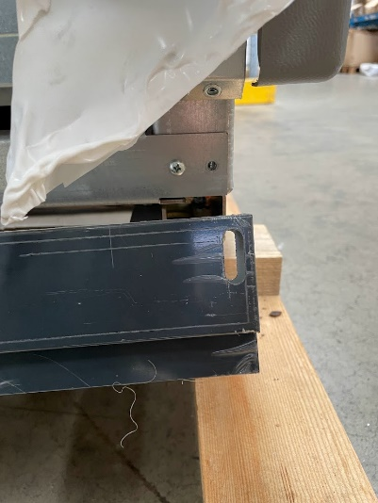

Attach rear panels  Use an impact driver to attach the rear panel in place, using the self-drilling screws. | 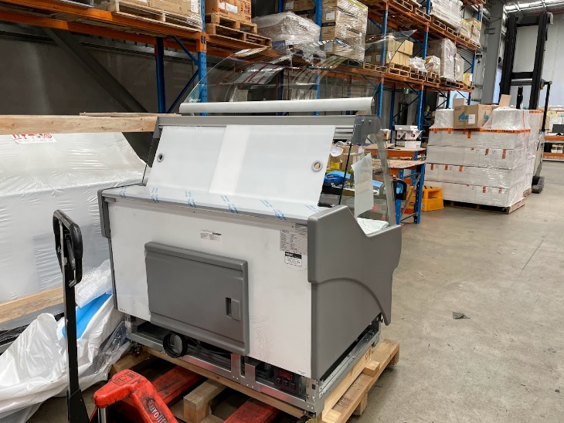  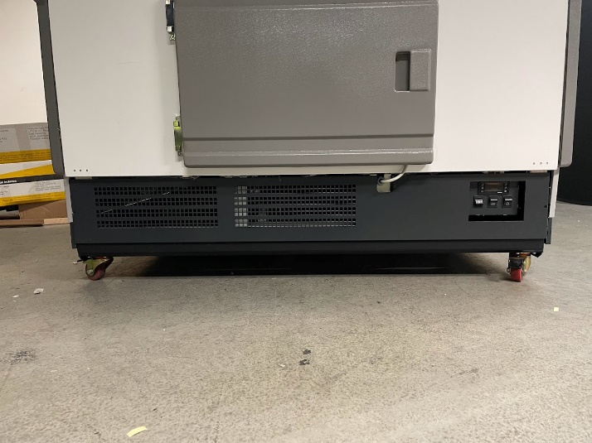  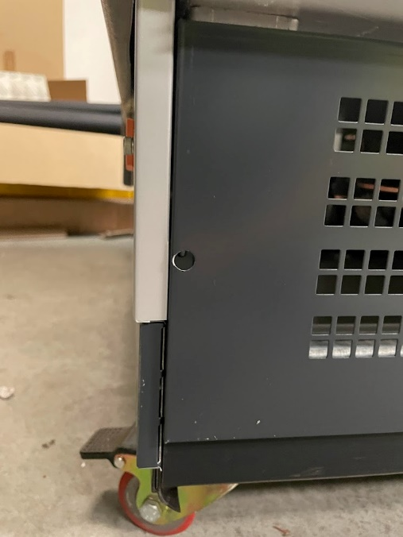
Attach side panels  Use an impact driver to attach the bottom side panel in place, using the self-drilling screws. | 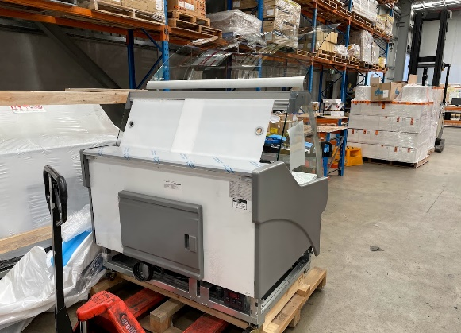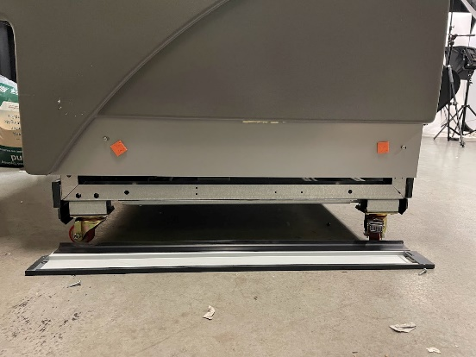  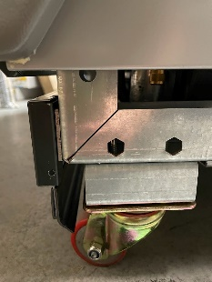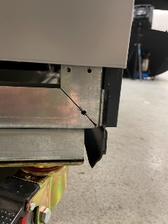  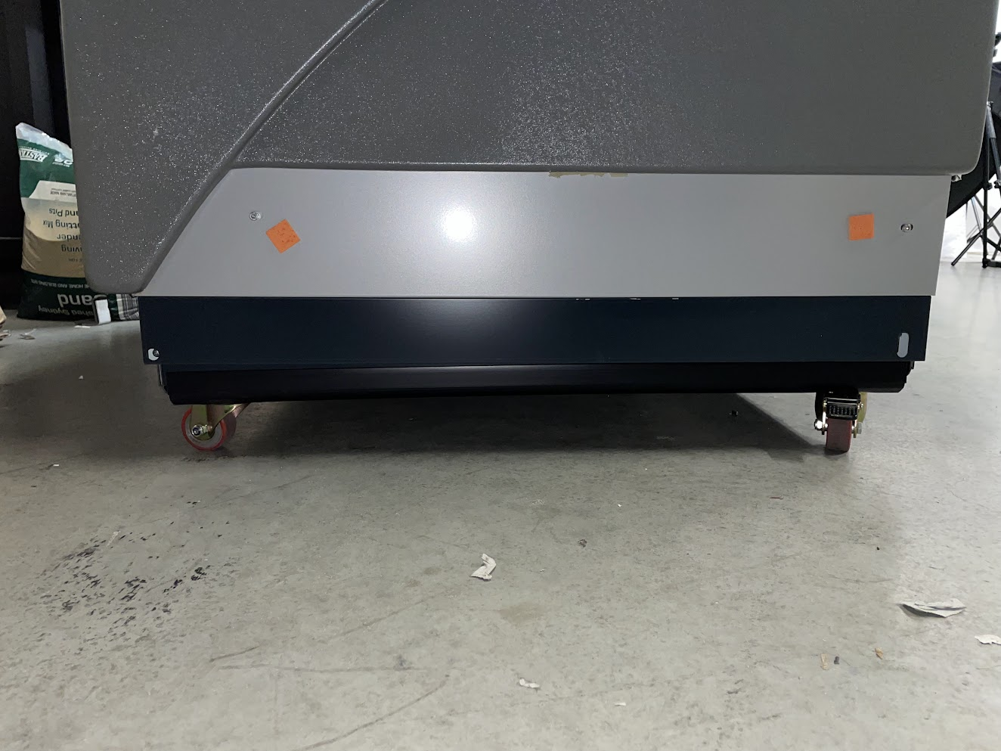

Top Glass Assembly
Top Glass Assembly  Remove the double-sided tape and stick the plastic covers on the roof of the cabinet.  The top glass rests on these plastic brackets. | 