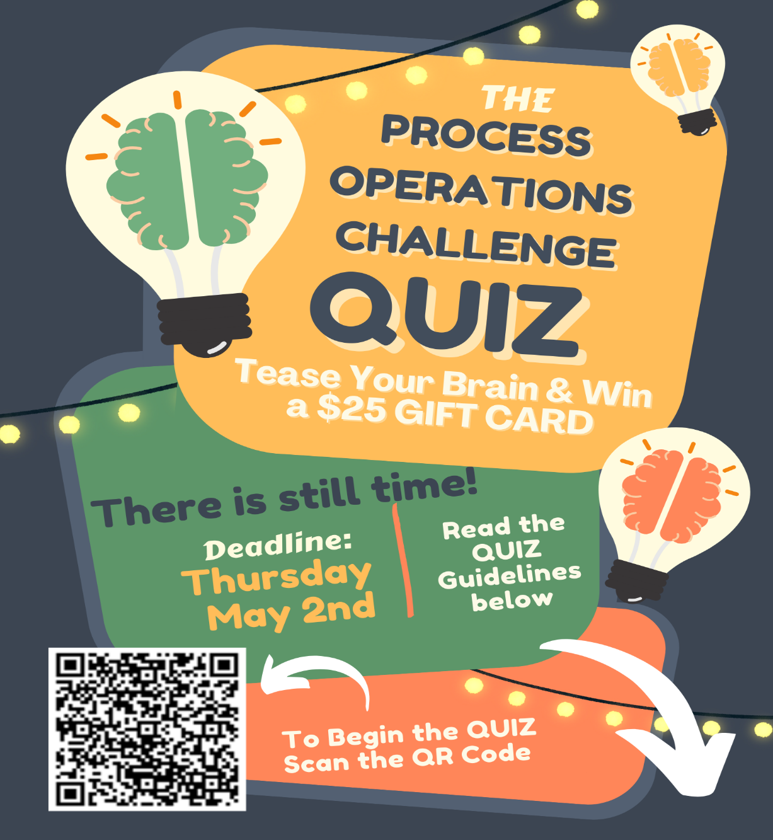

Quiz Guidelines

The Process Operations Challenge quiz is provided in each Influents issue with a QR code linking you to a Microsoft Form containing the quiz. This issue’s quiz consists of 4 questions that include multiple choice questions as well as one longer form scenario/calculation questions. A few notes:

- The quiz is timed and only your first submission will be considered.
- The top two winners will each receive a $25 gift card so make sure you answer the questions correctly but also quickly as your time will be a factor.
- You can decide whether you want to enter as a team or whether you want to enter as an individual but please provide contact information in any case. The winners will be notified by email following the completion deadline and the solutions will be included in the subsequent Influents issue.
- For this issue only, review the questions in the Influents Magazine (Page 52) to give you an edge when answering the form! Future quizzes will only be linked with the QR code.
- The topics of the quizzes link to the Science/Math corner that Hany Jadaa authors in each magazine issue so make sure you review his content before attempting the quiz for helpful tips and tricks.

If you require any assistance, please reach out to me at anna.lacourt@york.ca.

