Template for ASPE short and extended abstracts
Author R. One¹, Author R. Two²,
¹Department
Institute/company/university name
City, State/Region/Province, Country
²Department
Institute/company/university name
City, State/Region/Province, Country

Abstract
The abstrat goes here. The abstraction heading is unumbered. All acrnoyms used in the abstract must be defined before their first use. Consult the ASPE web page for a particular meeting for specific abstract requirements.

Instructions
This document provides formatting requirements for submission of an ASPE abstract or full paper and should be used directly as the template for abstract and paper preparation. Submissions must be in pdf format, follow the styles in this template, and follow any guidelines for lengths set for the particular meeting. Using the styles is important to provide document navigation and maintain consistent formatting. Body next uses the “Normal” style.
The paper size should be 8.5” x 11” (216 by 279 mm US letter size) with 1” (25.4 mm) margins on all sides. For authors using the A4 paper size (European, Asian and Latin American) in LaTeX, there is a button (dvi2pdf) used to create a pdf file in LaTeX installations based on WinEdt. To instruct dvipdfm to use US letter size paper by default, change the default paper size line in the config file in [TEXMF]\dvipdfm\config.
Body text be single spaced, 10-point Arial font using justified alignment in a two column format. Each column should be 3” (76.2 mm) wide with a 0.5” (12.7 mm) spacing between columns. Spacing between paragraphs should be 6 pt (which is built into the “Normal” style). Do not use page numbers, headers, footers, or footnotes within the manuscript.
References should be in the same typeface as the text and appear at the end of the paper arranged in order of appearance. Within the text, they should be numerically identified using closed brackets, for example [1]. Use the “Vancouver” numbering format described at http://www.icmje.org and demonstrated at the end of this document.

PAPER TITLE AND AUTHOR(S)
The paper title should start 1” (25.4 mm) from the top of the page and be 14-point bold, Arial font in all capital letters. The title should be centered on the page. There should be a 12 pt space between the title and the author listing(s) (this is build into the “Title” style).
Author name(s) should consist of first (given) name, middle initial (optional), and last (family) name. All author names and affiliations should be 12-point Arial bold, upper and lower case letters, and centered. All authors should be listed on the same line with their affiliations identified by numeric superscripts at the end of the name. In the case of a single author, do not use a superscript. Author affiliation(s) should consist of the following, as applicable:
- Department or division name
- Insitute, company, or university
- City, state/province/region, and country
More than two author affiliations may be listed in double columns. There should be a 12 pt space between the author listings and the first heading (this is build into the “Authors and Affiliations” style.

STYLES
This template contains the necessary styles to create title, author list, headings, figures, tables, and references. These styles can be viewed by opening the syle pane as shown in FIGURE 1. After opening the styles pane you should see the available styles list shown in FIGURE 2. Links to figures, headings and tables can be inserted using the ‘cross-reference’ section in the References tab.
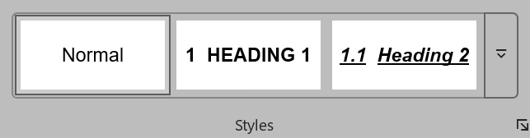
FIGURE 1. Opening style pane.
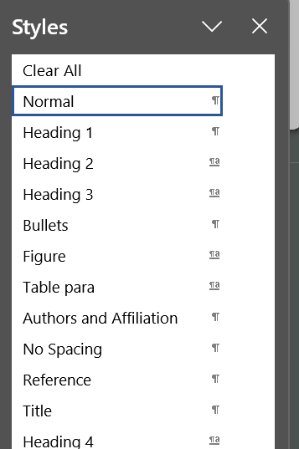
FIGURE 2. The available styles.

TEXT HEADING #1
The primary text heading should be 10-point Arial bold, all capital letters, flush left with the margin. If the heading is more than one line, the following lines should also be flush left. The spacing to the next heading or body should be 6 pt (this is build into the “Heading” style. To create this first-level text heading #1, select “Heading 1” style. If heading numbering does not automatically generate, then go to multilevel list shown in Figure 3. Pressing the Tab key once will create the second level heading #2, and pressing it again will create a third-level heading #3.

Text Heading #2
The first sub-heading should be 10-point Arial bold, upper and lower case letters, and underlined. The heading is flush left, and the spacing to the next heading or body text is 6 pt.

Text Heading #3
The third level of heading should be 10-point Arial bold, upper and lower case letters, and italicized. The heading is flush left, and the spacing to the next heading is 6 pt.
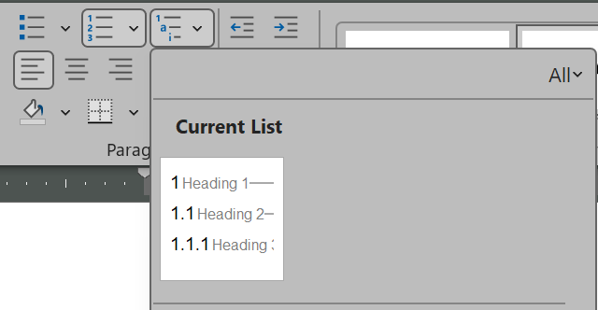
FIGURE 3. Selecting the multilevel list

TABLES AND FIGURES
All figures, tables and photos may be in color. Text within figures should have a font size of not less than 8-point. Raster based photos (jpg, png, etc) should be scanned at 200 DPI minimum and higher resulutions are acceptable. Figure and table captions should be numerically labeled in consecutive order. Caption text should follow the identification and use 10-point Arial font with upper and lower case letters, italicized, and justified, use the caption style to achieve this format, see FIGURE 2. If necessary, tables and figures may be inserted using a single column format.
FIGURE 4. The figure identification (e.g., FIGURE 1) should be 10-point Arial, italisized, and end with a period. It should be placed below the figure with 6 pt spacing between the figure and caption and 6 pt spacing between the caption and any following text. Use the caption style to produce a caption.
Tables shoud be sized to “Autofit to Window” (using the full column width). Table text should be 8 pt Arial, left aligned, column headings bolded, and have no space before after each line. Tables should only have horizontal borders for top and bottom of the first row and the bottom of the last row.
TABLE 1. The table identification (e.g., TABLE 1) should be 8-point Arial, italicized, and end with a period. It should be placed above the table with 6 pt space between the caption and table.
Value 1 | Value 2 | Value 3
1 | 0.1 | 0.6
2 | 0.5 | 1.5
3 | 1.0 | 0.5

PAPER SUBMISSION
Please submit your abstract as an Adobe Acrobat PDF file.
- Before submitting your PDF abstract (maximum two pages), ensure that all symbols were coverted appropirately from your word processing software into the PDF file.
- Before submitting your PDF abstract ensure that the PDF file contains all the required formatting outlined in this template. Please do not include page numbers, headers, footers or footnotes.
Short abstracts must be submitted in PDF format via the on-line submission portal on the ASPE website (www.aspe.net). Submission instructions are available on the website.
It is very important that you not send abstracts that are password protected or otherwise secured. All reviewers must have file access for proper consideration.

QUESTIONS
Please direct any questions to executive@aspe.net.

REFERENCES
- Lindeke R, Schoenig F Jr, Khan A, Haddad J. Machining of α,β-Titanium with Ultra-High Pressure Through the Insert -rfderence’ feature in the captions section within the ‘References’ tab.North American Manufacturing Research Institution of SME. 1991; 19: 154-161.
- Trigger K, Chao B. An Analytical Evaluation of Metal Cutting Temperatures. ASME Transactions, Journal of Engineering for Industry. 1951; 73: 57-68.
- Ulsoy A, DeVries W. Microcomputer Applications in Manufacturing. John Wiley and Sons, Inc. New York: 1989.

