
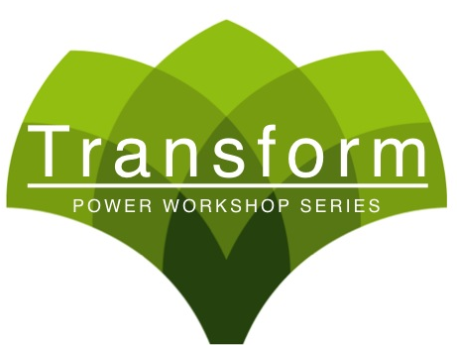




the
anti-cancer
code
workshop

A new way of living to help prevent & fight cancer
through a healthy lifestyle! Wellness awaits you!

\

September 12th 6:00-6:45pm
Seating Limited! Please Reserve Your Seat At The Front Desk!

