Here is a quick guide for network and operation status indicators and description about what each indicator means.

**Network Status**:

Network status show latest network connectivity behavior of eID/eUICC. Network status tab could show different status depending upon eID. These are the options you can see under network status tab.

|  |  |  |
| --- | --- | --- |
| Network status | Status | Description |
| Online | This indicates eID is Online |
| Enable | Data consumption is enabled on eID. |
| Disable/Stopped | Data consumption is disabled on eID. |
| Unactuated | eID is not activated. You will not be able use any Teal eSIM service until get eID activated. |

**Operation status**:

Operation status indicates the last status of profile change operation performed on eUICC. It doesn’t affect the eSIM connectivity at all. It only change the network carrier for connectivity.

|  |  |  |
| --- | --- | --- |
| Operation Stats | Status | Description |
| Waiting for device | Device is offline, profile operation queued and waiting for the device to come online. |
| Unscheduled | Profile change operation was applied and terminated in between. This status also displayed on new eIDs. |
| Failed | Profile change operation is failed for what so ever reason. This doesn’t mean eSIM has stopped working. It is just the status of profile change operation failure. |
| Activated | Profile change operation is successful and new profile is activated. |

**Bulk operations**:

These operations can be performed at once on a group of devices or on all devices by selecting them from the list. These options appeared on UI after pressing this button on OneChip eUICC page.

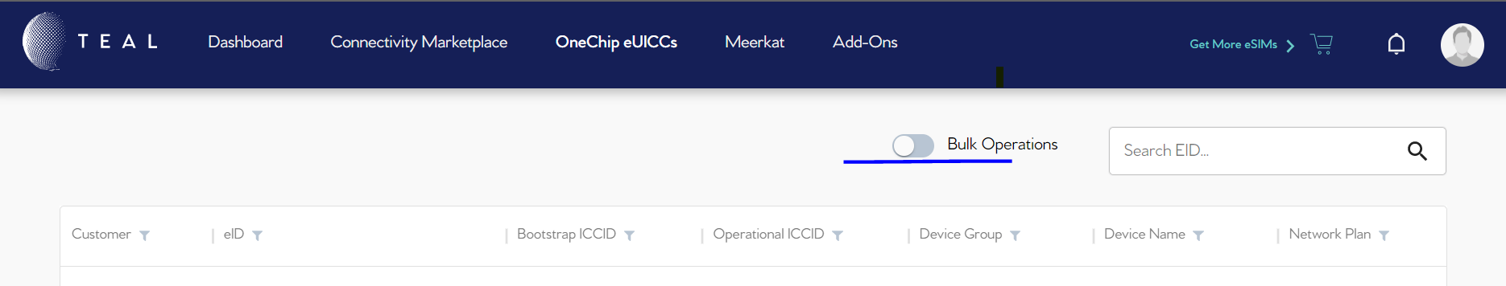

These are the operations you can perform under bulk operation tab.

|  |  |  |
| --- | --- | --- |
| Bulk Operation | Operation name | Description |
| Activate | Select multiple or all eIDs and activate at once. Activate means eID is enabled and Teal services can be availed on eID. |
| Activation upload | Rather than selecting eIDs from the list one by one upload CSV file containing the eIDs to activate, all at once. |
| Deactivate | To deactivate multiple eIDs send csv file to teal customer support. Deactivate is a permanent operation, you can’t activate them again. For temporary suspension of data use disable option. |
| Update device group | Select multiple eIDs in the list and create a group and enter the name of group in the space bar. |
| Bulk disable | Select all the eIDs from the list on which you want to suspend data consumption and click “Bulk disable”. Data consumption on all selected eIDs will be suspended. This data suspension is not permanent and can be resumed again by enable or resume data consumption. |
| Bulk enable | Select all the eIDs from the list on which you want to resume data consumption and enable them at once. |
| Download eSIM list | Select multiple or all eIDs from the list and click on this button to download a CSV file containing all the selected eIDs. |
| Set data cap | With this option user can set data cap on multiple eIDs at once. Data cap is the limit that how much data can be used, on an eID in a month. It automatically reset in next billing cycle. |
| Remove data cap | User can remove data cap on multiple eIDs at once by selecting them from the list. |
| Download Usage Report | To download data usage of multiple or all eID at once select all the eID and click “Download Usage Report”, select start and end date and click > continue. |