Reference Architecture:
Custom EC2 Instance with S3 Access Policy

Description: An Amazon Linux instance placed in us-east-1 boostrapped with a web server and custom content. Associated with a custom security group allowing secure SSH ingress for the developer and open WWW access for the public; also associated with a custom IAM Policy and Role allowing read/write access from the instance to a newly created S3 object storage bucket.
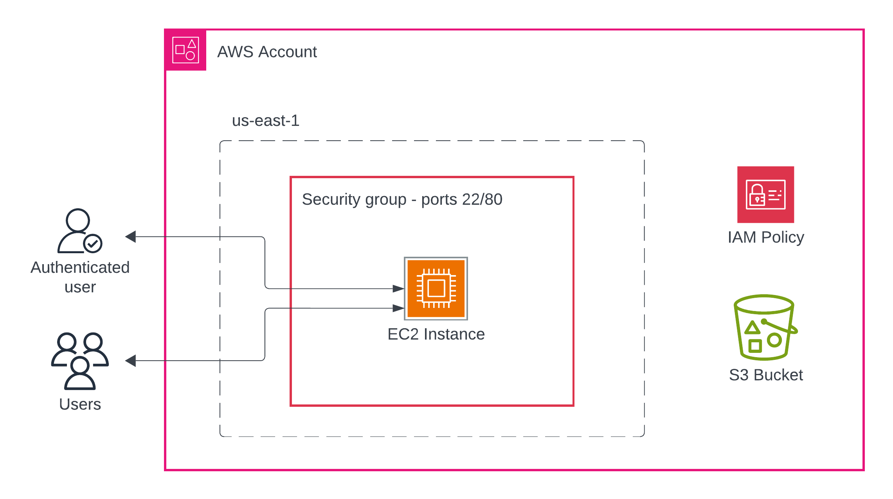

Resources | Description | Name / Identifier
AWS Account | Account #
Regional Placement | Availability Zone
EC2 Instance | Instance ID
Image ID | OS and base install (AMI)
Instance Type | Instance resources
Security Key | SSH access
Security Group | Associates instance with SG
Instance Profile | Consumes IAM policy as Role
UserData | Bootstrapping
Private IP | Internal network address
Public IP | Public network address
Security Group | Networking rules (ingress/egress)
S3 Bucket | Bucket name
IAM Policy | Read/write access to bucket

