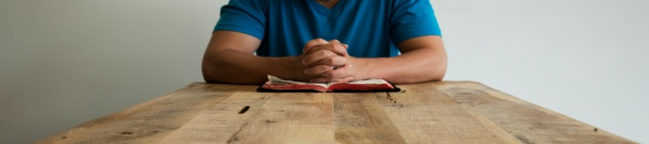
The Fourth Pledge … I am a Corps Member
When I received the free gift of salvation through Jesus Christ, I became a part of the body of Christ. As part of the body, my desire is to become
more like Jesus and exemplify holy living. I believe God placed me in this local corps fellowship to grow in my faith, humbly serve and participate
in the mission by using the gifts he gives for his glory and the sake of others. Therefore I will treasure both the gift and privilege of corps membership
and strive to joyfully share God’s gift of salvation with others.

Sign and Date

