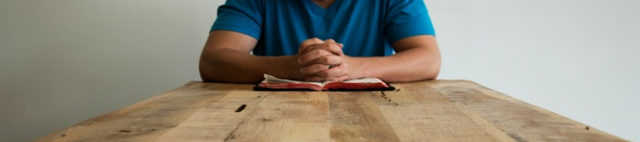
The Third Pledge … I am a Corps Member

I will not let my corps membership be defined by my preferences and desires. I will put others first and do whatever it takes to build and keep
unity in my corps. Through the guidance and power of the Holy Spirit,
I will seek to cultivate the mindset of Christ, by actively serving
within this fellowship. I believe through a life of humble obedience
I will discover the joy of being last.

Sign and Date

