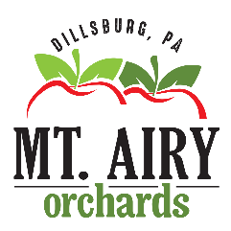
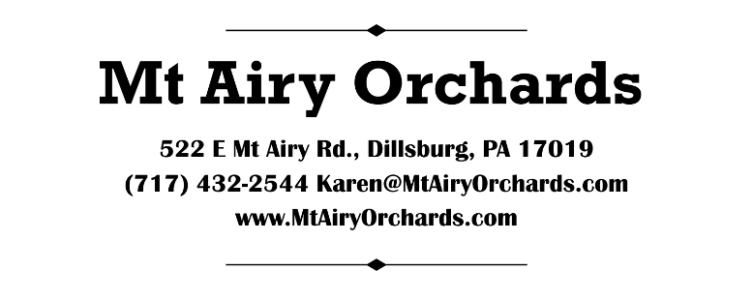

2026 Food/Drink Vendor Hold Harmless Agreement

Business Name: _________________________________ Contact Person: ________________________
Street Address: ________________________________________________________________________
City, State and Zip: _____________________________________________________________________
Business Phone: _________________________________ Cell Phone: ____________________________
Email Address: ________________________________________________________________________
Business License Number: _______________________________________________________________
PA Liquor License Number: _______________________________________ (if applicable)
Name of Insurance Carrier: ______________________________________________________________

***We require a certificate of liability insurance with general liability of $1m and a copy of your valid PA Food/Liquor License. Beer/Wine sales: we also require an exposition permit from the PLCB. You can obtain the exposition permit after you are an approved vendor and email it to Karen@MtAiryOrchards prior to the event date.

RELEASE, HOLD HARMLESS AND AGREEMENT NOT TO SUE:
You, your organization, and all voluntarily participating hereby release, discharge and agree not to sue Mt Airy Orchards along with all owners, employees, and volunteers connected to Mt Airy Orchards for any injury, death or damage to your personal property arising out of or in connection with your participation in our special events from whatever cause, including the active or passive negligence of the already named or any other participant in the named event.
We reserve the right to cancel due to weather, or any other uncontrollable events.
We will not and cannot set a guarantee on sales for your business at our event.
I, ON BEHALF OF MY ORGANIZATION AND ALL VOLUNTARY PARTICIPANTS IN THE 2026 ORCHARD EVENT, HAVE CAREFULLY READ THIS HOLD HARMLESS AGREEMENT AND FULLY UNDERSTAND ITS CONTENT. I AM AWARE THAT THIS IS A FULL RELEASE OF ALL LIABILITY AND SIGN IT OF MY OWN FREE WILL.
ACCEPTED AND AGREED:
Print Name: ___________________________________________________________________________
Signature: __________________________________________________ Date: ____________________
Name of Business: _____________________________________________________________________

