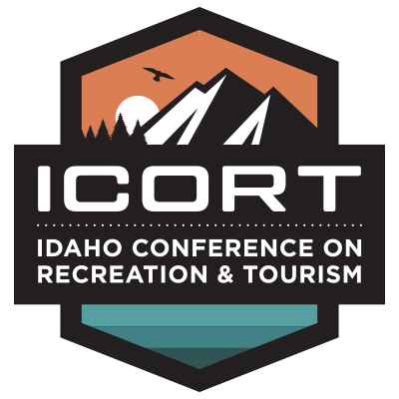
2022 Sponsorship Opportunities
Gem - $5,000
[Level One Activity Sponsorship]
Video/short presentation during conference
Additional conference registration
Listing in conference agenda
Vocal recognition during “housekeeping” announcement
Logo in sponsor reel
Garnet - $3,500
[Level Two Activity Sponsorship]
Listing in conference agenda
Visual representation at sponsored event
Logo in sponsor reel
Syringa - $2,000
Listing in conference agenda (contact information)
Admittance to ICORT (no presentation)
Logo in sponsor reel
All Sponsorships Include:
1 conference registration
1 6ft table
2 chairs
Ample opportunities to network with conference attendees

