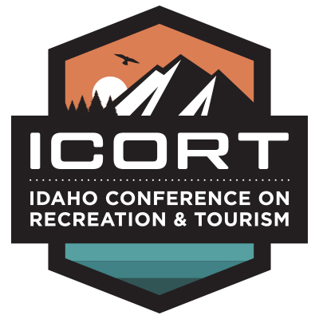

Virtual Idaho Conference on Recreation & Tourism
October 5, 2021
Wireless Network:
TWITTER: @icort2021 #icort2021
FACEBOOK: facebook.com/idahoconference
INSTAGRAM: #icort2021
Registration Site: https://icort.regfox.com/2021

Tuesday, October 5th

9:00 am – 9:30 am
Welcome from Governor Little

9:30 am - 10:15 am: Understanding Who is Coming to Idaho and Why
Anna Blount, Longwoods International
Anna will focus on Longwoods Travel USA research and bi-weekly traveler sentiment survey findings. She will address how the 2019 and 2020 Idaho domestic traveler was different (and sometimes the same) to understand who is coming to the state and provide insights for navigating potential crisis situations in the future.
10:15 am – 11:15 am: Astrotourism in Idaho
Michael Marlin, Author of ‘Astrotourism: Star Gazers, Eclipse Chasers, and the Dark Sky Movement’
This session will address ways to further develop your destination to cater to the astrotourist, explore the demographic of the astrotourist and share the economic impact of the Central Idaho Dark Sky Reserve and how a dark sky designation can have a ripple effect into communities.
11:15 am – 12:00 pm: Using Data to Drive Impact.
Dan Janes, Madden Media, will explore the visitation intelligence insights from the last year to identify growing audiences, shifting demographics, and emerging markets interested in Idaho destinations specific to each of the regions.
12:00 pm – 1:30 pm: Break

1:30 pm – 2:30 pm: Recreate Responsibly in Idaho
Join Ian Malepeai, Idaho Department of Fish and Game; Craig Quintana, Idaho Department of Parks and Recreation; and Wade Vagias, National Park Service, in a panel discussion on collaborative efforts to engage and educate locals and visitors on recreating responsibly and respecting special places in Idaho.
2:45 pm – 3:30 pm: Sports Tourism
Eric Olson, Huddle Up Group
As a sports tourism destination, do you know where your community ranks against your
competitive set? In your region? In your state? How do you stack up against
destinations with the same market size? Or those with similar budgets? What is your
facility development game plan and how does data factor in? Join Huddle Up Group
for this interactive session discussing the Sports Tourism Index.

3:30 pm: Announcement of 2022 ICORT & closing comments

