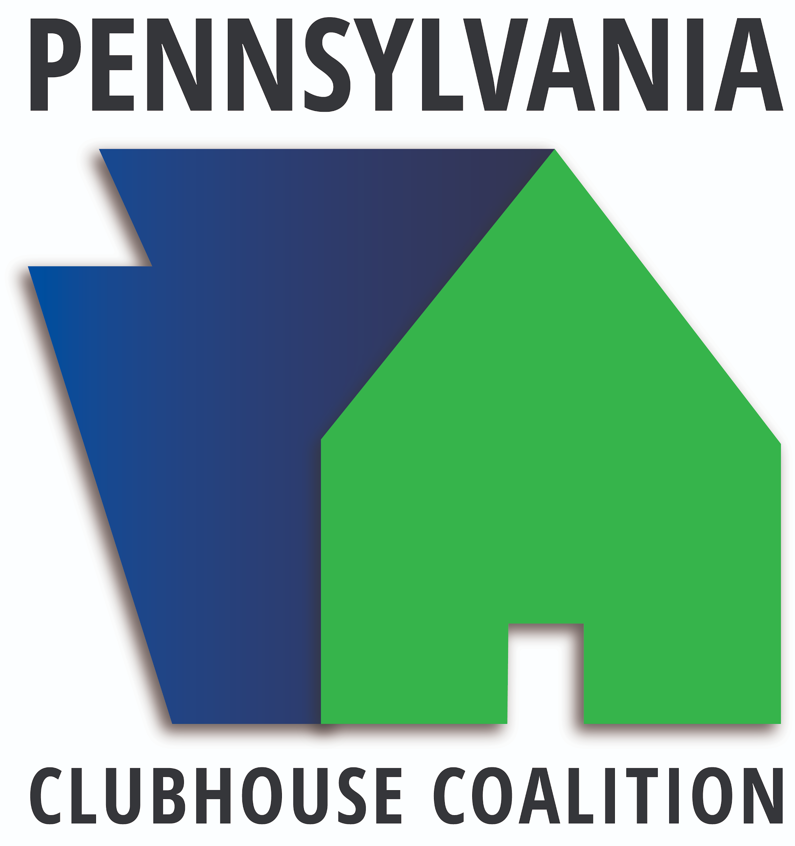

June 10th – 13th 2024

Doubletree by Hilton Conference Center

Monroeville, Pennsylvania

***2024 Sponsorship Packages***

***DIAMOND SPONSOR $10,000***

* Conference naming rights
* All Platinum Sponsor benefits with overnight accommodations for 4
* Headline promotion on all materials and marketing for the conference
* Headline sponsor for Dinner Gala
* Sponsorship of Community Partner award and Employer award

***PLATINUM SPONSOR $5,000***

* Four complimentary conference registrations with meals (does not include overnight accommodations)
* Table sponsor for Dinner Gala
* Sponsor banner hung in exhibit hall and logo included in slide show
* Sponsor video played in exhibit hall during program each day
* Inclusion in social media promotions
* Logo on conference t-shirts
* Full page ad in the Seminar Program
* Tabletop exhibit space for duration of Seminar
* Recognition in Welcoming & Closing remarks
* Daily recognition during morning opening
* Distribution of promotional materials

***GOLD SPONSOR $2,000***

* Two complimentary conference registrations with meals (does not include overnight accommodations)
* Sponsor logo included in slide show
* Inclusion in social media promotions
* Logo on conference t-shirts
* Recognition in the Seminar Program
* Tabletop exhibit space for duration of Seminar
* Recognition in Welcoming & Closing remarks
* Distribution of promotional materials

***SILVER SPONSOR $1,000***

* One complimentary conference registration with meals (does not include overnight accommodations)
* Sponsor logo included in slide show
* Recognition in the Seminar program
* Tabletop exhibit space for duration of Seminar
* Recognition in Welcoming & Closing remarks
* Distribution of promotional materials

***BRONZE SPONSOR $500***

* Reduced price conference registrations with meals for three days
* Recognition in the Seminar program
* Sponsor logo included in slide show
* Organizations name in plain text on conference t-shirts
* Tabletop exhibit space for duration of Seminar
* Recognition in Welcoming & Closing remarks
* Distribution of promotional materials

***MEAL SPONSOR $250***

* Recognition at each table and dining station for one conference meal (excluding Dinner Gala)
* Recognition in Welcoming & Closing remarks

***CLUBHOUSE PARTNER SPONSORSHIP $250***

***\*Open to any dues paying Clubhouse of the PCC\****

* Ad in the Seminar program
* Logo on conference t-shirts
* Placement of promotional materials in Seminar bags
* Inclusion in social media promotions and acknowledgement of sponsorship
* Tabletop exhibit space for duration of Seminar

***Annual Pennsylvania Clubhouse Coalition Seminar Deadline for submission: May 1, 2023***

***Sponsorship Application and Contract***

Diamond Sponsor ($10,000)

* Platinum ($5,000)
* Gold ($2000)
* Silver ($1000)
* Bronze ($500)
* Meal Sponsor ($250)
* Clubhouse Partner ($250)
* In-kind Donation (any amount)

Name of organization/business: ____________________________________________

Contact Person: ________________________________________________________

E-Mail Address: ________________________________________________________

Address: ______________________________________________________________

City: ______________________________ State: __________ Zip: _______________

Phone #: __________________________ Fax #: ______________________________

Company Website: ______________________________________________________

Social Media: __________________________________________________________

**Additional Details:**

Please email a full resolution JPEG company logo with your sponsorship application.

Promotional materials must be delivered to closest Clubhouse or mailed no later than **May 15th.**

Banners must be dropped off no later than **June 2nd.** Location must be coordinated with PCC team.

For our table exhibitors, we will provide one 8-foot draped table with 2 chairs.

**Sponsorship Total: _____________**

**In-Kind Donation Total: _____________**

**Final Total: _____________**

**Check-** Made Payable to “Pennsylvania Clubhouse Coalition”

**Credit Card:** ❍ Visa ❍ MasterCard

**Account Number:** ___________________________________ **Exp. Date:** ____/____ **Signature:** _________________________________________ **Date:** _____________

If you have questions, you can email Chris Stout: [cstout@yourgoodwill.org](mailto:cstout@yourgoodwill.org)

Please return this page, along with payment:

**Pennsylvania Clubhouse Coalition**

**Journey Center Clubhouse**

**C/O Kelsey Kinkade**

**944 Liberty St, Second Floor**

**Meadville, PA 16335**