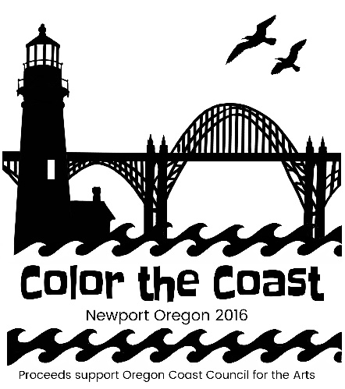

COLOR the COAST 3k Run

Come COLOR the COAST in a fabulous 3k fun run through the Nye Beach area of Newport!

Start the race with a clean palette, and throughout the run you will be saturated with non-toxic colored powder at color stations along the route of this awesome 3k! Don’t feel like running? You can walk it too!

Grab your family and friends, have a blast and bring a little color into your life!
The fun begins at 8am and ends with a Color Festival Party with prizes, music and color throws.

Become a living work of art and COLOR the COAST with us!

COLOR the COAST begins and ends at the Newport Performing Arts Center in Newport and is a fundraiser for the Oregon Coast Council for the Arts. Tie-dye yourself in color and support the OCCA!

Have Questions? Hopefully they are answered here!

What on Earth happens at the COLOR the COAST 3k event?
It is, hopefully, the most fun you’ll have running all year! You’ll start all clean and tidy in your perfectly WHITE clothes; as you run, walk, jog or skip through color zones throughout our 3k course, you will be doused with different colors at each station and when you are finished, you will be a living work of art!

Is the race timed?
Nope. This is just a fun event to share with family and friends.

Is the color safe?
We are using a colored cornstarch that is safe, biodegradable and non-toxic. As with any substance you do want to keep it out of your eyes and lungs. You may want to wear sunglasses or goggles for your eyes and a bandana or dust mask for your mouth.

Rain or shine?
We live in Newport. We do everything rain or shine, or we don’t do much of anything.

What about kids?
Kids are welcome! It will be fun for the whole family. Children 7 years old and under are FREE with a paid adult (only 2 free children with each paid adult), but must be registered with a number and signed waiver. Free participants will NOT receive the other registration items, but can be purchased as an add-on.

What about strollers?
Of course you can bring your stroller (no one wants to carry a little one almost 2 miles!), but remember that part of this race is on the beach, so plan accordingly.

What is included with my registration?
Each registration provides entry into the event, t-shirt, bandana, sunglasses, a race bib, wristband and a color pack. Children 7 and under who are running for free will only receive a race bib and wristband. The other items can be purchased as an add-on.

Packet Pick up!
Packet pick up is the day before the event at the Newport Performing Arts Center from 5-6pm.

Can I pick up my packet the day of the event?
Absolutely! We will be there at 8am with the race starting at 8:30am. Check in will be in the Newport Performing Arts Center parking lot.

How will you know participants from non-participants?
All participants 8 and up will have a t-shirt, race bib and wristband and only participants will be allowed to run through the color stations. Children 7 and under who are registered will have a race bib and wristband. Even though extra t-shirts can be purchased, a race bib and wristband are required and cannot be purchased without registering.
What should I wear?
You can wear whatever you want, but white clothing shows the color the best! You can even dress in costume if you want, but again the key here is WHITE to start. You’ll be really colorful at the end!

Will the color stain my clothes and shoes?
If you want a lot of color to hit your shirt, plan to run or walk closer to the color throwers. If you want only a little bit of color, don’t run or walk too close. The color mostly washes out after the event, but some of it can stain. As with anything, the sooner you wash it the better. We suggest wearing items that you don't mind getting the color on.

Will the color get in my car?
Bring a towel or some plastic bags to cover your seats and it shouldn’t be a problem. If you do get some in your car, you may need a vacuum.

What happens after the race?
There will be a party of course! A dance and color party! We will have prizes, music and periodic color throws until everyone is covered in color. It’s going to be a blast!!

Can my friends come watch?
Everyone is welcome to come and watch the run and join the party after the race. There will be extra color packets available for purchase on site so even those not running can throw some color and join the fun!

Who does this support?
We’ve put artistic fun in fundraiser!! COLOR the COAST is a fundraiser for the Oregon Coast Council for the Arts (OCCA) and ALL proceeds go to fund the arts on the Oregon Coast. Everyone working on this event is volunteering their time for this great cause.

Refunds?
Sorry, all sales are final and there are no refunds.

