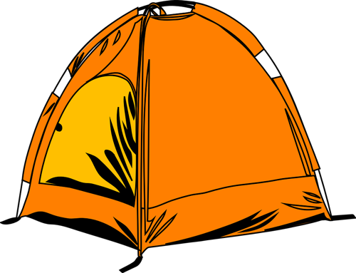
Campground Name: Camp Tecuya,
11701 Frontier Rd, Frazier Park, CA 93225
Trip Dates: July 14-16.
Temperature Range: H 80 to L 50

Camping Check List
CAMPSITE  □ Tent, stakes, and rain fly  □ Sleeping bags □ Pillows  □ Sleeping pad / air mattress  □ Mattress pump (optional)  □ Sheets / blankets (optional)  □ Camp table (optional)  □ Tablecloth  □ Camp chairs  □ Lantern / headlamps / string lights  □ Sun shade / rain shelter (optional)  □ Clothesline + clips (optional)  □ Rug / door mat for tent entry  CAMPFIRE TOOLS (OPTIONAL)  □ Check current fire regulations in the area  (charcoal and propane stoves are permitted)  □ Firewood  □ Fire starter / kindling □ Axe / hatchet  □ Lighter or matches  □ Charcoal + chimney starter  □ Water bucket for dousing fire □ Shovel  SAFETY & HYGIENE  □ First aid kit  □ Knife / multi-tool  □ Gear repair kit  □ Hand sanitizer  □ Trowel (optional)  □ Toilet paper | TOILETRIES  □ Toothbrushes □ Toothpaste □ Floss  □ Medications  □ Lip balm □ Sunscreen  □ Bug spray / insect repellent  □ Deodorant  □ Hand soap □Shower supplies  □ Shower shoes □ Quick dry towels  □ Camp shower (optional)  CAMP KITCHEN  □ Stove □ Stove fuel □ Lighter / matches  □ Cooler(s) □ Water jug  □ Skillet / frying pan □ Cook pot with lid  □ Pot holder / heat proof gloves  □ Instant read thermometer  □ Griddle (optional)  □ Portable grill grate (optional)  □ Dutch oven + lid lifter (optional)  □ Cooking utensils (spoon, tongs, spatula...)  □ Sharp knife □ Cutting boards  □ Mixing bowls (optional)  □ Measuring cups / spoons (optional)  □ Coffee maker  □ Can opener □ Bottle opener / corkscrew (optional)  □ Heavy-duty foil (optional)  □ Roasting sticks / skewers (optional)  □ Pie iron (optional)  □ Containers for leftovers  □ Organizational / storage bins  Note: At night your food coolers will be kept in the lodge. Also any perishables such as meat can be kept in the walk in freezer/fridge.

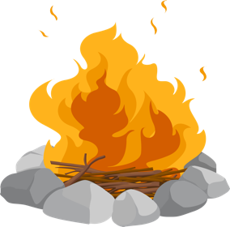
This Photo by Unknown Author is licensed under CC BY-NC

Camping Check List

SERVING  □ Plates □ Bowls □ Forks, spoons, and knives □ Napkins □ Drink glasses □ Coffee mugs  □ Water bottles  CLEANUP  □ Dish basin / sink □ Biodegradable soap  □ Sponge □ Scrubber □ Cast iron scraper  □ Microfiber dish towel  □ Paper towels (optional)  □ Dish drying rack (optional)  □ Trash can / trash bags  OTHER ITEMS  □_________________________________  □_________________________________  □_________________________________ □_________________________________ □_________________________________ □_________________________________ □_________________________________ | CLOTHING  □ Shirts / tanks □ Long sleeve shirt  □ Pants / shorts □ Underwear □ Socks  □ Sturdy shoes / hiking shoes  □ Camp sandals / slippers  □ Lightweight jacket  □ Warm / insulated jacket  □ Base layers / long underwear (optional)  □ Rain gear □ Sun hat □ Warm beanie  □ Gloves / mittens □ Sleep clothes  □ Bathing suit + water shoes (optional)  □ Sunglasses □ Other items for activities  EXTRAS / MISC.  □ Photo ID, credit card, cash  □ Camera, battery, memory card  □ Phone □ Charger cords + battery bank  □ Hammock  □ Journal + pen / pencil □ Book / Kindle  □ Instruments  □ Hiking daypack  □ Other items for activities  □_________________________________  □_________________________________  □_________________________________ □_________________________________ □_________________________________ □_________________________________ □_________________________________

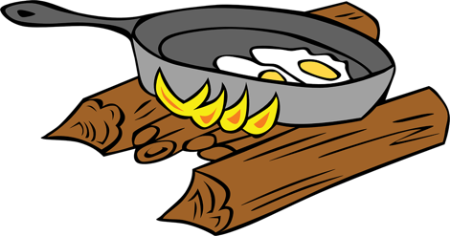
Camping Meal Plan

Day

Breakfast | Lunch/Snacks | Dinner/ Dessert

Day

Breakfast | Lunch/Snacks | Dinner/ Dessert

Day

Breakfast | Lunch/Snacks | Dinner/ Dessert

