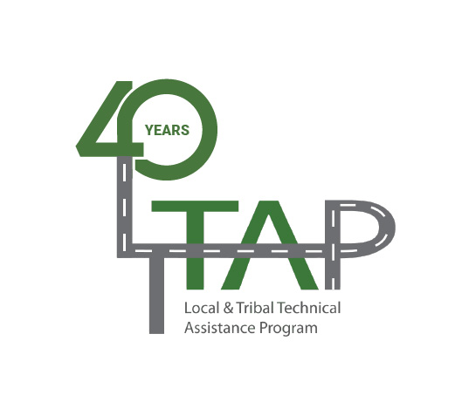
National LTAP/TTAP Conference
Seattle, Washington
July 18-21, 2022
Renaissance Seattle Hotel
Registration, Poster Information and Hotel Link at
https://nltapa.org/workgroups/conference/

Mary’s Place

Service Project

Monday, July 18
 | 2:00 - 5:00 | Mary’s Place Service Project  Contact Keith Knapp for more details kknapp@iastate.edu |  | www.marysplaceseattle.org

This year NLTAPA will have a service project as part of its national conference schedule. It will occur between 2:00 and 5:00 PM on Sunday. We will be helping our Mary’s Place in Seattle (see www.marysplaceseattle.org).

Mary’s Place’s mission is to provide safe, inclusive shelter and services that support women, children, and families on their journey out of homelessness. Please come help pack cold care kits for Mary’s Place throughout the afternoon as you are able.

Direct donations made be made out to ???. You also may bring socks to be donated at the conference or delivered to Keith Knapp while in Seattle. We would like to be able to build at least 100 kits.

Contact Keith Knapp at kknapp@iastate.edu if you have any questions.

If you would like to participate and/or contribute, and have Keith contact you, please let us know by clicking the Volunteering for the Mary’s Place Service Project box on the registration page: https://natltapassoc.regfox.com/preview/2cfcb73ce6f34e91bba7b151a9a9cd90.

