Introducing Jeff Lasselle

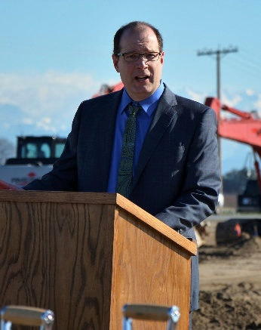
An accomplished operations executive with over 30 years of experience leading, coaching, and mentoring teams at the department, site, and regional levels within large multinational organizations. Known for building high-performing teams and fostering strong safety cultures, Jeff has consistently delivered operational excellence in complex manufacturing and distribution environments.
As Operations Vice President for Aldrich Chemical, a Merck KGaA subsidiary, Jeff received the 2021 People Leadership Award for his steady leadership during the COVID-19 pandemic. Earlier, he earned the 2015 Global Safety Award at Sigma Aldrich for spearheading a global leadership development initiative that trained 1,200 people-leaders, significantly improving safety culture and results across the international operational footprint of over 50 sites in dozens of countries.
Jeff began his career as a Chemical Process Engineer before quickly transitioning into leadership roles, driven by a passion for improvement—especially in safety. His career has spanned leadership of large departments in production, shipping, and maintenance, full-site manufacturing leadership (150–700 employees), and multi-site regional operations across North America. His leadership journey includes key roles at Merck KGaA, Sigma Aldrich Corporation, Sherwin Williams, and RPM International.
In 2023, Jeff founded Boosting Leadership, LLC, a consultancy focused on coaching and developing people leaders.
Jeff's areas of expertise include:
- Developing future leaders
- Coaching executives to optimize their impact
- Driving organizational change and employee engagement
Jeff holds a BS-degree in Chemical Engineering from Bucknell University, an MBA from Heriot-Watt University, and a certificate in management from the Kellogg School of Management.

