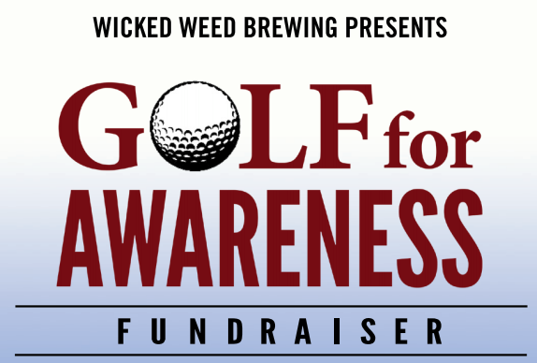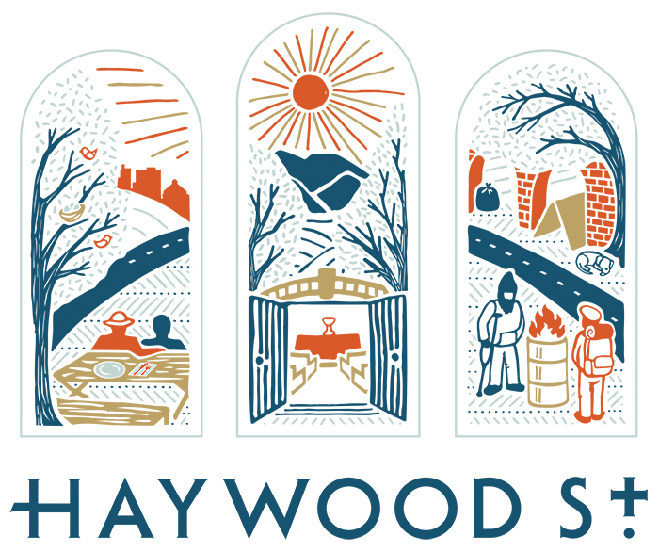

**A FUNdraiser for**

**Downtown Welcome Table**

**and Haywood Street Respite**

**Asheville Municipal Golf Course**

**Friday, September 20th, 2019**

**Registration/Check In at 12:30 – Shotgun Start at 1:30 p.m.**

**Lunch Provided**

**Format**

4-Person Captain’s Choice – 5 Club Tournament

Each team member will be allowed 5 clubs. Individual players will use these same 5 clubs for the entire tournament (pick and choose wisely). The 2019 winning team will only be allowed 4 clubs in the 2020 Tournament; 2019 last place team will be allowed 6 clubs in 2020. Tournament is limited to 110 golfers.

**REGISTRATION FORM**

🞎 Individual Player Registration $95

🞎 Foursome Registration $340

🞎 Threesome Registration (4th Haywood St. Friend will be added) $250

🞎 Player Sponsorship (sponsor a friend of HSC to play the tournament) $95

🞎 Mulligans (Limit 5 per player) $5

🞎 Red Tees (Limit 2 per player) $5

🞎 Available Sponsorships (circle one)

Silver $500 Gold $1,000 (includes 1 free registration) Platinum $2,500 (includes 2 free registrations)

Player 1 / Team Captain:

Address:

Phone #: Email:

Player 2:

Player 3:

Player 4:

Hole Sponsorship Name:

**Register by mail: PO Box 2982, Asheville, NC 28802**

Please Make Checks Payable to Haywood Street Congregation

Haywood Street Congregation is a 501 c3 tax deductible organization