Doubles Fire Build
Description: In Fire Building two contestants build a fire to boil 2 cups of soapy water in a can in the shortest possible time.
Set-up: Each team will be provided with a bolt of dry wood, three wooden matches, and a tin can with a wire handle. Just before the contest, each team will receive the same measured amount of soapy water. Each team may use a knife/drawshave and an axe to cut and split their firewood. The can may be supported using any technique (including another axe) and teams may build their fire and split on cookies.
Procedure:
On the starting signal the contestants will split their wood and build a fire to heat the soapy water.
If the competitors cannot start their fire with the three original matches, they may get extra matches (one at a time) from the head judge or another designated person as announced at the start of the event.
If any water is spilled from the can during the event, the entrants must get a complete refill from the judge. No extra wood may be used.
The can must be supported so that it remains upright during the event. The intention of this rule is that contestants cannot intentionally tilt the can in an effort to heat the side of the can.
Nothing may be used to make a lid on the can.
The time for fire building will run from the starting signal until the water boils over the edge of the can.
A time limit of 10 minutes will be imposed for this event.
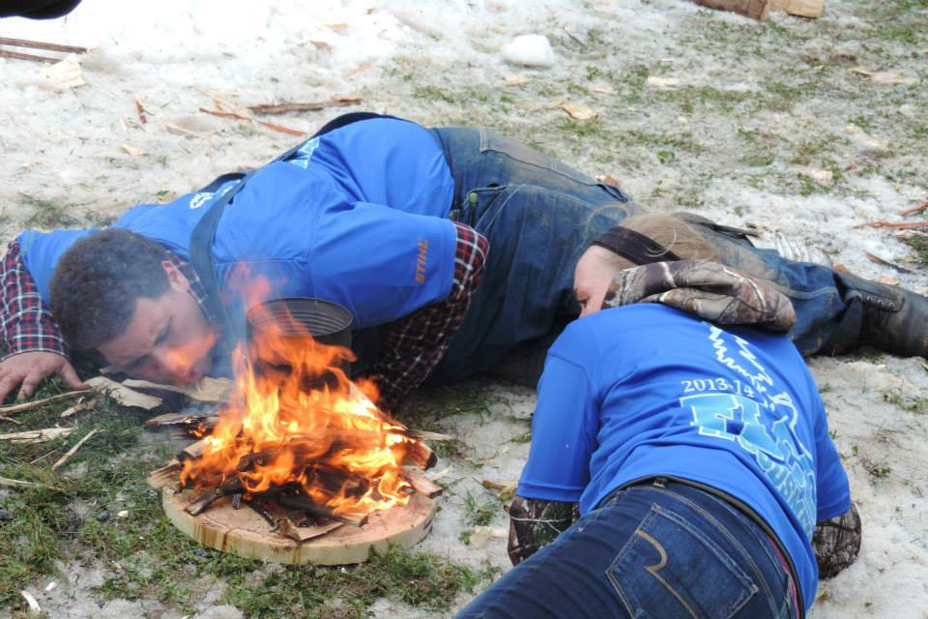
Scoring:
Each team's score for this event will be determined by the elapsed time plus additional time for penalties as follows:
1) If a team is deemed to be purposely trying to break the rules, a disqualification will result.
2) Spilling water and not getting a refill: 8 minutes.
3) Using wood not from the original bolt: 5 minutes.
4) Tilting a can, or not righting a tilted can: 2 minutes.
5) Using a lid on the can: 2 minutes

Event Judges
Each event must have a designated judge that is responsible for implementing the event at any competition. Such persons will be referred to as Event Judges. Event Judges will be recruited/hired by the Meet Director.
Event Judges will be familiar with these NEILA fire building rules and scoring procedures.
Timers
Each event should have at least one person helping the Event Judge that is operating a stopwatch. Timers responsibility is to time from the start to completion for each event.
Scorekeepers
Scorekeepers are responsible for collecting scores (or times) for each event from Event Judges and tracking all scores. Scorekeepers must ensure the accurate tracking of scores and apportionment of “points” that are earned for each participant in each event.
Scoring and Standings
Teams earn points proportionately, in each event according to every participant's performance in such events at any unique competition.
The team with the best performance, either fastest time, earns 100 points. Then, other teams’ performance in such events will be based on the proportion of their performance measured against the winner; their score/metric will act as the denominator and the winning performance metric as the numerator. For example, if the winning time is 30 seconds, and the next fastest time is 34 seconds, the winning team earns 100 points, and the next fastest time earns 88.24 points (30/34= 0.88235294 x100 =88.2352941). (Wording here could be simplified).
Community Equipment at Competitions
Meet Directors may provide equipment/supplies that are to be used by all competitors to maintain fairness and uniformity.
Community equipment may include water boiling cans, soapy water, matches, and all of the competition wood for the contest.
Competition Wood and Allocation
Meet Directors are responsible to procure, prepare, and then provide all competition wood for their competition. Competition wood shall be as uniform as possible for each team.
Personal Protective Equipment
All competitors using an axe in any event are required to use protection on their legs and feet. Failure to comply with safety regulations will result in disqualification for the event in question. Substitutions will not not be allowed for such forfeited events.
Safety Precautions- Event Starts
For all timed events the starting count-down will be as consistent as possible for all events, with a consistent tempo, and consistent tone so each competitor can time their start appropriately.
Each event start should follow as closely as possible this format : "Contestants ready?" "Judges and timers ready?" "3-2-l-GO"
Judging Errors
If a team feels an error has been made in judging or scoring, the captain of that team should notify the EVENT judge as soon as possible. The MEET DIRECTOR has the final say in any discrepancies NOT resolved by the EVENT JUDGE.
Whenever possible, real-time videos may be substituted by the Meet Director to re-time any event.
Event Time Limit
If any contestant(s) cannot finish any timed event, they may stop the event by telling the judge. To prevent dangerous fatigue and to expedite the contest, a time limit of ten (10) minutes will be imposed for all timed events except as noted below.
Competitor Acknowledgement
Upon completion of each event, one competitor must sign the Judge / Timer sheet to acknowledge the time and penalties as recorded.

