Travel information from the airport to the Hotel Tiber Fiumicino

Dear Brothers and Sisters,

The location of the Conference and your accommodation is Hotel Tiber Rooftop & Wellness Fiumicino, which you can learn more about here: https://www.hoteltiberfiumicino.it/en/
If you are arriving at the Leonardo da Vinci International Airport (Fiumicino), there are two options for traveling from the airport to the hotel:
Option 1 – Hotel Shuttle Services (Recommended)
The service from the Airport to the Hotel is not upon reservation; it is necessary to reach the meeting point according to the timetable. The service costs € 7 per person each way.
Only the service from the Hotel to the Airport must be reserved at the reception the day before.
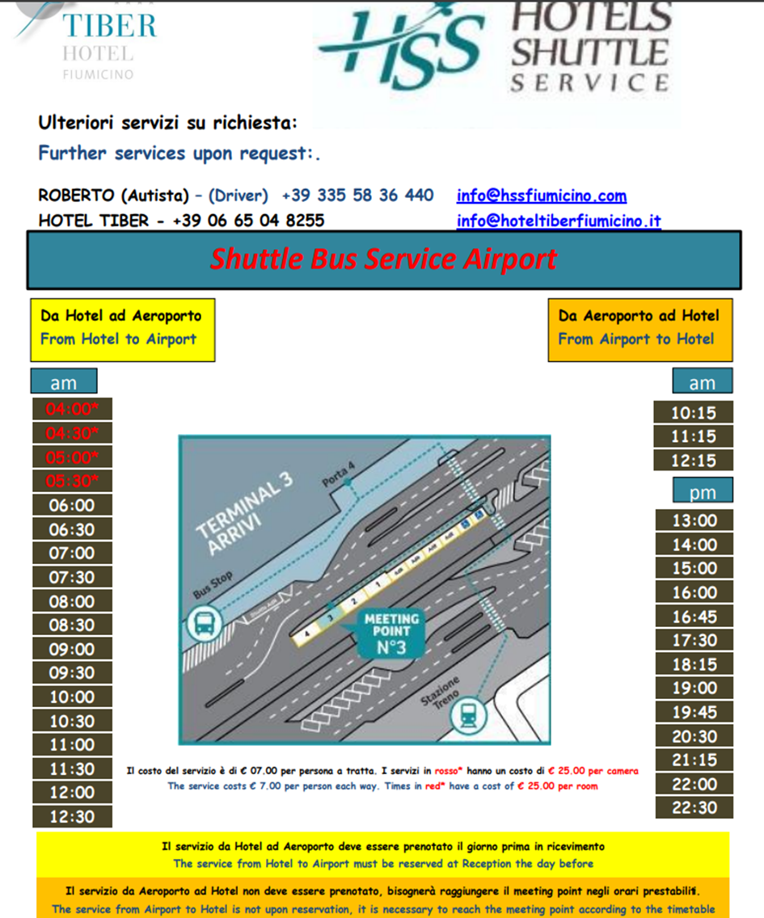

Option 2 – Public Transport

- By Bus (Cotral)
Taking the bus is a quick and affordable way to get from Rome Fiumicino Airport (Leonardo da Vinci) to the conference venue.
Where you can buy tickets: The Tobacconist "Titoli" is located in Terminal 1, near the COTRAL bus stop next to the taxi stand.
How to get there:
- From Terminal 1, exit the building and walk just a few meters to the Cotral bus stop.
- Board the Cotral regional bus towards Fiumicino.
- Stay on for 3 stops (about 10 minutes).
- Get off at Fiumicino – Via Torre Clementina.
- Walk about 150 meters (1 minute) to the venue at Via della Torre Clementina 180–210.
Key details:
- Travel time: 12 minutes
- Ticket cost: Between €1.10 and €2.20
  - If you buy the ticket on board, it is much more expensive (around €7, cash only).
- Where to buy tickets:
  - At the airport: Tabacchi shops, newsstands, or Cotral ticket machines near the bus area.
  - Online via the Cotral website or app.
- Validation: Remember to validate your ticket using the small stamping machine once you board.
- Bus frequency: Generally hourly, but schedules may vary depending on the time of day — always check the latest timetable.
- Arrival stop: Fiumicino – Via della Torre Clementina 276
Location of the hotel: Via della Torre Clementina 276 Fiumicino (Rm) 00054

- By taxi
A taxi ride costs approximately €25–€35 and takes around 7 minutes.

