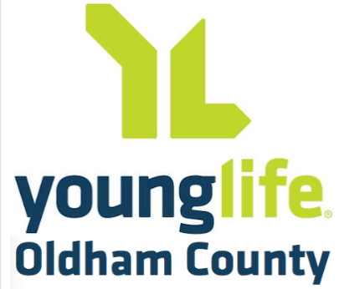
Oldham County Young Life Annual Golf Outing
Corporate Sponsorship Opportunities
Friday, September 11, 2026
Harmony Landing Country Club

Title Sponsor -- $5,000
Includes:
- 8 playing positions, including tee gift, lunch, and prizes
- Corporate identity on all tournament information and communications
- Recognition as Title Sponsor during event welcome
- Corporate identity on sponsor banners and at registration table
- Corporate recognition in Young Life newsletter

Tee Gift Sponsor -- $3,500
Includes:
- 4 playing positions, including tee gift, lunch, and prizes
- Corporate branding opportunity with tee gift
- Corporate identity on sponsor banners and at registration table
- Corporate recognition in Young Life newsletter

Cart Sponsor -- $3,000
Includes:
- 4 playing positions, including tee gift, lunch, and prizes
- Corporate identity on all golf carts
- Corporate identity on sponsor banners and at registration table
- Corporate recognition in Young Life newsletter

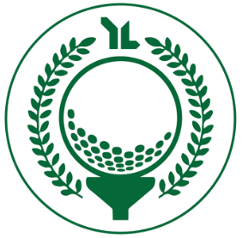
Oldham County Young Life Annual Golf Outing
Corporate Sponsorship Opportunities
Friday, September 11, 2026
Harmony Landing Country Club

Lunch Sponsor -- $2,500

Includes:
- 4 playing positions, including tee gift, lunch, and prizes
- Corporate identity at lunch in clubhouse prior to golf
- Corporate identity on sponsor banners and at registration table
- Corporate recognition in Young Life newsletter

Contest Sponsor -- $2,500

Includes:
- 4 playing positions, including tee gift, lunch, and prizes
- Corporate identity at all on-course games (closest to hole, etc.)
- Corporate identity on sponsor banners and at registration table
- Corporate recognition in Young Life newsletter

Gold Sponsor -- $1,000

Includes:
- 4 playing positions, including tee gift, lunch, and prizes
- Your company name will be on display at one of the 18 holes
- $300 savings compared to separately buying foursome ($800) and Hole Sponsorship ($500 – see details below)
- Corporate recognition in Young Life newsletter

Hole Sponsor -- $500

Includes:
- Your company name will be on display at one of the 18 holes
- Corporate recognition in Young Life newsletter

