INTERNACHI® AIRSTREAM INSPECTION CHECKLIST

This is a basic inspection checklist for inspecting an Airstream trailer. Use this checklist to build, improve and customize your own inspection checklist.

TRAILER DATA STICKER

Look for the trailer data sticker. Each trailer should have a data plate affixed in a permanent manner, including the date and VIN number. Collect information related to: date of manufacture, make and model, VIN, length, weight, and number of axles. Document the original manuals and service records.

EXTERIOR

Level
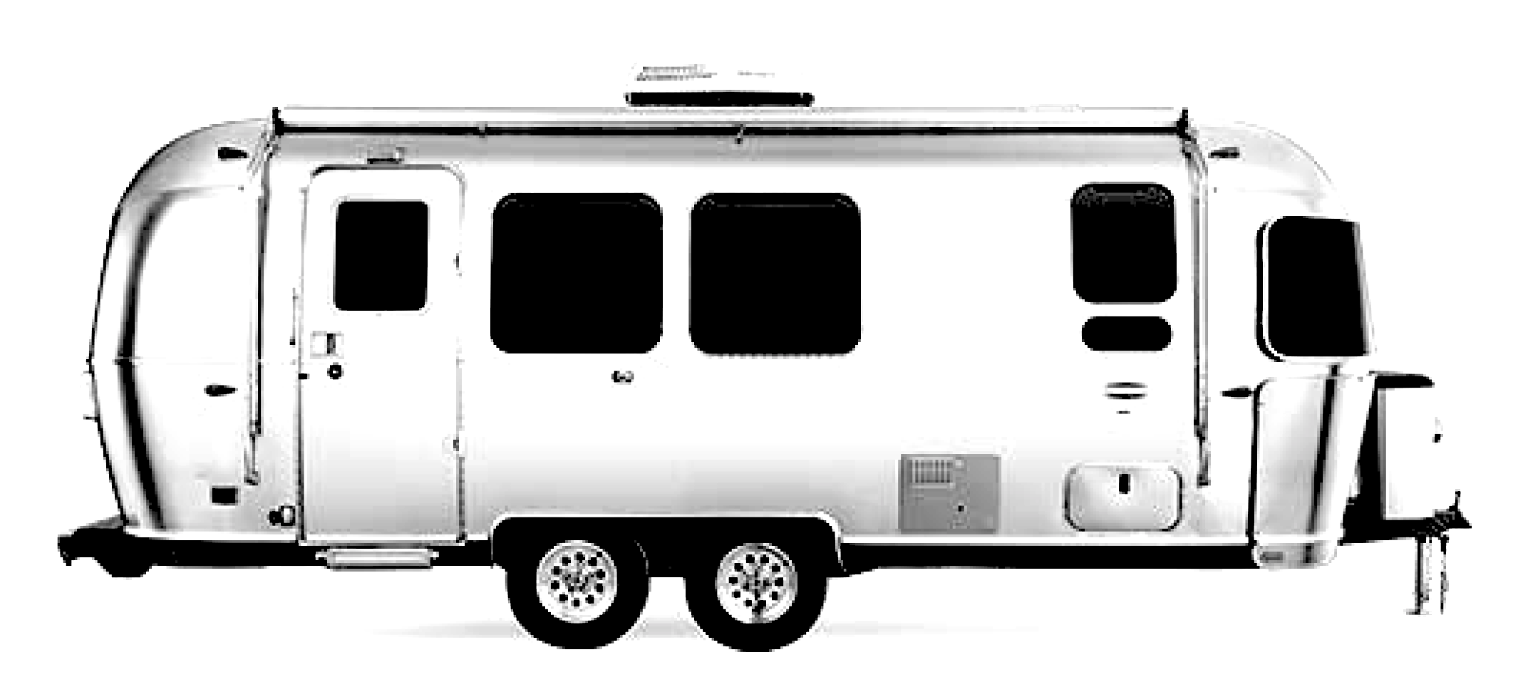
Check the trailer to see if it’s level. Some trailers may be parked or positioned on uneven ground, or the trailer may settle unevenly.

Wheels
Check each wheels and tires. Check each tire for condition and inflation. Each wheel has its own suspension.

Spare Tire
Check the condition.

Site
Check the site for proper drainage. The trailer should not be sitting in dirt or mud. Check the wheels for proper support.

Jacks
Check the trailer jacks. Look for missing parts, bent, damage. Check the stability of the concrete pads that support the jacks.

Chassis
Check frame or chassis for sag. Look for rust, corrosion, cracks. Airstream builds the entire structure of the trailer, then lifts it up by its roof, and places it on top of the chassis. It a way to ensure a strong and durable structure.

Hitch
Check for rust, cracks, damage.

Exterior Shell
Look for dents, scratches, punctures. About 1,200 square feet of treated aluminum is used on a trailer. It’s a lightweight but very strong material. They cut, bend, and flex form the aluminum into the shapes of the various types of trailers. The pieces of the aluminum sheets are riveted together to form an outer and inner shell. The aluminum is treated to resist ultraviolet rays, mold, discoloration, cracking, flaking, and pulverization. There is a white enamel applied to the roof to help reflect the sun and keep the inside of the trailer cool.

Rivets
Check rivets for damage, loose, broken. About 3,000 rivets are used to build each trailer. It takes two riveters (workers) to attach them. Once all of the rivets are installed and the seams are sealed, the aluminum body of the trailer acts as a “semi-monocoque” superstructure. The term semi-monocoque refers to a stressed shell structure that is similar to a true monocoque, but which derives at least some of its strength from conventional reinforcement. Semi-monocoque construction is used for, among other things, aircraft fuselages, car bodies, and motorcycle frames.

Clearcoat
Look for missing or peeling coating. Each trailer gets a coating and a wax by hand.

Rear Bumper
Check for damage, bent condition, missing.

Back-up Camera
Check the condition of the camera and housing.

Belly Pan
Check the underside of the trailer. Look for missing or loose material.

Insulation
Each trailer is insulated just like a building or house. Once the outer shell is placed onto the chassis, the plumbing, wiring and insulation are installed. Batt insulation is installed in the outer wall. It’s made from sand and recycled glass. Once all of the wiring, plumbing and insulation is installed, and inner aluminum layer (like an inner shell) is riveted to the frame, which makes up the interior walls of the trailer.

Windows
Look for cracked, missing, or fogged windowpanes. The windows are built in an extruded aluminum frame. Each is secured with rivets. The windows are made from tempered glass that’s bonded to the frame using polyurethane to help with water leaks. Each window as a built-in gutter to divert rain water. And the glass is tinted to minimize heat transfer. The front panoramic windows are shielded by three separate rock guards.

Door
The door is 26-inches wide. Look at the door alignment and seal. Check for broken door components. Check the handle and lock. Check the screen.

Door Chime
Check door chime.

Steps
Check the aluminum steps. Look for loose, missing or bent steps.

Compartment Doors
Look for missing parts. Check seals.

Fire Extinguisher
Check the fire extinguisher, indicator, and date.

Awnings
Functioning. Damaged. Fabric.

Roof Vents
Check for damage, cracks, missing. Check seals.

Antenna
Check for damage, broken, or missing parts.

Lights
Check for damage, broken, or missing parts. Check the operation.

Dump Valves
Check for damage, broken, or missing parts. Check the operation of the valves.

INTERIOR

Refrigerator
Check operation, seals, gaskets, cracks, damage, shelving, temperature.

Range and Oven
Check operation, damage, missing components.

Kitchen Counter
Check the countertops. Check for damage and scratches and loose components.

Exhaust Fan
Check the fan operation.

Microwave
Check operation. Look at condition. Look for damage, missing parts.

Water Pump
Check condition

Water Filter
Check the water filter. Installation. Date.

Water Valve
Check the main water shut off valve, its location, and for water leaks.

Fixtures
Flush the toilet. Check stability on the floor. Run hot and cold water at the fixtures in the bathroom and kitchen. Run water at the shower. Look for water leaks. Look for drainage issues. Look for water pressure issues. Look for dirty water or odor while running water at the fixtures. Check each valve for water leaks.

Furniture
Open and close cabinets and shelving. Check the operation of the table. Check the operation of the bed. Check the storage compartments. Open and close interior cabinet and storage doors and check the shelving. The furniture is brought inside the trailer during construction, just like residential furniture. The furniture and cabinetry is handcrafted to fit with the curves of the trailer. It’s made with wooden dowels and solid wood assemblies. There’s no particle board or thin paneling used for the furniture.

Flooring
Some trailers are built with a proprietary tongue-and-groove composite formed from waterproof, inert recycled glass and polypropylene. And it’s less susceptible to water leaks, and it inhibits mold, mildew, insect infestation, and water damage. If there’s a vinyl covering, check for scratches, cuts, and damage.

Doors and Windows
Open and close door and windows. Check the window screens. Look for cracked, missing, or fogged windowpanes.

Water Intrusion
Check for indications of water intrusion. Each trailer is put through a water test. The trailer is sprayed with more than 10,000 gallons of recycled water at hurricane-force pressure for 30 minutes. During the test, a quality control specialist is inside the trailer looking for water intrusion and water leaks.

WATER

Connection
Check the fresh water supply connection. Look for damage. Look for leaks. Look for potential contamination conditions.

Tanks
Airstream builds the holding tanks (fresh water, grey water, and black water holding tanks) into the frame. That results in a lower center of gravity and better weight distribution for a smoother towing experience. There is a heating duct to keep the tanks warm to prevent the tanks from freezing.

Fresh Water
Check the fresh water tank capacity. Check tank, pipe, hose, supply condition.

Grey Water
Check the grey water tank capacity. Check tank, pipe, hose, discharge.

Black Water
Check the black water tank capacity. Check the tank, pipe, hose, discharge. Check the drainage pipes, valve, and drainage connection.

Hot Water Source
Check the hot water source, the hot water tank, water supply, distribution, valve, pipe, TPR.

HEATING AND COOLING

Thermostat
Check the thermostat and its operation.

Air Conditioner
Check the air cooling system. Check operation. Check for damage, cracks, missing. Check the cover on the roof. Check the air filter.

Heat Pump
Check the heating system. There is an electric element that pulls the ambient heat from the air and transfers it to the coils, heating the trailer without a fuel-fired furnace. Condensate is drained through drip tubes that discharge under the trailer.

Propane Tank
Check condition. Check date.

ELECTRICAL

Connection
Check the electrical connection to the trailer. Look for potential hazards. Test the GFCI if installed.

Electrical
The receptacles are 110 volt. There are USB charging ports. Check charging system. Check receptacles. Check battery, compartments, connections. Check solar system.

GFCI
Test the GFCIs.

Generator
Check generator running hours. Check condition, wiring, connections, start.

Lights
Turn the lights on and off.

COURSE

You may be interested in taking the free, online How to Inspect Manufactured and Mobile Homes Course at www.nachi.org/manufactured-mobile-homes-course.

CHECKLISTS

More inspection checklists are available at www.nachi.org/home-inspection-checklist.

