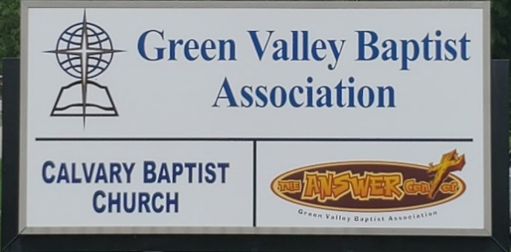
The BRIDGE BUILDER

A Family of Churches BUILDING BRIDGES between God & man, between our churches, and between churches
& the community.
Vol. 59 September 2026 No. 9

Ju

A Word from the Interim Mission Strategist…..

On August 27, Green Valley held its 68th Annual Session at Robards Baptist Church.
One of the reports provided to the Association at this meeting was the Green Valley Association ACP Report of Summary Information describing in general the impact of the ministries of our 28 churches for Christ in the Henderson area.
I have to admit that only 17 of our 28 churches filed an ACP. So while we can get some idea of the impact of some of our churches, we don’t have a complete report of all 28 churches of Green Valley.
Here is a brief summary of Green Valley’s impact for Christ in this part of Kentucky.
- Green Valley has 5,465 resident members in our churches.
- Total baptisms for this year from these 17 churches are 126.
- Total additions were 189 new members.
- Sunday School enrollment is 2,631 people.
- Average Sunday School attendance is 1,705.
- Worship attendance is 1,930 each Sunday.
- The Undesignated Receipts reported by the 17 churches equal $5,257,815.
- Cooperative Program giving is reported as a robust $492,647.
- Giving to Associational Missions is reported at $102,617.
- Total Missions giving as reported by those 17 churches equals a whopping $817,385.
Based on information in these reports, it shows that Green Valley is impacting a lot of people for Christ.

I hope and pray that next year the 11 churches who were not able to give us reports will do so next year so we can see more clearly the impact our churches have for Christ in our world.

Jeff Burke
Interim Mission Strategist
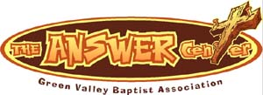
The Kathy J. Strange

Greetings from The Kathy J. Strange Answer Center!

During the month of August, we have been open for shopping on two Saturdays: August 8 and August 22. On those two Saturdays, we had a total of 318 people helped. There was 1 person who prayed to receive Christ as their Saviour. On those two Saturdays, we averaged 18 volunteers who helped us give The Answer of Jesus Christ to the Henderson area while meeting needs.

Overall, we can count at least 40 people who volunteer at The Answer Center. Some volunteers are at The Answer Center every time we are open for shopping as well as days we open during the week to sort through donations to prepare for the next Saturday we are open for shopping. Some volunteers show up a few times each month. All of our volunteers give a great blessing to us as well as to the people who come to The Answer Center for help. Our volunteers serve God faithfully and with such a loving spirit that is a blessing not only for us, but also for those we help through this ministry. Many of those who look to us for help struggle in ways we often don’t fully understand. We know God understands and loves them. We all work to show God’s love to all who come to The Answer Center for help.

So far this year, there have been 21 pray to receive Christ as their Saviour. That is central to this ministry.

We ask for your prayers as we work to give The Answer of Jesus Christ to the Henderson area.

Jeff Burke
Director

Associational Church Giving
Received by September 7, 2026

Advance $ ------- FBC Sebree $ 602.41
Airline $ 375.00 Geneva $ -------
Bellfield $ 905.00 Grace Point $ 143.39
Bethel $ ------- Greater Norris $ -------
Bridge $ ------- Hyland $ -------
Cash Creek $ 159.56 Lawndale $ 44.44
Cherry Hill $ ------- Mt. Pleasant $ -------
Corydon $1,705.48 New Hope $ -------
Covenant $ ------- Poole $ --------
DuPey $ 30.00 Robards $ 253.68
Eastview $ 85.38 Spottsville $ ---------
Finley $ -------- Victory $ -------
FBC, Hend. $2,536.24 Water's Edge $ -------
FBC, M’field $ 169.06 Zion $ 416.00

We encourage ALL our associational churches to give 3% - 5% of their undesignated offerings to GVBA to help support the work of your association. What you give goes out to the community & back to you. We can do so much more together than we can separately. Partner with us in spreading God’s message of love to our community. WE ARE BETTER TOGETHER!

best year ever.

Chur

Church Notes



Airline Baptist Church is searching for a Minister of Music. This is a paid, part-time position. We are also searching for a church pianist. If interested in either of these positions, please contact Larry Allen at 270-724-6117.

Airline Baptist Church, 1942 Clay Street, is holding revival services September 13-16th. 6:00PM. Come join us nightly with Dr. Wesley Paul, international evangelist, preaching and Tim Wilkerson leading our music.

Airline Baptist Church invites all pastors in the GVBA Association to attend a breakfast at Airline on Saturday, September 12, at 9:00AM. Our international revival evangelist, Dr. Wesley Paul, will be sharing with us
*****************************************************************************

Bellfield Baptist Church is seeking a Part-Time Worship Leader to serve approximately 10–12 hours per week. This role includes organizing and leading weekly practices, coordinating with our pastor and worship team, and assisting with music for special events.
We are a Jesus-loving Baptist church that believes, teaches, and stands firmly on the truth of God’s Word. Our desire is to worship in spirit and in truth, and we are looking for someone who shares that passion.
If you feel called to lead worship and help guide our church family in praising the Lord, please submit your resume and/or video links to: bellfieldbaptist@att.net
*****************************************************************************************

Lawndale Baptist Church in Henderson is looking for a bi-vocational, part-time pastor. Please contact Gary Shoulders at 270-831-4072 or gwshoulders@yahoo.com if interested.

Mom Joy is a conference designed to encourage, equip and celebrate the many seasons of motherhood. Breakout sessions will include Preparing for Christ-Centered Motherhood, Everyday Discipleship Through the Toddler Years, Homeschooling with Joy, Finding Joy in Grief and Loss, Spiritually Influencing Your Grandkids, Thriving as a Single Mom and more!

This will be a day of biblical encouragement, heartfelt worship and meaningful fellowship with other moms. Whether you are a new mom, seasoned mom, grandmother or somewhere in between, this conference is designed to encourage you in your God-given calling.

The main speaker is Ginger Hubbard, nationally recognized speaker and author of Wise Words for Moms, Don’t Make Me Count to Three and more. Her sessions will transform our parenting journey, encourage us to embrace the role God has given us and equip us as we lead others in our homes to abide in Christ.

Group pricing is available and early bird pricing until August 20th. Scan the QR code or register at Zionbaptist.org .

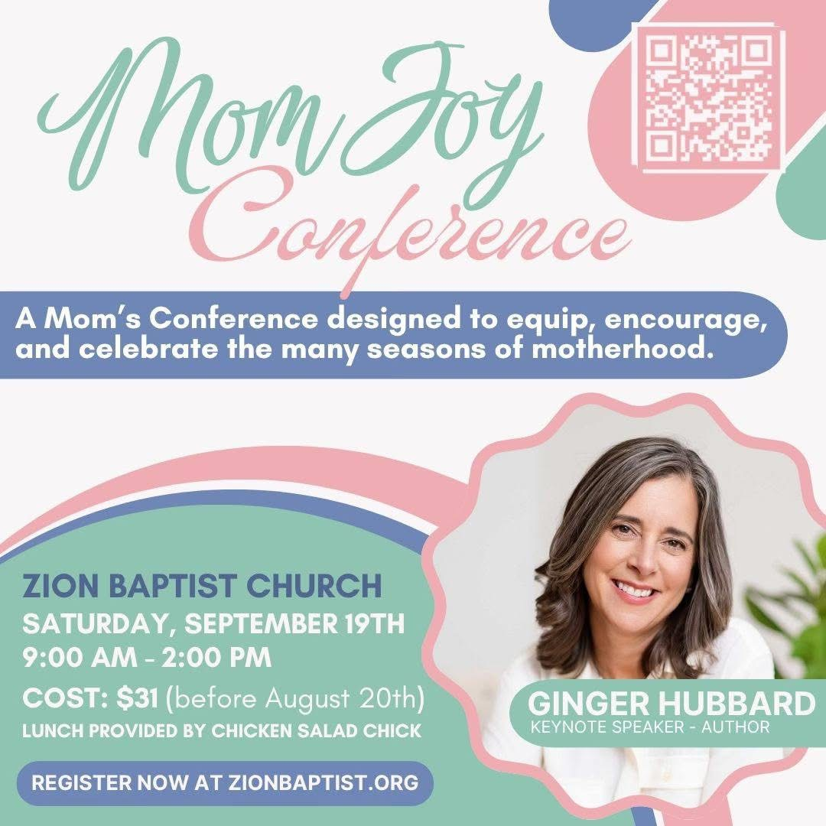

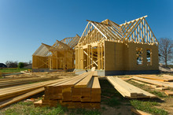

Sunrise Children’s Services will be building two foster care homes in rural Dixon. A fundraiser for the homes will be held on Friday, September 25, 6:00, at the Hidden Hills Wedding and Event Venue located at 3995 St. Rt. 132E, Dixon.

Sunrise President Dale Suttles extends an invitation for a delicious dinner, entertainment and info about the foster care homes at no charge.

Reservations need to be made no later than September 20, by calling 859-979-1726. If you cannot attend the event and wish to make a donation, you may send a check to Sunrise Children’s Services, 300 Hope St., Mt. Washington, KY 40047.

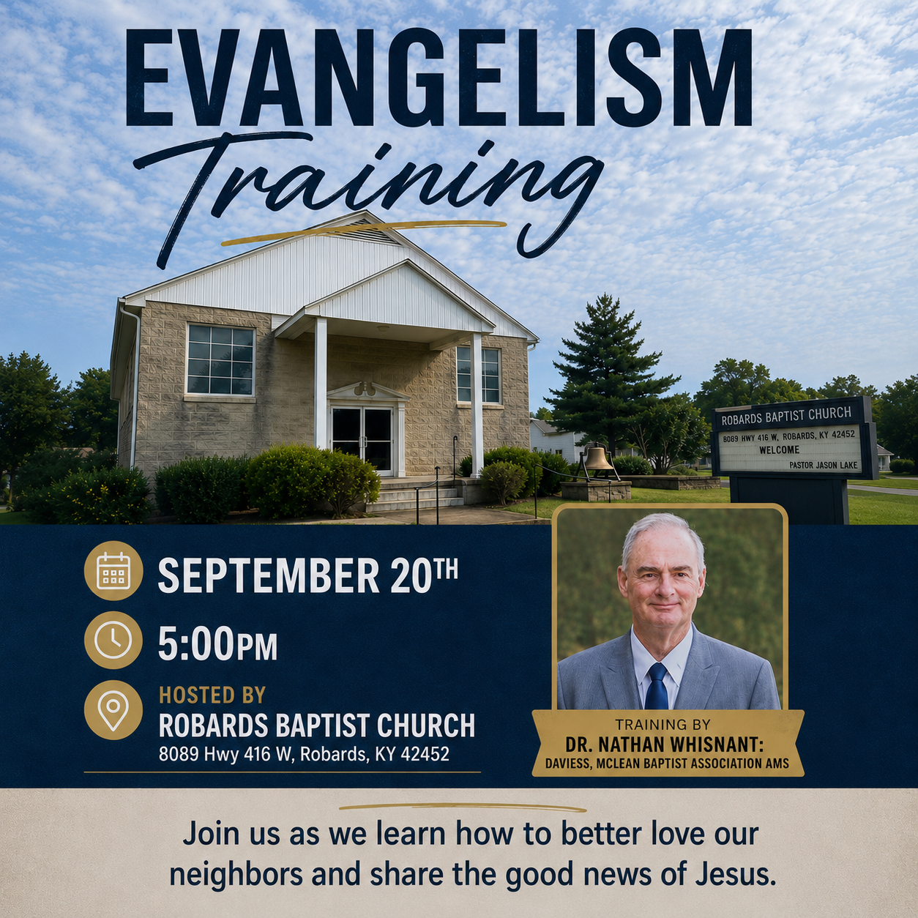

GREEN VALLEY BAPTIST ASSOCIATION
MINUTES OF SIXTY-EIGHTH ANNUAL SESSION
Robards Missionary Baptist Church
8089 Hwy 416W
Robards, KY 42452
BUSINESS SESSION
Rev. Paul Davis, Moderator, welcomed the congregation and Rev. Jeff Burke, Interim AMS, read from Hebrews 10:19-25 and opened the meeting with prayer.

Bro. Tim Wilkerson led the congregation in singing, “I Stand Amazed in the Presence.”

Bro. Paul Davis called the meeting to order and asked for a Motion to adopt the program. Dr. Bob Hardison made the Motion with a second by Dr. Steve Custer.

Bro. Paul Davis introduced Robards Missionary Baptist’s new pastor, Bro. Logan Lake.

NEW BUSINESS
Bro. Allen Butler made a Motion to adopt the 2025 Minutes of the GVBA Annual Session, second by Keith Brown. Motion carried.

Nancy Brown, Nominating Team, mentioned several openings and that if anyone would like to accept any position, please let the committee know.

Rick Crowder, Finance Team, presented the Financial Report. He discussed the Budget Worksheet, with the 2025 Budget of $148,900 versus the 2026 Budget of $154,600, with an increase of $5,700. He then addressed the Custom Summary Report which shows a Total Income of $119,286.90, Line Item #220 Capital Expense BLD Remodel of $23,165.00 (parsonage property improvements). Line Item #101 Missions Fund shows a negative amount of -$1,203.34, which shows we received a 2025 Foundation amount and it was actually more than we spent. Total Expenses were $115,516.42, with a Net Income of $3,770.48.
Associational Church Giving was $119,286.90. Total Churches giving was $107,482.90, Individuals of $50.00, Property Management was $11,754.00.

Custom Summary Report for TAC listed a Total Income of $23,276.08, with Total Expenses of $21,195.88 (includes a trailer which cost $10,296.92,) Interest Income of $14.04, for a Net Income of $2,094.24.

Total Income for TAC was $23,276.08 (breakdown of Churches giving of $8,339.54, GVBA of $1,430.34, Individuals of $4,641.00, Grants of $3,000, and Remains LLC of $5,865.20.
Rick also discussed the Statement of Activity for GVBA for January through July of this year. He also printed a sheet of bank balances.

Dr. Steve Custer made a Motion to accept the Financial Report, second by Bro. Allen Butler. Motion carried.

Bro. Jeff Burke reported that he has served as Interim AMS for two years, as of today.

TAC has seen 1,600 people come through their doors this year. In the last four months, over 600 people have come. There were 208 people that were helped one Saturday. Jeff said that 21 people have accepted Christ so far this year at TAC.

TAC began 26 years ago and their motto is “We give the answer of Jesus Christ to the Henderson area while meeting needs.” We have several women volunteers. Come see what our volunteers do and you are invited to join them!

Nancy Brown reported that the volunteers work Mondays and Thursdays from 9-11AM. We have 16 volunteers from Zion Baptist, FBC Henderson, Poole Missionary Baptist, and Bellfield Baptist. A widow who recently volunteered said, “This has been the greatest joy!” Many nationalities come to TAC. Two Hispanic women came recently.

Jeff has been the Director of TAC for 11 years and Nancy joined the staff shortly after that.

Faye Melton made a Motion to accept the Interim AMS Report and TAC Report. Second by Tina Zieman.

Beverly Davis presented the GVBA WMU report. She mentioned all the various mission projects the WMU is involved in: Christmas Jail Ministry in Webster and Henderson Counties, Lottie Moon Christmas Offering, Annie Armstrong Easter Offering, Marsha’s Place, Eliza Broadus Offering, Sunrise Children’s Services, C.R.O.S.S. Ministry at HCC, Ellis Park Racetrack Ministry, and Backpack Ministry for children over the weekends.

Tim Wilkerson made a Motion to accept the WMU Report, seconded. Motion carried.

Faye Melton mentioned that Poole Missionary Baptist and Eastview Baptist jointly provided a meal to the workers at Ellis Park Racetrack. The meal was enjoyed as well as a great sermon was given by the Chaplain at Ellis Park.

Faye also mentioned that Sunrise Children’s Homes will be building two foster care homes in rural Dixon. A fundraiser for the homes will be held on Friday, September 25, 6PM, at the Hidden Hills Wedding and Event Venue located on 3995 St. Rt. 132E, Dixon.

Sunrise President Dale Sutles extends an invitation for a delicious dinner, entertainment and info about the foster care homes at no charge. “Miss Kentucky” will be the speaker.

Reservations need to be made no later than September 20, by calling 859-979-1726. If you cannot attend the event and wish to make a donation, you may send a check to Sunrise Children’s Services, 300 Hope Street, Mt. Washington, KY 40047.

Dr. Bob Hardison gave the Foundation Team Annual Report. He compared the Foundation in two ways: 1. A big pot or kettle we put money into from cash, real estate, bonds, stocks, etc. That money is then invested by KBC Foundation and our association receives the revenues it earns quarterly.
2. Aesop’s Fables – The Goose that lays golden eggs. Our goose that produces the golden eggs is the GVBA Foundation and we are going to add to the funds that make the golden eggs annually.

Through these two ways, we are supporting missions!

Bro. Allen Butler made a Motion to accept the Foundation Report, with a second by Tim Wilkerson. Motion carried.

Paul Davis, Vision Forward Team, discussed the Strategic Vision for GVBA 2025-2040, and the goal: To equip, encourage, and empower every church within GVBA to flourish spiritually, engage their communities effectively, and advance the gospel faithfully in an evolving world. He discussed the Proposed New Structure for GVBA, the advantages of the new structure, as well as the key benefits. He read the proposed changes as listed in the booklet distributed to the congregation.

Bro. Jason Cowan made a Motion to accept these changes, with a second by Dr. Bob Hardison.

Bro. Logan Lake announced a special Evangelism Training will be held at Robards Missionary Baptist Church, September 20, 5:00PM, with Dr. Nathan Whisnant leading. Bro. Logan offered the blessing for our meal.

WORSHIP SESSION
Bro. Logan Lake welcomed everyone and led in prayer.
Bro. Tim Wilkerson led the congregation in “’Tis So Sweet to Trust in Jesus.”

Stephanie Schinault presented special music.

Bro. Tim led in another hymn, “Because He Loves.”

Stephanie Schinault presented another special song.

Bro. Logan Lake spoke on Romans 15:1-7, “Harmony Requires Humility.”
Closing Hymn was “The Bond of Love.”

Benediction

September |  |  |  |  |  | 2026
Monday | Tuesday | Wednesday | Thursday | Friday | Saturday |  |  | Sunday
 | 1 | 2 | 3 | 4 | 5 |  |  | 6
 |  | 12PM CROSS at HCC | 8:30AM Volunteers sort donations
7 | 8 | 9 | 10 | 11 | 9AM-Pastor’s 12 Breakfast at Airline |  |  | 13
Labor Day GVBA Office Closed |  | 12PM CROSS at HCC | 8:30AM Volunteers sort donations | Patriot Day | TAC open 9AM-10:30AM |  |  | Grandparents Day
14 | 15 | 16 | 17 | 18 | 19 |  |  | 20
8:30AM Volunteers sort donations |  | Russell Wood, Bethel 12PM CROSS at HCC | 8:30AM Volunteers sort donations |  |  |  |  | 5PM-Evangelism Training at Robards Baptist Church
21 | 22 | 23 | 24 | 25 | 26 |  |  | 27
8:30AM Volunteers sort donations | First Day of Autumn | 12PM CROSS at HCC | 8:30AM Volunteers sort donations |  | TAC open 9AM – 10:30AM
28 | 29 | 30
8:30AM Volunteers sort donations |  | Jason & Penny Cowan 12PM CROSS at HCC

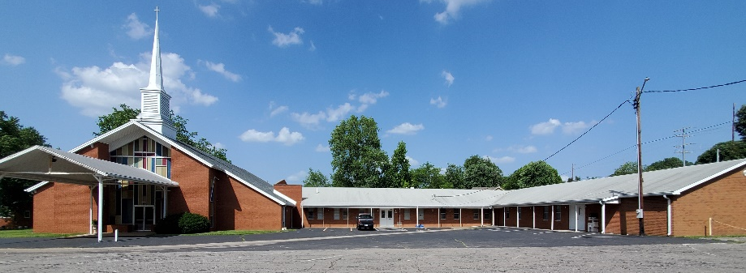

Green Valley Baptist Association
2360 Green River Road
Henderson, KY 42420
(270) 827-9867

Rev. Jeff Burke Ms. Alice Robinson
Director of Community Ministries/Interim AMS Ministry Assistant
jeff.burke1955@gmail.com ministryassistant@greenvalleybaptist.org

