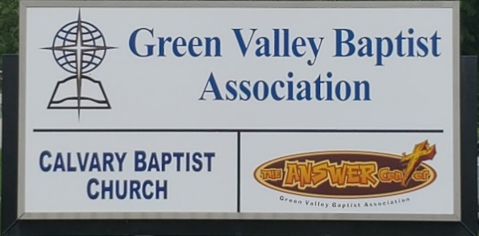
The BRIDGE BUILDER

A Family of Churches BUILDING BRIDGES between God & man, between our churches, and between churches
& the community.
Vol. 59 August 2026 No. 8

Ju

A Word from the Interim Mission Strategist…..

For nearly two years now, it has been my personal blessing to serve God as well as Green Valley as your Interim Associational Mission Strategist. I have enjoyed preaching in several of our churches and interacting with pastors as well as several lay people in our association. I hope you are still praying for the Vision Forward Team as they continue to show leadership for Green Valley. I also want to encourage you to pray for the future Mission Strategist of Green Valley. Pray God will be already preparing him to lead our association as we work together to serve God and reach the lost for Christ.
With the 28 churches in this association working together in serving Christ, we should be able to impact this part of Kentucky in a big way. That is something to pray for and work to see it happen.
This year our Annual Session will happen on Thursday, August 27, 2026, at Robards Missionary Baptist Church. Robards is located at 8089 Highway 416 West in Robards, KY.
The Business Session of our meeting will take place at 4:00PM followed by a meal and then the Worship Session at 6:30PM.
The people of Robards Baptist are looking forward to hosting this year’s annual session.
Their pastor, Rev. Logan Lake, has been serving the church for only a few months. Logan is going to be preaching to us and is excited to have this opportunity.
I hope Green Valley will make a special effort to attend this year’s Annual Session.

Jeff Burke
Interim Mission Strategist

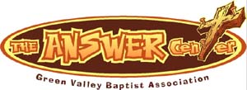
The Kathy J. Strange

Greetings from The Kathy J. Strange Answer Center!

The Answer Center is a ministry that reaches people from multiple counties in this area. We have people who come to us on the Saturdays we are open from Vanderburgh and Warrick Counties in Indiana and in Kentucky, we see people from Henderson, Webster, Union Counties as well as Daviess County.

July has been an exciting month of ministry at TAC. We were open for shopping on July 11 and July 25. On those two Saturdays, we helped 252 people with clothing, household items and all the other things we give away. On those two Saturdays there were four people who prayed to receive Christ as their Saviour.

One day during the week, we were blessed with a group of young people and their leaders from Mount Pleasant Baptist Church. They worked hard in different parts of our ministry helping us get ready for the next time we would be open. This was part of their Kids Camp and they were a lot of fun for us and a great blessing.

In August we will be open for shopping on Saturday, August 8 and Saturday, August 22.

Pray for The Answer Center Ministry as we continue to reach out to the Henderson area while meeting needs.

Jeff Burke
Director

Associational Church Giving
Received by August 9, 2026

Advance $ 825.53 FBC Sebree $ 649.69
Airline $ 750.00 Geneva $ -------
Bellfield $ 712.00 Grace Point $ 107.30
Bethel $ ------- Greater Norris $ -------
Bridge $ 500.00 Hyland $ 609.12
Cash Creek $ 209.54 Lawndale $ 35.06
Cherry Hill $ ------- Mt. Pleasant $ -------
Corydon $ 925.50 New Hope $ 586.00
Covenant $ ------- Poole $ --------
DuPey $ 60.00 Robards $ 237.44
Eastview $ 74.69 Spottsville $ 203.12
Finley $ -------- Victory $ -------
FBC, Hend. $2,873.68 Water's Edge $ -------
FBC, M’field $ 145.82 Zion $ 416.00

We encourage ALL our associational churches to give 3% - 5% of their undesignated offerings to GVBA to help support the work of your association. What you give goes out to the community & back to you. We can do so much more together than we can separately. Partner with us in spreading God’s message of love to our community. WE ARE BETTER TOGETHER!

best year ever.

Chur

Church Notes



Airline Baptist Church is searching for a Minister of Music. This is a paid, part-time position. We are also searching for a church pianist. If interested in either of these positions, please contact Larry Allen at 270-724-6117.

Bellfield Baptist Church is seeking a Part-Time Worship Leader to serve approximately 10–12 hours per week. This role includes organizing and leading weekly practices, coordinating with our pastor and worship team, and assisting with music for special events.
We are a Jesus-loving Baptist church that believes, teaches, and stands firmly on the truth of God’s Word. Our desire is to worship in spirit and in truth, and we are looking for someone who shares that passion.
If you feel called to lead worship and help guide our church family in praising the Lord, please submit your resume and/or video links to: bellfieldbaptist@att.net

Lawndale Baptist Church in Henderson is looking for a bi-vocational, part-time pastor. Please contact Gary Shoulders at 270-831-4072 or gwshoulders@yahoo.com if interested.

Bible Study
A Bible Study is being held every Wednesday at 10:00AM in the Fellowship Hall at the Green Valley Baptist Building, 2360 Green River Road. Everyone is invited to attend (both men and women). Come and join us for an interesting study of God’s Word, as well as wonderful fellowship!
It’s That Time Again!
Yes, it is time to prepare the ACP (Annual Church Profile)! The statistics should cover the period from July 1, 2025 through June 30, 2026. The ACPs need to be completed online no later than July 31st.

Green Valley Baptist Association
Annual Meeting
The Annual Meeting of Green Valley Baptist Association will be held at Robards Missionary Baptist Church, 8089 Hwy 416 West, Robards, KY 42452 on Thursday, August 27th. The Business Session begins at 4:00PM, Fellowship Meal is at 5:30PM, and the Worship Session is at 6:30PM. Bro. Logan Lake, pastor of Robards, will be bringing the message.

Mom Joy is a conference designed to encourage, equip and celebrate the many seasons of motherhood. Breakout sessions will include Preparing for Christ-Centered Motherhood, Everyday Discipleship Through the Toddler Years, Homeschooling with Joy, Finding Joy in Grief and Loss, Spiritually Influencing Your Grandkids, Thriving as a Single Mom and more!

This will be a day of biblical encouragement, heartfelt worship and meaningful fellowship with other moms. Whether you are a new mom, seasoned mom, grandmother or somewhere in between, this conference is designed to encourage you in your God-given calling.

The main speaker is Ginger Hubbard, nationally recognized speaker and author of Wise Words for Moms, Don’t Make Me Count to Three and more. Her sessions will transform our parenting journey, encourage us to embrace the role God has given us and equip us as we lead others in our homes to abide in Christ.

Group pricing is available and early bird pricing until August 20th. Scan the QR code or register at Zionbaptist.org .

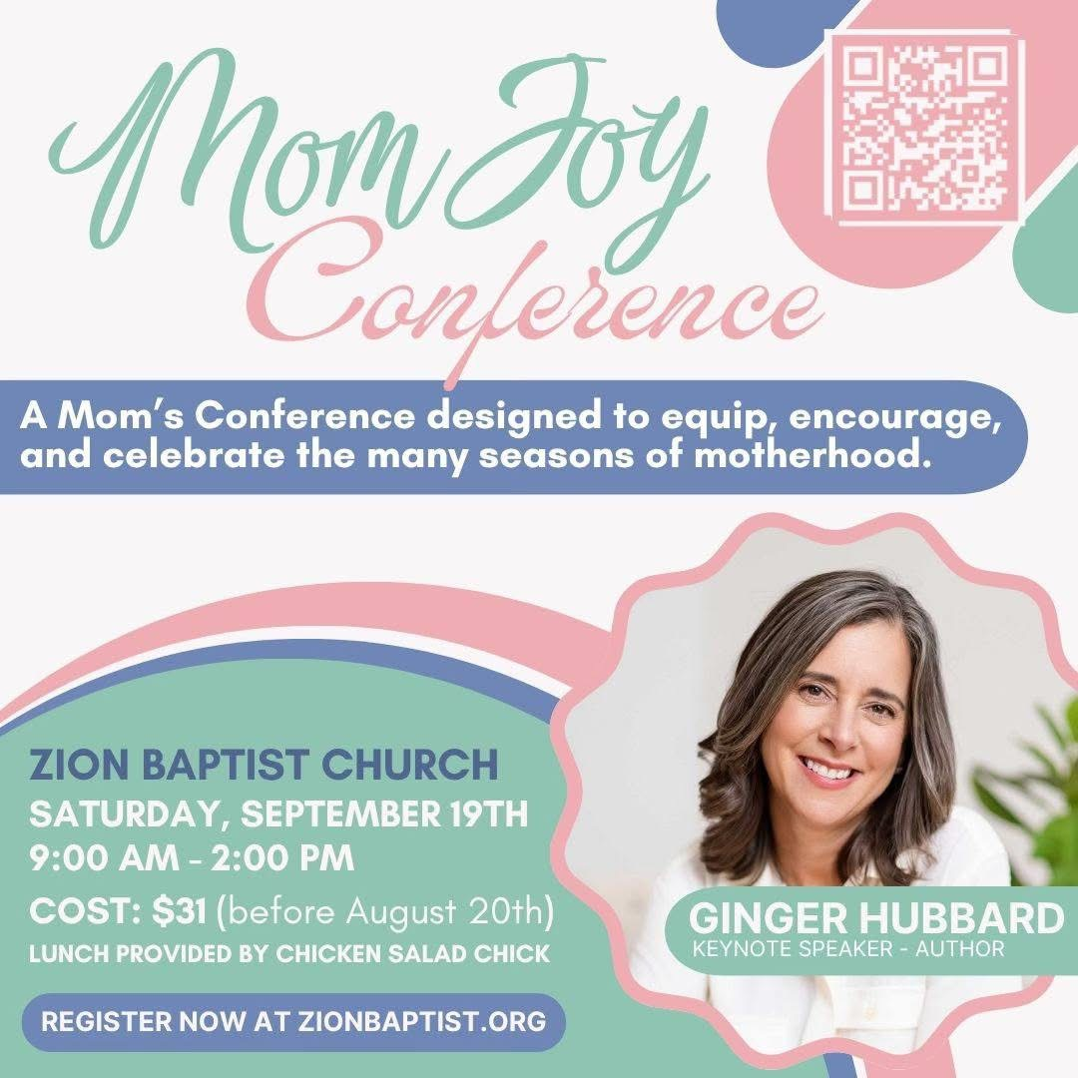



On behalf of the HCC CROSS student organization, we want to express our gratitude to the generous support of First Baptist and all the churches within the Green Valley Baptist Association for supporting our students by helping to nourish them both physically and spiritually. CROSS stands for Christ Reaching Out Saving Students and a new academic year is quickly approaching, We meet most every Wednesday from 12 - 1 during the fall and spring semesters. Students vary in ages from early college 16 years old to well-seasoned adults with very different backgrounds and levels of exposure to Jesus.
The wonderful lunches certainly help grow student attendance and show students they are cared for. We thank you for tirelessly prepping and providing delicious hot meals that some students don't get regularly nor often (unless they come to CROSS) 😊
The generous smiles and portions are so appreciated by all who are present and honestly do make an impact in a student and staff's day. You help them see God working in and through you to provide this loving service. We are grateful for your time, energy, love and support you have brought consistently through many years to these individuals, many of whom are carrying heavy loads and uncertain futures. Your presence may be the highlight of their week, and they have seen Jesus through service. Thank you to Paul Davis, Spottsville Baptist Pastor, for his service in a ministry role and currently Dylan Zahn, Pastor at Sebree First Baptist Church, who provides a literal mini-sermon. Scripture is shared and is related to our lives with the emphasis always being on how a decision for Christ is the absolute most important decision we will make, above anything else. The peace that only Christ can provide is very new to many. We ask that you pray for all college students attending classes this coming semester and that we can be a light for all on campus. Your seeds are planted each week that we know God uses to impact their soul as it continues to be nourished.
Thank you and blessings on you all!

Faculty sponsors, Laura Winstead & Cameron Edwards. Staff sponsor, Angie Watson.

Henderson Community College
Mission Opportunity

C.R.O.S.S. starts August 26, Wednesday! Each Wednesday the college students gather for a free noontime meal provided by the GVBA churches and for an encouraging message from God’s Word.

Would your church like to participate by providing a one-time meal on a Wednesday at 12 noon? Please call GVBA for details and sign up.

August |  |  |  |  |  | 2026
Monday | Tuesday | Wednesday | Thursday | Friday | Saturday |  | Sunday
 |  |  |  |  | 1 |  | 2
 |  |  |  |  |  |  | Paul Davis, Spottsville
3 | 4 | 5 | 6 | 7 | 8 |  | 9
8:30AM Volunteers sort donations |  |  | 8:30AM Volunteers sort donations |  | TAC open 9AM-10:30AM
10 | 11 | 12 | 13 | 14 | 15 |  | 16
8:30AM Volunteers sort donations |  |  | 8:30AM Vol. sort donations, School begins
17 | 18 | 19 | 20 | 21 | 22 |  | 23
8:30AM Volunteers sort donations |  |  | 8:30AM Volunteers sort donations |  | Jeff & Janet Burke, TAC open 9AM-10:30AM
24 | 25 | 26 | 27 | 28 | 29 |  | 30
8:30AM Volunteers sort donations |  | 12PM - C.R.O.S.S.  begins | Dylan & Kristin Zahn 4PM-Annual Meeting
31
8:30AM Volunteers sort donations



Green Valley Baptist Association and the Kathy Strange Answer Center would like to extend our deepest sympathy and prayers to the family of Jason Perry, who passed away recently. Jason was the owner of A-1 Tax Service and served God as part of our Finance Team for several years. Abby Nelson has recently purchased A-1 Tax Service and will be serving Green Valley and The Answer Center.

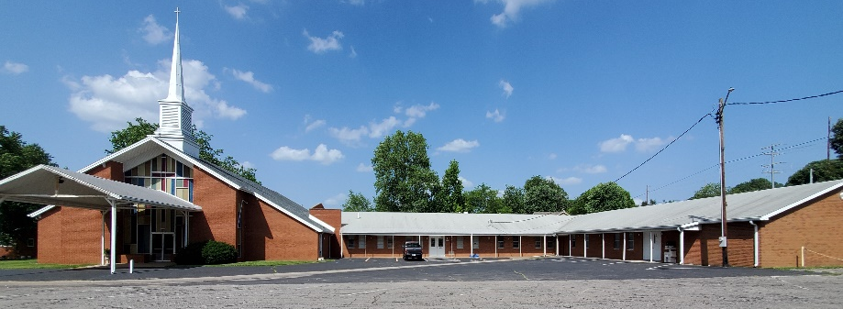

Green Valley Baptist Association
2360 Green River Road
Henderson, KY 42420
(270) 827-9867

Rev. Jeff Burke Ms. Alice Robinson
Director of Community Ministries/Interim AMS Ministry Assistant
jeff.burke1955@gmail.com ministryassistant@greenvalleybaptist.org

