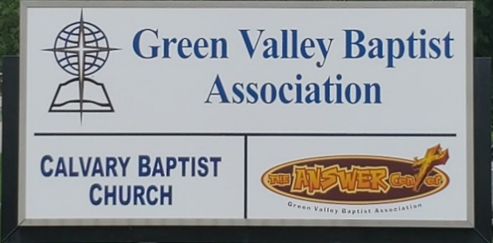
The BRIDGE BUILDER

A Family of Churches BUILDING BRIDGES between God & man, between our churches, and between churches
& the community.
Vol. 59 July 2026 No. 7

Ju

A Word from the Interim Mission Strategist…..

It has been my privilege to serve as the Interim Mission Strategist for nearly two years. Green Valley is an active association, working hard to faithfully serve God.

In June, we were blessed with a team of over 100 World Changers and their team leaders. They worked on a total of twenty projects, including helping The Answer Center on Friday, organizing donations and helping us with our trailer that we use to take a variety of our donations to St. Louis. From there they are shipped overseas. This generates money for TAC that we put right back into our ministry.

Several of our churches helped feed the World Changers.

Next month, Jeff Hesley, who leads this ministry for Green Valley, will have a full report for the Bridge Builder regarding the work of the World Changers.

On September 13-16th, Airline Baptist Church is holding a revival led by Evangelist Dr. Wesley Paul. Pastor Jeremy Aliff has let me know that Wesley would like to do a Pastor’s Breakfast with Green Valley Pastors on Saturday, September 12, to share an evangelist’s heart with them. Breakfast will take place from 8:30AM to 10:00AM at Green Valley. All of our ministers are invited.

Jeff Burke
Interim Mission Strategist

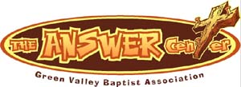
The Kathy J. Strange

Greetings from The Kathy J. Strange Answer Center!

So far this year, The Answer Center has been open for shopping nine Saturdays. On those Saturdays, we have helped as many as 1,100 people. We have helped over 100 people on weekdays as well. On Saturdays we average 17 volunteers and most importantly, we have seen 15 people saved during our exit interviews on those nine Saturdays.

Pray for us as we work to give The Answer of Jesus Christ to the Henderson area while meeting needs.

If you are looking for a way to serve God and minister to people in the Henderson area, The Answer Center is a great ministry for you to be a part of. We have volunteers who help us each week on Mondays and Thursdays. They usually arrive around 9AM and stay until around noon and sometimes they will be there into the afternoon. There is plenty to do and our volunteers are a fun, dedicated group. In the month of July, we will be open on Saturday, July 11, and Saturday, July 25.

On Saturdays we open at 9AM and remain open until 10:30AM. Usually we have people still shopping later than 10:30AM. We allow people to take as much time as they need to complete their shopping.

Jeff Burke
Director

Associational Church Giving
Received by July 7, 2026

Advance $ -------- FBC Sebree $ 769.19
Airline $ 375.00 Geneva $ -------
Bellfield $1,970.00 Grace Point $ 143.56
Bethel $ ------- Greater Norris $ -------
Bridge $ ------- Hyland $ 460.11
Cash Creek $ ------- Lawndale $ 86.20
Cherry Hill $ ------- Mt. Pleasant $ -------
Corydon $ 1,476.46 New Hope $ -------
Covenant $ ------- Poole $ 237.45
DuPey $ 60.00 Robards $ 443.20
Eastview $ Spottsville $ 1,052.49
Finley $ -------- Victory $ -------
FBC, Hend. $2,488.31 Water's Edge $ 600.00
FBC, M’field $ 1,073.92 Zion $ 416.00

We encourage ALL our associational churches to give 3% - 5% of their undesignated offerings to GVBA to help support the work of your association. What you give goes out to the community & back to you. We can do so much more together than we can separately. Partner with us in spreading God’s message of love to our community. WE ARE BETTER TOGETHER!

best year ever.

Chur

Church Notes



Airline Baptist Church is searching for a Minister of Music. This is a paid, part-time position. We are also searching for a church pianist. If interested in either of these positions, please contact Larry Allen at 270-724-6117.

Lawndale Baptist Church in Henderson is looking for a bi-vocational, part-time pastor. Please
contact Gary Shoulders at 270-831-4072 or gwshoulders@yahoo.com if interested.

It’s That Time Again!
Yes, it is time to prepare the ACP (Annual Church Profile)! The statistics should cover the period from July 1, 2025 through June 30, 2026. The ACPs need to be completed online no later than July 31st.

Green Valley Baptist Association
Annual Meeting
The Annual Meeting of Green Valley Baptist Association will be held at Robards Missionary Baptist Church, 8089 Hwy 416 West, Robards, KY 42452 on Thursday, August 27th. The Business Session begins at 4:00PM, Fellowship Meal is at 5:30PM, and the Worship Session is at 6:30PM. Bro. Logan Lake, pastor of Robards, will be bringing the message.

July |  |  |  |  |  | 2026
Monday | Tuesday | Wednesday | Thursday | Friday | Saturday |  | Sunday
 |  | 1 | 2 | 3 | 4 |  | 5
 |  |  | 8:30AM Volunteers sort donations |  | Happy Independence Day!
6 | 7 | 8 | 9 | 10 | 11 |  | 12
8:30AM Volunteers sort donations | Robert Duncan, Cash Creek |  | 8:30AM Volunteers sort donations |  | TAC open 9AM—10::30AM Cole & Leanna Caven
13 | 14 | 15 | 8:30AM 16 Volunteers sort donations | 17 | 18 |  | 19
8:30AM Volunteers sort donations |  |  | Marty & Ellie Coursey, 8:30AM-Vol. sort donations |  | Jason Cowan, Bridge Church
20 | 21 | 22 | 23 | 24 | 25 |  | 26
8:30AM Volunteers sort donations |  |  | 8:30AM Volunteers sort donations |  | TAC open 9AM-10:30AM
27 | 28 | 29 | 30 | 31
8:30AM Volunteers sort donations |  |  | 8:30AM Volunteers sort donations

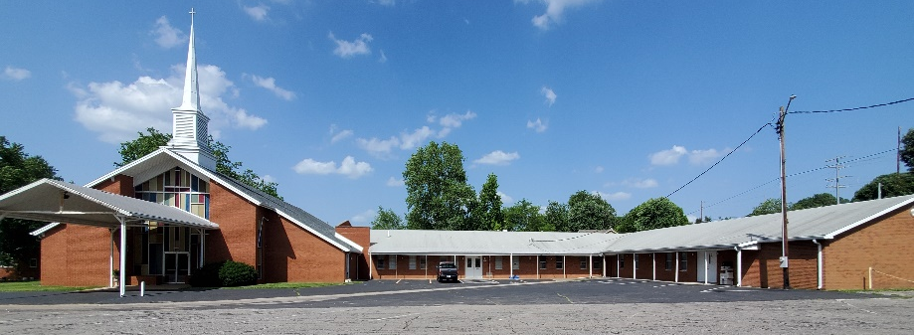

Green Valley Baptist Association
2360 Green River Road
Henderson, KY 42420
(270)827-9867

Rev. Jeff Burke Ms. Alice Robinson
Director of Community Ministries/Interim AMS Ministry Assistant
jeff.burke1955@gmail.com ministryassistant@greenvalleybaptist.org

