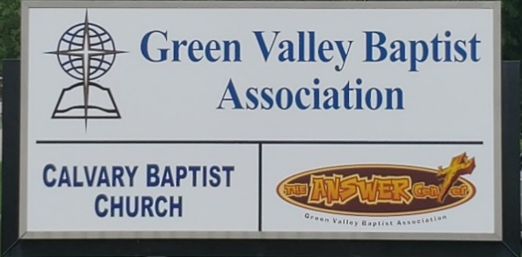
The BRIDGE BUILDER

A Family of Churches BUILDING BRIDGES between God & man, between our churches, and between churches
& the community.
Vol. 59 June 2026 No. 6

Ju

A Word from the Interim Mission Strategist…..

It has been my privilege to serve as Green Valley’s Interim Mission Strategist for nearly two years now. At our latest Executive Board meeting, there was a motion passed that the Vision Forward Team should begin now to accept resumes from people interested in serving as our next Mission Strategist. I hope you will pray for our search team that they will follow the guidance of the Lord in the search for a new Mission Strategist for Green Valley.

I am blessed by the financial support of our churches and the good work being done by our WMU as they look forward to the racetrack ministry.

Dylan Zahn is doing a great job leading the C.R.O.S.S. ministry at the Community College.

Jeff Hesley, Pastor of Mount Pleasant Baptist Church in Smith Mills, has done an excellent job of organizing the World Changers event for this year. There will be 100-130 young people coming to Green Valley to do work projects in this area. Mount Pleasant is hosting all of these young people and their adult leaders. They will arrive Monday, June 8, and work through Friday, June 12.

Grace Point has been a help in organizing this event and several of our churches are helping feed the teams.

If you have questions or are looking for some way to help, call Jeff and he will let you know how you can help.

Jeff Burke
Interim Mission Strategist


The Kathy J. Strange

Greetings from The Kathy J. Strange Answer Center!

It has been a great blessing for me to serve as Director of The Answer Center for eleven years now. We are blessed with a fun and hard-working team of volunteers each Monday and Thursday. They do a great job sorting through donations and then getting each of our ministry rooms ready for the next time we are open on a Saturday for shopping.

Some of our volunteers who work with us during the week also help us on the Saturdays we are open. So far this year we have been open nine Saturdays for shopping. On those Saturdays we averaged 17 volunteers. There have been 840 people helped on Saturdays as well as around 75 people who have been helped in between the days we are open for shopping.

The best news I can give you about the work of The Answer Center is that so far this year, there have been 14 people who have prayed to receive Christ on the nine Saturdays we have been open.

I also want to thank you for the huge and wonderful donations that come to us. We don’t know every donor although we are aware of some who put donations in our drop box. It is amazing how often we are able to empty our drop box and then within a week, it is overflowing once again.

Thank you for all the donations. The items you bring to us are a blessing to those who come and shop at TAC and help contribute to the number of people who have been saved at TAC this year. Once again, Thank You!

Jeff Burke
Director of The Kathy J. Strange Answer Center

Associational Church Giving
Received by June 1, 2026

Advance $ 250.48 FBC Sebree $ 443.86
Airline $ 375.00 Geneva $ -------
Bellfield $4,174.00 Grace Point $ 131.27
Bethel $ ------- Greater Norris $ -------
Bridge $ ------- Hyland $ 328.91
Cash Creek $ 175.70 Lawndale $ 53.46
Cherry Hill $ ------- Mt. Pleasant $ -------
Corydon $ 837.76 New Hope $ -------
Covenant $ ------- Poole $ 237.45
DuPey $ 30.00 Robards $ --------
Eastview $ 75.90 Spottsville $ 439.32
Finley $ -------- Victory $ -------
FBC, Hend. $3,408.40 Water's Edge $ -------
FBC, M’field $ 187.22 Zion $ 416.00

We encourage ALL our associational churches to give 3% - 5% of their undesignated offerings to GVBA to help support the work of your association. What you give goes out to the community & back to you. We can do so much more together than we can separately. Partner with us in spreading God’s message of love to our community. WE ARE BETTER TOGETHER!

best year ever.

Chur

Church Notes



Airline Baptist Church is searching for a Minister of Music. This is a paid, part-time position. We are also searching for a church pianist. If interested in either of these positions, please contact Larry Allen at 270-724-6117.

Lawndale Baptist Church in Henderson is looking for a bi-vocational, part-time pastor. Please
contact Gary Shoulders at 270-831-4072 or gwshoulders@yahoo.com if interested.

Green Valley Baptist Association Executive Board Meeting
Minutes of May 21, 2026

The Homeplace of Henderson Presentation was given by Jessica Beaven, Executive Director, and Grace Glenn, Director of Sales and Marketing. Jessica gave an overview of The Homeplace. It is local, homegrown, and provides long-term care in an assisted living environment. They provide independent living and memory care services. Enough capital was raised in 2019 to proceed with this project. They accept private pay, private insurance, as well as veteran benefits. The average cost for private pay is $4,800 per month, memory care is $7,700 per month. Studio apartments are $3,895. The average length of stay is three years.

Rev. Jeff Burke, Interim AMS, welcomed everyone and led in prayer. He spoke about Psalm 23:1.

Rev. Paul Davis, Moderator, called the meeting to order. A Motion was made by Rev. Steve Custer, second by Rev. Jeff Burke, to accept the minutes of the March Executive Board meeting.

Bro. Jeff Burke presented the following TAC report:
God has blessed The Answer Center (TAC) in many ways.
While TAC was on Second Street, we were struggling financially. We had less than $1,000 in our account and struggled to pay the utility bills and we could not always purchase items needed for Saturday shopping. It was brought to our attention there was a ministry in Corbin, Kentucky, led by a missionary commissioned by The Kentucky Baptist WMU, just like Nancy Brown, Keith Brown and myself. A few of us visited that ministry and learned how they took excess donations to Florida where they in turn were shipped overseas which generated income for their ministry.
So often TAC has received donations in large amounts. If the donations are soiled, have a bad odor or are damaged, they are thrown away. We keep the very best for our clients. In times past due to TAC not having enough storage space, we would take excess clothing to St. Vincent DePaul in Evansville. One day while dropping off TAC’s excess clothing there, I was introduced to the director of that ministry in Evansville and he showed me how they were shipping their excess clothing and what we were bringing them to Remains in St. Louis operated by Paul White. From there it was shipped overseas. This generated money for that ministry as well. I called Paul White and shortly after we moved to our current location, we began partnering with Remains. From this we have generated approximately $8,000 to $10,000 for and used by The Answer Center ministry.
We currently have one trailer that we are renting from a company in Sturgis in which we store the clothing we ship to St. Louis. We also have a smaller trailer in which we have stored clothing to also be shipped to St. Louis. We are in the process of moving the clothing from the smaller trailer to the larger trailer so that the smaller one can house clothing that is out-of-season and other items which we do not have space for inside the building.
I say this to report that recently there have been questions as to whether or not TAC is giving away clothing or is selling the clothing. I want to be transparent with how this ministry works.
This year we have been open seven Saturdays for shopping and have given away clothing to almost 700 people on those Saturdays. We have averaged 16 volunteers on the Saturdays we are open and some of those volunteers effectively share the gospel with the people who come to shop. As a result, there have been 14 people who have prayed to receive Christ as their Savior and Lord. This is the purpose of this ministry as we give The Answer of Jesus Christ to the Henderson area (which includes six surrounding counties) while meeting needs.
If you have never seen this ministry in action, I encourage you to come on Mondays and Thursdays to help sort donations, or on the Saturdays we are open for shopping. The Saturdays we will be open in June are June 6th and June 20th from 9:00 a.m. to 10:30 a.m.

Beverly Davis, Associational WMU Director, reported that she has been busy at Henderson County High School. She expressed thanks to all of the churches who have provided lunch for C.R.O.S.S. meetings at Henderson Community College. It is much appreciated. The Racetrack Ministry is wonderful and a special thanks to everyone who has signed up to help. If anyone is interested in beginning a children’s or women’s group in their church, please contact Beverly.

Rick Crowder, Finance Team Chairperson, went over the reports included in the packet that was distributed tonight. Our total 2026 Budget is $154,600. The Interest Income line is $31.38 (interest earned from CDs we have.) Operating Fund Receipts were $42,672.21 for a Total Income of $42,703.59. Item 101 Mission Fund was $-$3,907.25 (received from Foundation to fund mission projects.) Total Expense was $27,090.66 for a Net Income of $15,612.93. Receipts Detail: Churches (1) - $37,667.21; Individuals (1) – $1,000; Property Management - $4,005.00; for a Total of $42,672.21.

GVBA Statement of Activity: Operating Fund Receipts were $42,704 versus a YTD Budget of $51,533.

TAC Receipts Detail: Total of $9,624.16; Bank Balances for April were Total Undesignated of $117,067.95, Total Designated of $234,116.95, for a Grand Total of $351,184.90.

Rev. Paul Davis, Vision Forward Team, stated that they have nothing to report at the present time. The team does need permission to go ahead and proceed with accepting resumes. A Motion was made by Keith Brown, second by Rev. Logan Lake of Robards Baptist Church. Motion carried.

Old Business
An additional Trustee needs to be nominated soon. Gary Shoulders, Trustee, has been taking care of his parents recently. This will be tabled until the annual meeting.

New Business

Rev. Paul Davis, Moderator, welcomed Rev. Jerry Tooley, Bellfield Baptist Church and Rev. Logan Lake, Robards Baptist Church.

Motion to Adjourn made by Rev. Steve Custer, second by Keith Brown.

Seventeen (17) people were in attendance: Those in attendance: David Riley, Rev. Jason Cowan, Chuck Martinez, Ricky Crowder, Mary Martinez, Patti Burgard, Nancy Brown, Alice Robinson, Rev. Paul Davis, Beverly Davis, Karen Totton, Rev. Jeff Burke, Keith Brown, Mark Simpson. Rick Crowder, Rev. Logan Lake, Rev. Steve Custer. Nine churches were represented.

June |  |  |  |  |  |  |  |  |  |  |  | 2026
Monday | Tuesday |  |  | Wednesday | Thursday |  |  | Friday | Saturday |  |  |  | Sunday
1 | 2 |  |  | 3 | 4 |  |  | 5 | 6 |  |  |  | 7
8:30AM Vol. sort donations |  |  |  |  | 8:30AM Vol. sort donations |  |  |  | TAC open 9AM-10:30AM
8 | 9 |  |  | 10 | 11 |  |  | 12 | 13 |  |  |  | 14
8:30AM Vol. sort donations |  |  |  |  | 8:30AM Vol. sort donations |  |  |  |  |  |  |  | Flag Day
15 | 16 |  |  | 17 | 18 |  |  | 19 | 20 |  |  |  | 21
8:30AM Vol. sort donations, 9AM-Bridge VBS | 9AM-Bridge VBS |  |  | Hal & Bobbi Branson, S’ville, 9AM Bridge VBS | 8:30AM Vol. sort donations, 9AM-Bridge VBS |  |  | 9AM-Bridge VBS | TAC open 9AM-10:30AM |  |  |  | Father’s Day,  1st day of Summer
22 | 23 |  |  | 24 | 25 |  |  | 26 | 27 |  |  |  | 28
8:30AM Volunteers sort donations |  |  |  |  | 8:30AM Volunteers sort donations |  |  |  |  |  |  |  | Eric Fannin, Grace Point
29 | 30
8:30AM Volunteers sort donations

The Bridge Church will have Vacation Bible School June 15th – 19th, 9AM – 3PM each day.

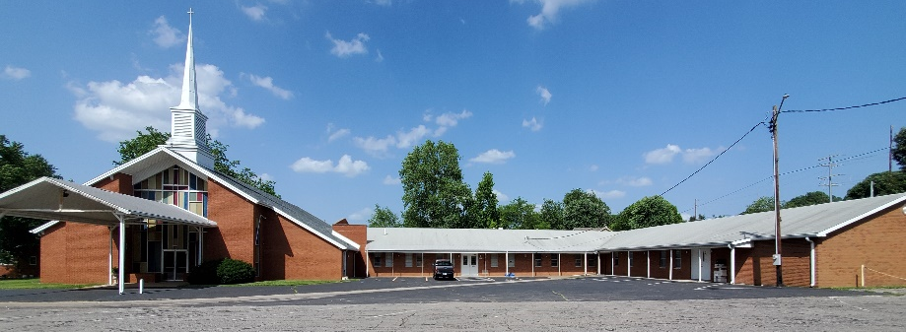

Green Valley Baptist Association
2360 Green River Road
Henderson, KY 42420
(270)827-9867

Rev. Jeff Burke Ms. Alice Robinson
Director of Community Ministries/Interim AMS Ministry Assistant
jeff.burke1955@gmail.com ministryassistant@greenvalleybaptist.org

