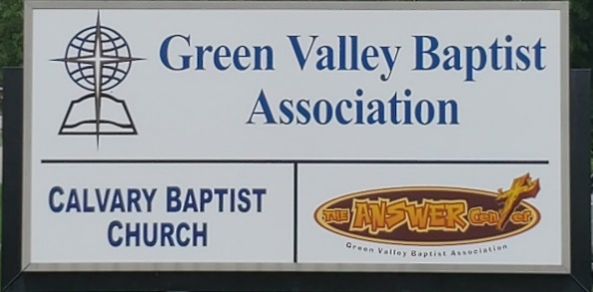
The BRIDGE BUILDER

A Family of Churches BUILDING BRIDGES between God & man, between our churches, and between churches
& the community.
Vol. 59 May 2026 No. 5

Ju

A Word from the Interim Mission Strategist…..

The Bible tells us in 1 Thessalonians 5:17 to pray without ceasing. As you pray about all that is in your heart, I ask you to pray for Green Valley Baptist Association that we may have a strong witness in this area for Christ.

Coming soon in our association and beyond, Vacation Bible Schools will begin to take place. Pray for the churches of Green Valley as they have Vacation Bible School. Pray that this will be a time of great joy in our churches and especially that there will be a harvest of souls saved this spring and summer.

Remember to pray for the Vision Forward Team as they provide some leadership for Green Valley in the search for our next Mission Strategist.

Pray for our upcoming Executive Board Meeting on May 21 at 6:00 p.m. at Green Valley. You are encouraged and invited to attend this meeting.

Pray for the churches of Green Valley that they may all experience a great outpouring of the Spirit of God. Always remember the churches in Green Valley that are without pastors -- Advance, Lawndale, Finley and Anchor.

I will certainly pray for the churches of Green Valley, our pastors and staff members. Join me in praying for an obvious outpouring of the Spirit of God in this area.

Jeff Burke
Interim Mission Strategist

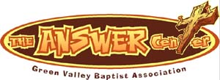
The Kathy J. Strange

Greetings from The Kathy J. Strange Answer Center!

This year has been another exciting year at The Kathy J. Strange Answer Center (TAC). In January we lost a shopping day due to the heavy snow. Other than that, we have been open a total of eight Saturdays for shopping through May 2nd.

On those Saturdays we have been blessed with an average of 18 volunteers. Our volunteers have ministered to a total of 615 people with their shopping.

We have a great team of volunteers who work not only on the Saturdays we are open for shopping, but we are also blessed with volunteers who work hard sorting through our donations and moving donated clothing to the ministry rooms. Then they organize the ministry rooms so that the rooms are ready for the next Saturday shopping day. I am convinced we have one of the best teams of volunteers among the non-profit ministries in Henderson. Some will work only on weekdays while others work exclusively on the Saturdays. All of our volunteers work with a lot of joy that is very contagious. It especially helps make volunteering at TAC enjoyable during the week and on the Saturday shopping days.

Some of our volunteers work very hard sharing the gospel on the Saturdays we are open. So far this year we have had 14 people pray to receive Christ as their Savior on the eight Saturdays we have been open.

On March 21st and April 4th we gave away 124 Easter baskets. The following week one of our volunteers took at least 60 Easter baskets to the Henderson Manor Nursing Home to share with the residents.

On weekdays there have been around 40 people helped in addition to the people we help on Saturdays.

If you are looking for a place to volunteer and serve God, I invite you to come and help us at TAC. I believe you will be very blessed.

Jeff Burke
Director of The Kathy J. Strange Answer Center

Associational Church Giving
Received by May 2, 2026

Advance $ 332.52 FBC Sebree $ 859.36
Airline $ 375.00 Geneva $ -------
Bellfield $4,416.00 Grace Point $ 123.66
Bethel $ ------- Greater Norris $ -------
Bridge $ ------- Hyland $ 523.03
Cash Creek $ 404.06 Lawndale $ 41.11
Cherry Hill $ ------- Mt. Pleasant $ -------
Corydon $ 1,119.09 New Hope $ 552.00
Covenant $ ------- Poole $ --------
DuPey $ 60.00 Robards $ 670.63
Eastview $ 155.67 Spottsville $ 288.99
Finley $ -------- Victory $ -------
FBC, Hend. $3,076.43 Water's Edge $ -------
FBC, M’field $ 166.66 Zion $ 416.00

We encourage ALL our associational churches to give 3% - 5% of their undesignated offerings to GVBA to help support the work of your association. What you give goes out to the community & back to you. We can do so much more together than we can separately. Partner with us in spreading God’s message of love to our community. WE ARE BETTER TOGETHER!

best year ever.

Chur

Church Notes



Airline Baptist Church is searching for a Minister of Music. This is a paid, part-time position. We are also searching for a church pianist. If interested in either of these positions, please contact Larry Allen at 270-724-6117.

Lawndale Baptist Church in Henderson is looking for a bi-vocational, part-time pastor. Please
contact Gary Shoulders at 270-831-4072 or gwshoulders@yahoo.com if interested.

Robards Baptist Church is pleased to announce that Bro. Logan Lake and his wife Rachel have accepted the call to be our new pastor! We are so thankful for God’s guidance during this time.

Attention: Green Valley Baptist Association Churches:

Annual Day of Prayer
The United States holds an annual National Day of Prayer, which takes place on the first Thursday in May, as established by Congress in 1988. It will fall on Thursday, May 7th, this year. Bro. Jeff Burke is inviting everyone to come and participate in the National Day of Prayer. It will be observed in the Fellowship Hall at the GVBA Building from 11:00AM-12:00 noon.

“Rededicate 250”
A major national prayer gathering, the Rededicate 250: National Jubilee of Prayer, Praise, and Thanksgiving, is scheduled for Sunday, May 17, 2026, on the National Mall in Washington, D.C. Announced by President Trump, this event aims to rededicate the United States as “one nation under God” as part of the 250th anniversary commemorations. This date marks exactly 250 years since the Second Continental Congress designated a day of prayer and fasting in 1776.

May |  |  |  |  |  |  |  |  | 2026
Monday | Tuesday |  | Wednesday | Thursday |  | Friday | Saturday |  |  | Sunday
 |  |  |  |  |  | 1 | 2 |  |  | 3
 |  |  |  |  |  |  | Brett Eblen, Cherry Hill - Alan Chamness, FBC
4 | 5 |  | 6 | 7 |  | 8 | 9 |  |  | 10
8:30AM Volunteers sort donations |  |  |  | 8:30AM Vol. sort donations, National Day of Prayer |  |  |  |  |  | Mother’s Day
11 | 12 |  | 13 | 14 |  | 15 | 16 |  |  | 17
8:30AM Volunteers sort donations |  |  |  | 8:30AM Volunteers sort donations |  |  | TAC open 9AM-10:30AM
18 | 19 |  | 20 | 21 |  | 22 | 23 |  |  | 24
8:30AM Volunteers sort donations |  |  |  | 8:30AM Vol. sort donations, 6PM EB Meeting
25 | 26 |  | 27 | 28 |  | 29 | 30 |  |  | 31
Memorial Day, GVBA Office Closed |  |  |  | 8:30AM Volunteers sort donations

TAC (The Answer Center) will be open on Saturday, May 2 and Saturday, May 16 from 9:00AM – 10:30AM.

The Executive Board of the Green Valley Baptist Association will meet on Thursday, May 21, at 6:00PM. The Finance Team will meet at 5:00PM.

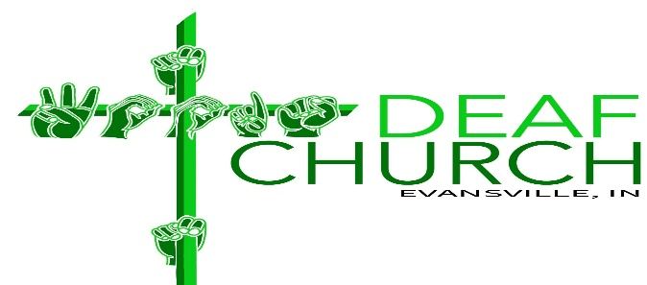

Subject: Partnership Opportunity – Northwoods Deaf Church Launch in Evansville, Indiana

Dear Pastor and Church Family,

Greetings in the name of our Lord and Savior, Jesus Christ. My name is Pastor Corey Harrison, and I am writing to share an exciting opportunity for partnership in reaching the Deaf community in Evansville, Indiana.

By God's leading, we are launching NorthWoods Deaf Church on Sunday, May 17th, 2026 at 9:00 a.m., meeting at NorthWoods Church in Evansville, IN. Following our launch, we will continue to gather every Sunday morning at 9:00 a.m.

Our mission is to provide a place where Deaf individuals can experience the Gospel, grow in their faith, and worship God in their heart language – American Sign Language (ASL). Many Deaf individuals struggle to fully engage in traditional hearing services, even with interpretation. A Deaf church allows for deeper understanding, stronger community, and spiritual growth in a way that is culturally and linguistically accessible.

We would like to ask for your partnership in two important ways:

1. Help Us Reach the Deaf Community

If your church has Deaf individuals or families, we kindly ask that you encourage them to connect with the NorthWoods Deaf Church. Our desire is not to take away from your ministry, but to help Deaf individuals thrive spiritually in a setting designed specifically for them.

2. Prayer and Financial Support

As we begin this new work, we are trusting God to provide the resources needed to grow and sustain this ministry.
Donations will help support:
- A full-time Deaf pastor
- Outreach efforts to reach the Deaf community
- Fellowship events to build strong relationships and discipleship

If your church feels led to support this mission, we would be deeply grateful for your partnership.

We believe this Deaf church will strengthen the overall Kingdom work in Evansville by reaching a community that is often underserved. Together, we can ensure that the Gospel is accessible to all.

If you would like more information or would like to partner with us, please feel free to contact me.

Thank you for your time, your heart for missions, and your commitment to the Great Commission.

In Christ,
Pastor Corey Harrison

NorthWoods Deaf Church
9920 N Green River Road
Evansville Indiana 47725

Text: 270-350-1465

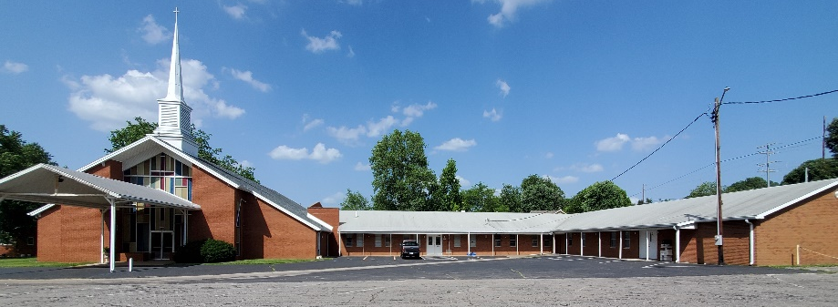

Green Valley Baptist Association
2360 Green River Road
Henderson, KY 42420
(270)827-9867

Rev. Jeff Burke Ms. Alice Robinson
Director of Community Ministries/Interim AMS Ministry Assistant
jeff.burke1955@gmail.com ministryassistant@greenvalleybaptist.org

