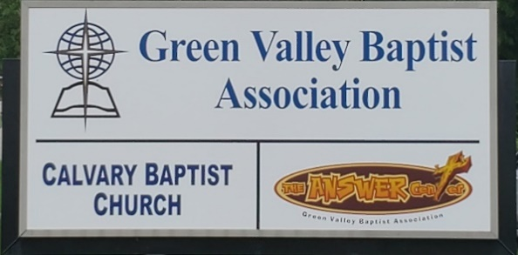
The BRIDGE BUILDER

A Family of Churches BUILDING BRIDGES between God & man, between our churches, and between churches
& the community.
Vol. 59 April 2026 No. 4

Ju

A Word from the Interim Mission Strategist…..

For a year and a half, it has been my privilege to serve Green Valley as your Interim Mission Strategist. I have been able to preach at several of our churches, especially the churches without pastors. I also have met one-on-one with some of our pastors and lay people. It has been a blessing for me to meet with the Vision Forward Team as they worked hard at fulfilling the task of reorganizing the structure of Green Valley with the idea of streamlining the ministries of the association. With that part of their work completed, I look forward to the process of searching for the next Mission Strategist for Green Valley. We need to all pray for this team, that God would direct them to the person He has set aside to lead Green Valley to greater ministries.
At our March Executive Board meeting, we learned about an exciting new ministry that is coming to Webster County in the near future. The Kentucky Baptist Children’s Home Ministry is going to build two new children’s homes in Webster County in close proximity to Green Valley.
Faye Melton, who is a member of Poole Missionary Baptist Church, presented a report to our Executive Board about some of the plans and potential ministry opportunities coming our way. It is exciting to look forward to these new ministries.
This is an exciting opportunity for Green Valley to be involved in ministry to these children’s homes. Pray for God’s guidance and that we will have opportunities to help minister to the young people who will one day be residents in these homes.

Jeff Burke
Interim Mission Strategist

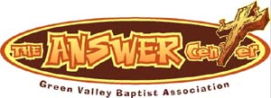
The Kathy J. Strange

Greetings from The Kathy J. Strange Answer Center!

The Mission Statement for the Kathy J. Strange Answer Center is…..We give The Answer of Jesus Christ to the Henderson area while meeting needs.

For 25 years now, this has been the central purpose of this ministry. Over those years, more than 300 people have been saved through the work of this ministry. We are blessed with a solid team of volunteers who are skilled at sharing The Gospel with the lost. Over the 4 Saturdays we have been open, there have been 213 people helped through this ministry. More importantly, there have been 10 people saved at The Answer Center.

On Saturday, March 7, because of a rainstorm that hit about the same time we were opening up for people to come in to shop, as it turned out, only 22 people came to us that Saturday.

Of the 22 people who came to TAC that day, there were 2 Mexican men who didn’t speak a bit of English. They had Google Translate to communicate with our volunteers who also pulled up Google Translate on their phones to try to communicate with these two men. Then a girl who came to us to shop stepped up and spoke in Spanish, helping to communicate their information to the volunteers working to get their contact information and help to shop for the items they needed.

When the two Mexican men finished shopping and came to the Fellowship Hall for their exit interview, once again, the young lady teamed up with one of our volunteers to help communicate the plan of salvation to the two and they both prayed to receive Christ as their Savior. God enabled us to communicate with two men so they could be saved. God blessed us greatly that day!

Jeff Burke
TAC Director

A Special Note:
TAC gave away 77 Easter baskets on Saturday, March 21st and we hope to give out a total of 200 of these baskets. TAC will be open this Saturday, April 4th.
Below are a few pictures of our recent Easter basket giveaway.
Jeff Burke, Director

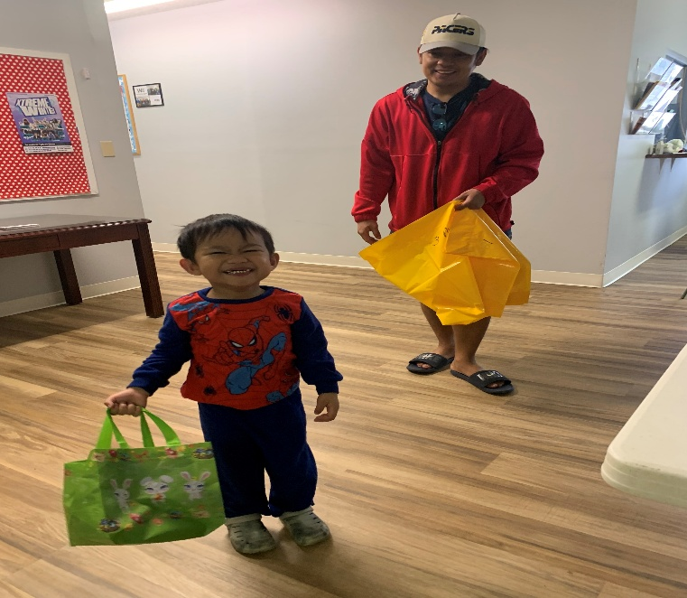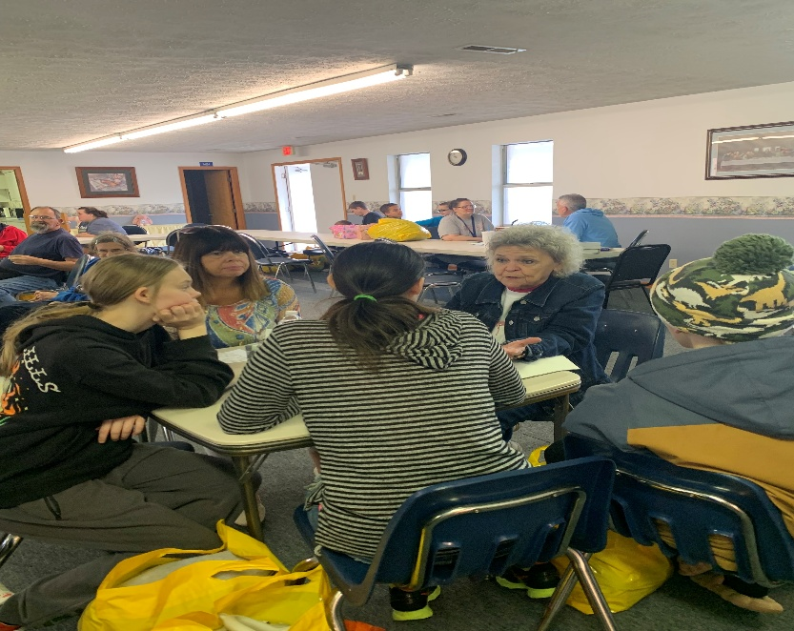

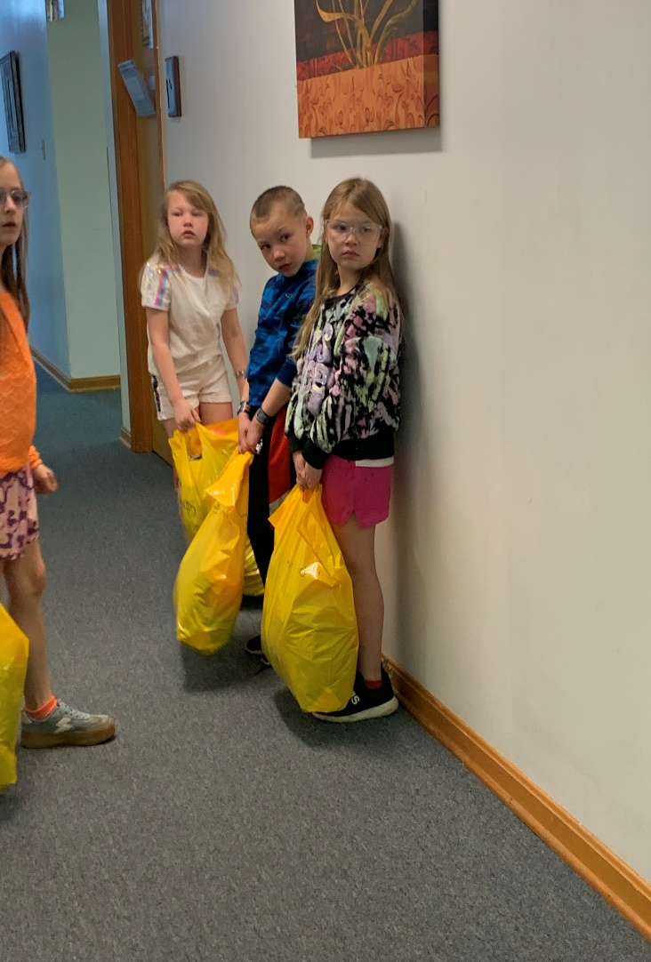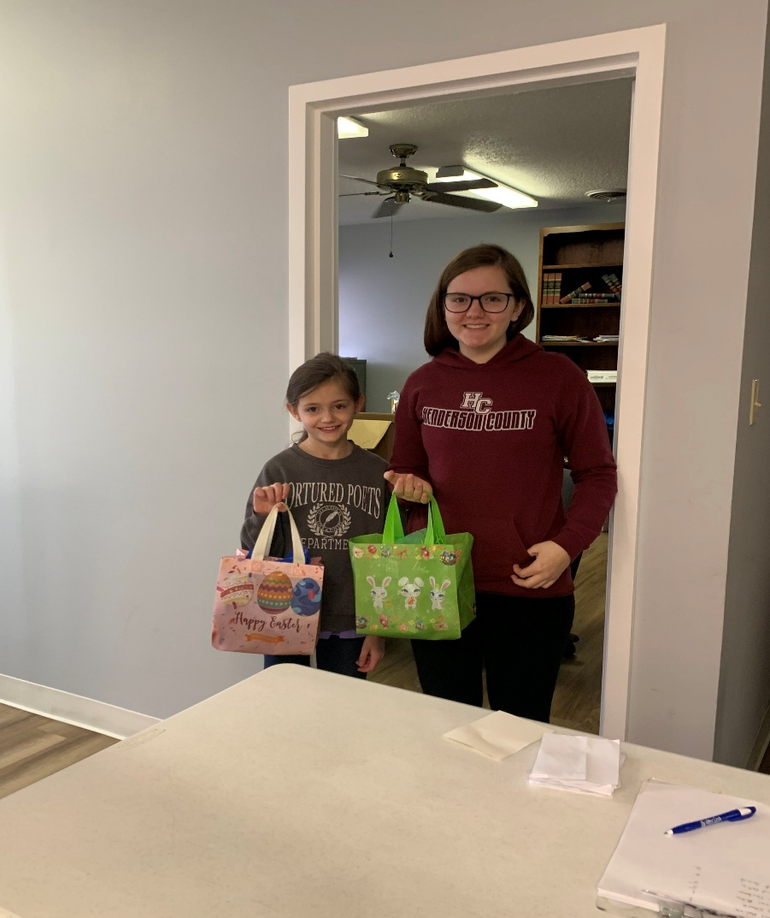

Associational Church Giving

Received by April 1, 2026

Advance $ 268.88 FBC Sebree $ 549.12
Airline $ 375.00 Geneva $ -------
Bellfield $ 910. 00 Grace Point $ 98.23
Bethel $ ------- Greater Norris $ -------
Bridge $ ------- Hyland $ 343.84
Cash Creek $ 650.07 Lawndale $ 55.46
Cherry Hill $ ------- Mt. Pleasant $ -------
Corydon $ 820.08 New Hope $ -------
Covenant $ ------- Poole $ --------
DuPey $ 30.00 Robards $ 269.40
Eastview $ 64.32 Spottsville $ 288.33
Finley $ 600.00 Victory $ -------
FBC, Hend. $3,951.00 Water's Edge $ -------
FBC, M’field $ 232.26 Zion $ 832.00

We encourage ALL our associational churches to give 3% - 5% of their undesignated offerings to GVBA to help support the work of your association. What you give goes out to the community & back to you. We can do so much more together than we can separately. Partner with us in spreading God’s message of love to our community. WE ARE BETTER TOGETHER!

best year ever.

Chur

Church Notes



Airline Baptist Church is searching for a Minister of Music. This is a paid, part-time position. We are also searching for a church pianist. If interested in either of these positions, please contact Larry Allen at 270-724-6117.

Bellfield Baptist Church is excited to announce that on March 1, 2026, their church family officially called Bro. Jerry and Alice Tooley to serve as their pastor and pastor’s wife. They make their home in Owensboro and the church is excited about welcoming them! His favorite Bible verse is “Casting all your care upon Him, for He cares for you.” I Peter 5:7

Lawndale Baptist Church in Henderson is looking for a bi-vocational, part-time pastor. Please
contact Gary Shoulders at 270-831-4072 or gwshoulders@yahoo.com if interested.

Attention: Green Valley Baptist Association Churches:

“America Reads the Bible”
“America Reads the Bible” is a national, week-long event taking place from April 18-25, 2026, where leaders will read the Bible aloud from Genesis to Revelation, marking America’s 250th birthday. Held in Washington, D.C., at the Museum of the bible, this initiative encourages nationwide participation in person or online. There will be a live-streamed event at the Capital Turnaround. The goal of this project is to have a public reading of Scripture to “reawaken American souls” and celebrate the nation’s 250th anniversary.

“Rededicate 250”
A major national prayer gathering , the Rededicate 250: National Jubilee of Prayer, Praise, and Thanksgiving, is scheduled for Sunday, May 17, 2026, on the National Mall in Washington, D.C. Announced by President Trump, this event aims to rededicate the United States as “one nation under God” as part of the 250th anniversary commemorations. This date marks exactly 250 years since the Second Continental Congress designated a day of prayer and fasting in 1776.

Annual Day of Prayer
The United States holds an annual National Day of Prayer, which takes place on the first Thursday in May, as established by Congress in 1988.



C R O S S
Christ Reaching Out Saving Students

Cross Schedule for Spring Semester – 2026

The Associational WMU thanks you for your participation in preparing meals for the college students each Wednesday at noon. The students and staff greatly appreciate the food and kindness you show them. They are fed not only a warm meal each Wednesday but also the truths from the Word of God. Thank you WMU groups, women’s ministry groups and Sunday School Classes for supporting this important ministry. If your church group would like a spot, please call the GVBA office at 270-827-9867 if you would like to provide a meal and a date will be arranged for you.

April 8 Bellfield Baptist Church

April 15 Mt. Pleasant Baptist Church

April 22 Spottsville Baptist Church

*

*Below are a few recent pictures of a special day when Bro. Dylan Zahn, Baptist Campus Ministries, and Angie Watson, Career Services, invited students at Henderson Community College to attend C.R.O.S.S. Gifts and information were distributed to anyone interested in attending the C.R.O.S.S. Wednesday noon meetings.

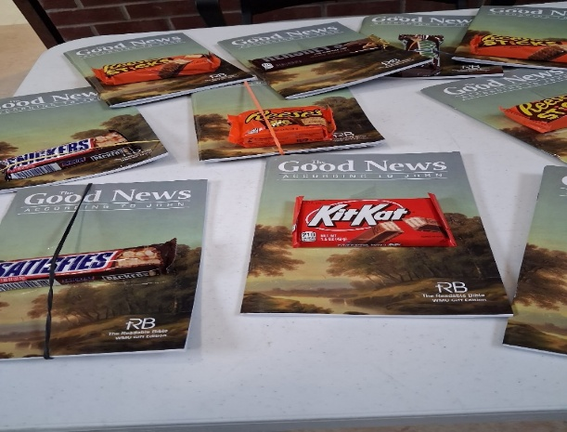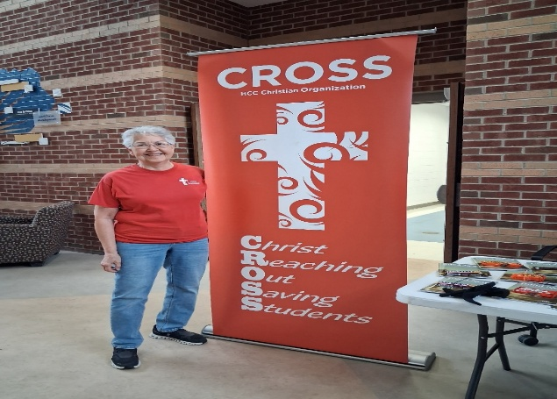

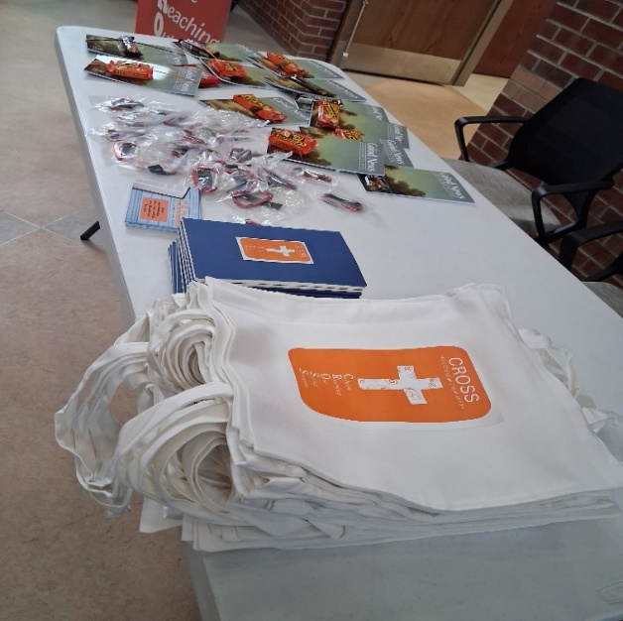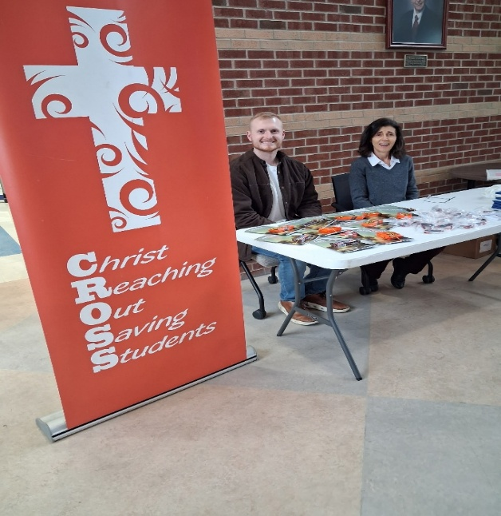

The following are the minutes from the recent Executive Board meeting held on March 19, 2026.

Green Valley Baptist Association Executive Board Meeting
March 19, 2026

Rev. Jeff Burke, Interim AMS, welcomed everyone and led in prayer.

Rev. Paul Davis, Moderator, spoke, beginning in Galatians 5:14, “The Fruit of the Spirit.” Paul spoke of yielding to the work God has called us to do. God does not call the qualified; He qualifies the called. Bro. Paul briefly commented on love, joy, peace, patience, kindness, goodness, faithfulness, gentleness (power under control) and self-control.

Bro. Davis then called the meeting to order. He jokingly said we have two new Grandma rules: 1. If you can’t say it in front of Grandma, don’t say it. 2. If you can’t say something nice, don’t say anything at all.

Bro. Jeff Burke presented his Interim AMS report as well as TAC report. He is excited about the Sunrise Children’s Homes being built in Webster County and the opportunity for our association to minister to the residents of these homes.

He also reported that two Hispanic men accepted Christ as their Savior at TAC recently with the help of Steve Allen, an evangelist who witnessed to them. TAC helped 213 people recently and there have been 10 people saved this past month.

Debra Kramer stated that her husband Bill is not able to be here tonight. They have had callouts through the winter and most of them have been handled by local groups. There was an Eastern Kentucky University rebuild in Glassco. Some volunteers from our association are participating in DR training. This Saturday, at First Baptist, Henderson, we will have statewide training. You can still register. We would love to see a wonderful attendance. It is an honor for First Baptist to host this DR training. If you have any questions after this EB meeting, please see Debra.

Bro. Paul Davis stated that his wife Beverly is attending a Pastors’ Wives’ Conference in Owensboro tonight.

Dr. Bob Hardison, Foundation Team Chairman, reported that our association funds are approximately $275,000 and that the funds are doing well. We are now making 3 ½% interest, to be issued to us four times a year. If any churches in our association are planning mission trips, please request funds from Bro. Jeff Burke. The funds are very secure and conservatively invested. We need more members to serve on the Foundation Team. He looks forward to the “pot” getting much bigger in the future. It is an honor to serve you.
Ricky Crowder, Finance Team Chairman, presented a brief financial report. The 2026 budget is $154,600. The Custom Summary Report for GVBA shows a total income through February of $23,186.84, with a Foundation (Missions Fund) receipt of $1,953.62. The breakdown of $23,186.84 consists of: Churches - $20,206.84, Individuals - $1,000, and Property Management – $1,980.00. The Insurance and Utilities line items have substantial expenses due to the recent cold weather. Net Income was $7,920.54.

Associational Church Giving was $20,206.84 for January through February. The Custom Summary Report for TAC shows a total income of $6,798.65, total expense of $1,265.20, for a net income of $5,535.37. The total income breakdown consists of: Churches - $972.65, GVBA - $651.00, Individuals - $4,125.00, Other - $50.00, and KY WMU Grants - $1,000.
Bank Balances: Total Undesignated: $116,422.53. Total Designated: $232,681.02 for a Grand Total of $349,103.55.

Rev. Paul Davis reported that we need approval from the Executive Board for a job description from the Vision Forward Team The Team then presented a job description for a part-time Associational Mission Strategist (AMS). Much discussion followed.

It was unanimously decided that Item #3 under Accountability should be amended to read as follows: The AMS will provide a summary or overview of the activities at each Executive Board meeting. Item #4 should be amended to read as follows: The AMS will be available for the office for at least four days per week.

Kellie Neal, from Sunrise Children’s Home, spoke about an upcoming project in rural Dixon, Kentucky. Kellie has been with Sunrise for 26 years and spoke about two new homes to be built.

She reported that a rural property, Still Waters Farm, in Dixon, Kentucky, has been donated for the purpose of building two homes for Sunrise Children’s Services.

She said that the hardest groups to place in foster care are teenagers, pre-teens and siblings. These homes to be built will be for families for people who will prosper. The Sunrise Children’s Homes receive funds from KBC.

Donations are now being accepted for this project. President Dale Suttles, of Sunrise Children’s Homes, requests that donations to Still Waters Farm be mailed to:

Sunrise Children’s Services
Attention: Still Waters Farm
300 Hope Street
P.O. Box 1429
Mount Washington, KY 40047
Please be sure to mark your check in the memo line for: Still Waters Farm.
Paul Davis encouraged those in attendance to specify that a portion of their life insurance be given to their church when they pass away.

Rev. Dylan Zahn, C.R.O.S.S., gave a report. He stated it is a privilege to serve in sharing Christ with them.

A Motion was made by Rev. Allen Butler to approve the minutes from the January EB Meeting. Second by Tina Zieman. Motion carried.

A Motion was made to approve the reports given, and a second. Motion carried.

Old Business

An additional Trustee needs to be nominated at the next EB meeting. Rev. Jeff Burke made a Motion to move old business to the next EB meeting. Second by Rev. Allen Butler. Motion carried.

New Business

Rev. Paul Davis made a Motion to appoint Rev. Allen Butler as the third member of the Advisory Team. Second by Rev. Kenny Kidd. Motion carried.

Bro. Paul reminded everyone of the upcoming Annie Armstrong Offering. Make sure the churches are set.

The Ellis Park ministry needs volunteers to help serve in this ministry.

Rev. Paul announced that Spottsville Baptist Church will have a Good Friday service at 6:00PM and a Sunrise Service Easter Sunday at 6:00AM.

Motion to Adjourn made by Rev. Allen Butler, second by Faye Melton.

Eighteen (18) people were in attendance:
Those in attendance: Rev. Dylan Zahn, Rev. Kenny Kidd, David Riley, Rev. Jason Cowan, Dr. Bob Hardison, Chuck Martinez, Ricky Crowder, Faye Melton,
Patti Burgard, Rev. Allen Butler, Nancy Brown, Alice Robinson, Rev. Paul Davis, Kellie Neal, Rev. Jeff Burke, Keith Brown, Debra Kramer, and Tina Zieman. Ten churches were represented.

April |  |  |  | 2026
Sunday | Monday | Tuesday | Wednesday |  | Thursday | Friday | Saturday
 |  |  | 1 |  | 2 | 3 | 4
 | 8:30AM Vol. sort donations |  | Passover Begins  12PM CROSS at HCC |  | Jeremy & Ginger Aliff  8:30AM Vol, sort donations | Good Friday | TAC open 9AM-10:30AM
5 | 6 | 7 | 8 |  | 9 | 10 | 11
Easter Sunday  He Is Risen! Brett & Mei Mei Eblen,CherryHill | 8:30AM Vol. sort donations |  | 12PM CROSS at HCC |  | 8:30AM Vol. sort donations
12 | 13 | 14 | 15 |  | 16 | 17 | 18
 | 8:30AM Vol. sort donations |  | 12PM CROSS at HCC |  | 8:30AM Vol. sort donations |  | TAC open 9AM-10:30AM
19 | 20 | 21 | 22 |  | 23 | 24 | 25
 | 8:30AM Vol. sort donations, Eric & Sarah Fannin, Grace Point | Charles Johnson, Greater Norris Chapel | 12PM CROSS at HCC |  | 8:30AM Vol. sort donations
26 | 27 | 28 | 29 |  | 30
 | 8:30AM Vol. sort donations |  |  |  | 8:30AM Vol. sort donations

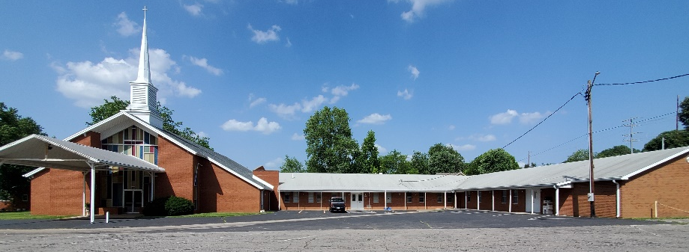

Green Valley Baptist Association
2360 Green River Road
Henderson, KY 42420
(270)827-9867

Rev. Jeff Burke Ms. Alice Robinson
Director of Community Ministries/Interim AMS Ministry Assistant
jeff.burke1955@gmail.com ministryassistant@greenvalleybaptist.org

