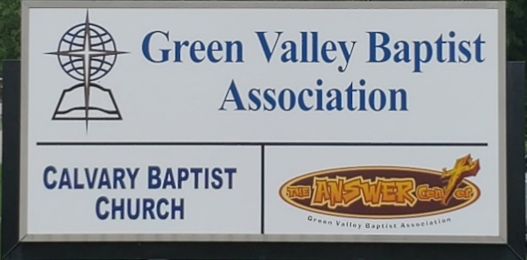
The BRIDGE BUILDER

A Family of Churches BUILDING BRIDGES between God & man, between our churches, and between churches
& the community.
Vol. 59 March 2026 No. 3

Ju

Greetings from the Interim Associational Mission Strategist!

Our next Green Valley Baptist Association Executive Board meeting is scheduled for Thursday, March 19, at 6PM in our fellowship hall. We need every church in our association to be represented. In this meeting, you will hear reports from the ministries of Green Valley including WMU, Disaster Relief, and The Answer Center. There will also be a report from the Vision Forward Team. I hope we will have every church in Green Valley represented in this meeting.

I want to remind you to pray for the 28 churches of Green Valley. We currently have six churches without pastors. Those six churches are Robards, Poole, Lawndale, Advance, Bellfield, and Finley. New Hope Baptist called Ken Lupton as their pastor. As I understand, the vote was unanimous.

In addition to praying for the remaining churches that are looking for a pastor, we need to pray for all of the churches of Green Valley that we could see a great harvest of people being saved and joining our churches. What a blessing that would be!

Jeff Burke
Interim Mission Strategist


The Kathy J. Strange

Greetings from The Kathy J. Strange Answer Center!

It is a wonderful blessing to see how God still uses this ministry to give The Answer of Jesus Christ to the Henderson area while meeting needs.

While we have lost one Saturday shopping event because of the snow, we still have been able to be open three Saturdays so far in 2026. We have been open on January 10th, February 7th and 21st.

Over those three Saturdays that we were open for shopping, we were blessed with an average of 18 volunteers. There were 191 people helped and best of all, there have been 8 people who have prayed to receive Christ as their Saviour.

Our next upcoming event will be giving away Easter baskets. We plan to do our giveaway on Saturday, March 21 and Saturday, April 4. Last year we gave away 210 Easter baskets and anticipate giving away about the same amount of Easter baskets this year.

If you would like to donate items to help with this ministry, here is a list of suggested donations:
Christian-themed coloring books Small packages of crayons
Jump Ropes Bubbles
Small toys, such as cars Individually wrapped candy
Slinkys Stuffed animals
Play Doh

We are ordering Easter baskets ourselves.

You are welcome to come and help us with this fun Easter event. Please arrive by 8:45AM.

You may be able to see someone saved.

Jeff Burke, Director

Associational Church Giving

Received by February 25, 2026

Advance $ 127.12 FBC Sebree $ 778.41
Airline $ 375.00 Geneva $ -------
Bellfield $ 580.00 Grace Point $ 86.30
Bethel $ ------- Greater Norris $ -------
Bridge $ ------- Hyland $ 282.18
Cash Creek $ ------- Lawndale $ -------
Cherry Hill $ ------- Mt. Pleasant $ -------
Corydon $1,195.66 New Hope $ 521.08
Covenant $ ------- Poole $ --------
DuPey $ 30.00 Robards $ 147.96
Eastview $ 52.08 Spottsville $ 166.72
Finley $ -------- Victory $ -------
FBC, Hend. $2,562.05 Water's Edge $ -------
FBC, M’field $ 71.90 Zion $ 832.00

We encourage ALL our associational churches to give 3% - 5% of their undesignated offerings to GVBA to help support the work of your association. What you give goes out to the community & back to you. We can do so much more together than we can separately. Partner with us in spreading God’s message of love to our community. WE ARE BETTER TOGETHER!

best year ever.

Church

Chur

Church Notes



Airline Baptist Church is searching for a Minister of Music. This is a paid, part-time position. We are also searching for a church pianist. If interested in either of these positions, please contact Larry Allen at 270-724-6117.

Lawndale Baptist Church in Henderson is looking for a bi-vocational, part-time pastor. Please
contact Gary Shoulders at 270-831-4072 or gwshoulders@yahoo.com if interested.

New Hope Baptist Church
Bro. Ken Lupton was unanimously called to serve as pastor of New Hope Baptist Church in Henderson. God’s Blessings to Bro. Ken and his lovely wife, Denise.



C R O S S
Christ Reaching Out Saving Students

Cross Schedule for Spring Semester – 2026

The Associational WMU thanks you for your participation in preparing meals for the college students each Wednesday at noon. The students and staff greatly appreciate the food and kindness you show them. They are fed not only a warm meal each Wednesday but also the truths from the Word of God. Thank you WMU groups, women’s ministry groups and Sunday School Classes for supporting this important ministry. If your church group would like a spot, please call the GVBA office at 270-827-9867 if you would like to provide a meal and a date will be arranged for you.

Mar. 4 First Baptist Church Sebree

Mar. 11 Spring Break - No Meeting

Mar. 18 Corydon Missionary Baptist Church

Mar. 25 Hyland Baptist Church

April 1 First Baptist Church Sebree

April 8 Bellfield Baptist Church

April 15 Mt. Pleasant Baptist Church

April 22 Spottsville Baptist Church



To the churches of the Green Valley Baptist Association:

What does serving with Disaster Relief look like?

How can I serve?

How am I able to be the hands and feet of Jesus through this ministry?

Learn the answers to these questions and more and also meet the DR family by attending Disaster Relief training right here in our association:

First Baptist Church Henderson
307 Center Street
March 21
Doors open 7:30am

Preregister: REGISTER@KYBAPTIST.ORG/DR
Registration fee $40 - Lunch included
Contact email: dr@kybaptist.org Cross-training also available

Local GVBA contact: Bill or Debra Kramer 270-826-4252

We look forward to seeing participation from every church in our association for training!

VBS Training for everyone! Church staff and volunteers



Bring the entire team to VBS Clinics

﻿﻿Practical training in all aspects of VBS.

Training is available for classrooms, missions, music, recreation, directors, and much more!

March 14 - Eastwood Baptist Church, Bowling Green,
March 21 – Ninth & O Baptist Church, Louisville,
March 28 – First Baptist Church, Richmond

March |  |  |  |  |  | 2026
Monday | Tuesday | Wednesday | Thursday | Friday | Saturday |  |  | Sunday
 |  |  |  |  |  |  |  | 1
2 | 3 | 4 | 5 | 6 | 7 |  |  | 8
8:30AM Volunteers sort donations |  | 12PM CROSS at HCC | 8:30AM Volunteers sort donations |  | TAC open 9AM-10:30AM |  |  | Daylight Saving Time Begins-change clocks
9 | 10 | 11 | 12 | 13 | 14 |  |  | 15
8:30AM Volunteers sort donations |  |  | 8:30AM Volunteers sort donations, Paul & Beverly Davis
16 | 17 | 18 | 19 | 20 | 21 |  |  | 22
8:30AM Volunteers sort donations |  | 12PM CROSS at HCC | 8:30AM Volunteers sort donations 6PM EB Meeting | First Day of Spring | TAC open 9AM-10:30AM
23 | 24 | 25 | 26 | 27 | 28 |  |  | 29
8:30AM Volunteers sort donations |  | 12PM CROSS at HCC | 830AM Volunteers sort donations |  | Cole Caven, FBC Morganfield |  |  | Palm Sunday
30 | 31
8:30AM Volunteers sort donations

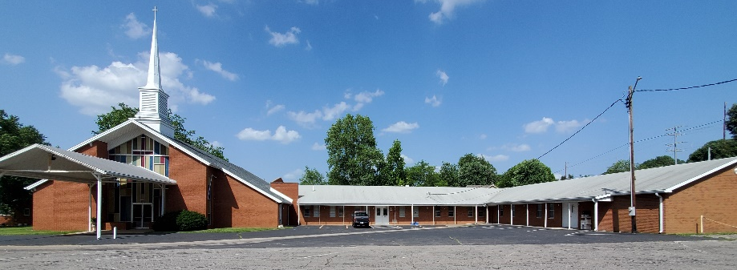

The Executive Board of Green Valley Baptist Association will meet Thursday, March 19, at 6:00 PM. All Executive Board members and pastors are invited to attend.

Green Valley Baptist Association
2360 Green River Road
Henderson, KY 42420
(270)827-9867

Rev. Jeff Burke Ms. Alice Robinson
Director of Community Ministries/Interim AMS Ministry Assistant
jeff.burke1955@gmail.com ministryassistant@greenvalleybaptist.org

REACH: Two days that will inspire, equip and refocus your church
﻿for the Great Commission.



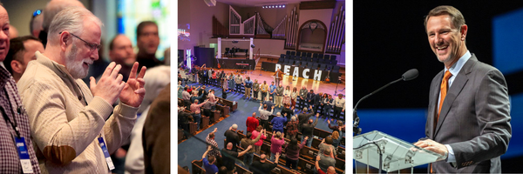

REACH Evangelism & Missions Conference
March 9-10
Louisville, Kentucky

Bring the whole team and find practical tools for reaching Kentucky and the nations with the gospel.

Speakers include: Paul Chitwood, Herb Reavis, Chris Johnson, Timothy Beougher and more.

Explore breakout sessions, including: Digital Evangelism, Growing a Church in Rural Kentucky, Church Fostering, Reaching the NOW Generation, Community Engagement, Building a Vibrant Missions Strategy and more.

Special interests at REACH:
Artificial Intelligence in Ministry Lunch & Learn
Multi-Language Ministry and Women's Ministry dinners
Missionary Sending Celebration and Women's Track

Network with leaders. Visit the exhibits. Refuel your passion for evangelism and missions.



