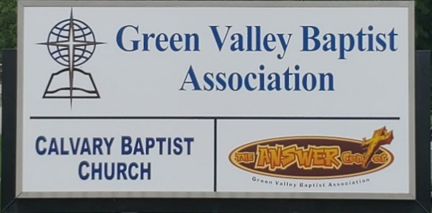
The BRIDGE BUILDER

A Family of Churches BUILDING BRIDGES between God & man, between our churches, and between churches
& the community.
Vol. 59 February 2026 No. 2

Ju

Greetings from the Interim Associational Mission Strategist!
In Psalm 100:1-2 The Bible tells us to make a joyful noise unto The Lord, all ye lands. Serve the Lord with gladness, come before His presence with singing.
Obviously, the teaching of just those two verses shows us that we should be joyful, even enthusiastic, as we serve God.
Sometimes we are a bit less than joyful as we serve the Lord. But I want to challenge you to make a commitment to be a joyful servant of God. Let’s serve God with gladness.
To help you see reasons to be joyful about serving together with other believers in Green Valley, I want to put in front of you a few facts about a recent history of our association.
I understand nearly all of our churches have seen a decline in church membership and attendance. As your interim AMS, I see very clearly a decline in participation in associational meetings and ministries.
With that in mind, I want to put two things in front of you that should cause us to rejoice in what God is doing in Green Valley.
First, over the past ten years, the 28 churches of Green Valley have seen 1,231 people pray to receive Christ as their Savior. It appears to me that the churches of Green Valley are actively reaching out to the lost in their ministry. That should be reason to rejoice together over what God is doing in Green Valley.
Second, over the past five years, collectively the churches of Green Valley have received offerings of approximately $30,000,000. That goes to pay church staff, donated to Green Valley to support associational ministries as well as pay staff. That money is also used to purchase literature, support mission work across Kentucky and beyond through The Lottie Moon, Annie Armstrong, and Eliza Broadus special mission offerings. In some churches, the money goes directly to ministries such as Green Valley’s own Answer Center as well as Marsha’s Place, and Christian Community Outreach.
God is blessing and using the churches of Green Valley to bless a lot of ministries. Our churches are actively reaching out to the lost so they may hear the Gospel and be saved.
We should rejoice in all that God is doing in our association.

Jeff Burke, Interim AMS

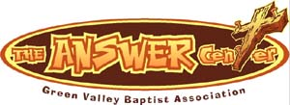
The Kathy J. Strange

Greetings from The Kathy J. Strange Answer Center!

In 2025, the Kathy J. Strange Answer Center was able to help over 2,500 people on the 24 Saturdays we were open for shopping. There were several more people we were able to help during the days between the Saturdays we were open for shopping.
Most importantly, there were 14 people who prayed to receive Christ as their Savior on Saturdays on which we were open. The reason we do so much of what we do in this ministry is so that we can sit down with people who come to us for help and talk to them about salvation. God has blessed us with so many volunteers skilled at giving The Answer of Jesus Christ to the Henderson area while meeting needs.
Maybe not all of you realize we reach into 6 counties in this area. In Kentucky, we have people who come to us mostly from Henderson County, but also Union, Webster, Daviess Counties in Kentucky and Vanderburgh and Warrick Counties in Indiana.
In 2026, we have been open on one Saturday, January 10th. We had a total of 17 volunteers that day. We were able to help 43 people with clothing, housewares, grooming kits, and so much more. But the best of all that happened is that there were 2 who prayed to receive Christ as their
Savior.
The weekend after we were open for shopping, the snowstorm shut down so much in this area including The Answer Center. Since we had our last Christmas backpack giveaway on December 13, we have been open for shopping only one Saturday. That was January 10th. As I write this, we intend to be open Saturday, February 7.
Your donations have continued to arrive and our drop box is filled to overflowing and we rejoice as we anticipate being able to give so much away to people who come to us for help. We thank you for your support and how you help us give The Answer of Jesus Christ to the Henderson area while meeting needs.
If you have never volunteered at The Answer Center on a Saturday, you should come and see this ministry in action. I’m convinced you will be blessed and you may see someone saved.
On Saturdays we are open (usually) the first and third Saturdays of each month. We open at 9AM until 10:30AM, or until all have finished their shopping.

Jeff Burke, Director

Associational Church Giving

Received by February 4, 2026

Advance $ 229.84 FBC Sebree $ 778.41
Airline $ 375.00 Geneva $ -------
Bellfield $ -------- Grace Point $ 131.84
Bethel $ ------- Greater Norris $ -------
Bridge $ ------- Hyland $ --------
Cash Creek $ -------- Lawndale $ -------
Cherry Hill $ ------- Mt. Pleasant $ -------
Corydon $1,840.18 New Hope $ 521.08
Covenant $ ------- Poole $ --------
DuPey $ 30.00 Robards $ 296.88
Eastview $ -------- Spottsville $ 1,852.24
Finley $ -------- Victory $ -------
FBC, Hend. $4,074.70 Water's Edge $ -------
FBC, M’field $ 71.90 Zion $ - ------

We encourage ALL our associational churches to give 3% - 5% of their undesignated offerings to GVBA to help support the work of your association. What you give goes out to the community & back to you. We can do so much more together than we can separately. Partner with us in spreading God’s message of love to our community. WE ARE BETTER TOGETHER!

best year ever.



C R O S S
Christ Reaching Out Saving Students

Cross Schedule for Spring Semester – 2026

The Associational WMU thanks you for your participation in preparing meals for the college students each Wednesday at noon. The students and staff greatly appreciate the food and kindness you show them. They are fed not only a warm meal each Wednesday but also the truths from the Word of God. Thank you WMU groups, women’s ministry groups and Sunday School Classes for supporting this important ministry. If your church group would like a spot, please call the GVBA office at 270-827-9867 if you would like to provide a meal and a date will be arranged for you.

Feb. 4 Corydon Missionary Baptist Church
Feb. 11 Poole Missionary Baptist Church
Feb. 18 First Baptist Church Henderson
Feb. 25 Spottsville Baptist Church
Mar. 4 First Baptist Church Sebree
Mar. 11 Spring Break - No Meeting
Mar. 18 Corydon Missionary Baptist Church
Mar. 25 Hyland Baptist Church
April 1 First Baptist Church Henderson
April 8 Bellfield Baptist Church
April 15 Mt. Pleasant Baptist Church
April 22 First Baptist Church Henderson

February |  |  |  |  |  |  |  |  | 2026
Monday | Tuesday |  | Wednesday | Thursday |  | Friday | Saturday |  |  | Sunday
 |  |  |  |  |  |  |  |  |  | 1
2 | 3 |  | 4 | 5 |  | 6 | 7  TAC open 9AM-10:30AM |  |  | 8
Groundhog Day |  |  | 12PM CROSS at HCC | 8::3am Volunteers sort donations
9 | 10 |  | 11 | 12 |  | 13 | 14 |  |  | 15
8:30AM Volunteers sort donations |  |  | 12PM CROSS at HCC | 8:30AM Volunteers sort donations |  |  | Valentin’sDay
16  President’s Day | 17 |  | 18  Ash Wednesday | 19  8:30AM Volunteers sort donations |  | 20 | 21  TAC open 9AM-10:30AM |  |  | 22
8:30AM Volunteers sort donations |  |  | 12PM CROSS at HCC
23 | 24 |  | 25 | 26 |  | 27 | 28
8:30AM Volunteers sort donations |  |  | 12PM CROSS at HCC | 8:30AM Volunteers sort donations |  |  | Rick O’Daniel, Corydon

Green Valley Baptist Association Executive Board Meeting
January 15, 2026

Rev. Paul Davis, Moderator, called the meeting to order.

Rev. Jeff Burke, Interim AMS, read from Matthew 28, in which Jesus stated that all authority is given to Him in heaven and earth. Jeff asked, “How long has it been since you shared the gospel with someone?”

Come and help us on Saturdays at TAC (43 people were served on the last Saturday we were open and 2 people were saved.)

Bro. Jeff then led in prayer.

He then reported that there are currently seven churches in our association who do not have a pastor. Bro. Eric Allen, who was here recently, said that this is a common problem in associations across the state.

Bro. Jeff reported that at TAC this past year fourteen people were saved and 2,500+ people came to TAC looking for help. He reported that a lady’s son had two holes in his eardrum, had his eardrum removed, the holes patched and the eardrum was put back in his ear. Another lady had just lost her three-year old son.

Faye Melton is present tonight and she is one of the TAC volunteers. Nancy Brown is also here tonight and she is a partner with TAC.

Bro. Jeff reported that 183 Christmas backpacks were given out one Saturday and another 132 on another Saturday in December. A grandmother who was raising nine grandchildren and was not able to give them any Christmas gifts was given nine backpacks.

Rev. Paul Davis requested prayer for Bill Kramer, Disaster Relief Director, who is having health issues.

Mrs. Beverly Davis, GVBA WMU Coordinator, presented her report.
Happy New Year! I pray that you have already had many blessings as we start 2026! God was definitely good to us in 2025!

The Lottie Moon Christmas Offering national goal for December 2025 was $210 million. As of January 2026, it looks as if we may greatly surpass that amount! Praise God for His blessings for our International Missions!

We will begin preparing soon for our Annie Armstrong Easter Offering in March. Our 2026 goal is $80 million to go to our North American Missionaries. We are invited to join in a season of prayer from March 1–8, 2026. You may contact the state WMU office or State Convention Office for free printed materials. Downloadable resources are available at anniearmstrong.com. Let’s be faithful!

In December, we filled 800 bags for our Jail Ministry (200 for Webster jail, and 600 for Henderson jail). What a blessing it was to know that we are spreading God’s Word to those who desperately need it! Again, I must say God is so very good! Thank you to all those who donated items to fill the bags, who made monetary donations to purchase items needed, and to those who came to help fill the bags, and those who helped provide a meal to the workers! We are all better together!

CROSS is back in full swing, and all slots have been filled. If a church group wanted a spot and did not get one, let Ms. Dolores Gilmore know, and she will help you out. The CROSS schedule for lunches being provided is in the most recent Bridge Builder. At our CROSS meetings, the Associational WMU is providing “The Gospel According to John, The Readable Bible” version, along with a large candy bar attached. We started this in November and will continue until our supply is depleted. The Readable Bible is a gift edition from the National WMU. It is an excellent evangelism resource for students to share with others on campus! Please continue to pray for our CROSS and for Bro. Dylan Zahn as he is now leading this ministry.

Please continue to pray for all our missionaries and for our sister churches as we prepare to share the gospel within our world in 2026! If you do not have a Women’s Missionary Group and would like to begin a WMU in your church, please feel free to reach out to me (270-635-6986 – Beverly Davis), and I will be happy to assist you. If you would like to begin a Children’s Mission Group, I can assist you there also.

Respectfully Submitted,

Beverly Davis
GVBA WMU Coordinator

GVBA Foundation Report
Dr. Bob Hardison, Foundation Team Chairman, said that it is so appropriate for him to give his report following the WMU report. WMU does missions and he referred to Matthew 28:17 and ACTS 1:8 that these words never get old. That is our mission; we are not in the money business; we are in the mission business. We need to educate people and church people about the foundation.

Dr. Hardison reported that we are now on the same distribution schedule KBC is on. We receive 3 ½% each quarter. The KBC takes an average of the past three years in order to determine the amount we get back.

He mentioned a PIE chart which shows our investments are 76% in equities, 21% in fixed income, and 1% in money market.

Someone asked a question as to were there any contributions to the foundation last year, to which Dr. Hardison answered “No.”

He stated that we had a really good year last year.

We had $275,115 on 11/30/2025. The last update of the amount in the foundation was $278,203. In 2025, the GVBF amount was $19.700.

Under the updated 3.5% spending policy, the estimated total distribution for the 2025-2026 cycle will be $7,814.48, paid in four quarterly installments of approximately $1,953.62 each.
For context, under the prior net-income-only approach, the Association received $3,453.34 on February 28,2025.

This aligns the fund with a standard 3.5% endowment spending policy.

It moves distributions to a predictable quarterly schedule: February, May, August, and November.

It more than doubles the annual distribution to the Association, compared to the prior net-income-only approach (from 1/? to 3.5%).

It brings the fund current by issuing the November 2025 distribution.

It simplifies future administration through a restated agreement.

Bro. Ricky Crowder, Finance Team Chairman, gave a full-year report. These reports have been approved by the Finance Team. He gave a Custom Summary Report for Green Valley, in which he noted that the $23,165 Item 220 Capital Expense BLD Remodel was funded through the Building Fund. Total Missions in Section 1 was $30,186.34, Total Missions Support, Section 2 was $59,679.47, with a Total Expense of $115,516.42, with a Net Income of $3,770.48.

Association Church Giving amounted to $107,482.90. Individuals were $50.00, Property Management was $11,754.00, Total Income was $119,286.90.

Budget Analysis was YTD Actual Operating Fund Receipts were $119,287 versus the YTD Budget of $148,900, resulting in a YTD Variance of $29,613.

The Insurance and Utilities columns showed a YTD Actual Cost respectively of $19,650 versus a YTD Budget of $17,100 and a YTD Actual Cost of $18,538 versus a $16,620 YTD Budget.

The Custom Summary Report for TAC showed a trailer purchased in the amount of $10,296.92, with a total expense of $21,195.88. Net Income was $2,094.24.

Total Church Giving to TAC was $8,339.54, GVBA of $1,430.34, Individuals of $4,641.00, Grants of $3,000.00, Remains LLC of $5,865.20, with a Total Income of $23,276.08.

Bank Balances Report showed $100,000 transferred from GVBA Funds to a five-month CD earning 4%. Matures 4/25/2026.

Rev. Paul Davis, Moderator, on behalf of the Vision Forward Team, reported that the team had recently met with Eric Allen. It was decided that the team cannot move forward until the Executive Board decides whether to hire a part-time or a full-time AMS. Eric stated that 1/3 of associations are currently without any kind of leadership and that many have gone to a part-time AMS.

He reported that the average salary for a part-time AMS is $44,934, while the average salary for a full-time AMS is $63,571 (includes a housing allowance).

Our association is kingdom work. Do we have the love for each other we are commanded to have? We must have unity in all the churches in our association.

Nancy Brown, member of the Vision Forward Team, read the minutes of their meeting with Eric Allen.

Kenny Kidd made a Motion to approve the reports given, second by Allen Butler. Motion carried.

Old Business
None

New Business
Bro. Ricky Crowder, Finance Team Chairman, presented the proposed 2026 budget. This has been approved by the Finance Team.

A 3% cost of living increase has been given to Bro. Jeff and Alice. Insurance has been increased by 10%.

A question was asked if the grant from KBC for the AMS position is for a part-time or full-time AMS. It may be used for either.

It was noted that the minutes from the October EB meeting had not yet been approved. Allen Butler made a Motion to approve, with a second by Kenny Kidd. Motion carried.

A Motion was made by Rev. Paul Davis of the Vision Forward Team to hire a part-time AMS, second by Allen Butler. Motion carried.

We will have a special-called Executive Board meeting in the future to implement this change.
Motion to Adjourn made by Kenny Kidd, second by Bob Hardison.

Fifteen people were in attendance:
Rev. Dylan Zahn, Rev. Kenny Kidd, David Riley, Rev. Jason Cowan, Dr. Bob Hardison, Beverly Davis, Chuck Martinez, Ricky Crowder, Faye Melton, Rev. Allen Butler,
Nancy Brown, Alice Robinson, Rev. Paul Davis, Reid Davenport, Rev. Jeff Burke. Nine churches were represented.

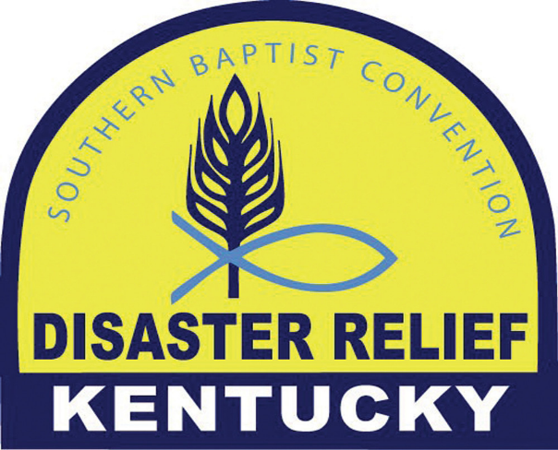

What does serving with Disaster Relief look like?
How can I serve?
How am I able to be the hands and feet of Jesus through this ministry?

Learn the answers to these questions and more and also meet the DR family by attending Disaster Relief training right here in our association: First Baptist Church Henderson
307 Center Street
March 21
Doors open 7:30am

Preregister: REGISTER@KYBAPTIST.ORG/DR
Registration fee $40 - Lunch included
Contact email: dr@kybaptist.org
Cross training also available

Local GVBA contact:
Bill or Debra Kramer 270-826-4252

Look forward to seeing participation from every church in our association for training.

PRE-REGISTRATION IS NOW OPEN
Join us in Orlando this June by pre-registering TODAY for the 2026 SBC Annual Meeting and Pastors' Conference.
WHAT YOU NEED FOR MESSENGER REGISTRATION
In order to pre-register as a messenger, you first need to be elected as a messenger from your church. Then, to complete the registration process you will need the following required information:
- Your church's SBC ID number. If you need your church's SBC ID, ask your state convention or look on your ACP form

- Your church's total undesignated receipts from Oct. 1, 2024 through Sept. 30, 2025. What your church collected in tithes and offerings

- Your church's CP giving from Oct. 1, 2024 through Sept. 30, 2025. What your church gave through the state or directly to the EC that was for the Cooperative Program.

- Your church's Annie Armstrong giving from Oct. 1, 2024 through Sept. 30, 2025.

- Your church's Lottie Moon giving from Oct. 1, 2024 through Sept. 30, 2025.

- Any other designated Convention giving from Oct. 1, 2024 through Sept. 30, 2025. Mission:Dignity, Send Relief, Global Hunger, etc.
NOTE: This DOES NOT include associational giving. The only amounts that count as "giving to Convention causes" are those that were given directly (or through the state) for NATIONAL ENTITIES. Giving to state agencies, state offerings, local associations, state colleges, etc. DOES NOT COUNT as Convention giving.
Finally, registration for childcare is also open. It will fill up fast this year as many families will be making the trip to Orlando.
We’ll see you in Orlando for SBC26!

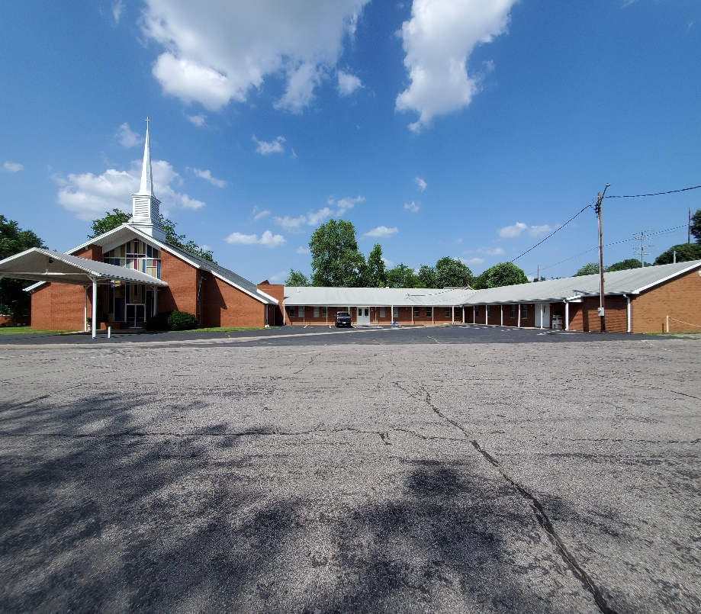

The 2025-2026 Annual Book of Reports and Directory is ready in the GVBA office. Just drop by and pick up a copy.

Green Valley Baptist Association
2360 Green River Road
Henderson, KY 42420
(270)827-9867

Rev. Jeff Burke Ms. Alice Robinson
Director of Community Ministries/Interim AMS Ministry Assistant
jeff.burke1955@gmail.com ministryassistant@greenvalleybaptist.org

