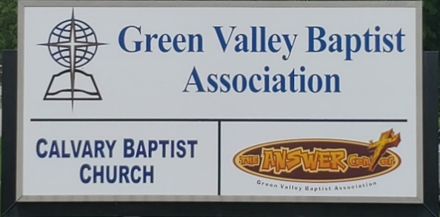
The BRIDGE BUILDER

A Family of Churches BUILDING BRIDGES between God & man, between our churches, and between churches
& the community.
Vol. 59 January 2026 No. 1

Ju

Greetings from the Interim Associational Mission Strategist!

It has been my pleasure and honor to serve as the Interim Mission Strategist for Green Valley. While I have enjoyed serving in this capacity, I hope you will join me in praying for the Vision Forward Team as they work to find the next Mission Strategist.

Also, pray for the churches in Green Valley who do not have a pastor. Those churches are Lawndale, Robards, New Hope, Advance, Bellfield, Finley, and Poole.

Of course, we still need to pray for all of our churches and the church staffs that God blesses each of our churches in a powerful way. Pray for an outpouring of the power of God seen in a great harvest of people being saved.

Pray for the ministries of Green Valley such as Disaster Relief, The Answer Center, and all the great work of our WMU: C.R.O.S.S., Race Track Ministry, Jail Bag Ministry.

Pray for Green Valley as we begin to implement some of the new structure of Green Valley Ministries in 2026.

There are a lot of ways to serve God in Green Valley. I pray we will continue to be blessed by all the ways people serve God in our association.

Jeff Burke, Interim Mission Strategist


The Kathy J. Strange

Greetings from The Kathy J. Strange Answer Center!

Last year was a great time to be part of The Answer Center (TAC) ministry. We were able to help over 2,500 people. Most importantly, there were 14 people who prayed to receive Christ as their Savior. The last two Saturdays we helped 314 people and gave away around 260 Christmas backpacks. We were blessed with 30 volunteers who helped on Saturdays, Mondays, and Thursdays and others who worked occasionally but were still a great help to our ministry.

We can always use more volunteers. Our volunteers help on Monday mornings an Thursday mornings. Some can stay only a couple hours; others stay into the afternoon. We also always need help on Saturdays when we open for shopping. Generally we try to open the first and third Saturday but sometimes we change that routine because of holidays. We post our schedule from month to month on Faeebook.

We are thankful for and are greatly blessed by all of you who bring donations to us. Our drop box is often filled to capacity and even overflows at times. Your donations help us meet the needs of those who come to us on Saturdays looking for help. The 14 people who were saved at TAC last year came to us because your generous donations that we put into our ministry rooms enable us to have good-quality items that are attractive to people who come on Saturdays. Most of you who bring donations we rarely see, but I hope you understand that you are impacting people for Christ every time you bring us your donations. Thank You!

Jeff Burke, TAC Director

Associational Church Giving

Received by January 7, 2026

Advance $ 239.92 FBC Sebree $ 686.06
Airline $ 375.00 Geneva $ -------
Bellfield $ 700.00 Grace Point $ 345,27
Bethel $ ------- Greater Norris $ -------
Bridge $ ------- Hyland $ 863.52
Cash Creek $ 532.18 Lawndale $ 68.28
Cherry Hill $ ------ Mt. Pleasant $ -------
Corydon $ 1,211.23 New Hope $ --------
Covenant $ ------- Poole $ --------
DuPey $ 60.00 Robards $ 196.64
Eastview $ 213.99 Spottsville $ 289.41
Finley $ -------- Victory $ 2,025.50
FBC, Hend. $2,056.14 Water's Edge $ -------
FBC, M’field $ 2,332.65 Zion $ 416.00

We encourage ALL our associational churches to give 3% - 5% of their undesignated offerings to GVBA to help support the work of your association. What you give goes out to the community & back to you. We can do so much more together than we can separately. Partner with us in spreading God’s message of love to our community. WE ARE BETTER TOGETHER!

best year ever.



C R O S S
Christ Reaching Out Saving Students

Cross Schedule for Spring Semester – 2026

The Associational WMU thanks you for your participation in preparing meals for the college students each Wednesday at noon. The students and staff greatly appreciate the food and kindness you show them. They are fed not only a warm meal each Wednesday but also the truths from the Word of God. Thank you WMU groups, women’s ministry groups and Sunday School Classes for supporting this important ministry. Please call the GVBA office at 270-827-9867 if you would like to provide a meal and a date will be arranged for you.

Jan. 21 First Baptist Church Henderson
Jan. 28 First Baptist Church Sebree
Feb. 4 Corydon Missionary Baptist Church
Feb. 11 Poole Missionary Baptist Church
Feb. 18 First Baptist Church Henderson
Feb. 25 Spottsville Baptist Church
Mar. 4 First Baptist Church Sebree
Mar. 11 Spring Break - No Meeting
Mar. 18 Corydon Missionary Baptist Church
Mar. 25 Hyland Baptist Church
April 1 First Baptist Church Henderson
April 8 Bellfield Baptist Church
April 15 Mt. Pleasant Baptist Church
April 22 First Baptist Church Henderson

2025 Jail Gift Bag Ministry
Assembly Party

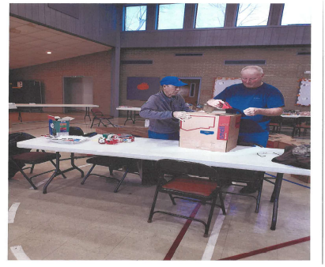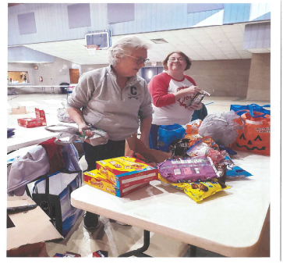

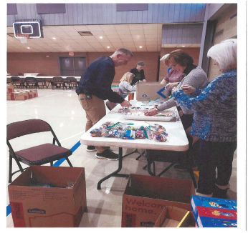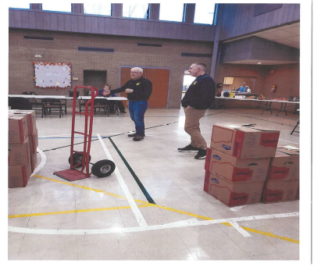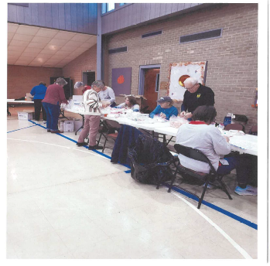

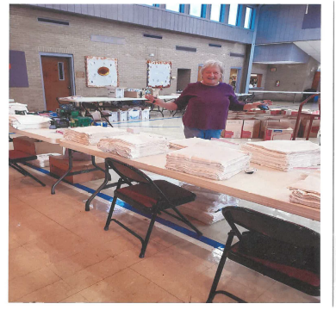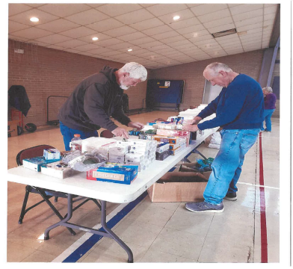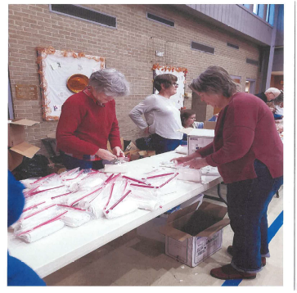

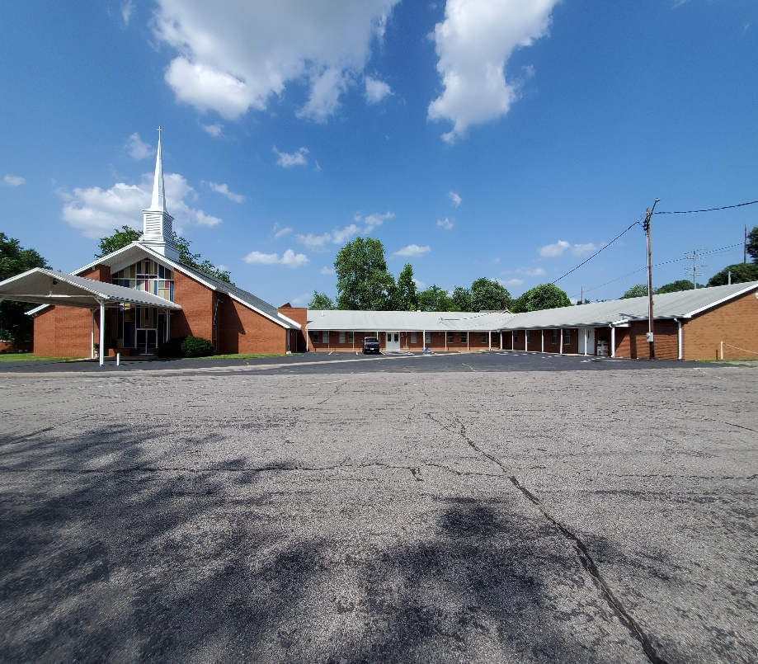

The Executive Board of GVBA will meet on Thursday, January 15, 2026, at 6:00PM. Please mark this date on your calendar.

The 2025-2026 Annual Book of Reports and Directory is ready in the GVBA office. Just drop by and pick up a copy.

Green Valley Baptist Association
2360 Green River Road
Henderson, KY 42420
(270)827-9867

Rev. Jeff Burke Ms. Alice Robinson
Director of Community Ministries/Interim AMS Ministry Assistant
jeff.burke1955@gmail.com ministryassistant@greenvalleybaptist.org

January |  |  |  |  |  |  |  |  | 2026
Monday | Tuesday |  | Wednesday | Thursday |  | Friday | Saturday |  |  | Sunday
 |  |  | 1 | 1  Happy New Year!  GVBA Closed |  | 2 | 3 |  |  | 4  Tim Shockley, Geneva Baptist
5 | 6 |  | 7 | 8 |  | 9 | 10 |  |  | 11
8:30AM Vol. sort donations |  |  |  | 8:30AM Volunteers sort donations |  | Ellie Coursey, FBC Henderson | TAC open 9AM-10:30AM
12 | 13 |  | 14 | 15 |  | 16 | 17 |  |  | 18
8:30AM Volunteers sort donations |  |  |  | 8:30AM Volunteers sort donations, 6PM-EB Meeting
19 | 20 |  | 21 | 22 |  | 23 | 24 |  |  | 25
8:30AM Vol. sort donations |  |  | 12PM-CROSS at HCC | 8:30AM Vol. sort donations |  |  | TAC open 9AM-10:30AM
26 | 27 |  | 28 | 29 |  | 30 | 31
8:30AM Volunteers sort donations |  |  | 12PM-CROSS at HCC | 8:30AM Volunteers sort donations

