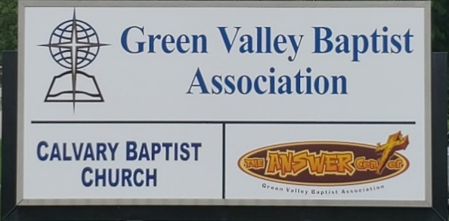
The BRIDGE BUILDER

A Family of Churches BUILDING BRIDGES between God & man, between our churches, and between churches
& the community.
Vol. 58 December 2025 No. 12

Ju

Merry Christmas!

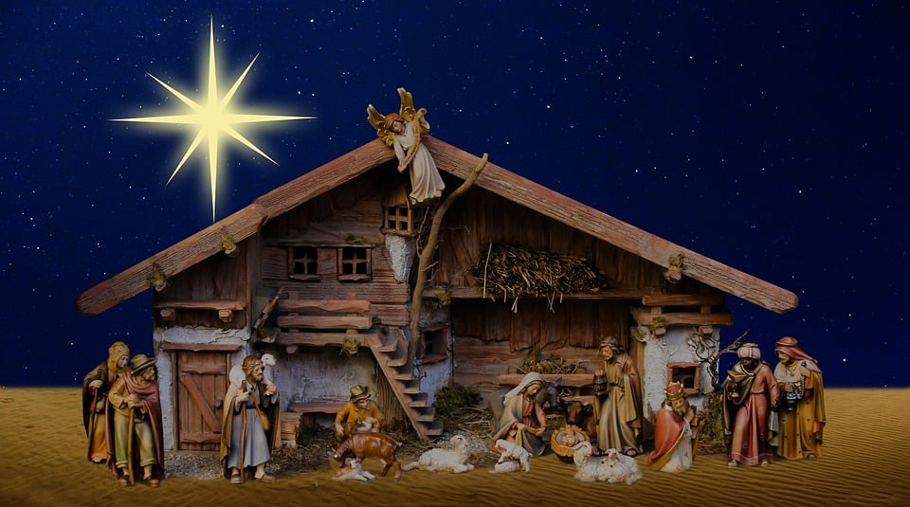

The office of Green Valley Baptist Association will be closed from December 22 - January
5, 2026.

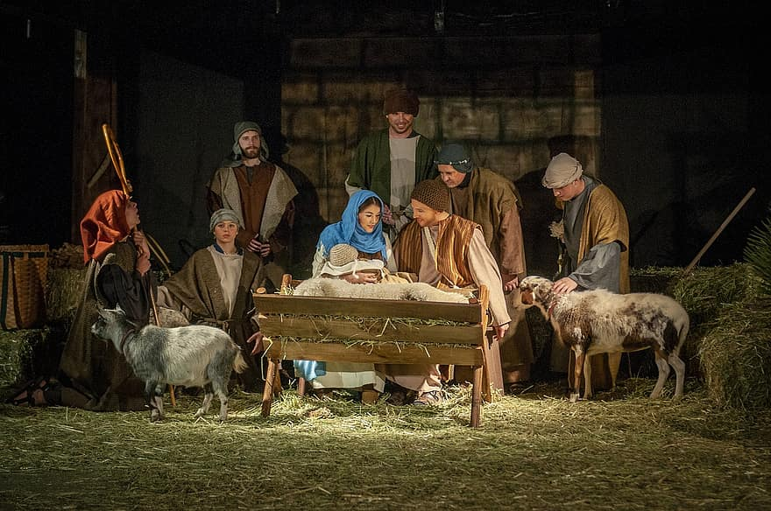

Greetings from the Interim Associational Mission Strategist!
In Luke, chapter 2, verse 7, the Bible tells us about the birth of Jesus. Beginning in verse 8, we learn that “There were in the same country shepherds abiding in the field keeping watch over their flock by night.
And, lo, the angel of the Lord came upon them and the glory of the Lord shone round about them and they were sore afraid.
And the angel said unto them, “Fear Not” for behold, I bring you good tidings of great joy which shall be to all people.
For unto you is born this day in the city of David a Saviour which is Christ the Lord.
And this shall be a sign unto you, Ye shall find the babe wrapped in swaddling clothes lying in a manger.
And suddenly there was with the angel a multitude of the heavenly host praising God and saying, “Glory to God in the highest, and on earth peace, good will toward men.”

My prayer for you is that as you celebrate Christmas this year that you will experience some of The Glory of God.

That you, too, will bring good tidings of great joy which shall be to all people because God has sent us a Saviour which is Christ the Lord.

That you may experience His peace in your heart.

Merry Christmas!
Jeff Burke, Interim Mission Strategist


The Kathy J. Strange

Greetings from The Kathy J. Strange Answer Center!

On the first two Saturdays in December (the 6th and 13th), The Answer Center will have our annual Christmas Backpack giveaway. At this time, we have received 270 backpacks which will be given away to children and young people from two years old through high school. The backpacks will be full of clothes, snack food, school supplies, a Bible, a printed Christmas story and other things as well. In addition to Green Valley, we have received backpacks from the Ohio Valley Association and the Ohio River Association.

In addition, we have received a donation of 250 “stuffies” to give away with the backpacks. Kris Knoth from Kuttawa has collected these stuffed animals, and repaired and cleaned each one. She takes a Billy Graham evangelism tract and attaches one to each stuffed animal. She has been bringing these to us each year for a while. We have a lot of fun giving these out with our Christmas backpacks.

On the two Saturdays in December when we are giving away our backpacks, each family and individual will be able to shop for clothing and household items as usual.

Before they leave, we will pray with each family as well as individuals and will talk with each one about eternity. Often there will be someone who will be saved on those Saturdays.

Pray for us as we minister December 6 and December 13.

If you have been thinking of volunteering with us, both of these Saturdays will be a good time to volunteer at TAC – you will be blessed!

Respectfully submitted,
Jeff Burke, TAC Director

Associational Church Giving

Received by December 3, 2025

Advance $ 254.99 FBC Sebree $ 614.35
Airline $ 375.00 Geneva $ -------
Bellfield $2,000.00 Grace Point $ -------
Bethel $ ------- Greater Norris $ -------
Bridge $ ------- Hyland $ 284.80
Cash Creek $ ------- Lawndale $ 36.07
Cherry Hill $ ------ Mt. Pleasant $ -------
Corydon $ 840.37 New Hope $ 554.00
Covenant $ ------- Poole $ --------
DuPey $ 30.00 Robards $ --------
Eastview $ -------- Spottsville $ 393.97
Finley $ -------- Victory $ -------
FBC, Hend. $2,663.80 Water's Edge $ -------
FBC, M’field $ Zion $ -------

We encourage ALL our associational churches to give 3% - 5% of their undesignated offerings to GVBA to help support the work of your association. What you give goes out to the community & back to you. We can do so much more together than we can separately. Partner with us in spreading God’s message of love to our community. WE ARE BETTER TOGETHER!

best year ever.


This holiday season, join us for a heartfelt musical celebration of hope, joy, and the true meaning of Christmas. Local singers and musicians Tim Wilkerson, Stephanie Schinault, and Andy Duckworth will share a story of love through music as they reflect on the coming of our Savior. All are welcome to experience the music and the spirit of Christmas!

December 5th Presbyterian Church…………...……….....7:00 pm
(After Christmas Tree Lighting in Central Park)
100 S Main St. Henderson Ky 42420
December 7th Mt. Pleasant Baptist Church…………..…..10:30 am.
11525 Ky 359 Waverly Ky 42462
December 8th Harbor House Christian Men’s Center…….6:30 pm
804 Clay St. Henderson Ky 42420
December 12th Redbanks Nursing Home ………….....……..2 pm
851 Kimsey Lane Henderson Ky 42420
December 14th Hyland Baptist Church …………………...10:15 am
1400 Wright St. Henderson Ky 42420
December 14th Spottsville Baptist Church.. ……………...…...6 pm.
6842 Old Spottsville Rd. Spottsville Ky 42458
December 19th Henderson 1st Baptist Church …………….…..1 pm
307 Center St. Henderson Ky 42420
December 21st Finley Baptist Church …………………….…10 am.
3800 US 41 Alt. Henderson Ky 42420
December 21st Airline Baptist Church…………... …………....6 pm.
1942 Clay St Henderson Ky 42420

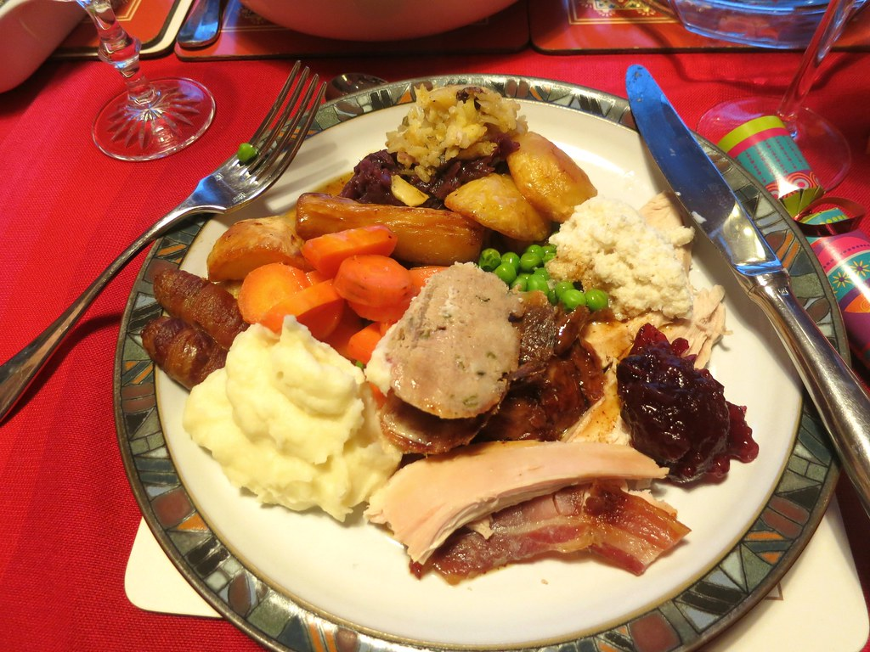
This Photo by Unknown Author is licensed under CC BY

Green Valley Christmas Dinner and Fellowship
Catered by Sidewalk Cafe
We will have our Christmas dinner and fellowship on Thursday, December 4th, in the Fellowship Hall here at Green Valley. Come and join us for a night of great food, fun and fellowship! Tim Wilkerson and Stephanie Schinault will be celebrating the season with hope, joy, and the true meaning of Christmas.

.
December 2025
Sun. | Mon. | Tue. | Wed. | Thu. | Fri. | Sat.
 | 1 | 2 | 3 | 4 | 5 | 6
 | 8:30AM Volunteers sort donations |  |  | 8:30AM Volunteers sort donations, 6PM GV Christmas Dinner, Spiveys | Sam Hinkson, FBCHenderson | TAC open 9AM to 10:30AM
7 | 8 | 9 | 10 | 11 | 12 | 13
 | 8:30AM Volunteers sort donations |  |  | 8:30AM Volunters sort donations |  | TAC open 9AM to 10:30AM
14 | 15 | 16 | 17 | 18 | 19 | 20
 | 8:30AM Volunteers sort donations |  |  | 8:30AM Volunteers sort donations
21 | 22 | 23 | 24 | 25 | 26 | 27
 |  |  | Christmas Eve | Christmas Day
28 | 29 | 30 | 31
 |  |  | New Year’s Eve

Notes | The offices of GVBA and The KJS Answer Center are closed from December 22, 2025 - January 5, 2026.

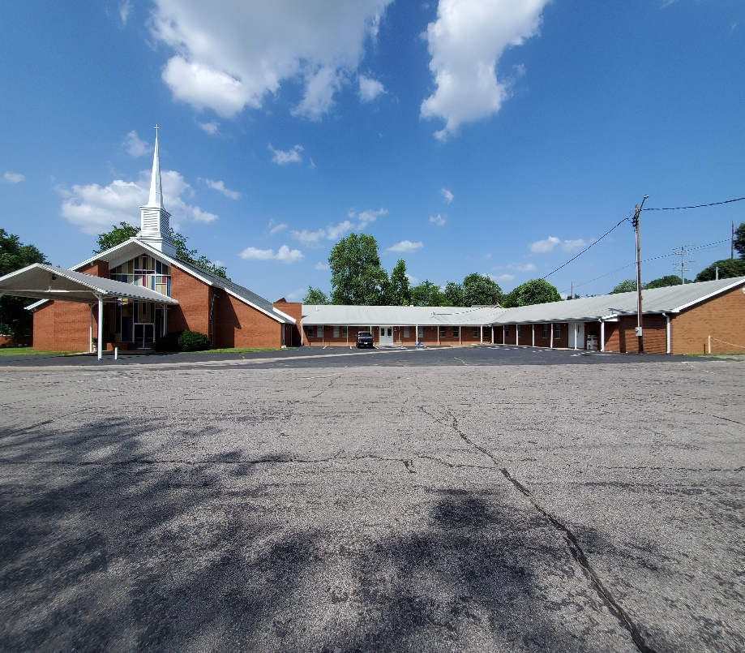

The Executive Board of GVBA will meet on Thursday, January 15, 2026. Please mark this date on your calendar.

Green Valley Baptist Association
2360 Green River Road
Henderson, KY 42420
(270)827-9867

Rev. Jeff Burke Ms. Alice Robinson
Director of Community Ministries/Interim AMS Ministry Assistant
jeff.burke1955@gmail.com ministryassistant@greenvalleybaptist.org

