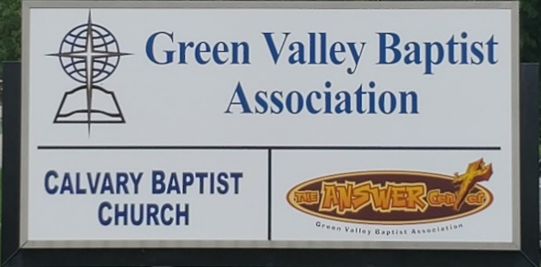
The BRIDGE BUILDER

A Family of Churches BUILDING BRIDGES between God & man, between our churches, and between churches
& the community.
Vol. 58 November 2025 No. 11

Ju

Greetings from the Interim Green Valley Mission Strategist!

These are exciting days to be in ministry in Green Valley Baptist Association. While a good number of our churches are struggling, there are others who seem to be doing some outstanding work for Christ in our association and beyond.

I’m convinced the six churches currently without pastors are likely the main churches in need of prayer and support. Those six churches are: Bellfield, Lawndale, New Hope, Advance, Finley and Robards. Would you join me in praying for these fine churches as they continue to serve Christ in the areas around their churches while looking for their next pastor?

It has now been about fifteen (15) months that I have been the Interim Mission Strategist for Green Valley. Now that the Vision Forward Team has done so much of the work in restructuring Green Valley for better ministry, I look forward to the time now where they begin looking for a new Mission Strategist to lead Green Valley in serving this area and beyond. This team needs us to pray daily for them as they work to find that next Mission Strategist for our association.

I have enjoyed serving as your Interim Strategist and will stay with it until we find the leader God has already chosen for us.

Jeff Burke, Interim Mission Strategist

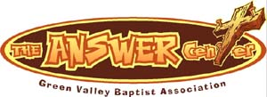
The Kathy J. Strange

Greetings from The Kathy J. Strange Answer Center!

This past Saturday was an exciting day at the Kathy J. Strange Answer Center. We were blessed with eleven volunteers who worked hard to minister to all who came to TAC for help. We pulled or created 28 files and there were 112 people who were shopped for. The most exciting thing to report is that there were two people who prayed to receive Christ. To see people saved is the main reason we do what we do. We work hard to give The Answer of Jesus Christ to the Henderson area while meeting needs.

We will be open for shopping only three more Saturdays between now and the end of the year. Those Saturdays are November 15, December 6 and December 13. On the two Saturdays we are open in December, we are giving away Christmas backpacks. These will be some busy and exciting days of ministry. This week we anticipate 204 Christmas backpacks to be brought to us from Salem, Kentucky, in the Ohio River Baptist Association. There are also 9 more Christmas backpacks coming to us from Union County. On those two Saturdays in December that we are open, we hope to give away all of our Christmas backpacks. These will be fun days.

If you are looking for a way to serve God, we invite you to come to TAC on December 6 and 13 and help us give out our Christmas backpacks. It is always a fun time for our volunteers.

Jeff Burke
Director

Associational Church Giving

Received by November 1, 2025

Advance $ 415.35 FBC Sebree $ 458.69
Airline $ 375.00 Geneva $ -------
Bellfield $ 830.00 Grace Point $ 346.59
Bethel $ ------- Greater Norris $ -------
Bridge $ ------- Hyland $ 282.68
Cash Creek $ ------- Lawndale $ 30.44
Cherry Hill $ ------ Mt. Pleasant $ -------
Corydon $ ------- New Hope $ -------
Covenant $ ------- Poole $ 533.37
DuPey $ 30.00 Robards $ 400.76
Eastview $ 88.95 Spottsville $ 227.64
Finley $ -------- Victory $ -------
FBC, Hend. $ 2,784.54 Water's Edge $ -------
FBC, M’field $ 456.75 Zion $ 416.00

We encourage ALL our associational churches to give 3% - 5% of their undesignated offerings to GVBA to help support the work of your association. What you give goes out to the community & back to you. We can do so much more together than we can separately. Partner with us in spreading God’s message of love to our community. WE ARE BETTER TOGETHER!

best year ever.

Minutes of Green Valley Baptist Association
Executive Board Meeting
October 16, 2025

Rev. Paul Davis, Moderator, called the meeting to order and asked Rev. Jeff Burke to pray. Bro. Jeff prayed for Linda Willingham, Alice Robinson’s sister, Beverly Davis’ brother-in-law, Marshall Brantley, Bro. David Riley and Mrs. Nancy Brown, as well as our entire association.

Rev. Jeff Burke, speaking on behalf of the Nominating Committee, briefly discussed the people to serve on the committee. David Riley stated that we won’t be able to adopt new people on this committee until we meet on January 15 of 2026.

Bro. Davis asked for a Motion to table all reports until the Executive Board meeting on January 15, 2026 and to suspend this meeting. Beverly Davis made the Motion, second by David Riley.

Motion to Adjourn made by Rev. Jeff Burke, second by Ricky Crowder.

Ricky Crowder led in prayer as we adjourned.

Six (6) people were in attendance.

Those in attendance: Rev. Paul Davis, Mrs. Beverly Davis, David Riley, Rev. Jeff Burke, Alice Robinson, Ricky Crowder. Five of the twenty-eight churches were represented.



This holiday season, join us for a heartfelt musical celebration of hope, joy, and the true meaning of Christmas. Local singers and musicians Tim Wilkerson, Stephanie Schinault, and Andy Duckworth will share a story of love through music as they reflect on the coming of our Savior. All are welcome to experience the music and the spirit of Christmas!

November 23rd Park Ave. Baptist Church…………………...6 pm.
132 Park Ave. Madisonville Ky 42431
November 30th Victory Baptist Church……………………...10am.
1504 Loeb St. Henderson Ky 42420
November 30th Bellfield Baptist Church…………..…..……..6pm.
9980 Ky 136 Henderson Ky 42420
December 5th Presbyterian Church…………...……….....7:00 pm
(After Christmas Tree Lighting in Central Park)
100 S Main St. Henderson Ky 42420
December 7th Mt. Pleasant Baptist Church…………..…..10:30 am.
11525 Ky 359 Waverly Ky 42462
December 8th Harbor House Christian Men’s Center…….6:30 pm
804 Clay St. Henderson Ky 42420
December 12th Redbanks Nursing Home ………….....……..2 pm
851 Kimsey Lane Henderson Ky 42420
December 14th Hyland Baptist Church …………………...10:15 am
1400 Wright St. Henderson Ky 42420

December 14th Spottsville Baptist Church.. ……………...…...6 pm.
6842 Old Spottsville Rd. Spottsville Ky 42458
December 19th Henderson 1st Baptist Church …………….…..1 pm
307 Center St. Henderson Ky 42420
December 21st Finley Baptist Church …………………….…10 am.
3800 US 41 Alt. Henderson Ky 42420
December 21st Airline Baptist Church…………... …………....6 pm.
1942 Clay St Henderson Ky 42420

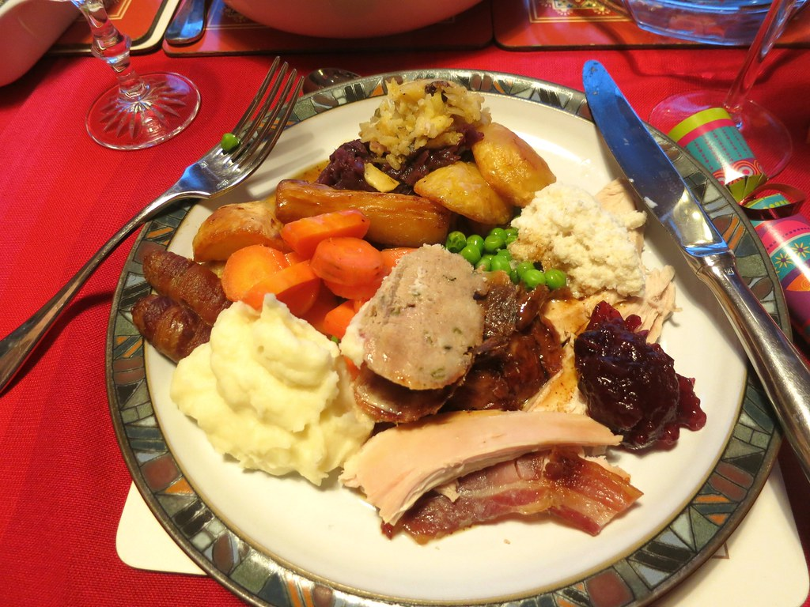
This Photo by Unknown Author is licensed under CC BY

Green Valley Christmas Dinner and Fellowship

We will have our Christmas dinner and fellowship on Thursday, December 4th, in the Fellowship Hall here at Green Valley. Come and join us for a night of great food, fun and fellowship! Tim Wilkerson and Stephanie Schinault will be celebrating the season with hope, joy, and the true meaning of Christmas. Details will follow.


This Photo by Unknown Author is licensed under CC BY-NC

November |  |  |  |  |  | 2025
Monday | Tuesday | Wednesday | Thursday | Friday | Saturday |  | Sunday
 |  |  |  |  | 1 |  | 2
 |  |  |  |  | TAC open 9AM-10:30AM |  | Daylight Saving Time Ends—Change Clocks
3 | 4 | 5 | 6 | 7 | 8 |  | 9
8:30AM-Volunteers sort donations | Election Day | 12PM-C.R.O.S.S. @ HCC | 8:30AM-Volunteers sort donations
10 | 11 | 12 | 13 | 14 | 15 |  | 16
8:30AM-Volunteers sort donations | Veterans Day, KBC Annual Meeting | 12PM-C.R.O.S.S. @ HCC | 8:30AM-Volunteers sort donations |  | TAC open 9AM-10:30AM
17 | 18 | 19 | 20 | 21 | 22 |  | 23
8:30AM-Volunteers sort donations |  | 12PM-C.R.O.S.S. @ HCC | 8:30AM-Vol. sort donations, Jeff Hesley. Pleasant |  | Jacob & Mary Clutts, FBC Henderson
24 | 25 | 26 | 27 | 28 | 29 |  | 30
8:30AM-Volunteers sort donations |  | Hal Branso, Spottsville Baptist | Thanksgiving Day-GVBA Closed |  |  |  | Week of Prayer for IMB & Lottie Moon Christmas Offering

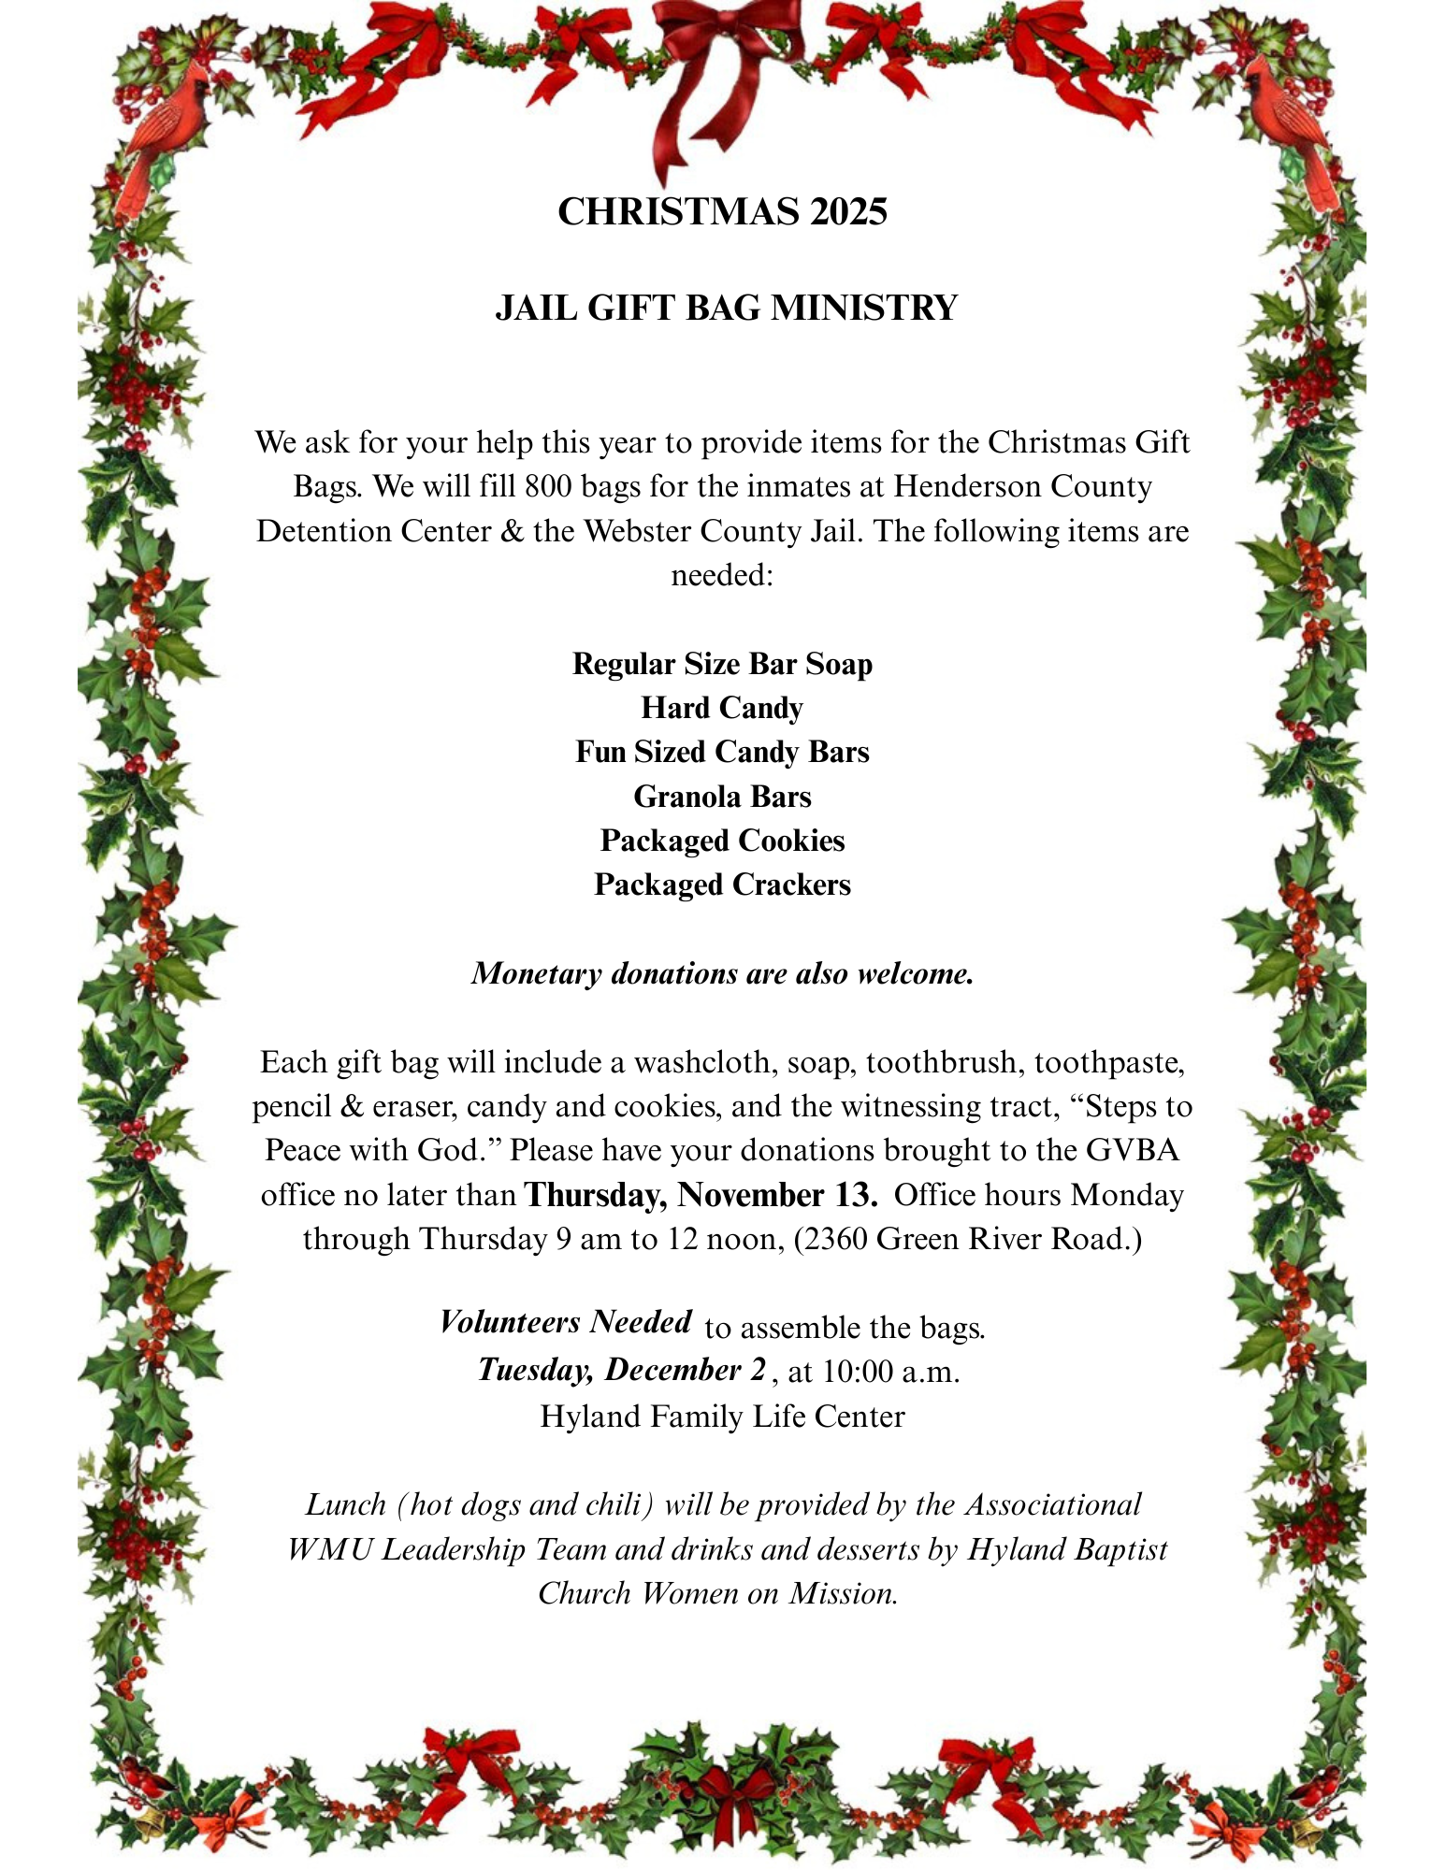

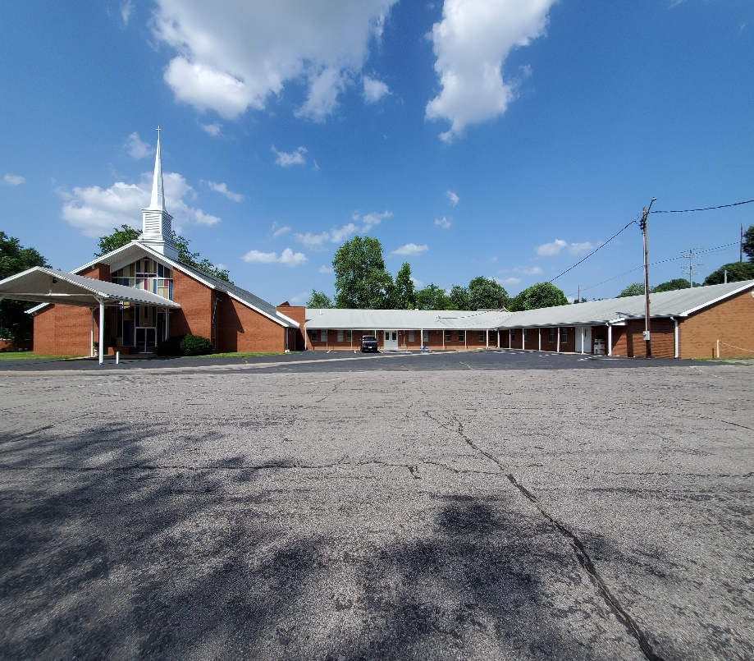
Green Valley Baptist Association
2360 Green River Road
Henderson, KY 42420
(270)827-9867

Rev. Jeff Burke Ms. Alice Robinson
Director of Community Ministries/Interim AMS Ministry Assistant
jeff.burke1955@gmail.com ministryassistant@greenvalleybaptist.org

