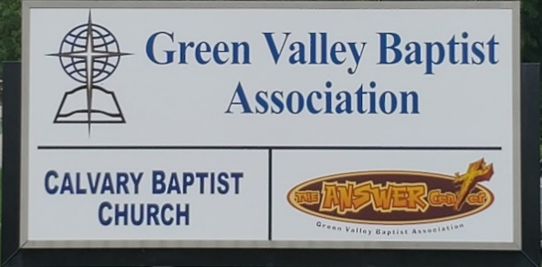
The BRIDGE BUILDER

A Family of Churches BUILDING BRIDGES between God & man, between our churches, and between churches
& the community.
Vol. 58 October 2025 No. 10

Ju

In Matthew 9:37-38 Jesus said to His disciples, “The harvest truly is plentiful, but the laborers are few. Therefore pray the Lord of the Harvest to send out laborers into His harvest.”

In John 4:34-35 Jesus says, “My food is to do the will of Him who sent Me, and to finish His work. Do you not say, ‘There are still four months and then comes the harvest’?”

We know that the vast majority of people who live in Henderson County are not in church on any given Sunday morning. We need to embrace the fact that “The harvest truly is plentiful, but the laborers are few.” We need to pray the Lord of the harvest to send us out in to the harvest.

There are 28 churches that make up The Green Valley Baptist Association. Twenty-five of our churches are in Henderson County, two are in Webster County and one in Union County. Working together across this part of the state, the churches of Green Valley working together can be a powerful evangelistic force for Christ. God is surely calling us to lift up our eyes and look at the fields for they are already white for harvest.

Will you join me in praying that God would get us out into the fields and working together? Perhaps we will see a harvest of souls in our churches.

Jeff Burke
Interim Associational Mission Strategist


The Kathy J. Strange

Greetings from The Kathy J. Strange Answer Center!

So far in 2025 we have been open 19 Saturdays and have helped a little more than 1,600 people through TAC. Mostly those we have helped have come to us on Saturdays but we also have helped at least 128 people during the week often with the same variety of clothing and household items. This past Saturday (October 4) there were 85 people shopped for and we were blessed with 16 volunteers who worked hard to minister to those who came to us for help. The greatest information I have to pass on to you is that there was one who prayed to receive Christ as their Savior. So far this year we have had 9 who have prayed to receive Christ as their Savior.

Over the remainder of 2025 we will be open five more Saturdays for shopping. Those Saturdays are October 18, November 1, November 15, December 6 and December 13. Both of the Saturdays in December we will be giving away Christmas backpacks. We anticipate a lot of people coming to us on those Saturdays. We likely will finish 2025 having helped over 2,000 people at TAC.

After December 13 we will be closed for shopping until the first Saturday in January which will be January 3, 2026.

We appreciate all of your prayers and support. If you are looking for a way to serve God, come help us. I believe you will enjoy being a part of TAC ministry.

Jeff Burke
Director of The Kathy J. Strange Answer Center

Associational Church Giving

Received by October 4, 2025

Advance $ ------- FBC Sebree $ 586.77
Airline $ 375.00 Geneva $ -------
Bellfield $1,660.00 Grace Point $ 303.55
Bethel $ ------- Greater Norris $ -------
Bridge $ ------- Hyland $ 362.64
Cash Creek $ 345.31 Lawndale $ 36.53
Cherry Hill $ ------- Mt. Pleasant $ -------
Corydon $ 1,826.27 New Hope $ -------
Covenant $ ------- Poole $ --------
DuPey $ 30.00 Robards $ 241.28
Eastview $ 198.23 Spottsville $ 259.01
Finley $ -------- Victory $ -------
FBC, Hend. $ 3,215.08 Water's Edge $ -------
FBC, M’field $ 1,086.35 Zion $ 416.00

We encourage ALL our associational churches to give 3% - 5% of their undesignated offerings to GVBA to help support the work of your association. What you give goes out to the community & back to you. We can do so much more together than we can separately. Partner with us in spreading God’s message of love to our community. WE ARE BETTER TOGETHER!

GREEN VALLEY BAPTIST ASSOCIATION
SIXTY-SEVENTH ANNUAL SESSION
Airline Baptist Church
Henderson, KY 42420
August 28, 2025
BUSINESS SESSION
Rev. Paul Davis, Moderator, welcomed the congregation and Rev. Jeff Burke, Interim AMS, read Matthew 18:20 and opened the meeting with prayer.

Bro. Tim Wilkerson led the congregation in singing “Tis So Sweet to Trust in Jesus.”

Bro. Davis explained where the Fellowship Hall and restrooms are located. He then called the meeting to order and a Motion to adopt the program was made by Dr. Bob Hardison with a second by Bill Fister. Motion passed.

New Business
Dr. Steve Custer made a Motion to adopt the minutes from the 2024 Annual Session with a second by Rev. Allen Butler. Motion passed.

Rev. Jeff Burke spoke on behalf of the Nominating Committee and stated that they had gotten off to a late start. Nancy Brown is also a member of the committee and Rev. Allen Butler will begin as Chairman in January. Linda Butler has officially agreed to serve as Chairperson of the Prayer Team. David Riley made a Motion to accept the Nominating Committee list as presented with a second by Rev. Dilland Gallant.

Ricky Crowder, Finance Team Leader, presented the financial reports. He presented the Custom Summary Report for January through December 2024 with a total income of $153,571.23, line item 220 Capital Expense BLD Remodel of $8,548.99. Total Missions were $54,044.24, Total Missions Support of $50,349.36, Total Expense was $114,656.15, and a Net Income of $38,915.08. The Associational church Giving for January through December 2024 was as follows: Total of $134,920.24, Operating Receipts were $146,851.23, AMS Grant of $6,720.00 (6 mos.), with a Total Income of $153,571.23. The Answer Center report was as follows: Total Income was $24,716.42, Total Expense was $11,603.64, and Net Income was $13,129.76. TAC receipts detail was also listed, with GVBA of $1,577.74, Individual of $7,771.54 for a Total of $24,716.42. The GVBA Custom Summary Report for January through July 2025 was listed as follows: Total Income was $74,494.39, Capital Expense BLD Remodel was $23,165.00, Payroll Taxes were $1,406.22, for a Total Missions of $15,222.13. Total Missions Support was $31,607.23. Total Expense was $71,400.58, for a Net Income of $3,093.81. GVBA Associational Church Giving for January through July 2025 was listed as a total of $67,640.39, for a 2025 YTD July Receipts detail of a total of $74,494.39. Receipts from Property Management were $6,804.00. The Budget Balance Worksheet was also distributed. TAC Custom Summary Report for January through July 2025 listed a Total Income of $16,870.20 with a Total Expense of $17,057.84. A net income of -178.87 was shown. TAC Associational Giving for January through July 2025 shows a total of $5,333.65 and also shows a 2024 YTD July Receipts Detail. A list of GVBA Bank Balances was also distributed. Ricky also gave reports on the trust accounts.

A Motion was made to accept the Financial Report with a second by Bill Fister. Motion passed.
A question was asked if GVBA is healthy or unhealthy. Ricky said we do have more funds available but he is not so sure if we are doing so well.

Rev. Cole Caven, Chairman of the Vision Forward Team, reported that this team was selected to investigate how effectively our association is serving our churches. Surveys were recently taken and a possible restructuring to improve our association’s interaction with our churches will be presented tonight. This restructuring will take place over the next fifteen years and the highlights of this restructuring will be: Equipping, Empowering, and Encouraging the churches. He briefly discussed the slides in the packet. He concluded that the local church should be our #1 priority.

Accompanying slides to reflect the language of all the changes is listed on page 31-47 of the packet.

Rev. Dylan Zahn, Vision Forward Team, presented the Strategic Vision for GVBA. He opened by saying that many people will say that they don’t know what Green Valley does. We are here to equip the church.

He discussed Equipping the Local Church – a Pastoral Mentorship Program, Collaborative Learning (Sharing how AWANA works), Best Practices, Technology & Communication, Modernizing digital platforms, including websites and social media, a resource hub for sermon materials, leadership resources, ministry tools, a weekly podcast. Encouraging the Church consists of: Leadership Retreats, joint worship services, mission projects, Engaging the Next Generation: provide resources for churches to develop young adult discipleship programs, utilize technology and social platforms, Empowering the Local Church: partnerships with NAMB and IMB to expand mission opportunities. He mentioned that Sebree First Baptist, where he pastors, had a missionary from IMB come and speak to them. These missionaries want to make connections with us. He closed with suggesting we promote healthy church growth strategies based on biblical principles.

Rev. Paul Davis, Vision Forward Team, discussed the Proposed New Structure for GVBA. The Administrative Team and its purpose as outlined in the packet; Its make-up would consist of an Associational Mission Strategist, Moderator, Vice-Moderator, Clerk, Treasurer, Foundation Representative, Three (3) Trustees and an Advisory Council. Its responsibilities were also discussed. He discussed the Church Strengthening Team and its purpose, make-up, focus areas, and example initiatives. He also discussed the Missions Partnership Team, its purpose, make-up, focus areas, and example initiatives. He also discussed the Community Ministries Team, its purpose, make-up, focus areas, and example initiatives. Advantages of this restructure were also discussed.
David Riley, Vision Forward Team, discussed the Proposed Constitutional Amendments, Article IV – Purpose, Current Language, and Proposed Change. He referred to page 44 in the packet which was distributed. How do we accomplish these goals? By Equipping, Empowering, and Encouraging the local churches. He mentioned a Motion needs to be made tonight but not voted on until next year.

Nancy Brown, Vision Forward Team, discussed Article I, Article VI, Article VIII, Article XII.
Article VI – Team Leadership: Current Language, Proposed Language Change, Article VIII – Annual Meeting: Current Language, Proposed Change, Article XII – Amendments: Current Language, Proposed Change.

Accompanying Slides reflect the language of all the changes and are listed on page 31-47 of the packet.

Rev. Cole Caven, Chairman of the Vision Forward Team, explained that the vote on these proposed changes will take place at next year’s annual meeting. The new structure will be more efficient, smaller and leaner.

David Riley, Vision Forward Team, made a Motion to form a “Quasi Committee of the whole” in order to determine the degree of interest the members of the Association have regarding the proposed structure changes in Team Leadership, with a second by Dr. Bob Hardison. Bro. Bob then stated that this is a very good idea and where there is no vision, the people perish. Rev. Cole Caven thanked everyone for all their support and asked everyone to pray as to how they can fit into this.

David Riley requested that we vote on how much interest there is in supporting this. A vote was taken and there was no opposition.

A Motion was made to vote to approve the constitutional amendment changes on January 1, 2027. Rev. Rick O’Daniel seconded the Motion. Motion approved.

David Riley made a Motion to approve the proposed Team Leadership structure changes on a temporary basis which would begin Y 1/2026 and end 12/31/2026. This would allow changes to be implemented until it comes to the formal vote next year. Rev. Dilland Gallant seconded the Motion. Motion approved.

A Motion to accept reports as presented was made by Rev. Dilland Gallant with a second by Rev. Allen Butler.

Rev. Jeremy Aliff made a Motion to Adjourn for our meal with a second by Rev. Dylan Zahn.

Rev. Jeremy Aliff, pastor of Airline Baptist, offered a blessing for our meal.

WORSHIP SESSION

Rev. Jeremy Aliff welcomed everyone and led in prayer. Tim Wilkerson led the congregation in “I Love to Tell the Story.”

Stephanie Schinault sang “The Goodness of God.”

Rev. Tim led the congregation in “Send the Light.”

Stephanie Schinault sang “Praise His Name.”

Rev. Rick O’Daniel brought a stirring message from Revelation 2. God told the church of Ephesus – “You have forsaken your first love.” He said that this association should be leading by Jesus Christ Himself. We are to go and spread the Good News. He referred to II Timothy 3:16-17 and II Peter. He gave statistics on people living in Henderson: 44,000 population, 12.2% attend church, 38,632 people do not attend church. Only 42% of people who attend church are born again. He referred to 2 Cor. 1:18. We have a vast amount of lost people all around us. There is a field ready for harvest right here in Henderson! We need to get busy and GO!

Bro. Tim led in “The Bond of Love.’

Benediction

Those in attendance were: Rev. Jeff Burke, Rev. Paul Davis, Stephanie Schinault, Tim Wilkerson, Rev. Jeremy Aliff, Keith Brown, Ryan Simcox, Pastor Rickey Jay, Pastor Betty Jay, Nancy Brown, Patti Burgard, Chris Reynolds, Dr. Bob Hardison, Violet Hardison, Beverly Davis, Tina Zieman, Rev. Eric Fannin, Dennis Elliott, Tony Wint, Bill Fister, Phil Gillespie, Jean Gillespie, Rev. Dylan Zahn, David Riley, Rev. Cole Caven, Rev. Brad Jones, Helen O’Daniel, Rev. Rick O’Daniel, Larry Gibson, Faye Melton, Rev. Dilland Gallant, Alex Messamore, Donald Duncan, Debbie Duncan, Gary Gibson, Rev. Robert Duncan II, Dr. Steve Custer, Debra Kramer, Bill Kramer, Linda Butler, Rev. Allen Butler, Dolores Gilmore, Peggy Moseley, Kathie Pullum, Ricky Crowder, Rev. Jason Cowan, Jeanne Ray, Jenette Roedel, Wayne Roedel, Alice Robinson. Seventeen of our association’s churches were represented.

t the best year ever.


Airline Baptist Church is searching for a Minister of Music. This is a paid, part-time position. We are also searching for a church pianist. If interested in either of these positions, please contact Larry Allen at 270-724-6117.

Lawndale Baptist Church is looking for a bi-vocational, part-time pastor. Please contact Gary Shoulders at 270-831-4072 or gwshoulders@yahoo.com if interested.


Executive Board Meeting Thursday, October 16 6:00PM
GVBA Fellowship Hall

October 2025

Monday | Tuesday |  | Wednesday | Thursday |  | Friday | Saturday |  | Sunday
 |  |  | 1 | 2 |  | 3 | 4 |  | 5
 |  |  | 12PM – CROSS @ HCC | 8:30AM TAC volunteers sort donations |  |  | TAC Open 9AM-10:30AM
6 | 7 |  | 8 | 9 |  | 10 | 11 |  | 12
8:30AM TAC Volunteers sort donations |  |  | 12PM – CROSS @ HCC | 8:30AM TAC volunteers sort donations |  |  | Russell & Laurie Wood - Bethel
8:30AM TAC Volunteers sort donations13 | 14 |  | 15  12PM – CROSS @ HCC | 8:30AM TAC volunteers sort donations16 |  | 17 | TAC Open 9AM – 10:30AM 18 |  | 19
 |  |  |  | 6PM EB Meeting
20 | 21 |  | 22 | 23 |  | 24 | 25 |  | 26
8:30AM TAC Volunteers sort donations |  |  | 12PM – CROSS @ HCC | 8:30AM TAC volunteers sort donations
27 | 28 |  | 29 | 30 |  | 31
8:30AM TAC Volunteers sort donations |  |  | 12PM – CROSS @ HCC | 8:30AM TAC volunteers sort donations

KENTUCKY BAPTIST CONVENTION UPCOMING EVENTS

Oct. 5 Cooperative Program Sunday
Oct. 10-11 Disaster Relief Chaplaincy Training Campbellsville
Oct. 11 Disaster Relief Volunteer Training Campbellsville
Oct. 17 Radiant Ministry Wives Retreat



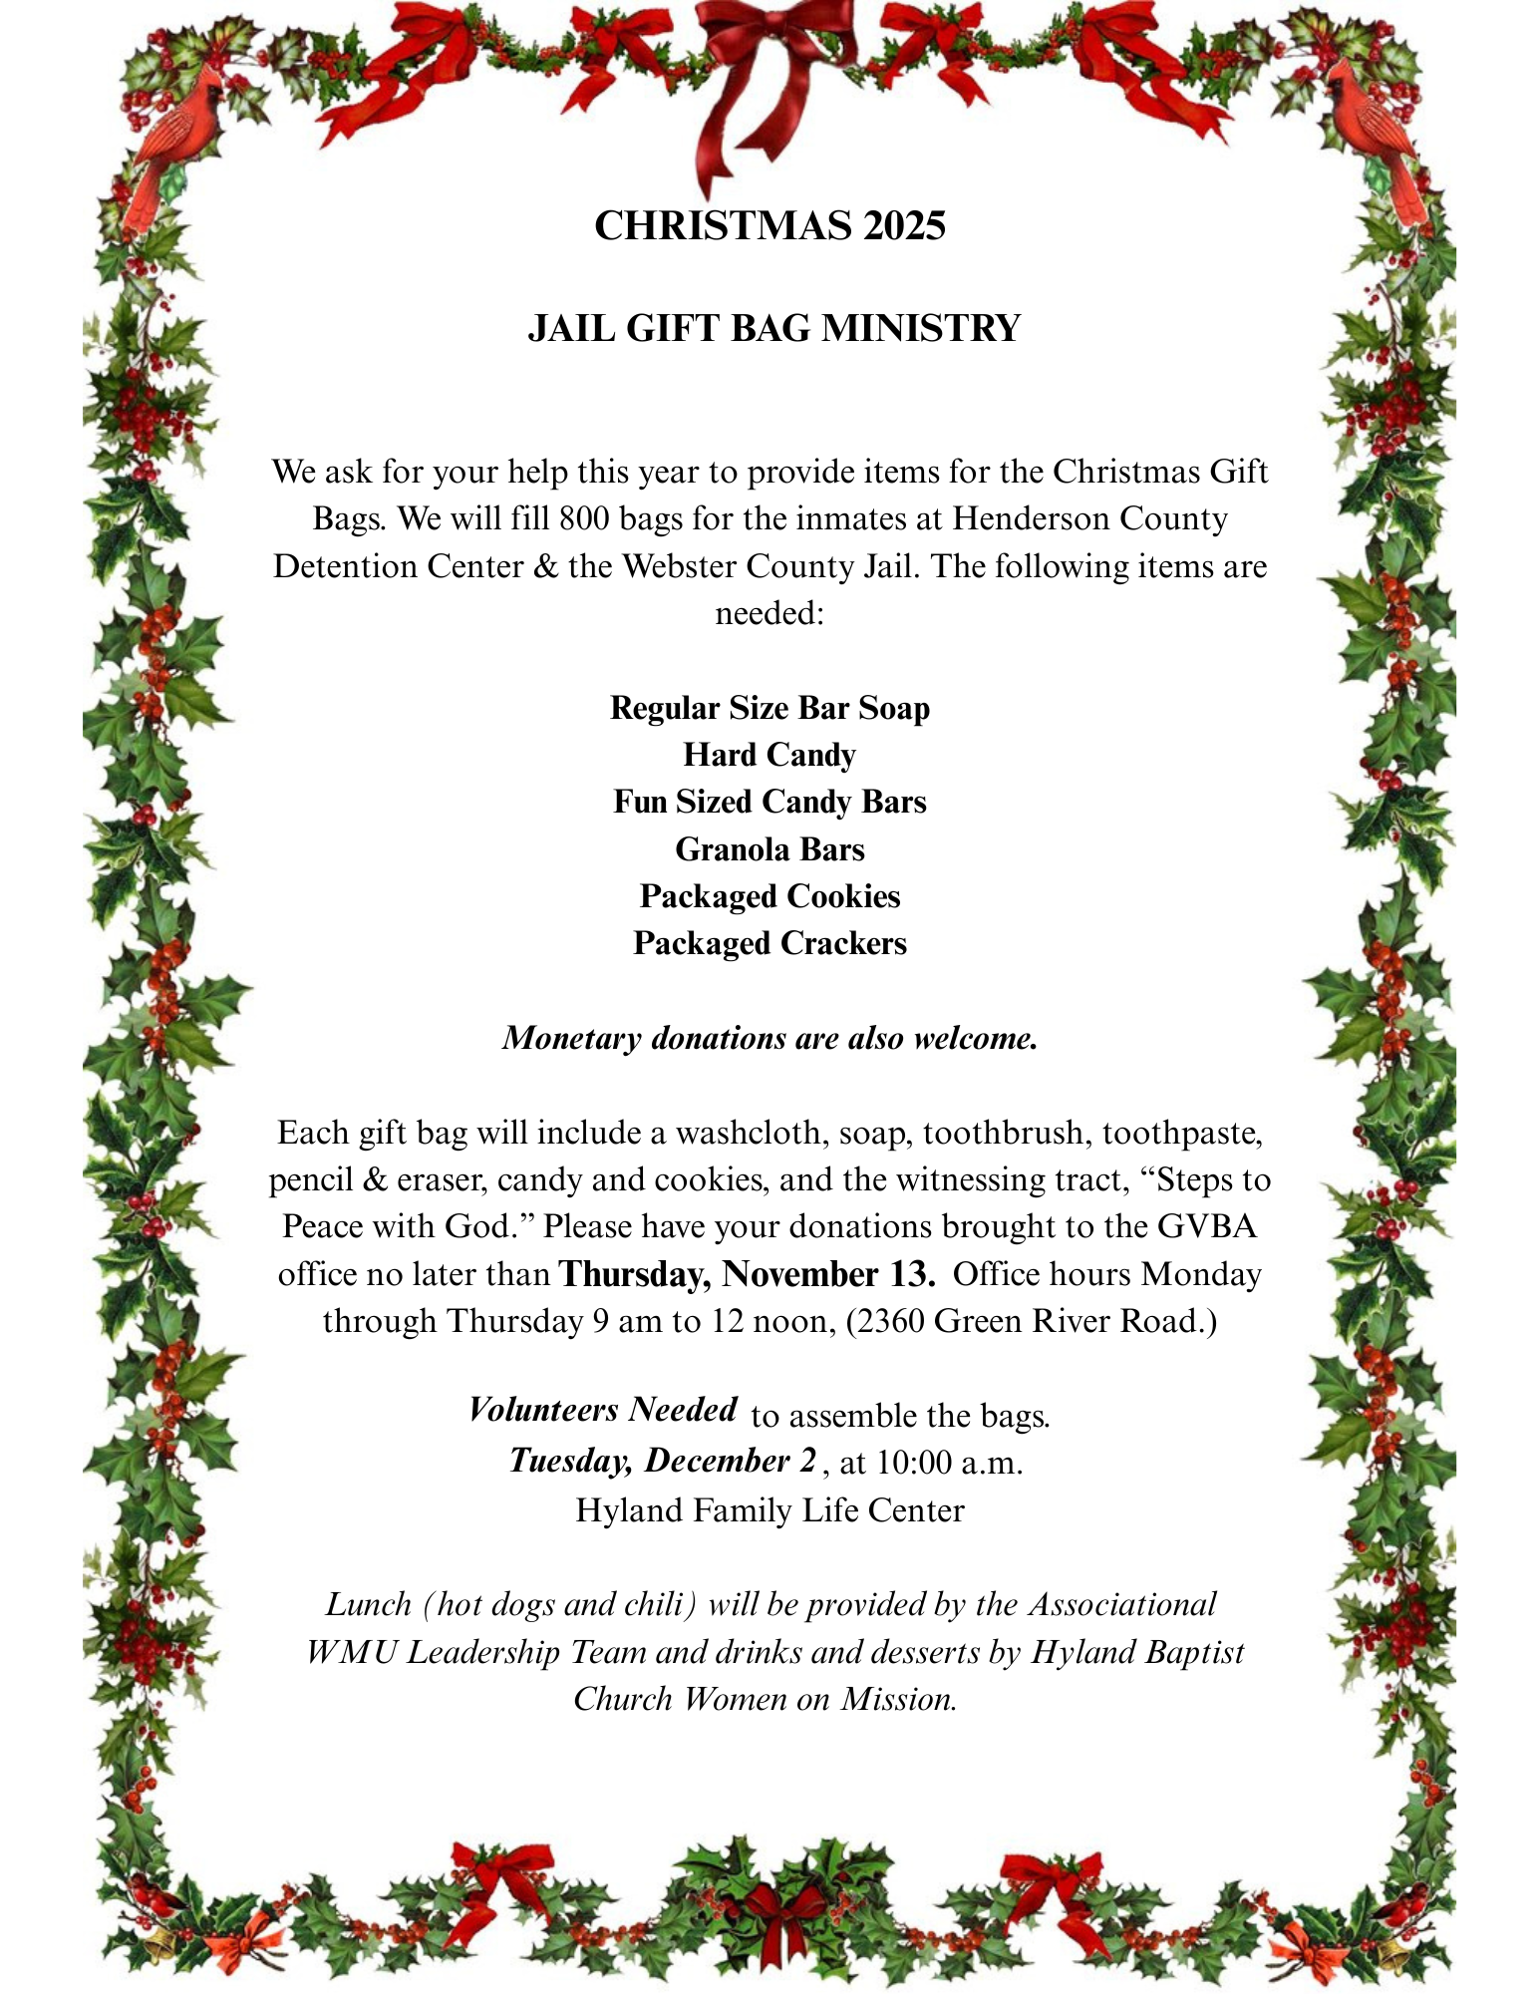

Discover healthy ways to handle stress in ministry.



Every pastor—regardless of church size—faces the heavy weight of daily challenges. How you manage stress directly impacts not only your health but also your effectiveness in leading God’s people.

Pastor/Leader Stress Management Workshop
October 27 and 30
West Kentucky Only!

Register Here.

  Dan Summerlin, speaker
  In this workshop, Dr. Dan Summerlin shares valuable lessons from over 40 years in pastoral ministry, equipping you with tools that will strengthen your resilience and sustain your calling.
  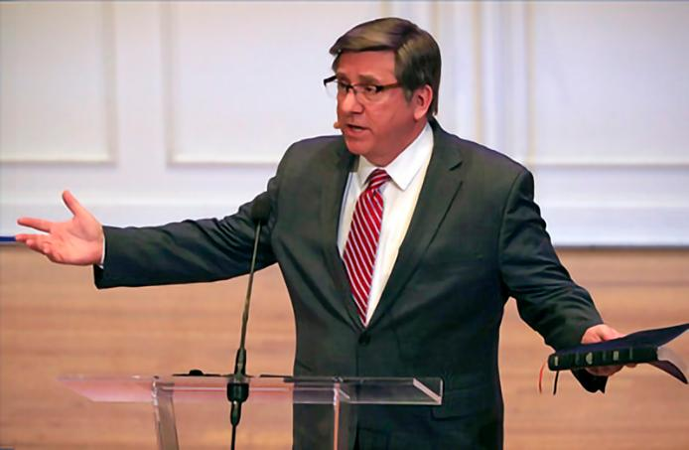

You’ll learn:
- Proven strategies for navigating ministry stress in healthy ways
- Practical secrets for maintaining spiritual, physical and emotional well-being
- Real-life lessons that apply to pastors and leaders in churches of every size

Instead of focusing on avoiding stress, this session will teach you how to face it with wisdom, ensuring your ministry and family thrive for the long haul.

More about this event.

Our mission: Helping churches reach their mission for Christ.
Thank you for giving to the Cooperative Program through the Kentucky Baptist Convention.

Kentucky Baptist Convention | 13420 Eastpoint Centre Drive info@kybaptist.org | Louisville, KY 40223-4160 US

.



Annual meeting registration has begun!

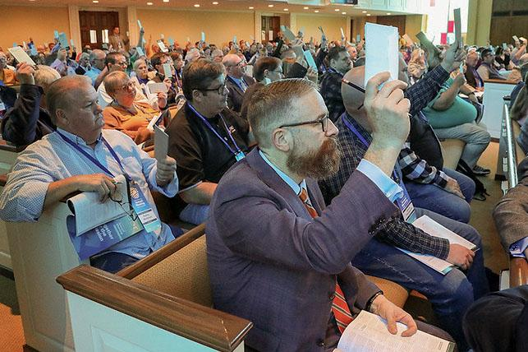

Churches are now registering their messengers for the KBC Annual Meeting, and yours can too when you log into SBC Workspace. Don't know how to access your church account? Eligible churches will receive credential information by mail with a username and password for online registration. See you in Cold Spring, Kentucky!

Download the KBC Annual Meeting app

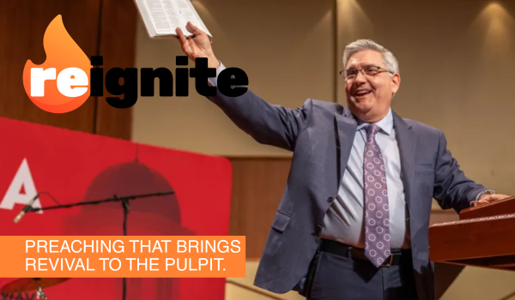

Kentucky Baptist Pastors Conference

Experience renewal in your preaching and refreshment in your spirit at the 2025 Kentucky Baptist Pastors’ Conference on Monday, Nov. 10 at First Baptist Church of Cold Spring. Gifted pastors and speakers bringing inspiration include David Allen, Rick Coram, Charles Goodman, Robert Smith, Jr., and Mike Stone.

Read more



Hope for Northern KY

Hope for West KY is a series of cooperative evangelical events aimed at impacting northern Kentucky with the gospel. The culminating event on Sunday, Nov. 9, will feature Daniel Ritchie, a Christian speaker and author who shares his story of living with no arms and trusting God.

Read more

See you at the KBC Annual Meeting on Nov. 11!

Our mission: Helping churches reach their mission for Christ.
Thank you for giving to the Cooperative Program through the Kentucky Baptist Convention.

Kentucky Baptist Convention | 13420 Eastpoint Centre Drive info@kybaptist.org | Louisville, KY 40223-4160 US

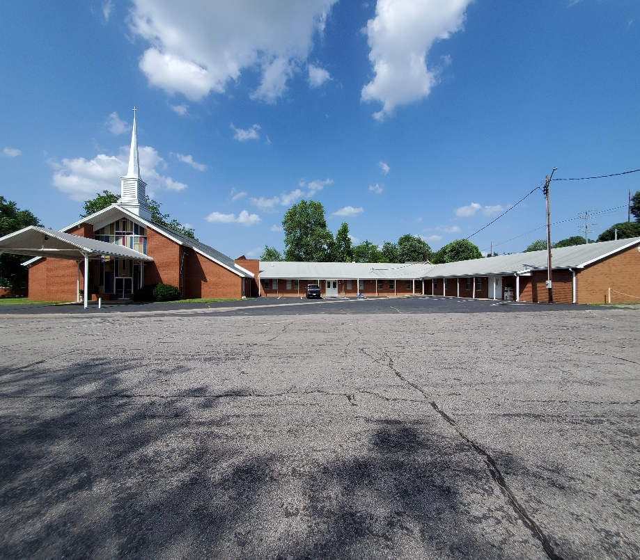

Green Valley Baptist Association
2360 Green River Road
Henderson, KY 42420
(270)827-9867

Rev. Jeff Burke Ms. Alice Robinson
Director of Community Ministries/Interim AMS Ministry Assistant
jeff.burke1955@gmail.com ministryassistant@greenvalleybaptist.org

