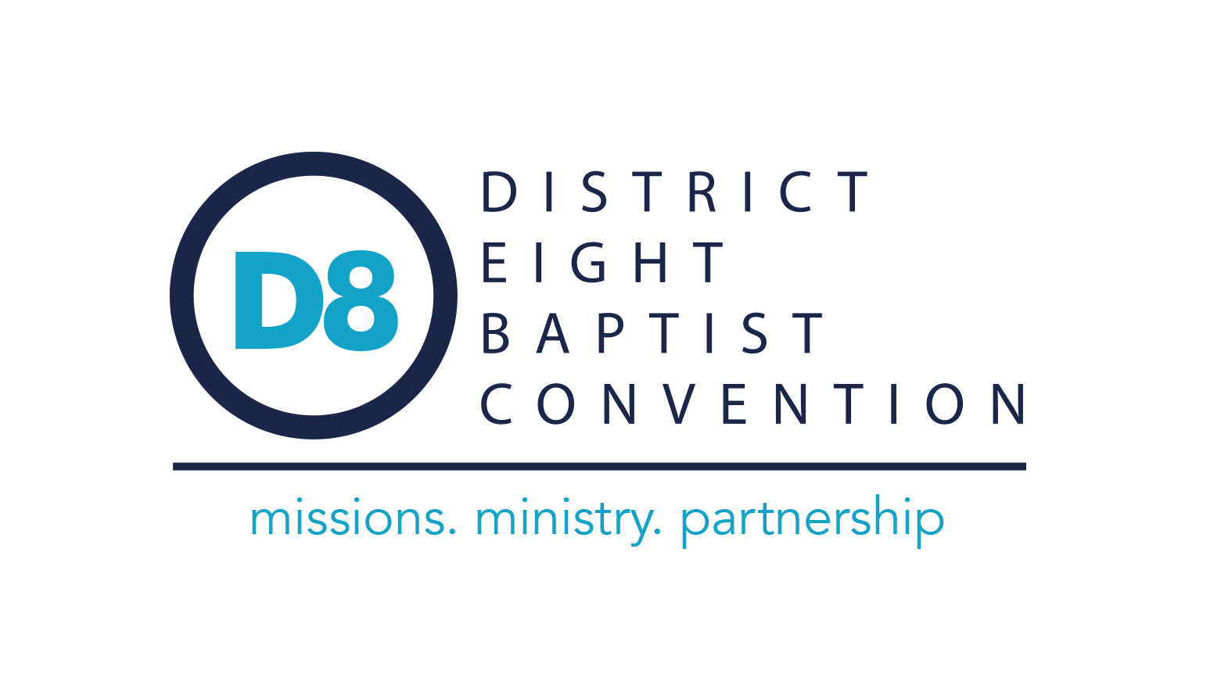

73rd Annual Meeting
February 12, 2026
(Previously scheduled for January 25, 2026, but rescheduled due to weather)

Book of Reports

DISTRICT EIGHT BAPTIST CONVENTION
73rd Annual Session

Meeting at

Clara Springs Baptist Camp
February 12, 2026

Welcome, Introductions, and Invocation Rev. Shawn Thrapp, President
Worship Miguel Bustillo & Praise Team
Message Rev. Shawn Thrapp, President

Call to Order and Organization of the Convention Rev. Shawn Thrapp, President
Organization of Convention:
Adoption of Program
Registration of Messengers
Recognition of New Pastors and Staff Dr. Jack Bell
Recommendation from Coordinator Search Committee……………………………………………Rev. Shawn Thrapp
Summary of 2025 Executive Board Actions Rev. Shawn Thrapp, President
District Eight Financial Report Rev. Richard Tull
Recommendations from Budget, Finance, & Personnel Committee Rev. Matthew Warren
2026 Budget
Nominating Committee Report
Toledo Bend Baptist Resort Ministry Report Ms. Mary Gore
Baptist Collegiate Ministry Report Rev. Bill Collins
Clara Springs Camp Ministry Report Rev. Jack Mills, III
District Coordinating Office Report Dr. Jack Bell

Election of Officers Rev. Shawn Thrapp, President

President ____________________________
First Vice-President ____________________________
Second Vice-President ____________________________
Recording Secretary ____________________________
Treasurer ____________________________

Miscellaneous Business

Motion to Adjourn

Closing Remarks

Closing Prayer

District Eight Baptist Convention

Mission Statement
The mission of the District Eight Baptist Convention is to serve cooperating churches by assisting, encouraging, and partnering with them to fulfil the Great Commission.
Core Values
The District Eight Baptist Convention values:
Prayer – We rely on private and corporate prayer in the formation, design, and implementation of all ministries and activities of the district and the associations.
Church Health – We encourage local congregations to advance the kingdom, make disciples, and lead believers toward spiritual maturity.
Missions and Evangelism – We encourage the local church to be active in evangelism and to participate in every aspect of the Acts 1:8 model of missions.
Partnership – We partner together to provide collective resources so that each church can have access to the ministry tools needed to fulfil God’s call for them.
Leadership Development – We equip leaders to grow in Christian maturity by providing opportunities for leadership training and Christian education to laity and ministry staff.
Minister Encouragement – We support those serving in ministry roles through fellowship, friendship, and emotional support.
Vision Statement
The District Eight Baptist Convention envisions healthy churches which are driven by missions involvement, active in personal and corporate evangelistic outreach, and developing maturing disciples. We envision this being accomplished through ongoing leadership development and discipleship training while embracing prayer as a means of seeking God’s power and wisdom in all endeavors.

AREA MISSIONS TEAM

ACTING COORDINATOR OF MISSIONS AND MINISTRIES ………Jack Bell
143 Taylor Road
P. O. Box 2880, Natchitoches, LA 71457-0880
Ph. (O) 318-352-4090 (C) 318-718-6393
E-mail – Jack@DistrictEightMissions.com
Web Site – www.DistrictEightMissions.com

Assistant to the Coordinator of Missions and Ministries ………Vacant

Ministry Assistant Mrs. Peggy Price
Ph. (O) 318-352-4090
E-mail – Office@DistrictEightMissions.com

Financial Secretary Mrs. Shea Boyt
Ph. (O) 318-352-4090
E-mail – Office@DistrictEightMissions.com

BAPTIST COLLEGIATE MINISTRY DIRECTOR Rev. Bill Collins
500 Caspari Street
NSU Box 3384, Natchitoches, LA 71497
Ph. (O) 318-357-6464 (H) 318-352-9168
E-mail – nsubcm@suddenlink.net

CLARA SPRINGS CAMP MANAGER Rev. Jack “Bubba” Mills III
4421 Hwy 177, Pelican, LA 71063-3221
Ph. (O)318-796-3875
E-mail – brobubba@clarasprings.com
Web Site – www.clarasprings.com

TOLEDO BEND RESORT MISSIONARY Ms. Mary Gore
3840 Carters Ferry Road, Zwolle, LA 71486-3715
Ph. (C) 318-452-9731
E-mail – tbbaptist@gmail.com
Web Site – www.tbbaptist.com

Assistant to the Missionary Mr. Danny Warmack
Ph. (C) 318-315-0173
E-mail – tbca_toledobend@outlook.com

2026 CALENDAR OF ACTIVITIES

Prayer Breakfast for each Association:
Sabine/North Sabine – 1st Monday of the month at Hope Chapel, 8:00 AM
Red River – 1st Tuesday of the month hosted by Open Door Fellowship, 8:00 AM
DeSoto – 1st Wednesday of the month hosted by Grand Cane Baptist Church, 8:00 AM
Natchitoches – 1st Thursday of the month hosted by Trinity Baptist Church, 8:00 AM

JANUARY 2026
23 4th Friday Fish Fry, Clara Springs Camp, 5:00 PM
26-27 Evangelism Conference, FBC Lafayette

FEBRUARY 2026
10 “Psychological Body Armor Chaplain Training-District Eight Office, Time 8:30-4PM
12 District Eight Baptist Convention, Clara Springs Camp, 5:30 PM
27 4th Friday Fish Fry, Clara Springs Camp, 5:00 PM

MARCH 2026
1-8 Week of Prayer for North American Missions
13-14 Clara Springs Kids Spring (Winter) Retreat
21 TBBRM Work Day
27 4th Friday Fish Fry, Clara Springs Camp, 5:00 PM
3/29-4/3 Campers on Mission @ Clara Springs

APRIL 2026
10-11 Disaster Relief Training, Ruston, 8:00 AM
17-18 “Embrace” statewide women’s conference, FBC Zachary
21 District 8 Executive Board Meeting, 6:00 PM
24 4th Friday Fish Fry, Clara Springs Camp, 5:00 PM

MAY 2026
2 TBBRM Children’s Fishing Derby and Youth Tournament, San Miguel Park
14 Adult Day, Clara Springs Camp, 10:00 AM through lunch
22 4th Friday Fish Fry, Clara Springs Camp, 5:00 PM

JUNE 2026
9-10 Southern Baptist Convention, Orlando, FL
26 4th Friday Fish Fry, Clara Springs Camp, 5:00 PM
6/29-7/2 Bloom Camp, Clara Springs

JULY 2026
3-4 Pre-Camp, Clara Springs
6-9 Kids Camp, Clara Springs
10-12 Young Adult Camp (18+) Clara Springs
13-16 Kids on Mission, Clara Springs
19-22 Journey (Youth) Camp, Clara Springs
23-25 Impact (Youth) Camp, Clara Springs

AUGUST 2026
20 District 8 Executive Board Meeting, 6:00 PM
28 4th Friday Fish Fry, Clara Springs Camp, 5:00 PM

SEPTEMBER 2026
6-13 Week of Prayer for State Missions
8 Natchitoches Association Annual Meeting, Calvary Baptist Church, 6:00 PM
10 North Sabine Association Annual Meeting, Calvary Baptist Church, Many, 6:00 PM
15 DeSoto Association Annual Meeting, FBC Frierson, 6:00 PM
21 Red River Annual Meeting, FBC Coushatta, 6:00 PM
25 4th Friday Fish Fry, Clara Springs Camp, 5:00 PM
28 Sabine Association Annual Meeting, FBC Many, 6:00 PM

OCTOBER 2026
9-10 LBC Ministry Wives’ Retreat, Tall Timbers
23 4th Friday Fish Fry, Clara Springs Camp, 5:00 PM

NOVEMBER 2026
10 LBC Annual Meeting Trinity Baptist Church, Lake Charles
16-19 Mexico Missions Collection Week
16-23 OCC Shoebox Collection Week
22-23 Youth Evangelism Celebration (YEC), Alexandria
29-30 Week of Prayer for International Missions and Lottie Moon Christmas Offering begins

DECEMBER 2026
1-6 Week of Prayer for International Missions and Lottie Moon Christmas Offering continues

Minutes
DISTRICT EIGHT BAPTIST CONVENTION
Executive Board Meeting
Held at the District Eight Missions Office - 143 Taylor Road – Natchitoches, LA
August 21, 2025

- CALL TO ORDER – Rev. Shawn Thrapp, President
He gave a devotion with scripture taken from Nehemiah 4:14, and then he called the meeting to order at 7:30 p.m. with an opening prayer.

- APPROVAL OF MINUTES – Rev. Shawn Thrapp
He asked the members to review the reports/recommendations from the April 22, 2025, Executive Board Meeting. There were no corrections to the minutes. Dr. Matt Endris moved that the minutes be approved; 2nd by Rev. Marty Williams; CARRIED.

- FINANCIAL REPORT – Rev. Richard Tull
Total Receipts (January 1 – July 31, 2025) $ 760,388.61
Total Expenditures (January 1 – July 31, 2025) $ 830,531.89
General Fund Balance – July 31, 2025 $ 2,091.28
Designated Accounts Balance - July 31, 2025 $ 43,546.67

Rev. Brian Rankin moved that the report be accepted; 2nd by Rev. Marty Williams; CARRIED.

- BAPTIST COLLEGIATE MINISTRY REPORT – Rev. Bill Collins
He said that students were back on the campus for the Fall 2026 Semester. Initially, 102 students have signed up for the small groups, and he anticipates the number will grow to 180+ as students learn about it. Although the BCM is closed on Sundays and attendance at a local church is emphasized, many students find the mid-week worship (8:30 pm) very convenient. Following the midweek worship services, the BCM provides an opportunity for some Biblical teaching.

He said he is still the Chaplain for the football team and noted that the Fellowship of Christian Athletes had placed a Bible in every athlete’s locker. The Bible provides him with an opportunity to interact with the athletes and answer any questions they may have as they read Scripture. He closed by saying he was looking forward to seeing what God would do this year and thanked the churches for their continued support.

- CLARA SPRINGS REPORT – Rev. Jack Mills, III
He said that Summer 2025 was very busy with 18 camps. There were 150+ decisions. He specifically relayed the special stories of 4 individuals: the Grumpy Camper, the Reader, the Screamer, and the Marine. Through the camps, God used workers, counselors, youth pastors, and others to minister to the campers.

He highlighted the following activities and needs:
- Fourth Friday Fish Fry – 8/22; 9/26; on 10/24 - Pastor Appreciation
- Two open positions – Maintenance and Housekeeping

He closed by thanking the churches for their faithful support so that the campers may come to the point where they hear Jesus calling and accept His invitation.

- TOLEDO BEND MINISTRY REPORT – Mary Gore
She gave her Summer Report. She said that the Children’s Fishing Derby held in May yielded 8 Professions of Faith. It was a busy summer with the VBS ministry (13) at the apartment complexes, Council on Aging, and smaller membership churches. She pointed out that teams from GOLA had spent 2 weeks helping with VBS. Also, Go Now Missions teams from Texas helped out. Additionally, she said that Chloe McGilvary spent 6 weeks with the ministry and, during that time, designed some promotional banners. The Back-to-School Rally was held at Many Elementary, where 175 students received supplies.

Mary updated the committee on Fall 2025 plans, including ministry at fairs and festivals, a Fall Carnival for SARC clients, and a Community Program Day on November 13, 2025. Plans for 2026 include the Easter outreach event at Wildwood Resort. She thanked the churches for their continued support of the ministry.

- ACTING COORDINATOR OF DISTRICT EIGHT MISSIONS AND MINISTRIES OFFICE – Dr. Jack Bell
He encouraged the churches to live out the District Eight Mission Statement:

District Eight Baptist Convention envisions healthy churches which are driven by missions involvement, active in personal and corporate evangelistic outreach, and developing maturing disciples. We envision this being accomplished through ongoing leadership development and discipleship training while embracing prayer as a means of seeking God’s power and wisdom in all endeavors.

Also, he said that although there have been significant changes in District Eight, God has been faithful to provide what is needed, e.g., Peggy Price as the ministry assistant for the office, and Shea Boyt as the Financial Secretary.

He stressed that the purpose of the District Eight teams, i.e., the Baptist Collegiate Ministry, the Clara Springs Baptist Camp, the Toledo Bend Baptist Resort Ministry, and the Missions and Ministries Office, is to help churches thrive in the mission of Jesus. He closed by thanking the churches for their involvement and support as District Eight works to take the gospel everywhere.

8. COMMITTEE RECOMMENDATIONS – BUDGET, FINANCE, AND PERSONNEL - Rev. Matt Warren
He presented the following recommendation:
…that Rev. Brent Shoalmire and Shea Boyt be added as additional check signers on all bank accounts for District Eight. CARRIED

Also, he reported that the committee had approved the hiring of the following individuals:
- Shea Boyt - hired as the Financial Secretary for the District Eight Office. She will work on Fridays.
- Peggy Price - hired as the Ministry Assistant for the District Eight Office. She will work Monday – Thursday. Note: These two individuals are replacing Lori Thompson.

Finally, he reported that the committee had approved two amendments to the District Eight Policy and Procedures Manual. Changes are indicated as follows: additions are underlined, and deletions are indicated by a strikethrough. See Attachment #1.

- Amendment #1 – Office Hours and Holidays (pgs. 3-4)
- Amendment #2 – Termination of Employees (p. 3)

9. MISCELLANEOUS BUSINESS

- SPECIAL COMMITTEE - DISTRICT EIGHT CONSTITUTION & BYLAWS REPORT – Dr. J. Cardinell
He referenced pgs. 20 - 24 in the Executive Board Meeting Book of Reports – 8/21/25.
He explained the process for approving changes to the governing documents. i.e., an initial approval from the Executive Board, followed by the final approval of the documents by the churches attending the 73rd Annual Meeting – January 25, 2026.

He made the following recommendation:
…that the Executive Board approve the changes to the Constitution of the District Eight Baptist Convention and the changes to the Bylaws of the District Eight Baptist Convention.

CARRIED (show of hands vote)

Note: A two-thirds majority will be needed at the Annual Meeting for final approval of the changes.

- SEARCH COMMITTEE - DISTRICT EIGHT COORDINATOR OF MISSIONS & MINISTRIES REPORT
The chairman of the committee, Rev. Shawn Thrapp, said the committee had received six resumes through 7/31/25. In early August, the committee members met and were asked to pray, read, and then narrow down the resumes to a group of three. From those steps, additional meetings will be held to further narrow the process.

10. ANNOUNCEMENTS AND PROMOTIONS
- Annual Church Profiles – due by September 5.
- Four of the Associations need to select new Clerks for the 2025-2026 Church Year
- 73rd Annual Meeting – January 25, 2026, at Clara Springs Camp – 4 PM

11. ADJOURNMENT
Rev. Richard Tull moved that the meeting adjourn; 2nd by Rev. Marty Williams; CARRIED. (8:40 p.m.)
Rev. Gaby Ruiz led the closing prayer.

Charles Verret, Recording Secretary

Attachment #1

Note: Changes are indicated in the following ways:
- additions use underlining;
- deletions are indicated by a strikethrough.

Amendments to the Policy and Procedures Manual

of the District Eight Baptist Convention
Reported by Rev. Matt Warren to the Executive Board on August 21, 2025

Amendment #1 - Office Hours and Holidays (p. 3-4)
Approved by the Budget, Finance, and Personnel Committee on January 15, 2025 and July 7, 2025

Generally, the Missions and Ministries Office is open from 9:00 a.m. to 5:00 p.m. Monday through Friday 9 a.m. to 12 p.m. and 1 p.m. to 4 p.m. Monday through Thursday and 9 a.m. to 12 p.m. Friday. However, while the desire is to maintain an office presence during these times, ministry may require the staff to deviate from these hours.

The missions office will close in observance of the following holidays:
New Year's Day (1 day)
President's Day (1 day)
Good Friday (1 day)
Memorial Day (1 day) Independence Day (1 day) Labor Day (1 day) Thanksgiving (2 days)
Christmas (Christmas Day Eve through the end of the year, 5 6 days).

If the holiday falls on a Saturday, the holiday may be observed on the Friday before.
If it falls on a Sunday, it may be observed on the Monday after. If a holiday falls on an employee's scheduled vacation, the holiday will not count as a vacation day.

Amendment #2 - Termination of Employees (p. 3)
Approved by the Budget, Finance, and Personnel Committee on July 7, 2025

4. Termination- Employees may be disciplined, up to and including termination, for inadequate job performance, misconduct, and/or unacceptable behavior. Employment of all employees other than the Coordinator of Missions and Ministries, Clara Springs Baptist Camp Manager, and Toledo Bend Baptist Ministries Director can be terminated by the Budget, Finance, and Personnel Committee at the recommendation of upon consultation with the supervisor. Employment of the Coordinator of Missions and Ministries, Clara
Springs Baptist Camp Manager, and Toledo Bend Baptist Ministries Director can be terminated by the Executive Board at a special meeting called for that purpose upon the
recommendation of the Budget, Finance, and Personnel Committee.

2026 District Eight Executive Board PROPOSED
Underlined names are being nominated for the first time to that committee, italicized names are being renominated to continue in their place of service. Members may be nominated up to 3 consecutive times for the same committee (up to 6 years)

Baptist Collegiate Ministries Advisory Committee

Association
DeSoto
Natchitoches
North Sabine
Red River
Sabine
Term Expiring 2027
Dr. Mike Hawkins
Mr. Robin Scarborough
___________________
Dr. Matthew Endris
Rev. Jimmie Glover
Term Expiring 2028
___________________
Rev. Gabriel Ruiz
Rev. G. Dwain Spillman
Mr. Josh Terry
Rev. Chuck Lusk

Clara Springs Baptist Camp Advisory Committee

Association
DeSoto
Natchitoches
North Sabine
Red River
Sabine
Term Expiring 2027
Mrs. Marsha Adkinson
Mr. David Cheatwood
Rev. Brian Rankin
Rev. Caleb Willis
Mrs. Jessica Gatti
Term Expiring 2028
Ashley Prudhomme
Mrs. Liz Durr
Rev. Dean Johnson
Mr. Paul Messenger
Mrs. Lisa Smith

Toledo Bend Baptist Resort Ministry Advisory Committee

Association
DeSoto
Natchitoches
North Sabine
Red River
Sabine
Term Expiring 2027
Rev. Amador Santos
Rev. Logan Brock
Rev. Phillip Collier
Mr. Chris Webb
Mrs. Kate Jackson
Term Expiring 2028
Rev. Mike Scott
Mr. Charles Verrett
Mrs. Pat Brumley
Rev. Marvin LeLeux
Dr. Virginia Burkett

Budget, Finance, & Personnel Committee

Association
DeSoto
Natchitoches
North Sabine
Red River
Sabine
Term Expiring 2027
Dr. Jeff Jinks
Rev. Brent Shoalmire
Mr. Tony Settle
Dr. J Cardinell
Rev. Joey Williams
Term Expiring 2028
Rev. Shawn Thrapp
Rev. Chase Burns
Rev. Marty Williams
Dr. Thumper Miller
Rev. Wade Penfield
2026 Nominating Committee:
Rev. Mel Campbell, DeSoto Association
Rev. Logan Brock, Natchitoches Association
Rev. Matthew Walker North Sabine Association
Dr. J Cardinell, Red River Association
Rev. Jason Lupo, Sabine Association
Rev. Shawn Thrapp, Ex Officio, District Eight Presiden
DISTRICT EIGHT FINANCIAL SUMMARY
January 1, 2025 through December 31, 2025

General Fund Balance – January 1, 2025 $ 68,519.27*

Designated Accounts Balance – January 1, 2025 $ 47,967.78*

Receipts:
District Budget Gifts to the General Fund $ 607,978.58
Designated Gifts $ 294,602.62
Clara Springs Baptist Camp $ 177,838.34
Northwestern BCM $ 21,634.48
Toledo Bend Resort Ministry $ 94,509.80
Other Designated Gifts $ 620.00

TOTAL RECEIPTS (January 1 –December 31) $ 902,581.20

Expenditures:
District Budget Expenses (see summary on next page) $ 641,086.40
Non-Budgeted Expenses………………………………………………………………………………………………$ 4,802.09
Designated Expenses $ 294,602.62

TOTAL EXPENDITURES (January 1 – December 31) ……………………………….$ 940,491.11

General Fund Balance – December 31, 2025 $ 30,609.36

Designated Accounts Balance- December 31, 2025 (see summary below) $ 45,286.67

Designated Accounts

Balance-December 31, 2025
Disaster Relief 40,310.73
Mission Trips 451.43
Capital Needs 1,500.00
Designated Programming 3,024.51

Total: $45,286.67
DISTRICT EIGHT BUDGET & BUDGET EXPENDITURES
January 1- December 31, 2025

Budget Expended
1. Acts 1:8 Missions $ 10,000.00 2,600.00
2. Baptist Collegiate Ministry at Northwestern State University 73,500.00 73,500.00
3. Clara Springs Baptist Camp 141,750.00 141,750.00
4. Toledo Bend Baptist Ministry 44,100.00 44,100.00
5. Ministries Coordinator Salary 60,858.00 40,704.15
6. Assistant to the Coordinator Salary 59,986.00 61,910.96
7. Ministries Coordinator Housing & Expenses 32,800.00 13,727.82
8. Assistant to the Coordinator Housing & Expenses 24,000.00 25,942.70
9. Retirement and Area Missions Team Insurance 150,292.00 124,212.41
10. District Office Expenses 50,000.00 46,764.34 11. District Eight Programming 25,000.00 19,810.58
12. Ministry Assistant and Financial Secretary 35,486.00 36,682.18
13. FICA Taxes 12,000.00 9,381.26
14. Contingency & Miscellaneous 500.00 0.00

Totals: $720,272.00 $641,086.40

Louisiana Baptist Foundation Accounts

District Eight Emergency Reserve
Beginning Balance- January 1, 2025 $185,526.74
Interest Earned $ 8,493.41
Ending Balance- December 31, 2025 $194,020.15

District Eight Building Fund
Beginning Balance- January 1, 2025 $ 38,720.92
Transferred from Foundation for A/C replacement……………………………… ($ 3,000.00)
Interest Earned $ 1,701.28
Ending Balance-December 31, 2025 $ 37,422.20

District Eight Church Revitalization Fund
Beginning Balance- January 1, 2025 $ 107,558.08
Interest Earned $ 4,924.03
Ending Balance- December 31, 2025 $ 112,482.11

Camp Manager Children’s Scholarship Fund
Beginning Balance- January 1, 2025 $ 1,798.19
Interest Earned $ 82.33
Ending Balance- December 31, 2025 $ 1,880.52
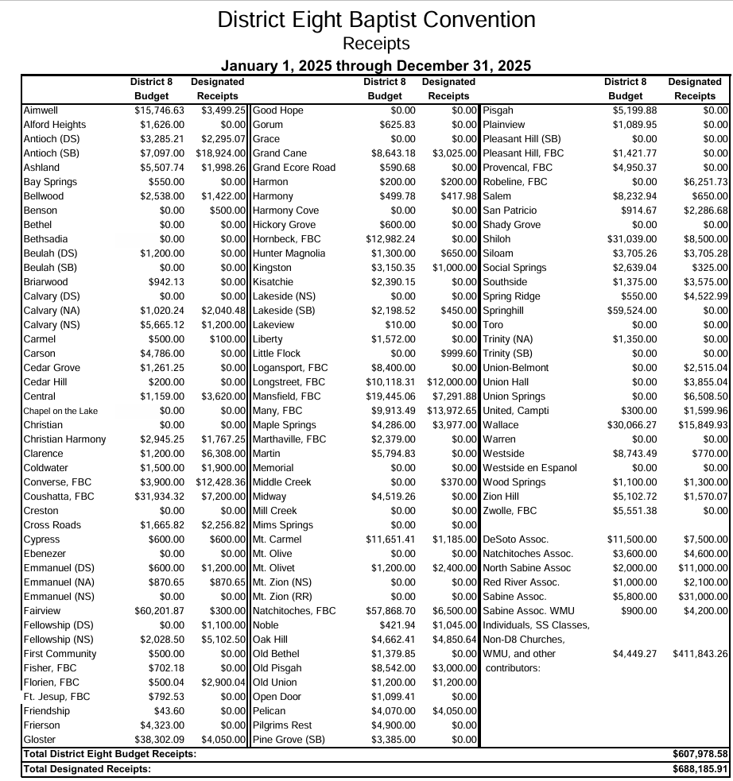


Memorial Gifts
Mr. Charles Richard Loenig
Mr. and Mrs. Randy Greer
Mr.s. Willa Dean Caldwell Randolph
Mr. and Mrs. Randy Greer
Mr. Hollis Jones
Mr. and Mrs. Randy Greer
Mr. Marion Snapp
Mr. and Mrs. Paul Craig
Mr. Jimmy Durasco
Ms. Melva Howard and Family
Mr. Benoyd Temple
Mr. and Mrs. Randy Greer
Mr. Michael Burch
Mr. and Mrs. Randy Greer
Mr. Howard Emery Baldwin
Mr. and Mrs. Randy Greer
Mrs. Barbars Merline Ross
Mr. and Mrs. Randy Greer
Mrs. Pat Berel
Ms. Hazel McComic
Mr. & Mrs. Dale Burr
Toby Shaw
Mr. and Mrs. Randy & Jan Greer
Nelda Renolds
Mr. & Mrs. Denver Pochodzay
Rev. Billy Davis


Love Gifts

Honor Gifts
Mrs. Sally Alford
Mr. and Mrs. Bill Jones
Mrs. Bobbie Haire
Bubba and Mandi Mills
Mrs. Bobbie Haire

Miss Mary Gore
Mrs. Beverly Smothers
Mrs. Carolyn Waggener

Mr. and Mrs. John Millar
Ms. Mary Almond
Mr. Preston Durr
The Durwood Thomas SS Class, Westside
Mr. and Mrs. Jerry Salley
Mr. and Mrs. Kenneth Gardner
Knights of Columbus
Mrs. Billie Jean Evans
Mr. and Mrs. JR Troha
Mr. and Mrs. George Strickland
Mr. and Mrs. Ernie Maynard
Mr. and Mrs. James Latham
Ms. Charla Streetman
Rev. and Mrs. Lee Rodgers
Ms. Joan Pickett
Ms. Delores Geoghagan
Mr. and Mrs. Terry Strout
Mr. and Mrs. Rickey Robertson
Mr. and Mrs. Merwyn Watkins
Ms. Beverly Smothers
Mrs. Gamble
Mr. and Mrs. Danny Warmack
Merwyn Watkins
Rev. Joe Waggener

Mr. and Mrs. Jeff Jagneaux
Mr. and Mrs. Judson Rives
Rev. and Mrs. Alton Middleton
Mr. and Mrs. Ted Hayes
Mr. Donnie Johnston
Mr. and Mrs. Daniel Gaske
Mr. and Mrs. Charles Mains
Mr. and Mrs. Daniel Sistrunk
Mr. William Menasco
Larry Bagley Campaign
Mr. and Mrs. Roger Dale Pope
Mr. Andy Cosanza
Mr. and Mrs. David Calhoun
Ms. Zelda Loftus
Mr. and Mrs. Milton Miley
Mr. Donald Winn
Duce Holdings
Mr. and Mrs. John Neal
Mr. and Mrs. Cobb
Mr. and Mrs. Donald Scaife
Mr. and Mrs. Gary Moore
Mr. and Mrs. Daniel Gaske
Mr. Rex Young
Mr. Donald Winn
Mr. Buddy Wood

DISTRICT EIGHT BAPTIST CONVENTION
2026 Proposed Budget

2025 2026

1. ACTS 1:8 MISSIONS (District, State, Nation, World) $ 10,000 10,000
To provide partial and supplemental funding for various
SBC Mission Projects, both locally and around the world.

2. BAPTIST COLLEGIATE MINISTRY at NSU $ 73,500 70,000

3. CLARA SPRINGS BAPTIST CAMP $ 141,750 114,800

4. TOLEDO BAPTIST RESORT MINISTRY $ 44,100 42,000

5. MINISTRIES COORD. SALARY AND HOUSING ALLOWANCE $ 80,658 89,500

6. MINISTRIES COORDINATOR EXPENSES $ 13,000 13,000
Books, Hospitality, and Travel Reimbursements

7. ASST. TO THE MINISTRIES COORD. SALARY & HOUSING $ 73,986 0
8. ASSISTANT TO THE MINISTRIES COORDINATOR EXPENSES $ 10,000 0
Books, Hospitality, and Travel Reimbursements

9. AREA MISSIONS TEAM INSURANCE & RETIREMENT $ 150,292 132,180
Group Medical Insurance for District Eight office staff, Clara Springs full-time
staff, and Toledo Bend full-time staff; District 8 Life Insurance and Retirement

10. DISTRICT MISSIONS & MINISTRIES OFFICE EXPENSES $ 50,000 50,000
Buildings Insurance, Workman’s Comp, Telephone, Postage,
ACS Maintenance Contract, Cable, Internet Service, Office Equipment,
Paper, Ink, Toners, Electricity, Kitchen Supplies, Etc.

11. DISTRICT PROGRAMMING $ 25,000 30,500
Training Events, Conventions, Conferences and other Meetings,
Food for various events and meetings

12. MINISTRY ASSISTANT AND FINANCIAL SECRETARY $ 35,486 38,808

13. FICA TAXES $ 12,000 8,745

14. CONTINGENCY & MISCELLANEOUS $ 500 500

TOTAL $ 720,272 600,033

Proposed Amendment to the District Eight Constitution
Article IX – Executive Board

The Executive Board of this convention shall be elected at the Annual Meeting of the
Convention and shall be composed of the Officers of the Convention, the Coordinator, a legal counselor, and up to eight members from the territory of each association composing District Eight. Each Member shall be elected to a two year term on the Executive Board and is eligible for renomination, but may not serve more than six consecutive years on any one committee of the Executive Board. The Executive Board shall be the Convention ad-interim. The Executive Board is to meet at least bi-annually to consider all items of interest to the Convention.

The Standing Committees of the Executive Board shall be: Executive Committee; Budget,
Finance and Personnel Committee; Baptist Collegiate Ministry Advisory Committee; Clara
Springs Camp Advisory Committee; and the Toledo Bend Baptist Center Advisory Committee. Each of these committees will have shall elect a chairman, vice chairman, and a recording secretary in conjunction with the District Eight Baptist Convention annual meeting and reported to the President in a timely manner. No member may serve on more than two standing committees simultaneously. The President and Coordinator shall be ex officio members of all committees. They shall hold no elective committee positions, but the President shall have voting privileges, and each shall represent the Board in legal matters.

The Executive Committee shall consist of the Chairman of each standing committee of the
Executive Board. The President of the Convention shall serve as chairman. The Executive
Committee's responsibility shall be to advise and assist the Executive Board in carrying out its function as the Convention ad-interim to the extent this function is delegated by the Convention. The Executive Committee shall present for adoption a recommended agenda at the annual meeting of the Convention. The Executive Committee meetings may be called by any member of the Executive Committee.

The Budget, Finance and Personnel Committee shall prepare and submit to the District Eight Convention for approval, a detailed inclusive budget indicating the amount needed for all District Eight mission programs. The adopted budget is effective, provided funds are available. The Committee shall secure the services of capable persons to audit all Mission Agencies and Ministries of District Eight. The Committee shall also have the responsibility to promote the financial needs of District Eight to the cooperating churches. Additionally, the committee will supervise the employed staff.

The BCM Advisory Committee shall assist the BCM Director in formulating policy, programs, and the expenditure of District Eight funds for the Baptist Collegiate Ministry program at Northwestern State University.

The Clara Springs Camp Advisory Committee shall assist the camp manager in formulating
policy, programs, and the expenditure of funds for the ministry of the Clara Springs Camp.

The Toledo Bend Baptist Center Advisory Committee shall assist the resort missionary in
formulating policy, programs, and the expenditure of funds for the Resort Ministry on Toledo Bend Lake.

The Executive Board of the Convention, upon recommendation from the Nominating Committee, shall be empowered to fill vacancies occurring on the Board, to a date within two months prior to the annual District Convention.

QUORUM: A Quorum shall consist of ten persons who have been elected as members of the Executive Board of the District Eight Convention.

MEETINGS: Regular meetings of the Executive Board shall be held at least bi-annually. Called meetings can be held at the discretion of the President or the Executive Committee.

REMOVAL: Upon recommendation of the Executive Committee, any Executive Board member may be removed from office by two-thirds vote, by secret ballot, of the Executive Board members present at a regular or called meeting of the Executive Board.

January 2026

Dear Friend of District Eight,

As we reflect on the past year, I want to express my heartfelt appreciation for your support of the ministries
of the District Eight Baptist Convention. Your generosity in 2025 made a real and lasting difference.
Because you chose to give, the Gospel was shared, churches were strengthened, and lives were changed
for eternity.

Across our district, God worked through a wide range of ministries—each one touched by your partnership.
Here are just a few of the ways your support helped advance His mission:

- Baptist Collegiate Ministry at NSU: Students heard the Gospel and grew in their faith through
ongoing discipleship opportunities. Also, after nearly 37 years of faithful service, Bill and Phyllis completed their ministry to college students, paving the way for new leadership under Director
Austin McCurry and Associate Director Haidyn Brossett as they guide the BCM into its next century
of ministry.

- Toledo Bend Baptist Resort Ministries: The Gospel was shared through Vacation Bible School, Backyard Bible Clubs, local nursing homes, campground services, and weekly park visitation.
Easter weekend found us extra busy with a new ministry opportunity at Wildwood Resort where we partnered with fifteen different churches and ministries, primarily from Sabine parish and shared
the true meaning of Easter with 250 plus individuals through games, crafts, the Easter story through
the Resurrection Eggs and a Saturday morning worship service that was attended by 128 folks. Our children’s fishing event saw 22 children and their families hear the Gospel and eight indicated they trusted Jesus as their Savior.

- Clara Springs Camp: What a tremendous year 2025 was for Clara Springs! We hosted a total of 18 camps, and 30 conferences and retreats. We witnessed over 150 campers make decisions for Christ. We were also blessed with just enough scholarships this year. We had the opportunity to
bless several campers who were either in DCFS care or part of the Louisiana Baptist Children’s home. Thank you for always providing a way for All campers to experience your camp! As we look forward to 2026, we are seeing our schedule fill very quickly with retreats and excitement growing
for summer camps. We are really excited about our new Young Adult Camp that will be in July. This
will be specifically for campers 18 years old and up. Our hope is to see young adults and college students come experience a summer camp designed just for them. Clara Springs is still in need of
volunteers! We have several small construction/maintenance projects along with plenty of cleaning
that needs to be done soon to prepare for campers. Most projects can be done within a
few hours or a day.
Please pray for us as we continue to search for a Maintenance Director and a Housekeeper. If you
know anyone interested, please send them our way. Thank you for supporting and praying for Your Camp! We have an extremely busy retreat schedule and look forward to what the Lord has in store
for us this year.

- Pastoral Encouragement: Pastors and their wives found renewal and strength through gatherings hosted by the District Eight Missions Office.

- Revitalization and Replanting: The Missions Office continued developing partnerships and
strategies to help plateaued and declining churches move toward renewed health and mission.

These highlights represent only a portion of what God accomplished through your giving. Whether you contributed to a specific ministry or to the general work of District Eight, your generosity multiplied
Kingdom impact in ways only God can fully measure.

As we move into 2026, we invite you to continue praying and partnering with us. We are developing a comprehensive Church Revitalization Strategy and exploring new partnerships to strengthen the churches
of District Eight and expand their effectiveness.

Thank you again for your faithful support. May the Lord bless you richly as you continue serving Him in the
year ahead.

In the grace and love of Christ

Bro. Jack Bell
Acting Coordinator of Missions and Ministries

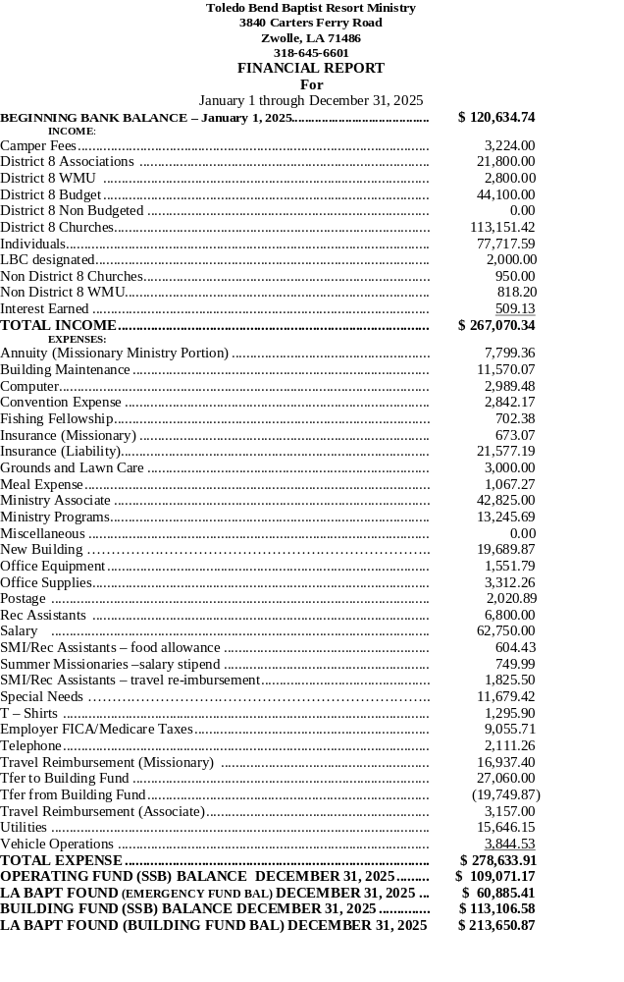
January 1, 2026 thru December 31, 2026
Toledo Bend Baptist Resort Ministry
Tentative (subject to change by event coordinators)

2026
February 28 – March 1: NORTH TOLEDO and SOUTH TOLEDO BEND state parks,
need volunteers need volunteers Sunday services and Saturday visitation begin
February 28 & March 1 thru September 26 & 27

March 21 Toledo Bend Workday at the Ministry Center, 8:00 a.m. until, lunch provided, need volunteers

March 28 – 29 CYPRESS BEND and PLEASURE POINT SRA parks need volunteers
Sunday services and Saturday visitation begin March 28 & 29 thru September 5 & 6

April 3 – 5 Easter weekend ministry, Good Friday outreach, Easter Sunrise services, music, puppets,
children’s activities, need volunteers

April 4 Easter on the Bend hosted by Wildwood Resort, 8:00 a.m. until, need volunteers

May 2 Children’s fishing event, bank fishing 9:00 a.m. – 1:00 p.m. with lunch San Miguel Park, need volunteers

May 22 – Aug 2 Summer programming, need volunteers, NEED MISSION TEAMS

Aug 1 Sabine parish back to school rally 8:00 a.m. Doors open 9:00 a.m. Many Elementary, conclude
with lunch, need volunteers

September 5 – 6 last visitation and service Cypress Bend and Pleasure Point for 2026

September 22 Fair worship and meal Sabine parish fairgrounds, 6:00 p.m. until, need volunteers

September 23 – 26 Fair ministry various times daily, Sabine parish fairgrounds other than Thursday
senior adult event Zwolle Fiesta grounds, need volunteers

September 26 -27 last visitation and service North Toledo and South Toledo for 2026

October 8 – 10 Zwolle Tamale Fiesta, 8:00 a.m. each day Thursday ends 1:00 p.m., Friday and Saturday
until, Zwolle Fiesta grounds, need volunteers

October 17 pre-tournament evangelistic event at Siloam, time to be determined (tentative date)

October 21 – 23 Bassmaster Elite Qualifier tournament Cypress Bend

November 6 – 7 Florien FreeState Festival, 8:00 a.m. until both days, Florien festival grounds, need
volunteers

November 28 Converse Christmas event

December 5 Zwolle Christmas event

December 12 Many Christmas event

Baptist Collegiate Ministries- NSU
Financial Report
1-1-25 to 12-31-25

Income
District Eight 114,357.38
LBC /Rental 7,930.00
Other (Reimbursements, fees, one -time gifts, missions) 17,649.45
Interest income 119.06
Total Revenue 140,055.89

Operating Expenses
Program Services $ 38,078.62
Salaries & Wages * 40,319.00
Payroll Taxes 2,770.01
Employee Benefits 2,400.00
Missions / 16,860.95
Legal and Accounting 4,063.33
Office Expenses 11,304.55
Telephone/ Cable/ internet 6,663.77
Repairs and Maintenance 19,036.43
Utilities 7,713.72
Vehicle fuel / insurance 2,651.68
Bank Charges/Penalties/Interest 467.71.
* Both Administrative Assistant and BCM Campus Missionary

Total Operating Expenses $ 154,267.77

Total Increase or (Decrease) (14,211.88)

SUMMARY
Beginning balance Checking 01-01-2025 9,133.60
Ending Balance checking 12-31-2025 3,772.51

Account Balances
City Bank Checking 12-31-2025 11,519.58
New Building Construction/Maintenance fund (LBC) 12-31-2025 7,671.72
Missions 12-31-2025 1,007.10
Student Development 12-31-2025 12,838.53
Building repair Fund 12-31-2025 9.03

Total Cash Assets 12-31-2024 $27,724.98

Clara Springs Baptist Encampment
4420 Hwy 177 Pelican, La. 71063 (318) 796-3875
Camp Manager: Rev. Jack Mills III
Email: clarasprings@cp-tel.net
www.clarasprings.com

Budget Item | 2026 Budget | 2025 Expenditures
Utilities | 100,000.00 | 104,489.43
Insurance | 105,000.00 | 101,557.97
Food Supplies | 175,000.00 | 164,023.69
Equipment | 30,000.00 | 63,329.47
Taxes | 20,000.00 | 15,714.52
Janitorial Supply | 15,000.00 | 15,396.85
Missions Offering | 0.00 | 3,200.00
Snack Shack & Store | 40,000.00 | 48,948.30
Maintenance | 30,000.00 | 75,156.17
Office & Supplies | 15,000.00 | 14,393.87
Year-Round Staff | 145,000.00 | 140,839.07
Program Staff | 37,000.00 | 35,974.99
Kitchen/Janitorial Help | 31,000.00 | 30,972.33
Contract Labor | 5,000.00 | 4,080.00
Program Staff Training | 5,000.00 | 5,449.30
Mileage/Retirement | 21,630.00 | 20,650.00
Camp Organizations | 3,000.00 | 3,346.00
Programming | 25,000.00 | 26,889.58
Pool & Recreation | 12,000.00 | 21,343.96
Conference Expenses | 10,000.00 | 9,499.22
Promotional Expenses | 5,000.00 | 5,511.12
Honorariums | 30,000.00 | 32,024.12
NSF | 0.00 | 0.00
Reimbursements | 0.00 | 7,142.60
TOTAL EXPENSES: | 859,630.00 | 949,932.56
Date: Jan. 01 – Dec. 31, 2025

TOTAL INCOME: $ 981,827.94

GENERAL BALANCE:
AS OF 12/31/2025 $ 115,886.96

BUILDING FUND BALANCE:
AS OF 12/31/2025 $4,850.30

2026 Fish Fry Dates
February 27
March 27
April 24
May 22
June 26
July-None
August 28
September 25
October 23

District 8 Events Date_______

Lawn Crew, Kitchen Help, Carpentry, Electrical, Landscaping, Power washing, & General Cleaning

Kids Winter Retreat January 30-31
GROW Women’s Retreat February 20-21
Campers on Mission March 29-April 3
La Children’s Home Retreat ????
Adult Day May 14
Workday May 2




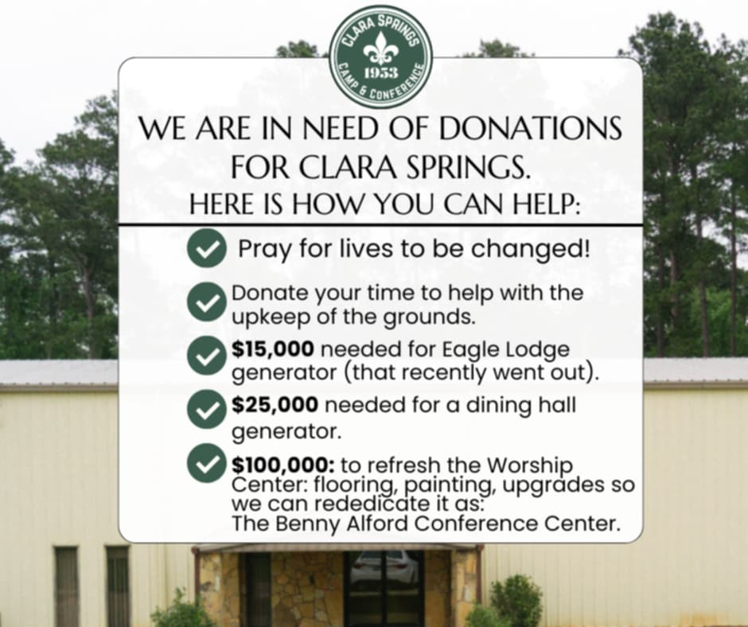



Southern Baptist Churches, and their Pastors, in the District Eight Area
CHURCH FIRST NAME LAST NAME ADDRESS CITY ST ZIP HOME PH WORK PH
{} AIMWELL Rev. Ronnie Sandifer 2178 Hwy 1215 Zwolle LA 714865102 645-7000 645-9955
{} ALFORD HEIGHTS Rev. Billy Gibbs P. O. Box 186 Florien LA 71429 586-4876 C318-527-1811
{} ANTIOCH (DS) Bro. Matt Ruiloba 233 Julie Lane Stonewall LA 71078 318-268-9456
{} ANTIOCH (SB) Rev. Wayne Chance 74 Arnold Dowden Road Hornbeck LA 71439 337-842-0127 318-586-7825
{} ASHLAND Bro. Danny Slack PO Box 327 Castor LA 71016 318-525-2774
{} BAY SPRINGS Dr. Dwight St. Andre 102 Chinquapin Place Natchitoches LA 71457 318-481-5726
{} BELLWOOD Rev. Roger Matkin 2029 DeSoto St. Provencal LA 71468 C-652-4498 C318-652-4498
{} BELMONT-UNION P. O. Box 60 Belmont LA 71406 256-2448
{} BENSON Bro. Jeff Feibel 3213 Hwy 512 Converse LA 714193514 318-572-2290
{} BETHEL Rev. Wiley C. Cole 3604 Hwy 507 Coushatta LA 710195230
{} BETHSADIA Rev. Dwayne Spillman 6843 Hwy 6 Natchitoches LA 71457 294-3974
{} BEULAH (DS) Dr. Freddie Williford 695 Powell Rd Stonewall LA 71078 318-840-6217
{} BEULAH (SB) Rev. Kenneth Leach 31665 Hwy 191 Many LA 714497797 256-2944
{} BRIARWOOD Bro. Chase Burns 1020 Hwy 9 Saline LA 71070 337-378-3620
{} CALVARY (DS) Pastor Alton Middleton 23609 Hwy 175 Pelican LA 71063 796-3626
{} CALVARY (NA) Rev Benjamin Keele 312 Hwy 3191 Natchitoches LA 71457 432-254-4077
{} CALVARY (NS) Dr. Cyle Clayton 105 West Peterson Many LA 714492554 256-0464 256-2871
{} CARMEL Rev. Larry Simpson 3760 Greenway Place Shreveport LA 71105 560-1383
{} CARSON Rev Scott Bates 2061 Hwy. 507 Castor LA 71016 417-943-0901
{} CEDAR GROVE Rev. Brian Adamson 1581 New Hope Road Many LA 71449 256-9295 C318-332-5781
{} CEDAR HILL Rev. Fred Mustiful 360 Rose Mary Lane Stonewall LA 710789312 C318-364-7115
{} CENTRAL Mr. Michael Tanner 9949 Natchitoches Hwy Robeline LA 71469 972-974-6262
{} CHRISTIAN
{} CHRISTIAN HARMONY Rev. David Matlock 2019 Hwy 1226 Natchitoches LA 714577405 352-6353 C318-663-0859
{} CLARENCE Rev. Wayne Spears 7580 Hwy 71 Clarence LA 71019 713-582-0741
{} COLDWATER Rev. Timothy Leach 6558 Hwy. 6 Natchitoches LA 714577028 318-663-3903
{} CONVERSE FBC Rev. Brian Rankin PO Box 53 Converse LA 71419 318-235-7989
{} COUSHATTA, FBC Rev. Cory Tucker 318-349-8852
{} CRESTON 414 Parkway Drive Natchitoches LA 71457 521.6995 C318-228-3145
{} CROSS ROADS Rev. Dean Crittenden 345 Magnolia Avenue Many LA 714493165 256-0198 315-5564
CHURCH FIRST NAME LAST NAME ADDRESS CITY ST ZIP HOME PH WORK PH
{} CYPRESS Rev. Bill Collins 154 Moss Hill Terrace Natchitoches LA 714576425 352-9168 357-6464
{} EBENEZER Rev. Clifford Grounds 1225 Ebenezer Road Florien LA 71429 409-509-2233
{} EMMANUEL (DS) 1314 Polk Street Mansfield LA 71052
{} EMMANUEL (NA) Rev. David Elkins 3252 Holly Grove Road Robeline LA 71469 472-8530 352-2211
{} EMMANUEL (NS) Rev. Patrick Morgan 2933 Natchitoches Hwy Many LA 714497203 315-5228
{} FAIRVIEW Dr. Matthew Endris 104 Hwy 71/84 Coushatta LA 710194158 932-4441 932-5940
{} FELLOWSHIP (DS) Rev. Weyland Gauntt 394 Bear Creek Road Converse LA 714193206 567-2811 C318-471-7004
{} FELLOWSHIP (NS) Rev. Phillip Collier 124 Fellowship Circle Converse LA 714193404 256-577-0195
{} FIRST COMMUNITY Rev. Marvin Leleux 230 Sledge Road Coushatta LA 71019 337-280-1389
{} FISHER FBC Rev. Casey Sanders P. O. Box 39 Fisher LA 714260039
{} FLORIEN FBC Rev. Bill Blackmon 2344 Anthony Road Florien LA 71429 586-3531
{} FORT JESUP Rev. Matthew Walker 994 Hwy 3118 Many LA 71449
{} FRIENDSHIP Rev. Logan Langton
{} FRIERSON Rev. Mel Campbell 8904 Shady Lane Shreveport LA 711182230 828-7470 C318-828-7470
{} GLOSTER Dr. Brandon Cottrell P.O. Box 86 Gloster LA 71030 318-933-5484
{} GOOD HOPE
{} GORUM Rev. Michael J. Dubois 355 Dubois Road Lena LA 714473401 379-0044
{} GRACE Mr. Greg Dunn 15927 Hwy 1 Cloutierville LA 71416
{} GRAND CANE Rev. Michael Scott P. O. Box 264 Grand Cane LA 71032 C318-272-2270 858-3341
{} GRAND ECORE Rev. Kevin Price 1700 Washington Street Natchitoches LA 71457 337-375-1098
{} HARMON Dr. Mike Honzell 606 Oakland Natchitoches LA 71457 476-2289 476-3739
{} HARMONY
{} HARMONY COVE Rev. Randall McFarlain 100 Holiday Drive Florien LA 71429 5318-86-4728
{} HICKORY GROVE Rev. Mike Fort 3635 Green Acres Unit #305 Bossier City LA 71111 318-549-3846 C318-963-6841
{} HORNBECK FBC Rev Jason Lupo 1139 Martin St Hornbeck LA 71439 318-334-8990
{} HUNTER-MAGNOLIA Rev. Amador Santos 147 Magnolia Lane Mansfield LA 710526235 697-9685 318-861-2150
{} KINGSTON Rev. Mike Naquin 716 Dumaine Drive Bossier City LA 71111 716-8728
{} KISATCHIE Rev. Jeff Taylor P. O. Box 532 Provencal LA 714680532 472-9617
{} LAKESIDE (SB) Rev. Bill Craft, Jr. 229 Miers-Mitchell Rd Florien LA 714294743 586-4807 508-0458
{} LAKEVIEW Rev. Freddie Hippler 1988 Maxey Hippler Rd Many LA 714495134
{} LIBERTY Rev. Harry T. Bamburg, Jr. 754 Riley Street Coushatta LA 710197535 932-3871 932-4025
CHURCH FIRST NAME LAST NAME ADDRESS CITY ST ZIP HOME PH WORK PH
{} LITTLE FLOCK Rev. Jimmy Speight 6261 Dess Road Florien LA 71429 586-9836
{} LOGANSPORT FBC Rev. Shawn Thrapp 1204 Dennis Street Logansport LA 71049 903-720-8853
{} LONGSTREET Rev. Clint Bagley P O Box 215 Keatchi LA 71046 318-697-5597
{} MANSFIELD FBC Dr. Chad Hardbarger PO Box 983 Mansfield LA 71052 455.2629
{} MANY FBC Rev. Wade Penfield 922 Milford Lane Many LA 71449 315.2534
{} MAPLE SPRINGS Rev. Robert Davis 17013 Hwy 5 Logansport LA 71049 318-245-2258
{} MARTHAVILLE FBC Rev. Danny Forsythe 2074 Johnson Chute Road Natchitoches LA 714576748 318-481-9313
{} MARTIN Dr. Richard Kaufman 4511 Hwy 155 Coushatta LA 710197112 932-6618 932-6141
{} MEMORIAL Rev. Benny Crittenden 3800 Marthaville Rd Many LA 714496954 256-5117
{} MIDDLE CREEK Rev. Lynn Laurence 973 Old River Road Anacoco LA 714032612 337-286-5160 C337-423-1314
{} MIDWAY Rev. Lee McClintock 803 Willow Street Logansport LA 710494313 C318-471-6053
{} MILL CREEK
{} MIMS SPRINGS Mr. William Jarrett 261 Rogers Rd Converse LA 71419 272-1014
{} MOUNT ZION Rev. Larry Carr POB 133 Coushatta LA 71019
{} MT. CARMEL Rev. Matthew Warren 5095 Hwy 118 Florien LA 714293235 C318-655-1932 586-4680
{} MT. OLIVET Rev. Richard Tull 14284 Hwy 84 Logansport LA 71049 C318-871-6911 697-4855
{} MT. ZION FIRST (NS)
{} NATCHITOCHES FBC Rev. Tommy Rush 2157 Johnson Chute Road Natchitoches LA 71457 357-0633 352-3737
{} NOBLE
{} OAK HILL Rev. Darren Carpenter 135 Pastor's Drive Many LA 71449
{} OLD BETHEL Rev. Wayne Salley 8375 Hwy 175 Belmont LA 71406 590-0130 315-3098
{} OLD PISGAH Rev. Dean Johnson P. O. Box 222 Pleasant Hill LA 710650222 796-2520 C-318471-2753
{} OLD UNION Rev. David Cox 342 Lucy Dr Converse LA 71419 461-2526 C-318.461.9388
{} OPEN DOOR Dr. Thumper Miller 200 Hope Street Mansfield LA 71052 453.5276
{} PELICAN
{} PILGRIM REST
{} PINE GROVE (SB) Rev. Dennis Bignar 643 McInnis Road Florien LA 71429 318-315-0808 C318-315-0808
{} PISGAH Rev. C. M. Kelly 343 Arnold Road Many LA 714494953 C-318-581-6107 256-9498
{} PLAINVIEW Bro. Jody Dale Mitchell 203 Bahnsen Lane Hornbeck LA 71439 337-378-3092
{} PLEASANT HILL Rev.Edgar Evans P. O. Box 87 Anacoco LA 71403 337-208-4064
{} PROVENCAL FBC Dr. Bill Hudson 325 Gene Lane Natchitoches LA 71457 356-0888
CHURCH FIRST NAME LAST NAME ADDRESS CITY ST ZIP HOME PH WORK PH
{} ROBELINE, FBC Rev. Brian Ray 9994 Hwy 6 Robeline LA 71469 318-294-3369 472-1004
{} SALEM Dr. Mike Hawkins P. O. Box 24 Stonewall LA 710780024 C-286-4478 318-925-9231
{} SAN PATRICIO Rev. Danny Asbell 61 San Patricio Road Converse LA 71419 871-2174 C318-471-2000
{} SHADY GROVE Rev. Rick Wing 250 Bethel Road Logansport LA 710492354 697-6921 318-286-3915
{} SHILOH 322 Church Road Keatchie LA 71046
{} SILOAM Rev. Chuck Lusk 197 Shady Lane Anacoco LA 71403 850.461.4092
{} SOCIAL SPRINGS Rev. Steve Pettey 5456 Hwy 371 Ringgold LA 71068 318-780-7645
{} SOUTHSIDE Rev. Wayne Dubose, Int. 7715 Millicent Way Shreveport LA 71105 318-773-9048
{} SPRING RIDGE P. O. Box 7 Pleasant Hill LA 71065
{} SPRINGHILL Rev. Russel LeFleur 259 Springhill Church Rd Ringgold LA 71068 318-453-9367
{} TORO Mr. Thomas Alford 2803 Gum Springs Loop Hornbeck LA 71439 C318-315-1169
{} TRINITY (NA) Rev. Logan R Brock 1030 Parkway Drive Natchitoches LA 71457 C318-315-0113
{} TRINITY (SB) Rev. Nick Remedies 2826 Natchitoches Hwy Many LA 71449 315-5834
{} UNION HALL Rev. Shawn Beard 1938 Hwy 507 Coushatta LA 71019 318-617-9785
{} UNION SPRINGS Rev Ronnie Osbourne 1032 Hwy 191 Converse LA 71419 318-548-6140
{} UNITED Rev. Dominic Mowrer PO Box 15 Campti LA 71411 903-650-2546
{} WALLACE Dr. Jeffrey A. Jinks 4193 Hwy 177 Pelican LA 710633277 318-282-8731 796-3860
{} WARREN Rev. Louis Slaughter 4404 Prospect Road Florien LA 714294710 586-7960
{} WESTSIDE Rev. Zach Anderson 524 Lindsey Dr. Natchitoches LA 71457 318-471-6337
{} WESTSIDE EN ESPANOL Rev. Gabriel Ruiz 221 Kelly Street Natchitoches LA 71457 352-2383
{} WOOD SPRINGS Rev. David K. Permenter P. O. Box 263 Grand Cane LA 710320263 858-3421 C318-464-6410
{} ZION HILL Rev. Jimmie E. Glover P. O. Box 8 Negreet LA 714600008 256-2270 C318-332-0992
{} ZWOLLE FBC Rev. Marty Williams 300 W W W Drive Frierson LA 710273005 C-318-402-3772

