**COMMUNITY LAW RESOURCES ASSOCIATION**

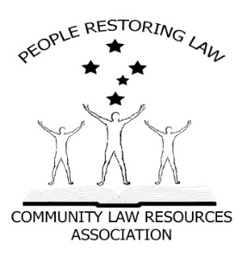 **Some Facts.**

**PRESS RELEASE**

**IS LOCAL GOVERNMENT VALID?**

1. **All** Parliaments require authority from somewhere to make Laws.
2. Where does the Victorian Parliament receive its authority from?
3. Answer; the Victorian Constitution section 16 and the Commonwealth Constitution section 108.
4. The Victorian Constitution is subject to the Commonwealth Constitution Section106.
5. Local Government relies on the Local Government Act 1989 (Vic) for its existence.
6. The Local Government Act 1989 (Vic) relies on section 74A of the Victorian Constitution for its existence.
7. Municipal institutions and local government, **is in the Commonwealth Constitution** as a department of a State Government. (Pages 935 & 936 of the Annotated Constitution).
8. In 1979, The Parliament of Victoria amended the Victorian Constitution to include section 74A, which inserts Local Government into the Victorian Constitution.

**Some questions.**

1. Can the Parliament of Victoria amend the Commonwealth Constitution? **NO.** Only the people of the Commonwealth can do that by means of section 128 (referendum) of said Constitution.

##### Can the Parliament of Victoria create any Laws that are inconsistent with the Commonwealth Constitution? NO. Section 106 & 108 of the Commonwealth Constitution.

**Some more Facts.**

1. Therefore, Section 74A of the Victorian Constitution is unlawful and, as a result, so is the Local Government Act 1989 and, consequently, so is Local Government as a Government.
2. Local Government can only be a Department of a State, and Departments of State Governments cannot govern us, cannot create Laws (Local Laws) and above all cannot Tax us (Rates).
3. Municipal institutions and “local governments” are in the Commonwealth Constitution as a department of a State Government. In 1979, the Victorian Parliament altered its Constitution to include a 3rd or an essential tier of Government, which has effectively altered, or is at least repugnant to the Commonwealth Constitution.

**Statement**

Local Governmentcannot govern us, cannot make laws for us (local law) and cannot tax us (rates).

Municipal institutions and local governments can only be a Department of a State, just like the Education Department or the Health Department.

**Now the question for all Victorian State politicians is:**

**In 1979, where did the Victorian Parliament get its authority from to alter,** **or at least, make laws that are repugnant to the Commonwealth Constitution?**