International Recruitment Process- For Nurses and Doctors from non- EU countries to work in the UK

Rapid Prime Care LTD in Partnership are offering opportunities for Nurses and Doctors to work in UK NHS TRUST Hospitals.

We are recruiting Nurses and Doctors worldwide. We offer our customers a quality, friendly and support service.

The best part is that We do not charge you any Agency fees

We Support you to:
- Practice your IELTS (English test) and sit the test
- Register with the NMC (UK nursing registration body)
- Get a VISA to work in UK as a Nurse(through employer sponsorships)
- Secure employment and adaptation
- Settle in UK healthcare settings.

This document introduces you to our services and what is involved in the International Recruitment of nurses. You can also use it for reference throughout your recruitment process.
Below is the 10 stage process we will take you through: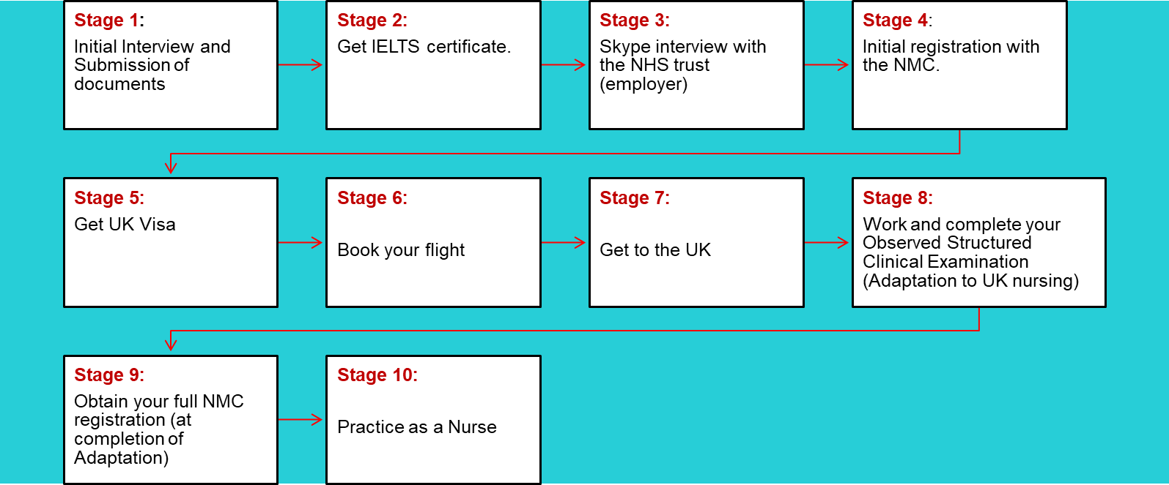

To embark on this journey please follow our Recruitment procedures and processes outlined in this document together with various links we have included for guidance.

Stage 1 : Document submission

- You are required to submit certified copies of the documents below:
Passport.
Local Registration from your country.
Nursing Certificate.
And a Detailed CV with a minimum of 1 year clinical work experience
Please send copies which are certified by one of these-Solicitors, commissioner of Oaths or legal persons.

- We will get back to you once we have reviewed your documents. If your documents are satisfactory, we require you to sign a commitment agreement to Skillzweb LTD & Rapid Prime Care being your screening and recruitment agencies based on the process outlined below.
- Skillzweb will conduct your initial screening by checking your documents and evidence of your IELTS exam score 7. If you have not achieved your IELTS score 7, Skillzweb will support you by offering advice, guidance and online resources. They will also arrange and manage your IELTS tutorials, where required. It is your responsibility to request for tutorials and to pay for them.
- Rapid Prime Care will undertake the rest of your screening, recruitment, relocation and work placement. Skillzweb will only pass you over to Rapid Prime Care for this only if you have the right qualifications, registration and have passed your IELTS exam.
Important: Your continued engagement with us as your consultants and use of our resources binds you to us as your recruitment agents for your relocation to the UK for work purposes. Please read the rest of this document and information in the advisory links within it, then sign it and return to us together with the documents requested above.

Please refer to information on UK international recruitment guidelines by the NMC via this link: https://www.nmc.org.uk/registration/joining-the-register/trained-outside-the-eueea/. This will help you understand what is expected.

Stage 2 : Get your IELTS certificate

IELTS is the International English Language Testing System; it measures the language proficiency of people who want to work in the UK. It is obtained from the local British council in your country. Fees apply.

Skillzweb will support you to practise and familiarise yourself with IELTS before you register for the tests. This is discussed with you in stage 1. Contac Tafara Gumbo for details on the support offered. Phone- +44 7917101150, email- skillzweb1@gmail.com. You can also contact him on Whatsapp and facebook messenger.

Please note that from 5th December 2018 the NMC a minimum score of 7 in the IELTS test. You must obtain this before moving onto the next stage.
Clink on the link for more information and test centre location: https://www.ielts.org/

We will send you a link to our IELTS online resources upon receipt of a signed copy of this document.
Stage 3: Interview with NHS Trust (potential employer)
Rapid Prime Care will arrange your interview, this will be with an NHS Trust (employer), Via Skype. You are required to produce evidence of your ILETS at this point to prove your eligibility to work in the UK.
You will be supported to prepare for the interview.
Stage 4 : Initial Registration with NMC
Once you have passed your interview with the NHS you are required to complete your initial registration with the NMC.
Get details on Nursing and Midwifery Council Registration via this link:
https://www.nmc.org.uk/registration/joining-the-register/trained-outside-the-eueea/
Nurses will join the register once they pass the 2nd Test of Competence, which is the Observed Structured Clinical Examination (OSCE). You will complete this in the UK.
The fees for the 2 NMC registration stages are
1st: £140 paid directly to NMC
2nd: £130 paid direct to NMC
Stage 5: Applying for a UK visa
Rapid Prime Care will guide and support you to apply for a UK visa. Do not attempt this stage before completing the first 4 stages above. Fees apply

Stages 6 & 7: You are responsible for undertaking these as soon as you get your visa and you are responsible for the costs. Contact Rapid Prime Care if you need support and guidance. We will support you with settling in the UK on your arrival, including facilitating your accommodation.
Stage 8& 9: Completion of the Observed Structured Clinical Examination (OSCE), (Adaptation)
Rapid Prime Care will arrange your placement for Observed Structured Clinical Examination (OSCE). You will apply for full NMC registration (PIN number) after passing the competence test. This is the 2nd NMC registration. We will support and guide you to learn /train NMC Blue Print etc, in preparation for your OSCE competence test.
Pre-Registered Nurses will require a Nurse Mentor in order to help with their training as per the NMC Blue Print and the Royal Marsden Manual of Clinical Procedures (9th Edition).
See link :https://www.nmc.org.uk/globalassets/sitedocuments/registration/registering-nurse-or-midwife-outside-eu.pdf
Stage 10: Once you get your NMC full registration you can practice as a Nurse in the UK
NB: Expenses to be paid back to you or reimbursed once you are in UK :
- Flight to the UK
- Airport transfer to Trust
- Certificate of Sponsorship
- Immigration Skills Charge
- UK Visa
- UKVI IELTS (if applicable)
- Immigration Health Surcharge (to be repaid by Nurse from salary)
- 1 attempt at IELTS (if applicable) (reimbursed on arrival)NMC
- 1 IELTS training course (if applicable) (reimbursed on arrival)
- 1 months free accommodation on site if available, or equivalent
- £500 cash on arrival (repaid over 2 months direct from pay)
- OSCE Fees (repayment will be directly from pay)
- OSCE prep training programme. Done in England
- Support of preceptorship co-ordinator throughout process. Done in England

I have read, understood this document and agree to be bound to the agents stated as my consultants and recruitment agents. I understand obligations, including meeting costs, where applicable. I understand that the agents stated here are under no obligation to facilitate my career move unless I meet my obligations as stated herein.

Client’s full name…………………………………. Signature………………………. Date…………………

