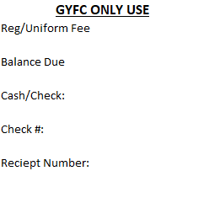
Last name:_____________________________________

First name:_____________________________________

DOB:_____________ Age (as of August 1st):_________


Home Address:__________________________________

City:__________________________ Zip:______________
:
School District Based on Residence:__________________

School Attended:__________________________________
:
Grade:_______ T-shirt Size:(Circle one) YS YM YL AS AM AL (For Camp)

Mother’s Name:__________________________________#:_______________
Receive Text : Yes/No

Father’s Name:___________________________________#:______________ :
Receive Text : Yes/No

Emergency Contact:_______________________________#:_______________

____________________________________________________________________________
Sibling (s) Team

Football is a sport of physical contact and injuries may occur. Your child’s safety and well-being are of the utmost importance and our primary concern.

Medical insurance is required for all players and the responsibility of the parents or legal guardian.

The Goshen youth football club organization, coaches or members assume no responsibility or liability for any injury occurring as a result of participation in conditioning, practicing, gameplay, equipment failure or during transportation to and/or from games and practices.

A mandatory three full practice days of conditioning must be completed before any player can wear full equipment. The conditioning program starts in July. Regular practices with full equipment start one week later. Coaches will advise parents of specific dates.

Each player will be responsible for their own equipment. If not returned by the end of the football season, the parents or legal guardians will be made financially liable for paying Goshen Youth Football Club $450. This is the cost of the equipment. If the equipment is not returned or paid for, legal action will be taken and the player will not be eligible to participate in future GYFC programs.
Parent involvement will make this organization a positive experience for your child. Parents are required to help with concessions/Spirt wear/gate and participate in our fundraisers.
Registration fee covers organizational fees, concessions stand set up, uniform/equipment administrative costs of running the program, ect. Because of these budget expenses, ABSOLUTELY NO REFUNDS will be given.

Parent/legal guardian signature__________________________________Date_____________

