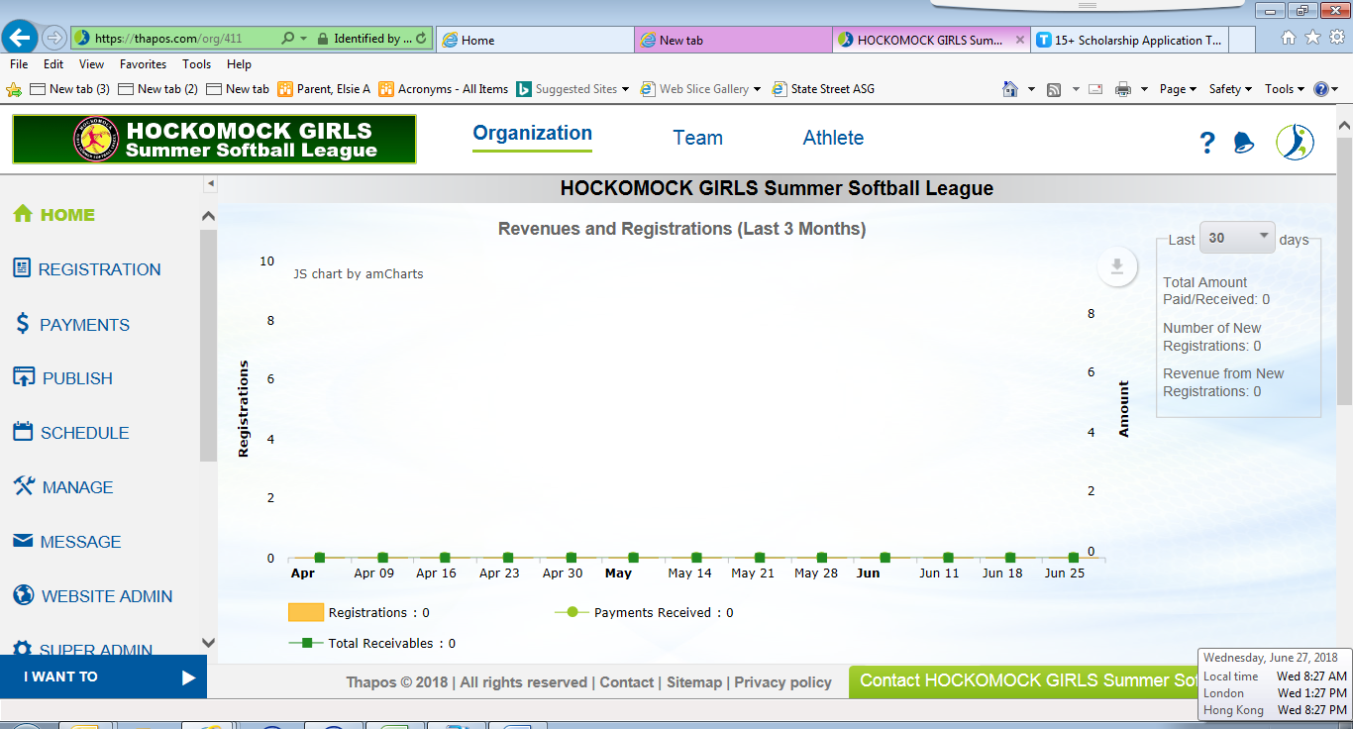
2020 SCHOLARSHIP AWARDS PROGRAM APPLICATION FORM

HGSSL is proud to announce the 2020 Scholarship Awards Program. Under this Program, three (3) $500 scholarships will be awarded to current or former softball players that have participated in a minimum of four HGSSL seasons (The number of seasons do not need to be consecutive.)

Deadline: This application form with essay must be received no later than August 03, 2020. Late applications will not be accepted.

Email completed form with essay to:
Elsie Parent – HGSSL President, vpsoftball@sagra.org
For any questions, please email the above or call/text (401) 835-7673

All fields must be completed to be considered.

Eligibility: Applicants must meet all three criteria to be eligible. Please initial.
- ____ I participated in a minimum of four summer HGSSL seasons
- ____ I am a HS graduate of the Class of 2020
- ____ I will be attending an institution of higher education in the fall of 2020.

Please type your answers. Essay may be typed in box# 7 or attached separately.
1. | Last Name: | First Name, Middle Initial:
2. | Mailing Address  Street:  City: State: Zip:
3. | Daytime telephone number: ( )  Email address:
4. | HGSSL Member Town Affiliation:
5. | Name and location of high school:
6. | Name and address of institute of higher education you will attend this fall:
7. | The Essay:  The scholarship committee would like to know in 1,000 words or less – What does the HGSSL program mean to you? The committee members will be especially interested in these points: how did it impact your life, how did the experience prepare you for college, and what notable qualities did you develop during your time in the league.

Certification Statement:
By signing my name below, I confirm that all of the information provided above and in the accompanying documents is true, completed by the applicant and correct to the best of my knowledge.

Signed:_________________________________Date:_______________

The applications will be reviewed and recipients will be selected by the HGSSL Scholarship Committee. The scholarship winners will be notified by a formal congratulatory notification with invitation by August 09, 2020. Awards will be presented at the end of the 18U summer championship game (Date/Time TBA). Scholarship winners should plan to attend the game.

