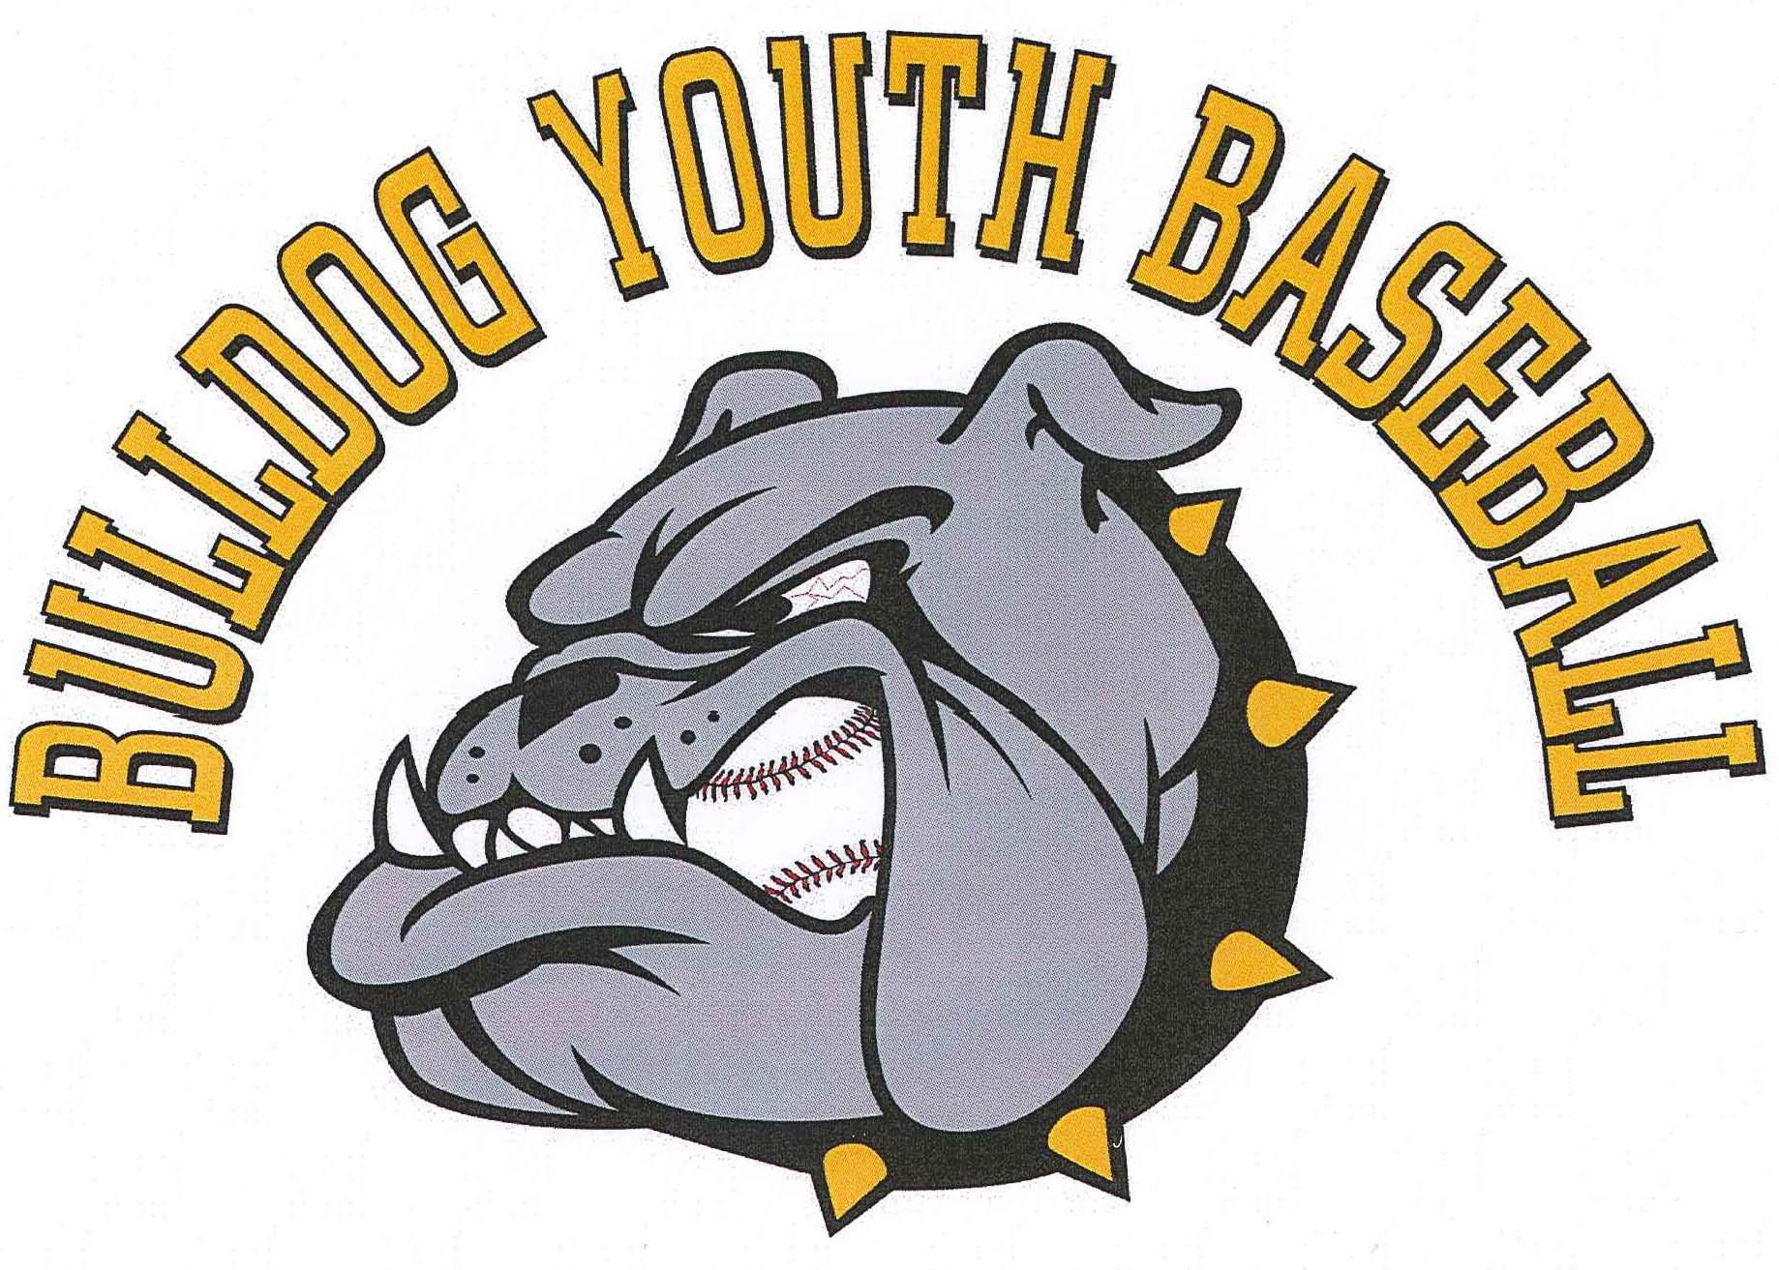

BULLDOG YOUTH BASEBALL
ASSOCIATION

HANDBOOK

2018

REVISED: May 1, 2018

TABLE OF CONTENTS

Introduction 3
Bulldog Youth Baseball Association (BYBA) baseball philosophy 3
Website/Email 3
2017 BYBA Board Members 4
Registration 4
Field Locations 4
Leagues/Teams 4
Tournaments/Tournament Teams 4
Playing Time Policy 5
Practice Policy 5
Game Day Policy 5
Player Code of Conduct 5
Parent Code of Conduct 6
Coaches Code of Conduct 6
Description and Development Expectations for Each Level
8 and Under (8U) 7
10 and Under (10U) 8
12 and Under (12 U) 8
14 and Under (14U) 8
Babe Ruth 9
Conclusions 9

Introduction

This handbook has been assembled as an aid for all coaches, players and parents associated with Bulldog Youth Baseball Association (BYBA) baseball program. This association was created to give the opportunity to play baseball to the youth of the Plainview, Elgin and Millville communities. BYBA wants our youth to succeed on and off the field now and in the future. The information provided in this handbook will help answer many of your questions. If you have any further questions, please contact your head coach, any BYBA board member or visit the website at www.bulldogyouthbaseball.com.

Bulldog Youth Baseball Philosophy

BYBA is about to enter its 6th season as a baseball program. The goal of this program is to create a positive environment in which kids will be taught the fundamentals of baseball while learning how to become exceptional young people. BYBA will be open to youth of all skill levels from ages 7-16. Playing time is very important to BYBA. Although this doesn’t mean “equal” playing time, all kids will play in every game, provided that they are actively participating with a positive attitude and working hard with the team. Ages 7-14 will compete in the Winona County Little League and be in the following groups: 8U, 10U, 12U and 14U. The 6-9 grade kids will be part of the “Babe Ruth” baseball program, which plays most of its games against communities around the Rochester area.
Mission Statement: Bulldog Youth Baseball Association’s mission is to provide the youth of Plainview, Elgin and Millville community the opportunity to play baseball. Through exemplary leadership; promote the qualities of integrity, discipline, and sportsmanship while teaching, developing, and improving the basic fundamentals of baseball in a fun, learning environment.

Website/Email

www.bulldogyouthbaseball.com
bulldogyouthbaseball@gmail.com
For information concerning the program, schedules, sponsorships, committees etc., this website will be updated regularly to keep everyone well informed of what is happening with BYBA. Coaches will update the website with their team’s box scores (results), notes from the games as well as practice information. Weather announcements will posted here as well. However, when in doubt, show up, don’t take for granted that a game or practice is cancelled just because it rained at some point. There are sometimes other drills that can be done if the fields are too wet. The team can be emailed directly from the website, so in the event of bad weather you will get either a phone call or an email from your coach. Please verify this with your coach, as each team may operate a little differently.

2018 BYBA Board Members

NAME POSITION PHONE EMAIL
Don Rademacher President 876-9978 drademacher@bulldogyouthbaseball.com
Tina Fenton Vice President/Sec. 259-9893 ryan_tina@yahoo.com
Carrie Eversman Treasurer 259-7997 carrie@nietzeversman.com
Scott Flattum Director 951-9234 sflattum@isd2899.k12.mn.us
Adam Sanders Director 259-2506 adamsanders9@gmail.com
Mike Klavetter Director 273-2800 mklavetter11@gmail.com
Trevor Briggs Director 269-6350 tbriggs27@gmail.com
Joe Suntken Director 273-4958 jsuntken@gmail.com

Registration

Registration for BYBA will take place in March. The registration fee will be $75 per child ($200 cap/family) and that will include a uniform comprised of: hat, shirt, pants, and belt. The team will also provide equipment including catching equipment, helmets etc. (and bats if needed). Babe Ruth players will be $125 per child and will also include bussing since the games are during the day and travel is more of an issue.

Field Locations

PEM 4-6 Field A 210 2nd Street SW, Elgin
PEM 4-6 Field B 210 2nd Street SW, Elgin
PEM K-3 Field A 600 West Broadway, Plainview
PEM K-3 Field B 600 West Broadway, Plainview
PEM Track Field 2nd Ave NW, Plainview
Elgin City Park 75 4th Ave. NW, Elgin
Eckstein Field 390 North Wabasha Street, Plainview
Hoenk Park Field A County Road 2, Elgin
Hoenk Park Field B County Road 2, Elgin

Leagues/Teams

Ages 7-14 will play in the Winona County Little League (8U, 10U, 12U & 14U). This league has other area towns in it that we will travel to (and they will travel here). Some of them may include: Dover-Eyota, St. Charles, Lewiston, Altura, Rollingstone, Minnesota City, Goodview and Ridgeway. This league sets the schedule and the nights that games are played.

Grades 6-9 will play in the Babe Ruth League. Some of the other towns in this league include: Stewartville, Byron, Rochester, Chatfield, Winona, Pine Island, Zumbrota & Cannon Falls.

Tournaments

Within each age group, we may join various weekend tournaments throughout the summer. Bulldog Youth Baseball encourages every team to participate in at least 1 tournament and will pay for 1 tournament for the team to be in. Your team/coach may want to enter more than 1 tournament, which is great, but may be an additional cost to do so.

Playing Time Policy

Playing time policy will differ from each age group slightly. However, the goal of our coaches is to get each player into every game. Each player will play at least 3 consecutive defensive outs and 1 plate appearance per game. This rule is in effect for 8U-12U. Our objective is to have fewer kids (about 12-13) on each team. This will increase playing time for all kids, but it will also increase the importance of attendance. If there are several kids missing from games, we will need to forfeit, which is embarrassing and unfortunate for those who are there.

Practice Policy

Players are expected to be at all practices on time. Players should arrive ready to start on time (this means that if practice starts @ 6:00, the kids should have their clothes, shoes and gloves on ready at 6:00; not getting out of the car at 6:00. BYBA understands there are certain situations where a player cannot attend practice due to certain reasons (family emergency, vacation etc.); however, the program is a time commitment and attendance is required.

Game Day Policy

Players are expected to be at all games on time. This time will be determined by each team’s coach. Some teams will have some practice time before games; others may not. Travel to and from the game will be the responsibility of the parents. However, carpooling with other parents is encouraged. The coach can provide a list of parent names/phone numbers, but please arrange any carpooling among yourselves if possible. If you cannot attend/drive your child to the game and cannot find a carpool, please contact the coach.

Player Code of Conduct

- Be in attendance for practices and games. Please notify coaches ahead of time when missing a practice or game. We are limiting the number of kids on each team to improve playing time. However, when we limit the number of kids on a team, it is more important that those on the team attend all games/practices.
- Display a positive attitude about yourself, your team/teammates, and coaches.
- Be a competitor, perform up to your full ability, and contribute to team unity. Compliment, support and cheer on teammates.
- Be attentive and work hard in practices and games. Make your best efforts at all times to perform the tasks as directed by the coaches.
- Show respect to opposing players, coaches, umpires and spectators.
- Display modesty in victory and graciousness in defeat.
- Place team goals ahead of individual goals.
- Learn and follow the rules of the sport.
- Realize your role on the team as a player/competitor, not a coach.
- Remember that you represent the communities of Plainview, Elgin and Millville; your family; your team; and your coaches as well as yourself. Enhance our reputations and character with your conduct on and off the field

Any incident of unsportsmanlike conduct or other violation of Bulldog Youth Baseball rules at any game, practice, or league activity is subject to disciplinary action by the Bulldog Youth Baseball Board of Directors. Disciplinary action can be anything from a request to stop, up to expulsion from Bulldog Youth Baseball.

Parent Code of Conduct

- Help your child learn to enjoy sports and develop skills that they are capable of performing. Practice with and help your child so that they will have an opportunity for skill improvement through active participation.
- Be realistic about the strengths and weaknesses of your child so that you may place them in situations where they have the best opportunity to succeed. Do not relive your athletic past through your child.
- Treat each player, coach, official and parent with respect and dignity.
- Accept the decision of the officials without showing inappropriate emotions.
- Understand and respect the difference between parental roles and coaching roles. Uphold the authority of officials and coaches who are working with your child. Assist them when possible and use good judgment if you disagree.
- Keep negative comments to yourself. Express concerns only to the coach in a straightforward, fair and objective manner. Inform the coaches of issues and conflicts as soon as they arise.
- Focus on performance which can be controlled by the athlete and decrease importance of winning or losing an outcome which is frequently outside the athlete’s control. Positively reinforce improved skills. It is more about trying hard and playing the game the right way.
- Help your child set realistic goals. Sport’s primary value is the opportunity for self-development. The probability of achieving lasting fame and glory is low; but, the experiences develop life-long values and self-esteem.
- Be positive and have fun.
- Volunteer as an assistant coach, umpire, grounds keeper, bench coach, banquet and other fundraiser officials.

Coaches Code of Conduct

- Coaches have the ultimate responsibility for their conduct and the conduct of the players and spectators.
- Accept the decisions of the umpires without showing inappropriate emotions.
- Playing time: All players must play in every game at least 3 consecutive defensive outs and 1 plate appearance. We would like to exceed this, but this is the minimum standard for Bulldog Youth Baseball.
- Place the emotional and physical well-being of your players ahead of any personal desire to win. Want to win and strive to win, but don’t “win at all costs”. Seek to achieve excellence.
- Ensure that you are knowledgeable in the rules of the sport that you coach, and teach these rules to your players. Develop the total individual, not just the athlete.
- Treat each player, coach, official and parent with respect and dignity.
- Treat each player as an individual; remember the wide spread of emotional and physical development for the same age group.
- Lead by example, in demonstrating fair play and sportsmanship to all players. Remember that the team is a direct reflection of the coach(es).
- Share your coaching style, playing-time philosophy, player expectations, team rules and season goals with your players and their parents before the season starts. Be open to player and parent input.
- Remember that you are a youth coach and the game is for children, not adults.
- Be positive and have fun.
- Communicate with parents regularly through the website, email and/or phone to schedule, reschedule and cancel games, practices, etc.
- Tobacco in any form is not allowed during games or practices.

Any incident of unsportsmanlike conduct or other violation of Bulldog Youth Baseball rules at any game, practice, or league activity is subject to disciplinary action by the Bulldog Youth Baseball Board of Directors. Disciplinary action can be anything from a request to stop up to expulsion from Bulldog Youth Baseball.

Description and Development Expectations for Each Level

8 and Under (8U)

After registration, the players will be evenly distributed into teams. The coaches will try to distribute talent and abilities evenly, however, this is not an exact science. Our goal is not to “have all the best players on one team”. However, it is difficult to know each child’s potential before the season and therefore some teams may outperform others. Playing time in this league should be much more even because there is free entry and no score keeping. Kids should have the opportunity to play multiple positions, but will be at the discretion of the coach.

Players should start to learn the fundamentals of the game. They will be introduced to the proper way to catch a baseball, field a ground ball, catch a fly ball, throw a baseball, run the bases, swing the bat and the basic rules of the game. Players will also be taught what it means to be a good teammate and display good sportsmanship for their teammates, coaches, opponents, umpires and fans. This league plays in a “pitching machine” format where the batter is allowed up to 5 pitches to hit the ball. No balls and strikes will be called. Outside of the league tournament, game scores are not kept.

10 and Under (10U)

After registration, the players will be evenly distributed into teams. The coaches will try to distribute talent and abilities evenly, however, this is not an exact science. Our goal is not to “have all the best players on one team”. Playing time in this league will follow the 3 consecutive defensive outs and at least 1 plate appearance rule, but will also be determined based on the player’s ability, skills, attitude and commitment to practice.

Players should be focusing on improving the basics of the game, hand-eye coordination for game play. Players will be taught and drilled on proper techniques of catching in the field, and hitting. Levels of performance will be a step up from 8U. Players will be taught what to do in different situations of the game such as getting the lead runner on a force out. This will be a “live pitcher” league and will be the first taste of competitive games. This does not mean that 10U is a “win at all cost” level of baseball. All players will play and enjoyment of the game is still emphasized in all situations, but scores are kept and players will begin to be put in competitive situations. 46ft pitching mound distance and 65ft bases will be used.

12 and Under (12U)

After registration, the players will be evenly distributed into teams. The coaches will try to distribute talent and abilities evenly; however, this is not an exact science. Our goal is not to “have all the best players on one team”. Playing time in this league will follow the 3 consecutive defensive outs and at least 1 plate appearance rule, but will also be determined based on the player’s ability, skills, attitude and commitment to practice.

Players will learn the basics of situations, bunting, developing a consistent swing, hitting off-speed pitching, pitch selection (knowing the count). Pitchers will pitch, throw off-speed pitches and cover bunts. Defensively, players will learn advanced fielding techniques, backing up bases, advanced defensive situations and proper footwork on double plays. 46ft pitching mound distance and 65ft bases will be used.

14 and Under (14U)

After registration, the players will be evenly distributed into teams. The coaches will try to distribute talent and abilities evenly; however, this is not an exact science. Our goal is not to “have all the best players on one team”. Playing time in this league will be determined by the head coach, but will also be based on the player’s ability, skills and commitment to practice.

Field sizes will increase (55ft pitching mound distance and 75ft bases will be used). Players will continue with the advancement of bunting and recognizing different pitches, while developing a consistent swing and pitch selection. Pitchers will work from the stretch off of a mound, developing multiple pitches and placement of pitches. Defensive players will continue to advance in the finer points of defensive situations (backing up, cutting off, keeping runners close, 1st & 3rd situations and double plays.

Babe Ruth (Jr & Sr)

After registration, the players will be organized onto the team. Depending on the number of kids signed up, we may need to split up the kids either into squads, have multiple teams or even have cuts to make sure that we have a manageable number of players on the teams. This will be determined after sign-up. If cuts are necessary, you will be refunded your entry fee. Playing time in this league will be the discretion of the coach(es) and will be determined based on the players ability, skills and commitment to practice etc. Players can play on both 14U/12U and Babe Ruth if they are eligible and ready for the commitment.

This league is a competitive league and is a step below High School varsity and American Legion baseball. Players will continue to develop and fine tune their skills for a higher level of competition (High School varsity and American Legion). 60ft 6in pitching mound distance and 90ft bases will be used.

Conclusion

Bulldog Youth Baseball Association strives to create the best possible baseball environment for local youths of all skill levels. If you have any questions or concerns regarding the program, its philosophy or expectations, please contact a member of the board, one of the coaches, visit the website or send us an email. We hope you enjoy and Play Ball!

