Teaching Suzuki's Allegretto:

Puzzle and Patterns
By Ruth Brons
Unique teaching idea, as presented in Remscheid, Germany at the 5th Suzuki Teachers' XChange Conference, 2013.
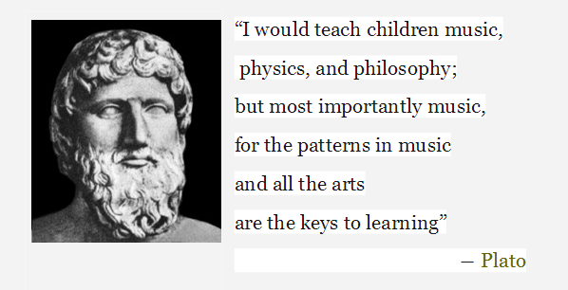
I love teaching our Suzuki core repertoire over and over again, because each student, with his or her own unique set of challenges, provides an opportunity to improve my presentation of the material.
And it is the most challenging students that have proven most enlightening.
For years I noticed students often found it difficult to get through Allegretto, and I constantly tried a great number of ways to present it.
About 8 years ago, it was time to teach it to a particularly challenging five year old student, who was the next year, not surprisingly, diagnosed with an entire array of learning disabilities.
This particular student’s need to absolutely break the piece into smallest parts and then put them together in a logical manner led to the way I have been presenting Allegretto ever since.
While there is much to study in this piece, including string crossings, left hand technique, compositional form, musicianship, and rhythm, a favorite focus is the development of the left hand technique of leaving-the-last-finger-played-down-because-you-just-might-need-it-again.
This works beautifully with Dr. Suzuki’s choice of rhythm and finger patterns.
The following method of presentation of Allegretto works quite well, and students enjoy the surprising break in lesson routine.
I hope you enjoy it as well!

Step #1: The Introduction

Fold a sheet of paper in half three times, so there are 8 layers of paper.

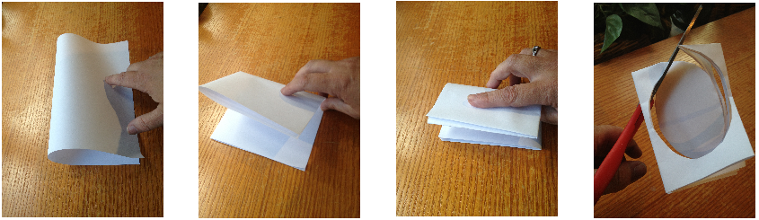

Then cut an egg shape with scissors,
through all 8 layers,
while singing:

On a hot Summer day At the edge Of the wood
The three bears Went outside Extra Notes For a walk.
On a hot Summer day At the edge Of the wood
The three bears Went outside For a walk.
There’s the big Papa Bear And the nice Mama Bear
And the sweet Oh so sweet Oh so sweet Ba – by Bear…

On a hot Summer day At the edge Of the wood
The three bears Went outside For a walk
Adapted from “Mrs. Poole’s Poems”, published circa 1980 in Suzuki World Magazine

Step #2: Establish Rhythmic Pattern

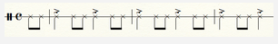

Student plays rhythm on a drum, pizzicatos open D or claps, and then teacher joins in on piano or violin, and sings the song again.
If student is doing pizzicato, switch him/her to open A for the third line.

Step #3 Desk Work: The Egg Hunt

Student identifies rhythmic groups, and circles them,
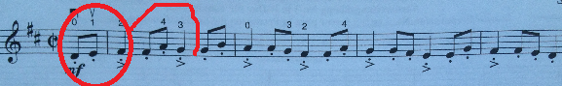

until 8 “eggs” have been found.

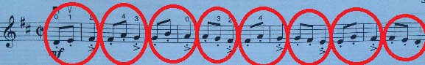

Step #4 Analysis: Finding the Pattern

We look for patterns, noting that:

-Our snake of eggs starts with a zero and ends with a zero, and
- The last number or letter of each egg is the first number or letter of the next egg

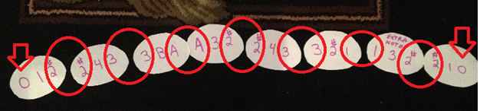

Step #5 Floor Work: Scrambled Eggs Puzzle

Surprise the student by scrambling the eggs.
Then step back and let the student re-assemble,
using knowledge of this melody and its patterns.

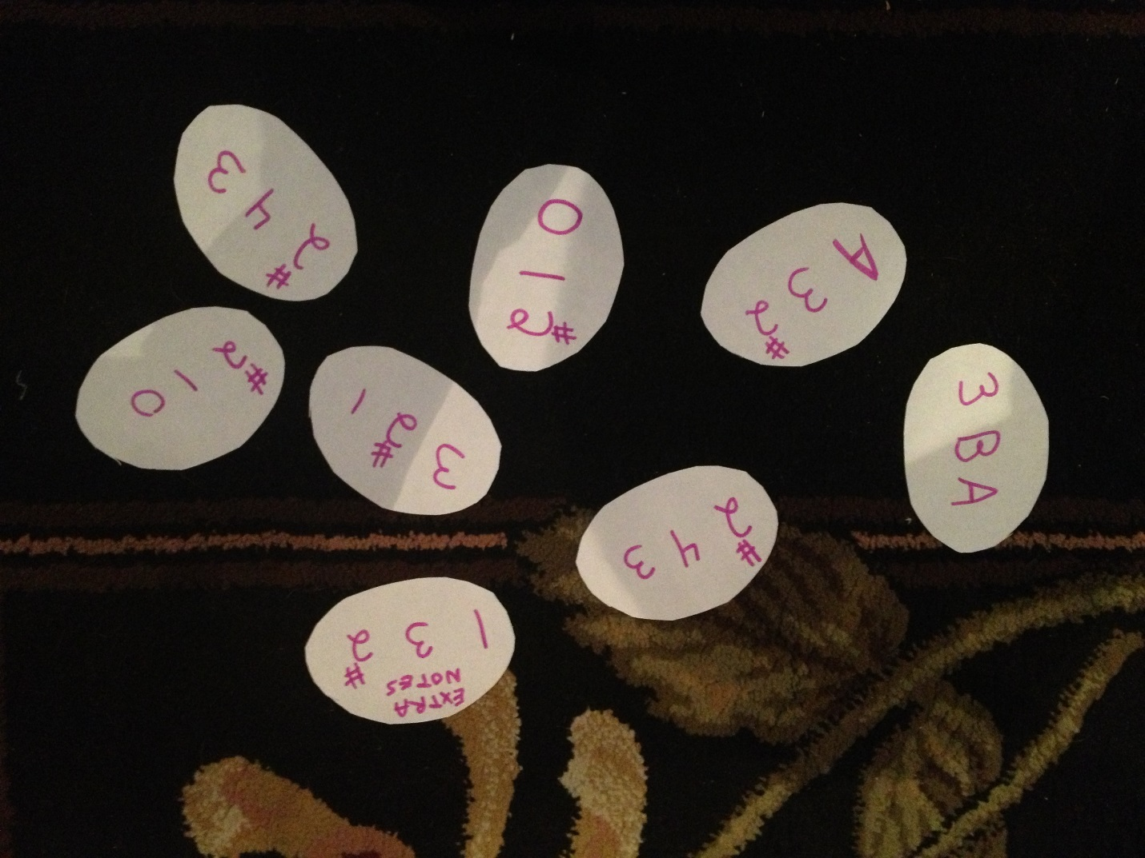

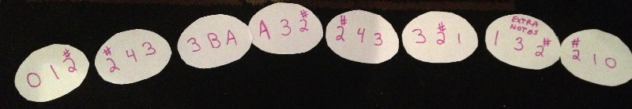

Together, sing the snake of eggs to check student work.

Step #6 Component Mastery: Playing Each Egg

Carefully stack the eggs of the Egg Puzzle, in order, so the first egg is on top of the pile.

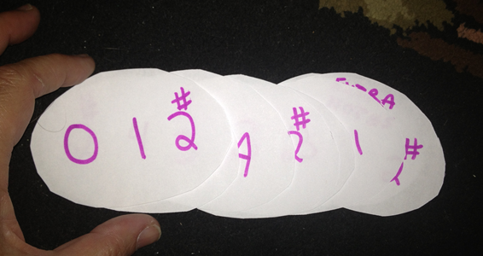

At the music stand, student practices eggs as they as presented, in order, one at a time.

Last finger played is reminded to stay down while teacher places the next egg onto the stand, because we know we will need that finger to start the next egg.

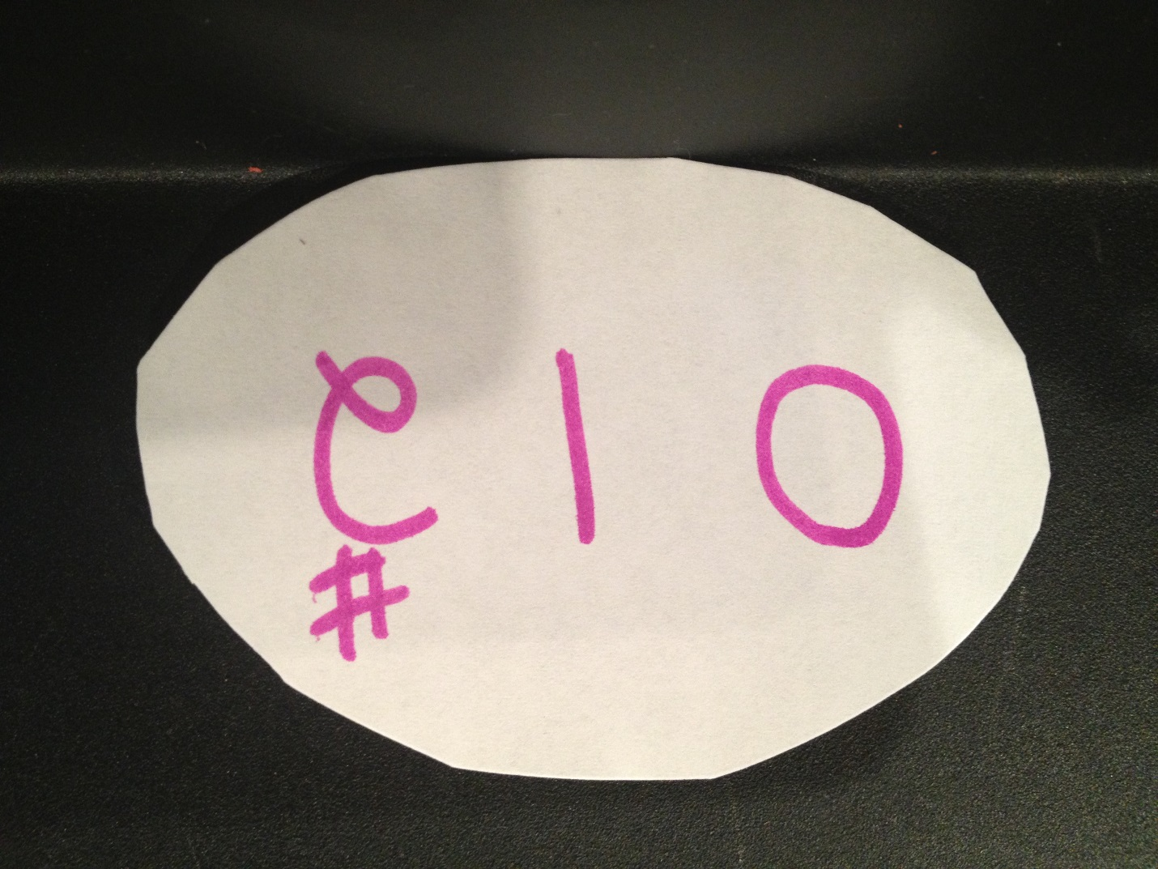

Step #7 Putting Together: Playing First Line of Piece

Now student is ready to play the entire A section.
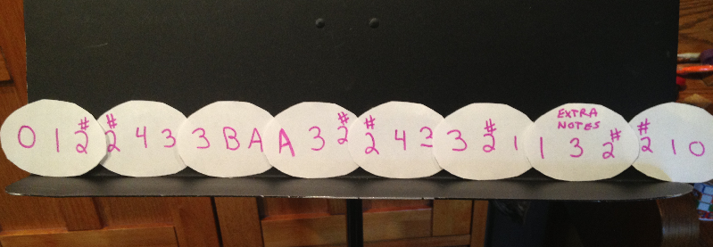

Step #8 Putting Together: Playing Second and Last Lines of Piece

Simply remove the “Extra Notes egg”, and play A1 section!

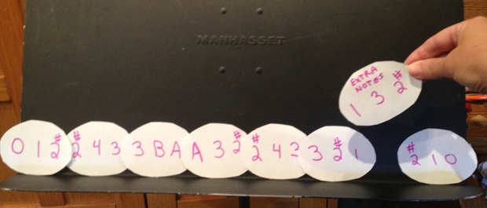

End of Lesson Wrap-Up:

Because the form of this piece is A – A1 –B – A1, at the NEXT lesson,
we can easily complete the piece by adding the B section.

Students enjoy taking their Egg Puzzle home for practice (or to decorate!).

