# Revelation Wrap Up x

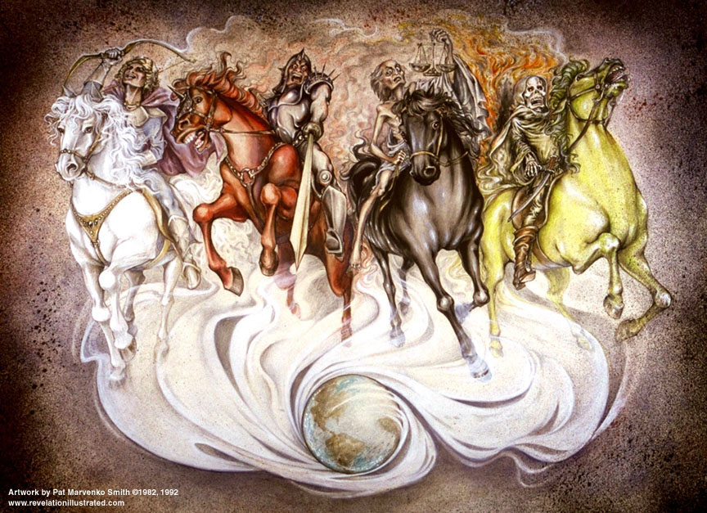

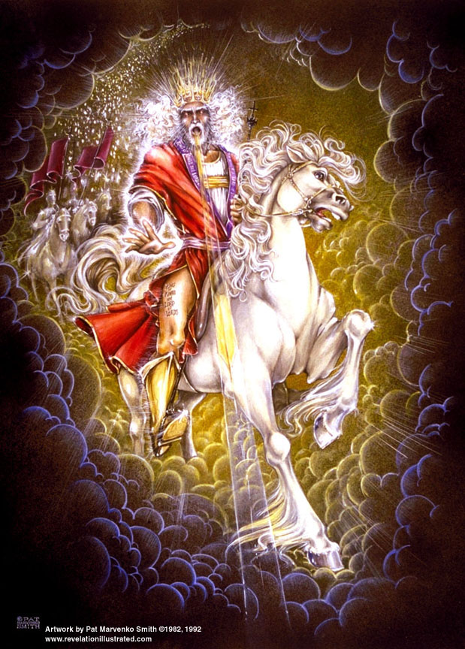

**Daniel 8:19** And he said, "Behold, I am going to let you know **what will occur at the final period of the indignation**, for *it* pertains to **the appointed time of the end**.

**Psalm 102:13-15** Thou wilt arise *and* have compassion on Zion; For **it is time to be gracious to her**, **For the appointed time has come**… 15So the **nations will fear the name of the Lord**, **And all the kings of the earth Thy glory**.

The Lamb opens the seals.

Angels sound the trumpets.

God sends the bowls out, full of the wrath of God.

“When you are certain of your future, then you can concentrate on your present.  **Revelation** is a blessing book; it comes with a promise.” – Adrian Rogers

**Revelation 1:1-3** The Revelation of Jesus Christ, which God gave Him **to show to His bond-servants**, the things which must soon take place; and He sent and communicated *it* by His angel to His bond-servant John, **2** who testified to the word of God and to the testimony of Jesus Christ, *even* to all that he saw. **3****Blessed** **is he who reads and those who hear the words of the prophecy, and heed the things which are written in it; for the time is near**.

**Revelation 1:19** "Therefore write the things which you have seen, and the things which are, and the things which will take place after these things."

**1 Corinthians 13:13** But now **faith**, **hope**, **love**, abide these three; but the greatest of these is love. [***firm conviction, expectation of good, unconditional desire for the good of***]

**Review Questions**

1. Who was the target audience for Revelation? Why?
2. What hope does God provide during the 7 year tribulation period?
3. What does scripture say about the Millennium?
4. How would you summarize Revelation?
5. What major events are portrayed in the Revelation of Jesus Christ?

|  |  |
| --- | --- |
| **The things which you have seen** | |
| * His coming promised (1:7) | **Rev. 1:7** Behold, He is coming with the clouds, and every eye will see Him, even those who pierced Him; and all the tribes of the earth will mourn over Him. Even so. Amen. |
| * John commanded (1:19-20) | **Rev. 1:19** "Write therefore the things which you have seen, and the things which are, and the things which shall take place after these things. |
| **The things which are: Letters to the seven churches** | |
| * "The things which are" (2:1-3:22)   + The church in Ephesus (2:1-7)   + The church in Smyrna (2:8-11)   + The church at Pergamus (2:12-17)   + The church at Thyatira (2:18-29)   + The church at Sardis (3:1-6)   + The church at Philadelphia (3:7-13)   + The church at Laodicea (3:14-22) | **Rev. 2:7** 'He who has an ear, let him hear what the Spirit says to the churches. **To him who overcomes**, I will grant to eat of the tree of life, which is in the Paradise of God.'  **Rev. 2:11** … **He who overcomes** shall not be hurt by the second death.'  **Rev. 2:17** … **To him who overcomes**, to him I will give *some* of the hidden manna, and I will give him a white stone, and a new name written on the stone which no one knows but he who receives it.'  **Rev. 2:26** 'And **he who overcomes**, and he who keeps My deeds until the end, to him I will give authority over the NATIONS;  **Rev. 3:5 'He who overcomes** will thus be clothed in white garments; and I will not erase his name from the book of life, and I will confess his name before My Father and before His angels.  **Rev. 3:12** **'He who overcomes**, I will make him a pillar in the temple of My God, and he will not go out from it anymore; and I will write upon him the name of My God, and the name of the city of My God, the new Jerusalem, which comes down out of heaven from My God, and My new name.  **Rev. 3:21** **'He who overcomes**, I will grant to him to sit down with Me on My throne, as I also overcame and sat down with My Father on His throne. |
| **The things which shall take place after these things: Tribulation, 2nd Coming, Millennium, Great White Throne Judgment, New Heavens, New Earth, New Jerusalem** | |
| * The lamb (5:5-7) | **Rev. 5:1** And I saw in the right hand of Him who sat on the throne a book written inside and on the back, sealed up with seven seals.  **Rev. 5:5** and one of the elders said to me, "Stop weeping; behold, the Lion that is from the tribe of Judah, the Root of David, has overcome so as to open the book and its seven seals." |
| * The seven seals (6:1-8:1)   + The first parenthesis (7:1-17)     - The 144,000 from Israel (7:1-8)     - The multitudes of Gentiles (7:9-17) | **Rev. 6:1** And I saw when the Lamb broke one of the seven seals, and I heard one of the four living creatures saying as with a voice of thunder, "Come." |
| * The seven trumpets (8:2-11:19)   + The two witnesses (11:1-13) | **Rev. 8:2** And I saw the seven angels who stand before God; and seven trumpets were given to them.  **Rev. 11:3** "And I will grant *authority* to my two witnesses, and they will prophesy for twelve hundred and sixty days, clothed in sackcloth." |
| * The crucial personages (12:1-14:20)   + The pained woman: Israel (12:1-2)   + The red dragon: Satan (12:3-4)   + The man-child: Christ (12:5-6)   + The war (12:7-17)   + The beast out of the sea: political leader (13:1-10)   + The beast out of the earth: religious leader (13:11-18) | **Rev. 12:7-8** And there was war in heaven, Michael and his angels waging war with the dragon. And the dragon and his angels waged war, 8and they were not strong enough, and there was no longer a place found for them in heaven.  **Rev. 12:13** And when the dragon saw that he was thrown down to the earth, he persecuted the woman who gave birth to the male *child.* |
| * The third parenthesis (14:1-20)   + The triumph of the 144,000 (14:1-5)   + The three angels (14:6-13)   + The campaign of Armageddon (14:14-20) | **Rev. 14:1** And I looked, and behold, the Lamb *was* standing on Mount Zion, and **with Him one hundred and forty-four thousand**, having His name and the name of His Father written on their foreheads.  **Rev. 14:6** And I saw **another angel** flying in midheaven, having an eternal gospel to preach to those who live on the earth, and to every nation and tribe and tongue and people;  **Rev. 14:8** And **another angel**, a second one, followed, saying, "Fallen, fallen is Babylon the great, she who has made all the nations drink of the wine of the passion of her immorality."  **Rev. 14:9** And **another angel**, a third one, followed them, saying with a loud voice, "If anyone worships the beast and his image, and receives a mark on his forehead or upon his hand, |
| * The seven bowls (15:1-18:24) | **Rev. 15:1** And I saw another sign in heaven, great and marvelous, seven angels who had seven plagues, *which are* the last, because in them the wrath of God is finished. |
| * The consummation (19:1-22:5)   + Introduction (19:1-10)   + **The second advent of Christ (19:11-16)**   + The great supper of God (19:17-21)   + The binding of Satan (20:1-3)   + **The reign of Christ (20:4-6)**   + The release of Satan (20:7-10)   + The great white throne (20:11-15)   + **The eternal state (21:1-22:5)** | **Rev. 19:7-9** "Let us rejoice and be glad and give the glory to Him, for the marriage of the Lamb has come and His bride has made herself ready." 8And it was given to her to clothe herself in fine linen, bright *and* clean; for the fine linen is the righteous acts of the saints. 9And he said to me, "Write, 'Blessed are those who are invited to the marriage supper of the Lamb.' " And he said to me, "These are true words of God."  **Rev. 19:11** And I saw heaven opened; and behold, a white horse, and **He who sat upon it *is* called Faithful and True; and in righteousness He judges and wages war**. |

1. Other apocalyptic scripture:

**Isaiah 24-27**; **Ezekiel 38-39**; **Daniel 7-12**; **Joel 2**; **Zechariah 9-14**; **Matthew 13, 24, 25**; **Mark 13**; **Luke 12; 2 Thessalonians 2**.