# Revelation 13 ⎯ Ending the Conflict of the Ages (2 Evil Enemies)

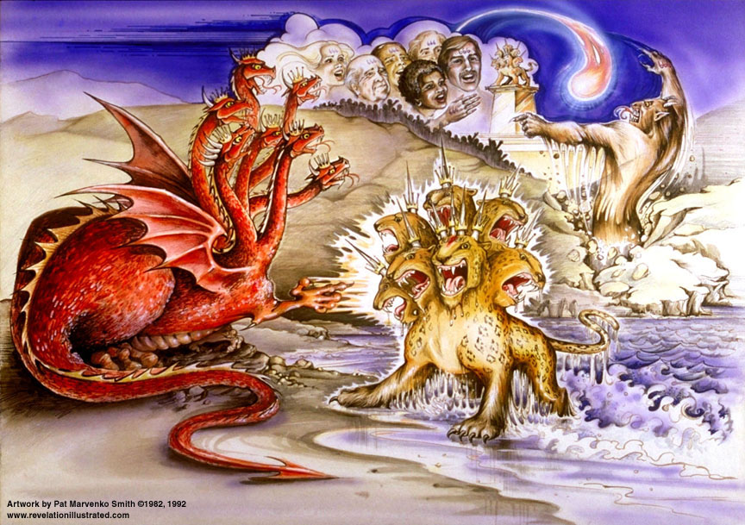

**Rev. 12:3** And another sign appeared in heaven: and behold, a **great red dragon** having seven heads and ten horns, and on his heads *were* seven diadems.

**2 More Actors in the End Times**

| **Revelation 13** | **Bible References** | | **Notes** | |
| --- | --- | --- | --- | --- |
| **Rev. 12:17**  So the **dragon was enraged** with the woman, and **went off to make war with the rest of her children**, who keep the commandments of God and **hold to the testimony of Jesus**. | | | | |
| **The Antichrist (“against” Christ) Arises** | | | | |
| **Rev. 13:1** And the **dragon** [*KJV, “I”]* stood on the **sand of the seashore**. And I [*John*] saw a **beast coming up out of the sea**, having **ten horns** and **seven heads**, and **on his horns** *were* **ten diadems**, and on his heads *were* **blasphemous** names.   * **Seven heads (Rev 17:3-13)**   1. Egypt   2. Assyria   3. Babylonia [**Lion**]   4. Medo-Persia [**Bear**]   5. Greece [**Leopard**]   6. **Rome** [*aggregate of all*, ***4th of Daniel’s 4 beasts***, **Dan 7:4-7]**   7. Revived Rome   8. **Antichrist** [*8th of John’s kings*] | **Rev. 11:7** When they have finished their testimony, the **beast** **that comes up out of the abyss** will make war with them, and overcome them and kill them.  **Luke 22:3** And **Satan entered into Judas** who was called Iscariot, belonging to the number of the twelve.  **1 John 2:18** Children, **it is the last hour**; and just as you heard that **antichrist** is coming, even now many **antichrists** have arisen; from this we know that **it is the last hour**.  **1 John 2:22** Who is the liar but the one who denies that Jesus is the Christ? This is the **antichrist**, …  **1 John 4:3** and every spirit that does not confess Jesus is not from God; and this is the spirit of the **antichrist**, …  **2 John 1:7** … those who do not acknowledge Jesus Christ as coming in the flesh. This is the deceiver and the **antichrist**. | | * “sand of the seashore” – among the multitudes, the gentiles [**Rev 20:8**] * The **beast** - **both** a person and a system – king and kingdom (**the antichrist**); not just false doctrine! * “last hour” – began with the coming of the Messiah * **Sea** – peoples of world; some say it is the abyss – **best is both**: a gentile man empowered by Satan. * **Ten horns –** 10 nation confederacy of the revived Roman empire   + **Rev 12:3** diadems on 7 heads??   + **Rev 13:1** diadems on 10 horns?? | |
| 2And the beast which I saw was like a **leopard**, and his feet were like *those* of a **bear**, and his mouth like the mouth of a **lion**. And the **dragon** gave **him** his power and his **throne** and great **authority**. | **Daniel 7:8**  "While I was contemplating the horns, behold, **another horn, a little one**, came up among them, and three of the first horns were pulled out by the roots before it; and behold, this horn possessed eyes like the eyes of a man and a mouth uttering great *boasts.* | | **Rev 17:11** "And **the beast** which was and is not, is himself also an **eighth**, and is *one* of the seven, and he goes to destruction.  ***MacArthur****: This is Satan's supreme human instrument* ***to destroy Israel*** *– to prevent Christ from reigning – to prevent God fulfilling His covenant.* | |
| 3And *I saw* **one of his heads** **as if** it had been **slain**, and his **fatal wound** was **healed**. And the **whole earth was amazed** *and* ***followed* after the beast**; 4and they **worshiped** the **dragon**, because **he gave his authority to the beast**; and they **worshiped** the **beast**, saying, "Who is like the beast, and who is able to wage war with him?" | **Rev. 17:8-11** "The **beast** that you saw **was** and **is not**, and **is about** to **come up out of the abyss** and to go to destruction. And **those who dwell on the earth** will wonder, whose name has **not** been written in the book of life from the foundation of the world, when they see the beast, that **he was** and **is not** and **will come**. …11"And the beast which **was** and **is not**, **is** himself also an **eighth**, and is ***one* of the seven**, and he goes to destruction.  See verses **12 & 14** below. | | * “Fatal wound” meaning either:  1. 6th kingdom, Rome, disappears and is revived as 7th kingdom   or   1. Antichrist slain and resurrected   or   1. # 2 above, but faked   #3 is strongest; see **Rev 13:14** below.   * Worship is the principle aim of Satan | |
| 5And there was **given** to him a mouth speaking arrogant words and **blasphemies**; and authority to act for **forty-two months** was **given** to him. 6And he opened his mouth in **blasphemiesagainst God**, to **blaspheme** His **name** and His **tabernacle**, *that is*, those who dwell in heaven. | **Isaiah 14:14** 'I will ascend above the heights of the clouds; I will make myself like the Most High.'  **Daniel 11:36-37** "Then the king will do as he pleases, and he will exalt and **magnify himself above every god**, and will speak **monstrous things against the God of gods**; and he will prosper until the indignation is finished, for that which is decreed will be done. 37"And he will show **no regard for the gods of his fathers** or for the **desire of women**, nor will he show regard for **any *other* god**; for **he will magnify himself above *them* all**. | | * “desire of women” – in context all references are to ‘his’ **worship**; he will worship only himself. * “Forty-two months” – ?? * “Blaspheme” – not curses but slandering God | |
| 7And it was **given** to him to make **war with the saints** and to overcome them; and **authority over** every **tribe** and **people** and **tongue** and **nation** was **given** to him. | **Daniel 7:21** "I kept looking, and that horn was waging war with the saints and overpowering them | | * Note that all these things are “**given**” to him. | |
| 8And **all who dwell on the earth** will worship him, *everyone* whose name has not been written **from the foundation of the world** in the **book of life** **of the Lamb** who has been slain. | **Philip. 4:3** … help these women who have shared my struggle in the cause of the gospel, together with Clement also, and the rest of my fellow workers, whose names are in the **book of life**.  **Rev. 17:8** "… And **those who dwell on the earth** will **wonder**, whose name has not been written in the **book of life** from the foundation of the world, when they see the beast, that he was and is not and will come.  **Rev. 20:12-15** And I saw the dead, the great and the small, standing before the throne, and books were opened; and another book was opened, which is the **book of life**; and the dead were judged from the things which were written in the books, according to their deeds…15And if anyone's name was not found written in the **book of life**, he was thrown into the **lake of fire**. | | * “**all who dwell on the earth**” – unbelievers, not everyone. Mentioned 4 times in **Rev 13**.   **1 Peter 1:18-19** knowing that you were **not redeemed with perishable things** like silver or gold from your futile way of life inherited from your forefathers, 19but with **precious blood**, as of a lamb unblemished and spotless, ***the blood* of Christ**.   * **Christ owns the book of life**. | |
| 9If **anyone has an ear, let him hear**. 10If anyone *is destined* for captivity, to captivity he goes; if anyone kills with the sword, with the sword he must be killed. Here is the **perseverance** and the **faith** of the **saints**. | **Matthew 11:15** "**He who has ears to hear, let him hear**.  **Matthew 13:9** "**He who has ears, let him hear**."  **Matthew 13:43** "Then the righteous will shine forth as the sun in the kingdom of their Father. **He who has ears, let him hear**.  **Rev. 2:7** **'He who has an ear, let him hear what the Spirit says to the churches**. …[*repeated for all 7 letters to churches*]  ***Daniel 7:21*** *"I kept looking, and that horn was waging war with the saints and overpowering them* | | * “If anyone has an ear, let him hear” – **flag** noting import of statement * Note missing phrase – “what the Spirit says to the churches” * This exhorts believers **NOT** to take up arms – **perseverance** [***hopeful endurance***]   **Romans 8:25** But if we **hope for what we do not see**, with **perseverance** we wait eagerly for it. | |
| **The Final False Prophet** | | | | |
| 11And I saw **another** **beast coming up out of the earth**; and he had two horns like a **lamb**, and he spoke as a **dragon**. 12And he **exercises all the authority of the first beast** in his presence. And he makes the earth and **those who dwell in it** to **worship** the **first** **beast**, whose **fatal wound** was healed. | | **Rev. 16:13** And I saw *coming* out of the mouth of **the dragon** and out of the mouth of **the beast** and out of the mouth of **the false prophet**, three unclean spirits like frogs; | | * “another” – of the same kind, meaning a human not an institution * “Out of the earth” implies from human society, e.g. secularism, apostate religion. * “lamb” – meekness and gentleness deception * We have an **unholy trinity** now. |
| 13And he performs **great signs**, so that he even makes **fire** come down out of heaven to the earth in the presence of men. 14And he **deceives** **those who dwell on the earth** because of the signs which it was given him to perform in the presence of the **beast**, telling **those who dwell on the earth** to make an **image to the beast** who **had the wound of the sword and has come to life**. | | **2 Thes. 2:3-4** Let no one in any way deceive you, for ***it will not come*** unless the **apostasy comes first**, and the **man of lawlessness is revealed, the son of destruction**, 4who opposes and exalts himself above every so-called god or object of worship, so that **he takes his seat in the temple of God**, displaying himself as being God…  **Rev. 19:20**  And the beast was seized, and with him **the false prophet who performed the signs in his presence**,  **Matt 24:15** "Therefore when you see the **ABOMINATION OF DESOLATION** which was spoken of through Daniel the prophet, standing in the holy place (let the reader understand), | | **2 Kings 1:10** And Elijah answered and said to the captain of fifty, "If I am a man of God, **let fire come down from heaven** and consume you and your fifty." Then fire came down from heaven and consumed him and his fifty.   * “deceives” – Greek **planao**, literally to cause to wander, root of the word planet |
| 15And there was **given** to him to **give** **breath** **to the image of the beast**, that the image of the beast might even **speak** and cause as many as do not worship the image of the beast to be **killed**. 16And he causes **all**, the small and the great, and the rich and the poor, and the free men and the slaves, to be given a **mark** on their **right hand**, or on their **forehead**, 17and *he provides* that **no one should be able to buy or to sell**, except the one who has the mark, *either* the **name** of the beast or the **number** of his name. | | **Daniel 3:3-6** Then the satraps, the prefects and the governors, the counselors, the treasurers, the judges, the magistrates and all the rulers of the provinces were assembled for the **dedication of the image that Nebuchadnezzar the king had set up**; and they stood before the image that Nebuchadnezzar had set up….6"But **whoever does not fall down and worship shall immediately be cast into the midst of a furnace** of blazing fire."  **Deut. 11:18** "You shall therefore impress these words of mine on your heart and on your soul; and you shall bind them as a sign on your **hand**, and they shall be as frontals on your **forehead**. | | * “breath” – spirit or wind * See martyrs of **Rev 6:9-11; 7:13-14** |
| 18Here is **wisdom**. Let him who has understanding calculate the number of the beast, for the **number** is that of a **man**; and his number is **six hundred and sixty-six**. | |  | | * “Here is wisdom” – only those alive at the time **can and must** determine the meaning |
| ***Revelation 13*** *gives much insight into the character of the Great Tribulation. It will be a time of one world government and one world religion, with one world economic system. Those who will resist the ruler and refuse to worship him will be subject to execution, and the martyrs may outnumber the believers who survive. It will be Satan's final and ultimate attempt to cause the world to worship him and to turn them from the worship of the true God and Jesus Christ as their Savior. This chapter also makes it clear that the postmillennial dream of a world getting better and better through Christian effort and gospel preaching is not supported in the Bible. Instead the final form of world religion will be apostate, satanic, and blasphemous. There are many indications today that the world is heading in this direction, with the corresponding conclusion that the coming of the Lord may be near.* | | | | |