The Revelation of Jesus Christ
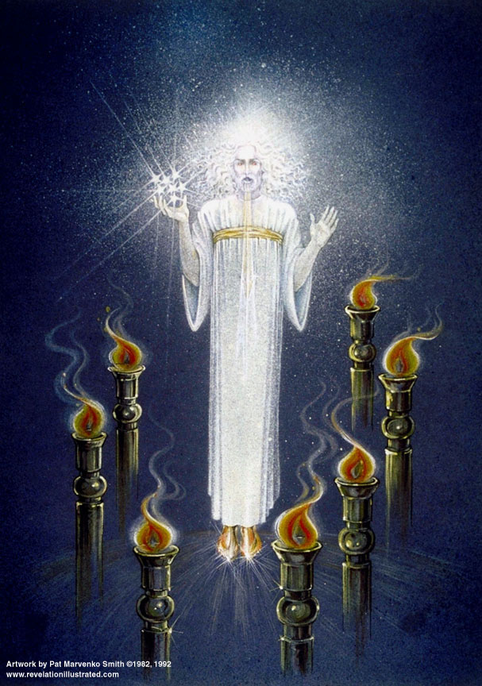
Lsn 3a of 22

5 – Sardis

The City

Sardis (plural noun) means “those escaping” or “remnant”, Pentecost p.152

Built on a small elevated plateau; later had to expand to the base of the tower; thus it was two towns.

Wealthy from textiles, dyes, and jewelry; on east-west trade route; first to produce coins.

Originally military power; overthrown twice by scaling the cliffs when they were asleep [549 BC and 214 BC].

Gross depravity – many mystery cults, secret societies; grossest most decadent religious rituals.

worship of mother goddess Cybele (or Artemis, earth mother – Gaia)

remains of a small church building discovered next to the temple to Artemis.

Letter starts with condemnation

Rev. 3:1-6 "And to the angel of the church in Sardis write:

He who has the seven Spirits of God, and the seven stars, says this: 'I know your deeds, that you have a name that you are alive, but you are dead. 2'Wake up, and strengthen the things that remain, which were about to die; for I have not found your deeds completed in the sight of My God. 3'Remember therefore what you have received and heard; and keep it, and repent. If therefore you will not wake up, I will come like a thief, and you will not know at what hour I will come upon you. 4'But you have a few people in Sardis who have not soiled their garments; and they will walk with Me in white; for they are worthy. 5'He who overcomes shall thus be clothed in white garments; and I will not erase his name from the book of life, and I will confess his name before My Father, and before His angels. 6'He who has an ear, let him hear what the Spirit says to the churches.'

Cross Reference verses:

Seven Spirits of God
Isaiah 11:2 The Spirit of the LORD will rest on Him, The spirit of wisdom and understanding, The spirit of counsel and strength, The spirit of knowledge and the fear of the LORD.
John 15:26 "When the Helper comes, whom I will send to you from the Father, that is the Spirit of truth who proceeds from the Father, He will testify about Me,
John 16:8 "And He, when He comes, will convict the world concerning sin and righteousness and judgment”
John 16:13 "But when He, the Spirit of truth, comes, He will guide you into all the truth… ¹⁴"He will glorify Me, for He will take of Mine and will disclose it to you.
Galatians 5:22-23 But the fruit of the Spirit is love, joy, peace, patience, kindness, goodness, faithfulness, ²³ gentleness, self-control; against such things there is no law.

Come like a thief?
1 Thessalonians 5:4 But you, brethren, are not in darkness, that the day would overtake you like a thief;

Unstained, white linen.
James 1:27 Pure and undefiled religion in the sight of our God and Father is this: to visit orphans and widows in their distress, and to keep oneself unstained by the world.
Revelation 19:7-8 "Let us rejoice and be glad and give the glory to Him, for the marriage of the Lamb has come and His bride has made herself ready." ⁸ It was given to her to clothe herself in fine linen, bright and clean; for the fine linen is the righteous acts of the saints.

The Book of Life
Matthew 25:34 "Then the King will say to those on His right, 'Come, you who are blessed of My Father, inherit the kingdom prepared for you from the foundation of the world.
Revelation 17:8 "The beast that you saw was, and is not, and is about to come up out of the abyss and go to destruction. And those who dwell on the earth, whose name has not been written in the book of life from the foundation of the world, will wonder when they see the beast, that he was and is not and will come.
John 10:28 and I give eternal life to them, and they will never perish; and no one will snatch them out of My hand.
Romans 8:38-39 For I am convinced that neither death, nor life, nor angels, nor principalities, nor things present, nor things to come, nor powers, ³⁹ nor height, nor depth, nor any other created thing, will be able to separate us from the love of God, which is in Christ Jesus our Lord.

Sardis-1: 1517-1789 AD – Reformed Church
(Church History in Plain Language, Bruce Shelley)

Reformation 1517 – 1648

Period characterized as “Christians compelling conformity to their sect”; man served one of two authorities [the church or the Bible]; concern in this life was preparing for next life

1517 AD, Martin Luther’s 95 Theses

Issues: How saved? Basis for religious authority? What is the Church? What is Christian living?

Answers: Faith alone. Scripture alone. Not a hierarchy, but community of believers. Serving God in ecclesiastical or secular calling.

1521 Anabaptist [Zwigli] rejected infant baptism: 5000 executed

Discipleship; Congregational; separation of church and state; freedom of religion

Forerunner of all Protestants.

1525 William Tyndale’s Bible: “I will make it possible for a boy behind the plow to know more Scripture than you do,” to a priest. Burned at the stake in 1537.

1536 John Calvin - Justification by faith; Sovereignty of God
- 1545-1563 Council of Trent - Catholic condemnation of Protestant heresies (see below on Five Solas)
- 1552 “Bloody Mary” restored Catholicism, burned over 280 Protestants at the stake
- 1630 400 Puritans set sail for the New World
- Rise of Protestant denominations – “called by” or denominated by.
  - Sects claim Christ only for themselves, all others are unsaved
  - Denominations have common core beliefs but differing practices

1648 Peace of Westphalia ends 30 Years War between Catholics and Protestants.
  - Each prince would have the right to determine the religion of his own state, the options being Roman Catholicism, Lutheranism, and Calvinism
  - Christians living in principalities where their denomination was not the established church were guaranteed the right to practice their faith in public during allotted hours and in private at their will.

The result was “state churches”, not the ideal in which ministers are controlled by, and subject to, Christ alone without any human intermediary.

Out of the Reformation: Five Solas
- Sola Scriptura — by Scripture alone (authority)
- Sola Fide — by faith alone (justification)
- Sola Gratia — by grace alone (salvation)
- Solus Christus — through Christ alone (‘’)
- Soli Deo Gloria — glory to God alone (none other)

Sardis-2: 1517-1789 AD – Dead Church
(Church History in Plain Language, Bruce Shelley)

Age of Reason (Enlightenment) 1648 – 1789

The birth of secularism

1648 Peace of Westphalia ends 30 Years War between Catholics and Protestants.
- Religious tolerance rules the day – behavior is more important than belief
- Age of Reason: “The birth of secularism”
- Copernicus (center of solar system), Kepler (sun’s gravity drives), Galileo (telescope), Newton (harmonized laws of motion): man can determine truth thru “senses & reason”
- Originally attempted harmony of reason & faith; then reason replaced faith; revelation rejected; man’s concern becomes happiness in this life.
- Man viewed as basically good, needs common sense more than grace
- New faith in law & order: Man can legislate good behavior
- Modern culture is freed from Christianity; attempts to organize religiously neutral civilization
- 1733 Great Awakening: Jonathan Edwards, George Whitfield, John Wesley
- 1789 French Revolution and the “Evangelical Awakening”

The hidden treasure

Matthew 13:44 "The kingdom of heaven is like a treasure hidden in the field, which a man found and hid; and from joy over it he goes and sells all that he has, and buys that field.
Deuteronomy 7:6 "For you are a holy people to the LORD your God; the LORD your God has chosen you to be a people for His own possession out of all the peoples who are on the face of the earth.
Deuteronomy 26:18 "The LORD has today declared you to be His people, a treasured possession, as He promised you, and that you should keep all His commandments;
Deuteronomy 32:9-10 For the LORD'S portion is his people; Jacob is the lot of his inheritance. ¹⁰ He found him in a desert land, and in the waste howling wilderness; …
Exodus 19:5 Now therefore, if ye will obey my voice indeed, and keep my covenant, then ye shall be a peculiar treasure unto me above all people: for all the earth is mine:
Psalm 135:4 For the LORD hath chosen Jacob unto himself, and Israel for his peculiar treasure.

Application:

- To the Church local & universal –

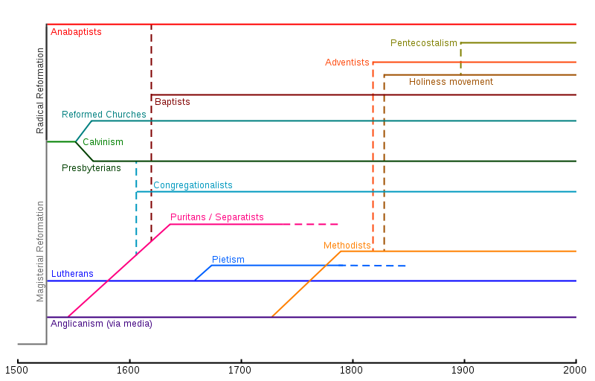
http://en.wikipedia.org/wiki/Christian_denomination

- To the Individual Christian –

