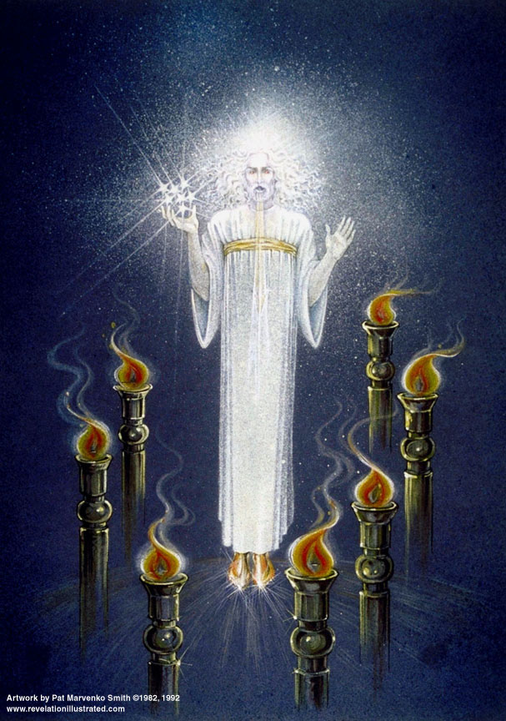

The Revelation of Jesus Christ
Lsn 2c of 22

3 - Pergamum

The City

Pergamos [per + gamos] = “additional marriage”

Wealthy, college [Chaldean origin]

Many temples; Satan’s throne [vs. synagogue of Satan in letter to Smyrna]

Civic & religious life entwined

Guilds, heathen feasts

Doctrine of Balaam accepted

Doctrine of Nicolaitans accepted

Christianity became popular

Rev. 2:12-17 "And to the angel of the church in Pergamum write:

The One who has the sharp two-edged sword says this: 13'I know where you dwell, where Satan's throne is; and you hold fast My name, and did not deny My faith, even in the days of Antipas, My witness, My faithful one, who was killed among you, where Satan dwells. 14'But I have a few things against you, because you have there some who hold the teaching of Balaam, who kept teaching Balak to put a stumbling block before the sons of Israel, to eat things sacrificed to idols, and to commit acts of immorality. 15'Thus you also have some who in the same way hold the teaching of the Nicolaitans. 16'Repent therefore; or else I am coming to you quickly, and I will make war against them with the sword of My mouth. 17'He who has an ear, let him hear what the Spirit says to the churches. To him who overcomes, to him I will give some of the hidden manna, and I will give him a white stone, and a new name written on the stone which no one knows but he who receives it.'
The Sharp Two-edged Sword
2 Timothy 3:15-16 …from childhood you have known the sacred writings which are able to give you the wisdom that leads to salvation through faith which is in Christ Jesus. ¹⁶ All Scripture is inspired by God and profitable for teaching, for reproof, for correction, for training in righteousness;
Heb 4:12 For the word of God is living and active and sharper than any two-edged sword, and piercing as far as the division of soul and spirit, of both joints and marrow, and able to judge the thoughts and intentions of the heart.
Ephesians 6:17 And take THE HELMET OF SALVATION, and the sword of the Spirit, which is the word of God.
Isa 11:4 But with righteousness He will judge the poor, And decide with fairness for the afflicted of the earth; And He will strike the earth with the rod of His mouth, And with the breath of His lips He will slay the wicked.
2 Thessalonians 2:8 Then that lawless one will be revealed whom the Lord will slay with the breath of His mouth and bring to an end by the appearance of His coming;
Rev 2:16 'Therefore repent; or else I am coming to you quickly, and I will make war against them with the sword of My mouth.
Rev 19:15 From His mouth comes a sharp sword, so that with it He may strike down the nations, …
Rev 19:21 And the rest were killed with the sword which came from the mouth of Him who sat on the horse, and all the birds were filled with their flesh.

Reference verses in slides:
Rev 8:13 Then I looked, and I heard an eagle flying in midheaven, saying with a loud voice, "Woe, woe, woe to those who dwell on the earth, because of the remaining blasts of the trumpet of the three angels who are about to sound!“
Heb 11:13 All these died in faith, without receiving the promises, but having seen them and having welcomed them from a distance, and having confessed that they were strangers and exiles on the earth.
Matt 10:32-33 "Therefore everyone who confesses Me before men, I will also confess him before My Father who is in heaven. ³³ "But whoever denies Me before men, I will also deny him before My Father who is in heaven.
1 Tim 4:6 In pointing out these things to the brethren, you will be a good servant of Christ Jesus, constantly nourished on the words of the faith and of the sound doctrine which you have been following.
John 6:32-35 Jesus then said to them, "Truly, truly, I say to you, it is not Moses who has given you the bread out of heaven, but it is My Father who gives you the true bread out of heaven. ³³ "For the bread of God is that which comes down out of heaven, and gives life to the world." ³⁴ Then they said to Him, "Lord, always give us this bread." ³⁵ Jesus said to them, "I am the bread of life; he who comes to Me will not hunger, and he who believes in Me will never thirst.”

Pergamum: 313-500 AD – Compromising Church
(Church History in Plain Language, Bruce Shelley)
- 312 AD, Constantine conquered Rome under the sign of the Cross
  - Favored Christianity, Sunday a holiday, no crucifixions
  - Ruled Christian bishops as he did his civil servants
  - Church moves from only convicted believers to now include politically ambitious
  - Decline in Christian commitment
- Heresies about Christ arise – 350 to 451 AD -> Councils
  - Nicaea 325 – Christ fully divine
  - Constantinople 381 – Christ fully human
  - Ephesus 431 – Christ a unified person
  - Chalcedon 451 – Christ fully human and divine in one person
- Doctrine of the Trinity developed during this age
  - Latin word ‘persona’ did not mean ‘person’ as today; but referred to the the actor’s mask.
  - As used in doctrine it meant that in the Trinity are “three personal disclosures of Himself.”
- 455 AD Bishop Leo assumed title “Pontifex Maximus”
  - Bishop in major regional town supervised bishop in metropolis; bishop in metropolis supervised bishops in the provincial towns; bishop in province towns supervised new churches in countryside led by priests.
- Barbarians join the church by individual conversion; also by king/national conversion and infiltration of traditions [view of Jesus as war lord].

Parable: The mustard seed
Matthew 13:31-32 He presented another parable to them, saying, "The kingdom of heaven is like a mustard seed, which a man took and sowed in his field; 32and this is smaller than all other seeds; but when it is full grown, it is larger than the garden plants, and becomes a tree, so that the birds of the AIR come and nest in its branches."

[In the parable of the Sower, what did the birds represent?]

Take Away – “What does it mean to compromise?”

