The Revelation of Jesus Christ
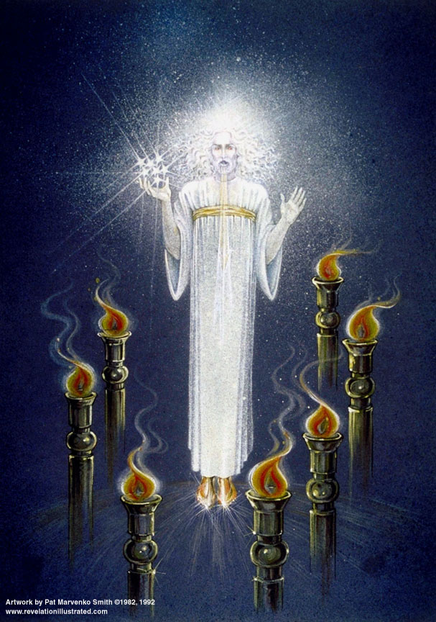
Lsn 2d of 22
4 - Thyatira

The City

Transliterated – Thuateira: "thuo" sacrifice +"ateires" unweary (or continuing)
[Harry Ironside]

Small and obscure manufacturing town, especially purple dye

Acts 16, Lydia converted; seller of purple

Baal worship (Jezebel, 1 Kings 18-20), pagan doctrines part of the culture

Some think the local church was possibly led by a woman (why is this not true?)

The Letter: Rev. 2:18-29 "And to the angel of the church in Thyatira write:

The Son of God, who has eyes like a flame of fire, and His feet are like burnished bronze, says this: 19'I know your deeds, and your love and faith and service and perseverance, and that your deeds of late are greater than at first. 20'But I have this against you, that you tolerate the woman Jezebel, who calls herself a prophetess, and she teaches and leads My bond-servants astray, so that they commit acts of immorality and eat things sacrificed to idols. 21'And I gave her time to repent; and she does not want to repent of her immorality. 22'Behold, I will cast her upon a bed of sickness, and those who commit adultery with her into great tribulation, unless they repent of her deeds. 23'And I will kill her children with pestilence; and all the churches will know that I am He who searches the minds and hearts; and I will give to each one of you according to your deeds. 24'But I say to you, the rest who are in Thyatira, who do not hold this teaching, who have not known the deep things of Satan, as they call them-- I place no other burden on you. 25'Nevertheless what you have, hold fast until I come. 26'And he who overcomes, and he who keeps My deeds until the end, to him I will give authority over the NATIONS; 27AND HE SHALL RULE THEM WITH A ROD OF IRON, as the vessels of the potter are broken to pieces, as I also have received authority from My Father; 28and I will give him the morning star. 29'He who has an ear, let him hear what the Spirit says to the churches.'
Cross Reference verses:
1 John 5:5 Who is the one who overcomes the world, but he who believes that Jesus is the Son of God?
1 Kings 21:25 Surely there was no one like Ahab who sold himself to do evil in the sight of the LORD, because Jezebel his wife incited him.
1 Corinthians 6:2 Or do you not know that the saints will judge the world? If the world is judged by you, are you not competent to constitute the smallest law courts?
Revelation 22:16 "I, Jesus, have sent My angel to testify to you these things for the churches. I am the root and the descendant of David, the bright morning star."

The Church Period: 500-1517 AD – Love, but Corrupted Church
(Church History in Plain Language, Bruce Shelley)

- Breakdown of Roman society and rise of the church as unifying influence
  - Vandals, Huns, and Goths over run Europe
  - Rome sacked in 455, no longer a stabilizing influence
  - “The church sought to combine Christianity with pagan philosophy and heathen religious rites so that much of the ritual of the church of that period is directly traceable to comparable ceremonies in heathen religion.” – Walvoord, p 75.
- 590 AD Gregory [a monk] elected the “Reluctant” Pope
  - taught man wins merit by his good works plus grace…
  - must do penance for sins committed after baptism…
  - belief in the intercession of the saints, holy relics have power, remaining sins atoned in purgatory, Eucharist is actual body and blood of Christ
  - priest offers the blood for the sins of the participants, unlike Christ for all men
- 800 AD King Charles the Great (Charlemagne) rescued Pope Leo III, who then crowns him King of all Christendom
- Weak succeeding kings lead to feudalism, political popes
  - Lords, vassals, fiefs, local government; bishops and abbots became vassals
- 1100-1300 AD Crusades; Inquisitions to drive out heresies (including rejection of authority)
- ~1300 Mary elevated to co-redemptress
- 1348-1350 – The Black Death sweeps Europe; ~100 million die (40% of population) à “Ring around the rosie”
- 1378 John Wycliffe (first reformer, Wycliffe Bible, persecuted, body desecrated)
  - “Every man, whether priest or layman, holds an equal place in the eyes of God.”
  - Believers should search the scriptures themselves
  - Preaching is of more value than any sacrament; NO transubstantiation
  - NO transubstantiation; mediating priesthood is not necessary!!
  - “The papal institution is full of poison. It is Antichrist itself, the man of sin who exalts himself above God. Let judgment fall!”
  - “The church is other than an organization on earth headed by a pope”
  - Too powerful to martyr, John Wyclif was persecuted and after death his body was desecrated
- 1517 Martin Luther’s 95 Theses
- 1522 William Tyndale to a clergyman, "I defy the Pope, and all his laws; and if God spares my life, ere many years, I will cause the boy that driveth the plow to know more of the Scriptures than thou dost!"

- The parable of the leaven – [focus on the nature of leaven once it is added to flour]

Matthew 13:33 He spoke another parable to them, "The kingdom of heaven is like leaven, which a woman took, and hid in three pecks of meal, until it was all leavened."

Matthew 16:5-12 And the disciples came to the other side of the sea, but they had forgotten to bring any bread. ⁶ And Jesus said to them, "Watch out and beware of the leaven of the Pharisees and Sadducees." ⁷They began to discuss this among themselves, saying, "He said that because we did not bring any bread." ⁸ But Jesus, aware of this, said, "You men of little faith, why do you discuss among yourselves that you have no bread? ⁹ "Do you not yet understand or remember the five loaves of the five thousand, and how many baskets full you picked up? ¹⁰ "Or the seven loaves of the four thousand, and how many large baskets full you picked up? ¹¹"How is it that you do not understand that I did not speak to you concerning bread? But beware of the leaven of the Pharisees and Sadducees." ¹² Then they understood that He did not say to beware of the leaven of bread, but of the teaching of the Pharisees and Sadducees.

1 Corinthians 5:6-13 Your boasting is not good. Do you not know that a little leaven leavens the whole lump of dough?... ⁹ I wrote you in my letter not to associate with immoral people; ¹⁰ I did not at all mean with the immoral people of this world, or with the covetous and swindlers, or with idolaters, for then you would have to go out of the world. ¹¹ But actually, I wrote to you not to associate with any so-called brother if he is an immoral person, or covetous, or an idolater, or a reviler, or a drunkard, or a swindler—not even to eat with such a one. ¹² For what have I to do with judging outsiders? Do you not judge those who are within the church? ¹³ But those who are outside, God judges. REMOVE THE WICKED MAN FROM AMONG YOURSELVES.
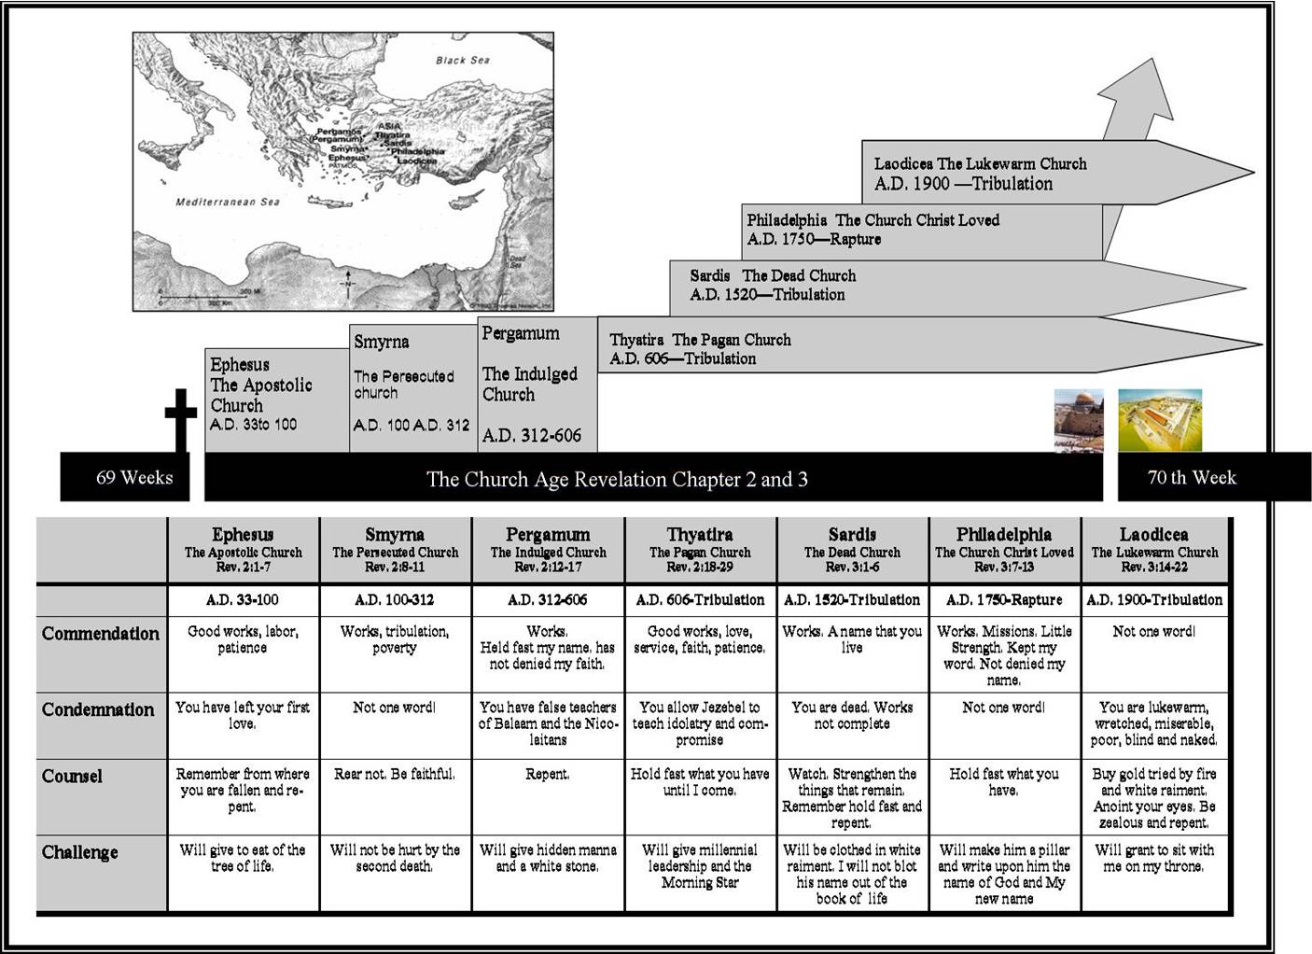
www.truthnet.org

