The Revelation of Jesus Christ – Letter to Ephesus
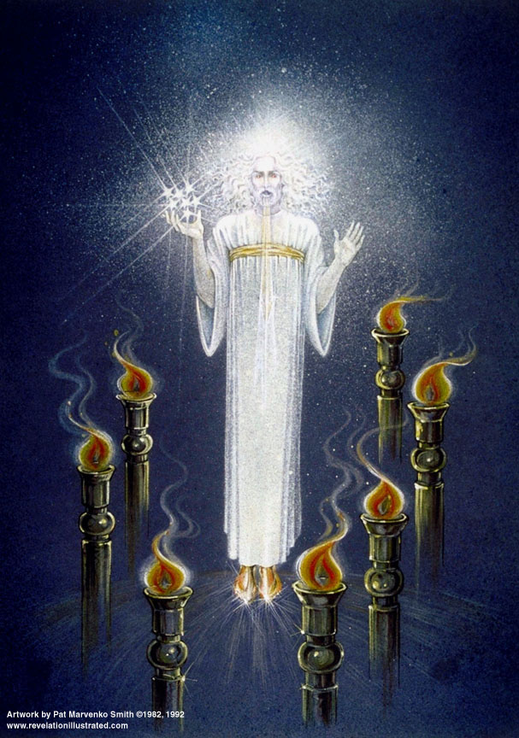
Lsn 1b of 22

Preparatory Material

- Some thoughts on the Course of the Church Age in Scripture
- There are several purposes in the writing of the 7 letters – (Walvoord, Major Bible Prophesies, p51)
  - The 7 churches in Rev 2&3 were selected because the spiritual state in each was precisely as described, and the exhortation received was perfect.
  - They were also selected since they were normative and represented the various states of the local churches at that time, and throughout history.
  - The messages to the churches also prove extremely valuable to the individuals in those churches as pertaining to their personal Christian walk.
  - Finally, Pentecost adds, “…they foreshadowed the successive predominant phases through which the nominal Church was to pass, from the time when John saw the vision until the Lord came.” (Pentecost, Things to Come, p. 151)
- The age from the rejection of the Messiah by Israel to His reception by Israel at His second advent is outlined in two portions of scripture: Matt 13 and Rev 2 & 3: the former from the view point of God’s kingdom program and the latter from the point of view of the Church program – (Pentecost, p 138)
- Since the parables of Matt 13 and the letters to the churches in Rev 2 & 3 cover essentially the same time period we would expect there to be a parallelism in the development. We do not intend to infer that there is a one to one correspondence, rather, that there is a similarity in the progress of the course of the church age as revealed in them. (Pentecost, pp 141-144. 153)

- The Context of the Parables in Matthew13, the Kingdom of Heaven

Kingdom Announced

Matthew 3:1-2 Now in those days John the Baptist came, preaching in the wilderness of Judea, saying, ² "Repent, for the kingdom of heaven is at hand."

Matthew 4:17 From that time Jesus began to preach and say, "Repent, for the kingdom of heaven is at hand."

[Matthew distinguishes between kingdom of heaven and kingdom of God. The former includes unbelievers; the latter does not. Matt 19:24 "Again I say to you, it is easier for a camel to go through the eye of a needle, than for a rich man to enter the kingdom of God."]

Kingdom Validated

Matt 8-10: hundreds of miracles performed fulfilling Isaiah advent of the Messiah prophesy –
Isaiah 35:5-6 Then the eyes of the blind will be opened And the ears of the deaf will be unstopped. ⁶ Then the lame will leap like a deer, And the tongue of the mute will shout for joy. For waters will break forth in the wilderness And streams in the Arabah.

Kingdom Preached

Matthew 10:5-6 These twelve Jesus sent out after instructing them: "Do not go in the way of the Gentiles, and do not enter any city of the Samaritans; ⁶ but rather go to the lost sheep of the house of Israel.

Kingdom Rejected

Matthew 12:10-14 … And they questioned Jesus, asking, "Is it lawful to heal on the Sabbath?"—so that they might accuse Him …¹³ Then He *said to the man, "Stretch out your hand!" He stretched it out, and it was restored to normal, like the other. ¹⁴ But the Pharisees went out and conspired against Him, as to how they might destroy Him.

Kingdom Delayed for Israel (Jesus judges Israel)

Matthew 12:41-45 "The men of Nineveh will stand up with this generation at the judgment, and will condemn it because they repented at the preaching of Jonah; and behold, something greater than Jonah is here... ⁴³ "Now when the unclean spirit goes out of a man, it passes through waterless places seeking rest, and does not find it. ⁴⁴ "Then it says, 'I will return to my house from which I came'; and when it comes, it finds it unoccupied, swept, and put in order. ⁴⁵ "Then it goes and takes along with it seven other spirits more wicked than itself, and they go in and live there; and the last state of that man becomes worse than the first. That is the way it will also be with this evil generation."

Delayed for a reason! Romans 11:11 I say then, they did not stumble so as to fall, did they? May it never be! But by their transgression salvation has come to the Gentiles, to make them jealous.

Mystery Kingdom Prophesied by Christ
- Matthew 13 presents the 7 parables of the kingdom of heaven.

Matthew 13:10-11 And the disciples came and said to Him, "Why do You speak to them in parables?" ¹¹ Jesus answered them, "To you it has been granted to know the mysteries of the kingdom of heaven, but to them it has not been granted."

Israel rejected Christ. What happens to the kingdom program? Since the kingdom is the result of an irrevocable covenant it cannot be abandoned. Matt 13 gives the events in the development of the mystery kingdom. Instead of the world getting better it will get worse. Evil will prevail until Christ’s second advent [Pentecost, p141-144]

- On the Letters to the Churches in Rev 2 & 3
- It is worthy of note that the "Messages to the Seven Churches" are inserted between Two Visions, the "Vision of Christ" in the midst of the "Seven Lampstands" in Rev 1, and the "Vision of the Four and Twenty Elders" round about the Throne, in Rev 4. (Clarence Larkin, “Dispensational Truth”)
- To fill in the details of the actual history of the Church we will depend on Bruce Shelley’s The History of the Church in Plain Language

- How we will study Rev 2 & 3
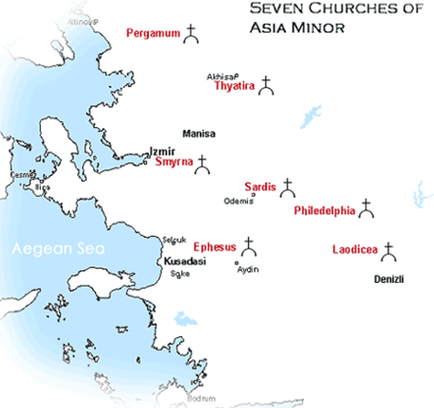

Interpretation: 7 actual churches in Asia

Application — Letters to the Church universal

No letters to Troas, Miletus, Colossi, Hierapolis

# 7 represents “completion”; used 57 times in Revelation

Application — Instruction to individual Christians

Application — General progress of Church in history from Pentecost to Rapture. (Walvoord, Revelation of Jesus Christ, p52)

7 epochs in the progress of the Church

Succeeding epoch does not necessarily end the preceding one

Insight – Matt 13 parables

1 - Ephesus

Rev. 2:1-7 "To the angel of the church in Ephesus write:

The One who holds the seven stars in His right hand, the One who walks among the seven golden lampstands, says this: ²'I know your deeds and your toil and perseverance, and that you cannot endure evil men, and you put to the test those who call themselves apostles, and they are not, and you found them to be false; ³and you have perseverance and have endured for My name's sake, and have not grown weary. ⁴'But I have this against you, that you have left your first love. ⁵'Remember therefore from where you have fallen, and repent and do the deeds you did at first; or else I am coming to you, and will remove your lampstand out of its place-- unless you repent. ⁶'Yet this you do have, that you hate the deeds of the Nicolaitans, which I also hate. ⁷'He who has an ear, let him hear what the Spirit says to the churches. To him who overcomes, I will grant to eat of the tree of life, which is in the Paradise of God.'

Ephesus: 30-100 AD – Apostolic Church
(Church History in Plain Language, Bruce Shelley)

How did a Jewish Messiah, preaching a Jewish them (the Kingdom of Heaven) to a Jewish following become the Savior of the World?

Read the Book of Acts [especially Stephen’s defense]

Early followers loyal to Jewish law, worshiped in synagogue. Were they part of Judaism or something new?

Bound by two ordinances they grew rapidly

Dispute between Palestinian and Hellenistic followers. Deacons named, including Stephen.

Stephen taught in Hellenistic synagogues, angered Jewish leaders

Stephen’s confrontation with Jewish authorities.

Not what scripture says but what it means!

Hebrew believers left alone, but Hellenist believers forced to flee Jerusalem to Samaria and Syria

Culturally they were at ease among their new neighbors, more so than Jewish believers

Founded churches in Damascus, Antioc, Tarsus, Cyprus, and Egypt

Paul heads for Damascus!!

The Sower has sown the Seeds!!

Parable: The Sower
Matthew 13:1-9 That day Jesus went out of the house and was sitting by the sea. ² And large crowds gathered to Him, so He got into a boat and sat down, and the whole crowd was standing on the beach. ³ And He spoke many things to them in parables, saying, "Behold, the sower went out to sow; ⁴ and as he sowed, some seeds fell beside the road, and the birds came and ate them up. ⁵ "Others fell on the rocky places, where they did not have much soil; and immediately they sprang up, because they had no depth of soil. ⁶ "But when the sun had risen, they were scorched; and because they had no root, they withered away. ⁷ "Others fell among the thorns, and the thorns came up and choked them out. ⁸ "And others fell on the good soil and *yielded a crop, some a hundredfold, some sixty, and some thirty. ⁹ "He who has ears, let him hear."

Matthew 13:10-13 And the disciples came and said to Him, "Why do You speak to them in parables?" ¹¹ Jesus answered them, "To you it has been granted to know the mysteries of the kingdom of heaven, but to them it has not been granted. ¹² "For whoever has, to him more shall be given, and he will have an abundance; but whoever does not have, even what he has shall be taken away from him. ¹³ "Therefore I speak to them in parables; because while seeing they do not see, and while hearing they do not hear, nor do they understand.

Matthew 13:18-23 "Hear then the parable of the sower. ¹⁹"When anyone hears the word of the kingdom, and does not understand it, the evil one comes and snatches away what has been sown in his heart. This is the one on whom seed was sown beside the road. ²⁰"And the one on whom seed was sown on the rocky places, this is the man who hears the word, and immediately receives it with joy; ²¹yet he has no firm root in himself, but is only temporary, and when affliction or persecution arises because of the word, immediately he falls away. ²²"And the one on whom seed was sown among the thorns, this is the man who hears the word, and the worry of the world, and the deceitfulness of riches choke the word, and it becomes unfruitful. ²³"And the one on whom seed was sown on the good soil, this is the man who hears the word and understands it; who indeed bears fruit, and brings forth, some a hundredfold, some sixty, and some thirty."

