The Revelation of Jesus Christ
Lsn 1 of 30
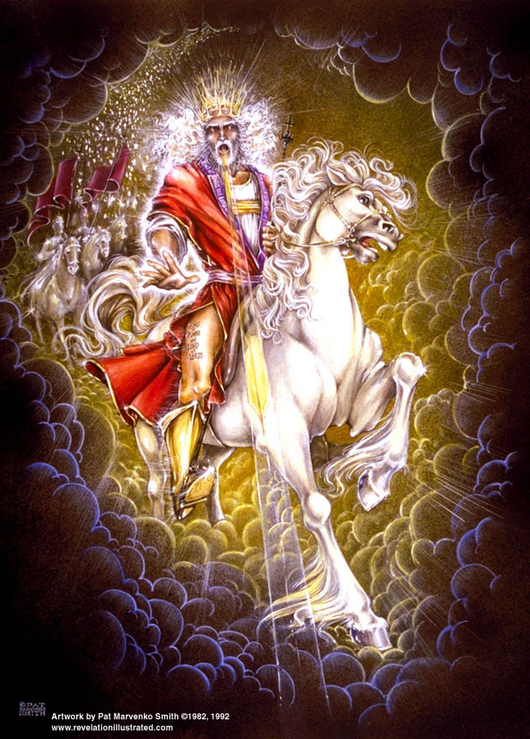

Introduction and Rev 1

- Three Points about Biblical Prophecy

________________________

________________________

________________________

Isaiah 46:10-11 Declaring the end from the beginning, And from ancient times things which have not been done, Saying, 'My purpose will be established, And I will accomplish all My good pleasure'; ¹¹ …Truly I have spoken; truly I will bring it to pass. I have planned it, surely I will do it.

2 Peter 1:20-21 But know this first of all, that no prophecy of Scripture is a matter of one's own interpretation, ²¹for no prophecy was ever made by an act of human will, but men moved by the Holy Spirit spoke from God.

1 Peter 1:10-12 As to this salvation, the prophets who prophesied of the grace that would come to you made careful search and inquiry, ¹¹seeking to know what person or time the Spirit of Christ within them was indicating as He predicted the sufferings of Christ and the glories to follow. ¹²It was revealed to them that they were not serving themselves, but you, in these things which now have been announced to you through those who preached the gospel to you by the Holy Spirit sent from heaven-- things into which angels long to look.

- Some Thoughts Revelation

Why are people interested in Revelation?

Why should people be interested in Revelation?

The Greek word for revelation is apokalupsis from which we get _________________________________________.

The Greek word means ____________________________________.

The English word means ___________________________________.

Why was John on Patmos when he received this revelation?

- Some Terms

The Rapture _________________________________________

The Tribulation _________________________________________

The 2nd Coming _________________________________________

The millennium _________________________________________
There is debate regarding the existence and order of these events/periods. Your position depends on several things.

The Millennial Kingdom _________________________________________

The Day of the Lord _________________________________________

- Simple timeline of God’s unfolding events:

Church Age
7 yrs of tribulation
Millennium
Eternal State

- What Airplane Are You On?

Biblical Interpretation

allegorical

literal, grammatical-historical

Millennial View (when does the 2nd Coming occur)

amillennial

post-millennial

pre-millennial

Eschatological View of Revelation

historical

preterist

historical-spiritual (symbolic/idealist)

futurist

Rapture View (when does the Rapture occur)

mid-tribulation

post-tribulation

pre-wrath

pre-tribulation

General Theological View

Covenant theology

Dispensational theology

- Millennial Views

  - Premillennialism – Christ returns and establishes His Kingdom on earth for 1000 years.
  - Amillennialism – millennium is symbolic (occurring now) and ends with the 2nd Coming (also Replacement Theology)
  - Postmillennialism – whole world will be Christianized, then 2nd Coming.

Constantine - 313AD
Augustine - ~400AD
Reformation – 1517AD

premillennialism
amillennialism
amillennialism
postmillennialism
premillennialism

- Eschatological Views of Revelation
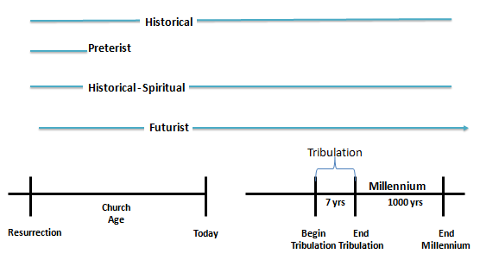
Revelation 20:4 Then I saw thrones, and they sat on them, and judgment was given to them. And I saw the souls of those who had been beheaded because of their testimony of Jesus and because of the word of God, and those who had not worshiped the beast or his image, and had not received the mark on their forehead and on their hand; and they came to life and reigned with Christ for a thousand years.

- Rapture Views

1 Thessalonians 4:16-17 For the Lord Himself will descend from heaven with a shout, with the voice of the archangel and with the trumpet of God, and the dead in Christ will rise first. ¹⁷ Then we who are alive and remain will be caught up together with them in the clouds to meet the Lord in the air, and so we shall always be with the Lord.
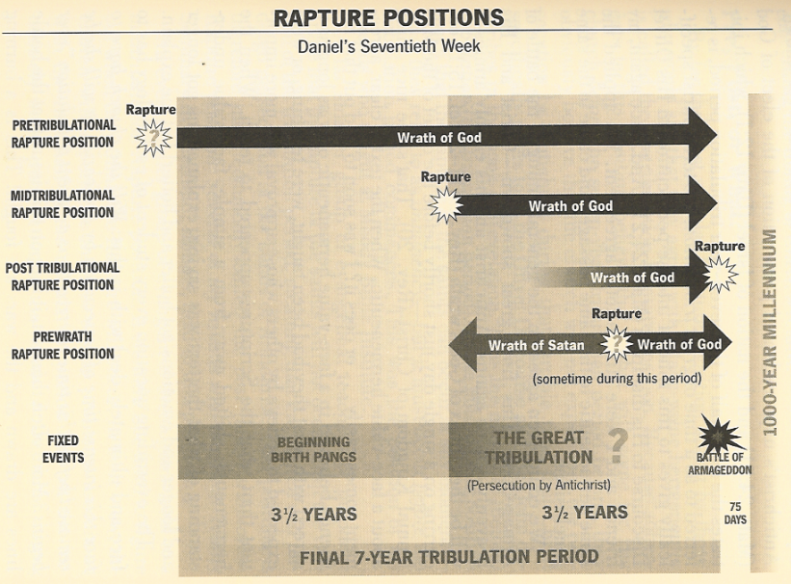
(Paul N. Benware, “Understanding End Times Prophecy”)

- General Theological Views
Interpretive View of… | Dispensational Theology  (Chafer, Walvoord, LaHaye, Darby, Scofield) | Covenant Theology  (Hodge, Warfield, Sproul…)
End Times [Eschatology] | Premillenial ⎯ The Church and Israel have separate and distinct roles and blessings in the Millennium, an actual 1000 reign of Christ on the earth. | Amillennial ⎯ Israel plays no role in the millennium [in fact, there is no millennium]  Postmillennial⎯ Church ushers in the millennium.
Biblical Interpretation | Literal grammatical-historical interpretation except where obviously symbolic | Dual-hermeneutic, unfulfilled prophesy is allegorical.  http://www.biblicalreader.com/btr/pdf/covenant_theology.pdf
Structure | 7 to 9 periods of stewardship (dispensations) in which God gives duties to man and holds him responsible for fulfilling…  innocence/conscience/govmnt/patriarch/mosaic/church/millennial | God’s relation to man based on three theological covenants (man-made concepts)…  redemption works grace  eternity past pre-fall old - new
View of history | Realistic: the Last Days are marked by increasingly worse wickedness in the world and by apostasy in the church | Optimistic: God is extending His kingdom thru the efforts of His Church.
Israel | Covenant promises to Israel are eternal and will be fulfilled. Israel will be restored as a nation after the Tribulation. | Covenant promises to Israel were conditional on obedience and Israel flunked. (Supersessionism or replacement theology)
Church | Created at Pentecost and is composed only of those baptized by the Holy Spirit. | The Church consists of all believers of all time, and is the true benefactor of God’s Old Testament promises.
Social implications | The only way to save the world is to save individuals; therefore evangelism takes precedence over "social action" | Emphasizes "cultural mandate", social activism
http://reformed-theology.org/html/c-vs-dis.htm
- On Israel [Larkin, “Dispensational Truths” - 1919]

- Dispersed for centuries among all nations, without a national centre, capital, government, flag, or rallying point, …never absorbed by the nations, … and we have the unique spectacle of a nation without a king… and a land that seems to be under a curse, awaiting the return of its legal owners.
- Amos 9:14-15 "Also I will restore the captivity of My people Israel, And they will rebuild the ruined cities and live in them; They will also plant vineyards and drink their wine, And make gardens and eat their fruit. ¹⁵ "I will also plant them on their land, And they will not again be rooted out from their land Which I have given them," Says the LORD your God.
- They will be gathered unconverted and judged:
Ezekiel 20:34-35 "I will bring you out from the peoples and gather you from the lands where you are scattered, with a mighty hand and with an outstretched arm and with wrath poured out; ³⁵ and I will bring you into the wilderness of the peoples, and there I will enter into judgment with you face to face.
- Then they will be cleansed:
Ezekiel 36:24-25 "For I will take you from the nations, gather you from all the lands and bring you into your own land. ²⁵ "Then I will sprinkle clean water on you, and you will be clean; I will cleanse you from all your filthiness and from all your idols.

- Overview of Revelation
(Benware, Understanding End Times Prophecy)
Location of events in each Revelation chapter
EVENTS IN HEAVEN: 1 4 5 19 - 20
EVENTS ON EARTH: 2 3 6 - 19 20 21 - 22
Church Age Tribulation Millennium Eternity
- Symbols in Revelation

(Walvoord, Every Prophecy of the Bible, p522, 523)

Seven stars (1:16)

Seven lampstands (1:13)

Hidden manna (2:17)

Morning star (2:28)

Key of David (3:7)

Seven lamps of fire (4:5)

Living creatures (4:7)

Seven eyes (5:6)

Odors of the golden vials (5:8)

Four horses and riders (6:1ff)

Fallen star (9:1)

Jerusalem: the great city (11:8)

Stars of heaven (12:4)

Woman and child (12:1-2)

Great dragon, old serpent (12:9, 20:2)

Time, times and a half time (12:14)

1260 days (12:6)

Beast out of the sea (13:1-10)

Beast out of the earth (13:11-17)

Harlot (17:1)

Waters (17:1)

Ten horns (17:12)

Lamb (17:14)

Fine linen (19:8)

Rider on white horse (19:11-16, 19)

Lake of fire (20:14)

Root and descendant of David (22:16)

- Facts about Revelation
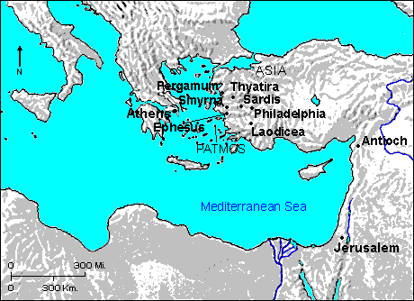
Patmos

Written ~ 90-96 AD

Only NT prophetic book

John covers eternity past (John 1) to eternity future (Rev 22)

There are 7 beatitudes (blessings)

It is like Union Station

It is not new prophecy, but a culmination of God’ plan presented in prophecy

It is Christ centered, a revelation of Jesus Christ (unveiling)

Begins with Jesus in His current ministry (High Priest)

Revelation 1 ⎯ “…things which you have seen…” (vs. 19)
Revelation 1 | Reference Verses | Other Verses & Notes
Prolog:  Rev. 1:1-3 The Revelation of Jesus Christ, which God gave Him to show to His bond-servants, the things which must shortly take place; and He sent and communicated it by His angel to His bond-servant John, ²who bore witness to the word of God and to the testimony of Jesus Christ, even to all that he saw. ³Blessed is he who reads and those who hear the words of the prophecy, and heed the things which are written in it; for the time is near. | Galatians 1:11-12 For I would have you know, brethren, that the gospel which was preached by me is not according to man. ¹² For I neither received it from man, nor was I taught it, but I received it through a revelation of Jesus Christ.  Mark 13:32 "But of that day or hour no one knows, not even the angels in heaven, nor the Son, but the Father alone.  John 12:49 "For I did not speak on My own initiative, but the Father Himself who sent Me has given Me a commandment as to what to say and what to speak  1 Cor. 2:14 But a natural man does not accept the things of the Spirit of God; for they are foolishness to him, … | 1 Peter 4:13 but to the degree that you share the sufferings of Christ, keep on rejoicing, so that also at the revelation of His glory you may rejoice with exultation.  Blessed: “possessing the favor of God”  Heed:”to guard, to keep, to fulfill a duty”
Salutation:  Rev. 1:4-8 John to the seven churches that are in Asia: Grace to you and peace, from Him who is and who was and who is to come; and from the seven Spirits who are before His throne; ⁵and from Jesus Christ, the faithful witness, the first-born of the dead, and the ruler of the kings of the earth. To Him who loves us, and released us from our sins by His blood, ⁶and He has made us to be a kingdom, priests to His God and Father; to Him be the glory and the dominion forever and ever. Amen. ⁷Behold, He is coming with the clouds, and every eye will see Him, even those who pierced Him; and all the tribes of the earth will mourn over Him. Even so. Amen.  ⁸"I am the Alpha and the Omega," says the Lord God, "who is and who was and who is to come, the Almighty." | Revelation 22:16 "I, Jesus, have sent My angel to testify to you these things for the churches. I am the root and the descendant of David, the bright morning star."  Ephes. 2:4-5 But God, being rich in mercy, because of His great love with which He loved us, 5even when we were dead in our transgressions, made us alive together with Christ (by grace you have been saved),.  Zech. 12:10 "And I will pour out on the house of David and on the inhabitants of Jerusalem, the Spirit of grace and of supplication, so that they will look on Me whom they have pierced; and they will mourn for Him, as one mourns for an only son, and they will weep bitterly over Him, like the bitter weeping over a first-born. | - Who is the Book for?  1 Cor 15:20 But now Christ has been raised from the dead, the first fruits of those who are asleep.  Daniel 7:13 "I kept looking in the night visions, And behold, with the clouds of heaven One like a Son of Man was coming, And He came up to the Ancient of Days And was presented before Him.  - Which Coming is this?
Vision of Christ Glorified:  Rev. 1:9-11 I, John, your brother and fellow partaker in the tribulation and kingdom and perseverance which are in Jesus, was on the island called Patmos, because of the word of God and the testimony of Jesus. ¹⁰I was in the Spirit on the Lord's day, and I heard behind me a loud voice like the sound of a trumpet, ¹¹saying, "Write in a book what you see, and send it to the seven churches: to Ephesus and to Smyrna and to Pergamum and to Thyatira and to Sardis and to Philadelphia and to Laodicea." |  | - What kingdom?  - Why was John on Patmos?  - To whom is this book written?
Rev. 1:12-16 And I turned to see the voice that was speaking with me. And having turned I saw seven golden lampstands; ¹³and in the middle of the lampstands one like a son of man, clothed in a robe reaching to the feet, and girded across His breast with a golden girdle. ¹⁴And His head and His hair were white like white wool, like snow; and His eyes were like a flame of fire; ¹⁵and His feet were like burnished bronze, when it has been caused to glow in a furnace, and His voice was like the sound of many waters. ¹⁶And in His right hand He held seven stars; and out of His mouth came a sharp two-edged sword; and His face was like the sun shining in its strength. | Exodus 25:37 "Then you shall make its lamps seven in number; and they shall mount its lamps so as to shed light on the space in front of it.  Daniel 10:6 His body also was like beryl, his face had the appearance of lightning, his eyes were like flaming torches, his arms and feet like the gleam of polished bronze, and the sound of his words like the sound of a tumult.  Hebrews 4:12 For the word of God is living and active and sharper than any two-edged sword, and piercing as far as the division of soul and spirit, of both joints and marrow, and able to judge the thoughts and intentions of the heart. | - How is a lampstand different from a candle?  - Describe the Speaker.
Rev. 1:17-20 And when I saw Him, I fell at His feet as a dead man. And He laid His right hand upon me, saying, "Do not be afraid; I am the first and the last, ¹⁸and the living One; and I was dead, and behold, I am alive forevermore, and I have the keys of death and of Hades.  ¹⁹"Write therefore the things which you have seen, and the things which are, and the things which shall take place after these things.  ²⁰"As for the mystery of the seven stars which you saw in My right hand, and the seven golden lampstands: the seven stars are the angels of the seven churches, and the seven lampstands are the seven churches. | Acts 10:25-26 When Peter entered, Cornelius met him, and fell at his feet and worshiped him. ²⁶ But Peter raised him up, saying, "Stand up; I too am just a man."  Revelation 19:10 Then I fell at his feet to worship him. But he *said to me, "Do not do that; I am a fellow servant of yours and your brethren who hold the testimony of Jesus; worship God. For the testimony of Jesus is the spirit of prophecy." | - Who is the Speaker?  - Here is the outline of the Book of Revelation:  1.  2.  3.

- Beatitudes of Revelation

1st Beatitude: Rev. 1:3 Blessed is he who reads and those who hear the words of the prophecy, and heed the things which are written in it; for the time is near.
Chapters  Revelation Outline | Topic
1 | Things which you have seen ─ Glorified Christ in heaven
2-3 | Things which are ─ 7 letters to the 7 churches
4-5 | Things which shall take place ─ Introduction/background to the future — 7 sealed scroll
6 | 6 seals
7 | 1st parenthetic ─ 2 groups (144,000; multitude of gentiles in white robes)
8 | 7th seal and first 4 trumpets
9 | 5th & 6th trumpets, 1st & 2nd Woes
10-11:14 | 2nd parenthetic ─ the little book, the two witnesses, end of 2nd Woe
11:15-19 | 7th trumpet, 3rd Woe
12 | 3rd parenthetic ─ important characters
13 | 3rd parenthetic ─ wicked rulers
14 | 3rd parenthetic ─ visions of Christ triumphant
15-16 | 7 bowls leading to the 2nd coming of Christ
17 | 4th parenthetic ─ Destruction of ecclesiastic Babylon
18 | 4th parenthetic ─ Destruction of political Babylon
19 | 2nd Coming of Christ, the great supper of God
20 | Millennial reign of Christ ─ Satan bound, 1000 year reign, Satan released, great white throne judgment
21 | New Jerusalem, new heaven and new earth
22 | Concluding revelations
John Walvoord, The Revelation of Jesus Christ

