Revelation 8 ⎯ The Seventh Seal; Beginning of The “Time of Distress” (Dan 12:1)
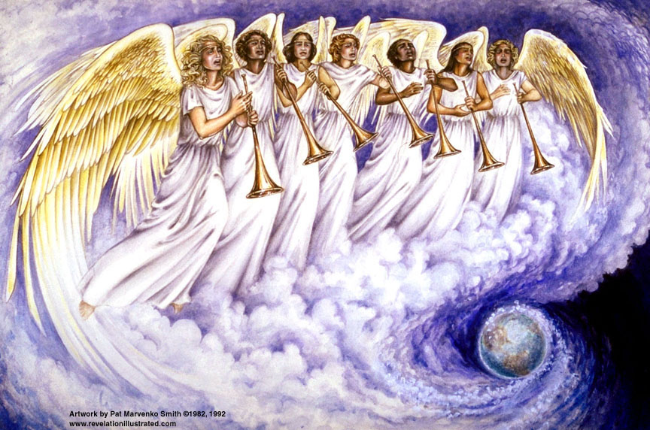
Zechariah. 2:10-13 "Sing for joy and be glad, O daughter of Zion; for behold I am coming and I will dwell in your midst," declares the Lord. ¹¹"And many nations will join themselves to the Lord in that day and will become My people. Then I will dwell in your midst, and you will know that the Lord of hosts has sent Me to you. ¹²"And the Lord will possess Judah as His portion in the holy land, and will again choose Jerusalem. ¹³"Be silent, all flesh, before the Lord; for He is aroused from His holy habitation."
Zechariah 8:23 "Thus says the LORD of hosts, 'In those days ten men from all the nations will grasp the garment of a Jew, saying, "Let us go with you, for we have heard that God is with you."'"

1
White
6
Signs
5
Martyrs
4
Ashen
3
Black
2
Red
Earthquake, hail
Euphrates dried
Earth in darkness
Sun scorches
Rivers to blood
Sores
Sea to blood
1/3 Earth
1/3 Sea
1/3 Rivers
1st Woe, Locusts
1/3 Heavens
3rd Woe, 7 Bowls
2nd Woe, 1/3 Men Die
7
Wrath
The Lamb
opens the
seals.
Angels sound
the trumpets.
God sends the
bowls out, full
of the wrath of
God.
Tribulation
Great Tribulation
Matt 24:8 "But all these things are merely the beginning of birth pangs.”
Trumpet Judgments 1 Thru 4
7
Trumpets
Revelation 8 | Bible References | Notes
¹And when He broke the seventh seal, there was silence in heaven for about half an hour. ²And I saw the seven angels who stand before God; and seven trumpets were given to them. ³And another angel came and stood at the altar, holding a golden censer; and much incense was given to him, that he might add it to the prayers of all the saints upon the golden altar which was before the throne. ⁴And the smoke of the incense, with the prayers of the saints, went up before God out of the angel's hand. | Zephaniah 1:7 Be silent before the Lord GOD! For the day of the LORD is near, For the LORD has prepared a sacrifice, He has consecrated His guests.  Daniel 9:27 "And he will make a firm covenant with the many for one week, but in the middle of the week he will put a stop to sacrifice and grain offering; and on the wing of abominations will come one who makes desolate, even until a complete destruction, one that is decreed, is poured out on the one who makes desolate." | - The 7th Seal opens the scroll; the 7th Trumpet announces the 7 Bowls  - Silence = something big is about to happen.  - Most believe “another angel” is the Angel of Jehovah – Christ; but “another” carries the meaning of likeness to other angels [Walvoord].
⁵And the angel took the censer; and he filled it with the fire of the altar and threw it to the earth; and there followed peals of thunder and sounds and flashes of lightning and an earthquake. ⁶And the seven angels who had the seven trumpets prepared themselves to sound them.  [Beginning of the Time of Distress in the Great Tribulation] | Revelation 6:9-10 When the Lamb broke the fifth seal, I saw underneath the altar the souls of those who had been slain because of the word of God, and because of the testimony which they had maintained; ¹⁰ and they cried out with a loud voice, saying, "How long, O Lord, holy and true, will You refrain from judging and avenging our blood on those who dwell on the earth?"  Leviticus 16:12 "He shall take a firepan full of coals of fire from upon the altar before the LORD and two handfuls of finely ground sweet incense, and bring it inside the veil. | - Moses was shown the Tabernacle in heaven. [see Heb.9]. Fire on the altar of burnt offerings came from the Lord at the inauguration of priestly service. [Lev. 9:24]  - Incense represents the prayers of the saints. They are heading toward earth!
⁷And the first sounded, and there came hail and fire, mixed with blood, and they were thrown to the earth; and a third of the earth was burned up, and a third of the trees were burned up, and all the green grass was burned up. | Genesis 19:24 Then the Lord rained on Sodom and Gomorrah brimstone and fire from the Lord out of heaven,  Exodus 9:23-25 And Moses stretched out his staff toward the sky, and the Lord sent thunder and hail, and fire ran down to the earth. And the Lord rained hail on the land of Egypt. ²⁴So there was hail, and fire flashing continually in the midst of the hail, very severe, such as had not been in all the land of Egypt since it became a nation. ²⁵And the hail struck all that was in the field through all the land of Egypt, both man and beast; the hail also struck every plant of the field and shattered every tree of the field. | - This is only a partial judgment from God – a warning. His full wrath is yet to be unleashed.  - Since the 7th plague in Egypt is considered literal, this should be also.
⁸And the second angel sounded, and something like a great mountain burning with fire was thrown into the sea; and a third of the sea became blood; ⁹and a third of the creatures, which were in the sea and had life, died; and a third of the ships were destroyed. | Exodus 7:20-21 So Moses and Aaron did even as the LORD had commanded. And he lifted up the staff and struck the water that was in the Nile, in the sight of Pharaoh and in the sight of his servants, and all the water that was in the Nile was turned to blood. ²¹ The fish that were in the Nile died, and the Nile became foul, so that the Egyptians could not drink water from the Nile. And the blood was through all the land of Egypt. | - Since the 1st plague in Egypt is considered literal, this should be also.
¹⁰And the third angel sounded, and a great star fell from heaven, burning like a torch, and it fell on a third of the rivers and on the springs of waters; ¹¹and the name of the star is called Wormwood; and a third of the waters became wormwood; and many men died from the waters, because they were made bitter. | Jeremiah 23:14-15 "Also among the prophets of Jerusalem I have seen a horrible thing: The committing of adultery and walking in falsehood; And they strengthen the hands of evildoers, So that no one has turned back from his wickedness. All of them have become to Me like Sodom, And her inhabitants like Gomorrah. ¹⁵"Therefore thus says the Lord of hosts concerning the prophets, 'Behold, I am going to feed them wormwood And make them drink poisonous water, For from the prophets of Jerusalem pollution has gone forth into all the land.' " | - Wormwood, Gk “apsinthos” or mugwort, is a very bitter plant, and it represents the bitterness of God’s judgment.  - The name Chernobyl has an interesting history, meaning "place where mugwort grows."
¹²And the fourth angel sounded, and a third of the sun and a third of the moon and a third of the stars were smitten, so that a third of them might be darkened and the day might not shine for a third of it, and the night in the same way. | Exodus 10:22 So Moses stretched out his hand toward the sky, and there was thick darkness in all the land of Egypt for three days.  Joel 3:14-15 Multitudes, multitudes in the valley of decision! For the day of the Lord is near in the valley of decision. ¹⁵The sun and moon grow dark, And the stars lose their brightness.
¹³And I looked, and I heard an eagle flying in midheaven, saying with a loud voice, "Woe, woe, woe, to those who dwell on the earth [inhabit], because of the remaining blasts of the trumpet of the three angels who are about to sound!"  [3 woes are 5th, 6th, and 7th trumpets, see Rev 9:12, 11:14, and 12:12.] | Rev. 12:12 "For this reason, rejoice, O heavens and you who dwell [tabernacle] in them. Woe to the earth and the sea, because the devil has come down to you, having great wrath, knowing that he has only a short time."  Rev 20:4 And I saw thrones, and they sat upon them, and judgment was given unto them: and I saw the souls of them that were beheaded for the witness of Jesus, and for the word of God, and which had not worshipped the beast, neither his image, neither had received his mark upon their foreheads, or in their hands; and they lived and reigned with Christ a thousand years. | - While both believers and unbelievers experience the terrors described in Rev. 8:7-12, “those who dwell on the earth” are the unbelievers who will meet spiritual harm through the next three trumpet judgments. God has guaranteed believers protection from spiritual harm (Rev. 7:2-3).

Note: Zechariah: Yahweh remembers; Zephaniah: Yahweh hides

The plagues on Egypt (Exodus 7:14-11:8)

- Nile turned to blood (7:14-25)
- Frogs (8:1-15)
- Gnats (8:16-19)
- Swarms of insects (8:20-32)
- Pestilence upon the livestock (9:1-7)
- Boils (9:8-12)
- Hail (9:13-35)
- Locust (10:1-20)
- Darkness (10:21-29)
- The last plague announced (11:1-8)

 | Seals (Birth pangs) | Trumpets (Warnings??) | Bowls (Judgment)
First | rider on white horse – antichrist | hail fire mixed with blood hurled to earth, third of the earth, trees and green grass burned up. | Ugly and painful sores on those who had the mark of the beast and worship his image
Second | rider on red horse – war | third of sea turned to blood, third of living creatures in sea died, third of ships destroyed. | Sea turned to blood, everything in the sea died
Third | rider on black horse – famine | third of waters turned bitter, many people died | Rivers and springs became blood
Fourth | rider on pale horse – death /Hades, 1/4th earth | A third of the day and night was without light | Sun scorches people with fire
Fifth | martyrs | locusts out of the Abyss torture mankind for five months | Kingdom plunged into darkness, men gnawed their tongues in agony
Sixth | great earthquake, sun black, moon like blood, stars fall from sky, sky roll up like a scroll, “Who can stand?” | Third of mankind killed by fire, smoke and sulfur i.e. war | Three evil spirits (frogs) gather kings of the earth for battle on the great day of God Almighty.
Seventh | silence in heaven for about ½ hour | end of the age, time of the judgment, lightening, thunder, earthquake, hailstorm. | end of the age, flashes of lightening, thunder, a great earthquake and plague of hail

