Revelation 7 ⎯ The Saints of the Great Tribulation
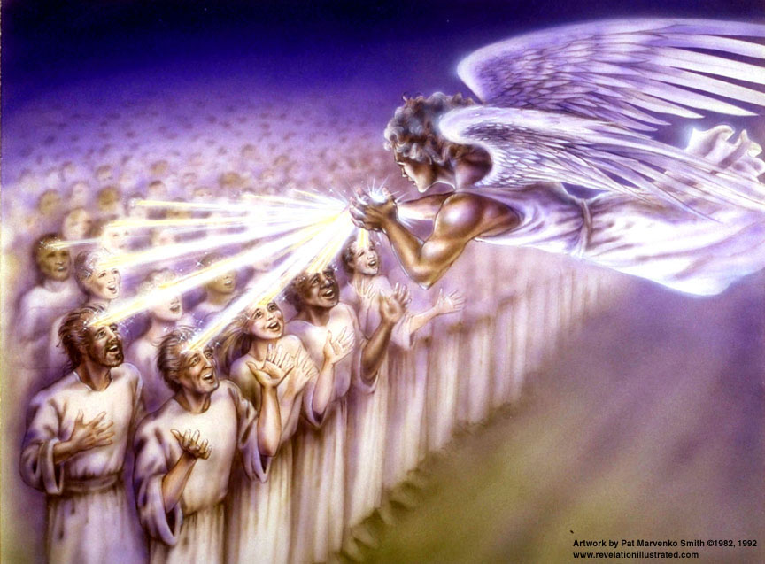
Deut. 32:43 "Rejoice, O nations, with His people; For He will avenge the blood of His servants, And will render vengeance on His adversaries, And will atone for His land and His people."
[Song of Moses]

1
White
6
Signs
5
Martyrs
4
Ashen
3
Black
2
Red
Earthquake, hail
Euphrates dried
Earth in darkness
Sun scorches
Rivers to blood
Sores
Sea to blood
1/3 Earth
1/3 Sea
1/3 Rivers
1st Woe, Locusts
1/3 Heavens
3rd Woe, 7 Bowls
2nd Woe, 1/3 Men Die
7
Wrath
The Lamb
opens the
seals.
Angels sound
the trumpets.
God sends the
bowls out, full
of the wrath of
God.
Tribulation
Great Tribulation
Matt 24:8 "But all these things are merely the beginning of birth pangs.

“Who is able to stand?”- 144,000 of Israel sealed; multitude of saints before the throne dressed in white
Revelation 7 | Bible References | Notes
¹After this I saw four angels standing at the four corners of the earth, holding back the four winds of the earth, so that no wind should blow on the earth or on the sea or on any tree. ²And I saw another angel ascending from the rising of the sun, having the seal of the living God; and he cried out with a loud voice to the four angels to whom it was granted to harm the earth and the sea, | Ezekiel 7:2 "And you, son of man, thus says the Lord God to the land of Israel, 'An end! The end is coming on the four corners of the land.”  Jeremiah 49:36 'And I shall bring upon Elam the four winds From the four ends of heaven, And shall scatter them to all these winds; And there will be no nation To which the outcasts of Elam will not go. | - For our benefit, explanatory interludes occur between the 6th and 7th seals and the 6th and 7th trumpets  - Rev 7 is a parenthetic insertion to answer the question asked in Rev 6:17.  - Wind is a symbol of judgment.  - Loud voice – GK: phone megas, or megaphone! Something important coming!!  2 Peter 3:9 The Lord is not slow about His promise, as some count slowness, but is patient toward you, not wishing for any to perish but for all to come to repentance.
³saying, "Do not harm the earth or the sea or the trees, until we have sealed the bond-servants of our God on their foreheads." ⁴And I heard the number of those who were sealed, one hundred and forty-four thousand sealed from every tribe of the sons of Israel: | Ezekiel 9:4-5 …And the Lord said to him, "Go through the midst of the city, even through the midst of Jerusalem, and put a mark on the foreheads of the men who sigh and groan over all the abominations which are being committed in its midst.  Rev. 9:4 And they were told that they should not hurt the grass of the earth, nor any green thing, nor any tree, but only the men who do not have the seal of God on their foreheads.  Rev 14:1-5 Then I looked, and behold, the Lamb was standing on Mount Zion, and with Him one hundred and forty-four thousand, having His name and the name of His Father written on their foreheads… ³ And they *sang a new song …; and no one could learn the song except the one hundred and forty-four thousand who had been purchased from the earth. ⁴ These are the ones who have not been defiled with women, for they have kept themselves chaste… | - “until” indicates judgment restrained but imminent.  - “bond-servants” - This begins the conclusion of the prophesy Matthew 24:14 "This gospel of the kingdom shall be preached in the whole world as a testimony to all the nations, and then the end will come.  - McGee notes that in dealing with Israel scripture uses numbers and dates but never with the Church or other saints.  Romans 11:25-27 For I do not want you, brethren, to be uninformed of this mystery—so that you will not be wise in your own estimation—that a partial hardening has happened to Israel until the fullness of the Gentiles has come in; .... ²⁷ "THIS IS MY COVENANT WITH THEM, WHEN I TAKE AWAY THEIR SINS."
⁵from the tribe of Judah, twelve thousand were sealed, from the tribe of Reuben twelve thousand, from the tribe of Gad twelve thousand, ⁶from the tribe of Asher twelve thousand, from the tribe of Naphtali twelve thousand, from the tribe of Manasseh twelve thousand, ⁷from the tribe of Simeon twelve thousand, from the tribe of Levi twelve thousand, from the tribe of Issachar twelve thousand, ⁸from the tribe of Zebulun twelve thousand, from the tribe of Joseph twelve thousand, from the tribe of Benjamin, twelve thousand were sealed. | Romans 9:27 And Isaiah cries out concerning Israel, "Though the number of the sons of Israel be AS THE SAND OF THE SEA, IT IS THE REMNANT THAT WILL BE SAVED;  Romans 11:5-6 In the same way then, there has also come to be at the present time a remnant according to God's gracious choice. ⁶But if it is by grace, it is no longer on the basis of works; otherwise grace is no longer grace.  Romans 11:11 I say then, they did not stumble so as to fall, did they? May it never be! But by their transgression salvation has come to the Gentiles, to make them jealous. | - Note: there are still 12 tribes of Israel! God knows who they are.  - Dan is omitted – first into idolatry? (Judges 18:30). In Scripture there are 29 listings of 12 tribes of Israel with many variations of the names.  Zechariah 13:8-9 "It will come about in all the land," Declares the Lord, "That two parts in it will be cut off and perish; But the third will be left in it. ⁹ "And I will bring the third part through the fire, Refine them as silver is refined, And test them as gold is tested. They will call on My name, And I will answer them; I will say, 'They are My people,' And they will say, 'The Lord is my God.'"  - 2010 population of Israel = 5.75M Jewish, 1.8M gentile → 1.9M Jewish saved, 3.8M lost
⁹After these things I looked, and behold, a great multitude, which no one could count, from every nation and all tribes and peoples and tongues, standing before the throne and before the Lamb, clothed in white robes, and palm branches were in their hands;  ¹⁰and they cry out with a loud voice, saying, "Salvation to our God who sits on the throne, and to the Lamb." ¹¹And all the angels were standing around the throne and around the elders and the four living creatures; and they fell on their faces before the throne and worshiped God, | Romans 15:8-10 For I say that Christ has become a servant to the circumcision on behalf of the truth of God to confirm the promises given to the fathers, ⁹ and for the Gentiles to glorify God for His mercy; as it is written, "Therefore I will give PRAISE TO YOU AMONG THE GENTILES, And I will sing to Your name." ¹⁰Again he says, "Rejoice , O Gentiles , with His people."  Psalm 116:15 Precious in the sight of the LORD Is the death of His godly ones.  Doxology [7:10] | - Palm branches are a symbol of celebration, joy, and/or victory.  Rev. 20:4-5 And I saw thrones, and they sat upon them, and judgment was given to them. And I saw the souls of those who had been beheaded because of the testimony of Jesus and because of the word of God, and those who had not worshiped the beast or his image, and had not received the mark upon their forehead and upon their hand; and they came to life and reigned with Christ for a thousand years. 5The rest of the dead did not come to life until the thousand years were completed. This is the first [best, or chief] resurrection.
¹²saying, "Amen, blessing and glory and wisdom and thanksgiving and honor and power and might, be to our God forever and ever. Amen." ¹³And one of the elders answered, saying to me, "These who are clothed in the white robes, who are they, and from where have they come?" ¹⁴And I said to him, "My lord, you know." And he said to me, "These are the ones who come out of the great tribulation, and they have washed their robes and made them white in the blood of the Lamb. | Doxology [7:12] – seven fold  Rev. 6:11 And there was given to each of them a white robe; and they were told that they should rest for a little while longer, until the number of their fellow servants and their brethren who were to be killed even as they had been, should be completed also.  Rev. 13:15 And there was given to him to give breath to the image of the beast, that the image of the beast might even speak and cause as many as do not worship the image of the beast to be killed.  But what about:  2 Thessalonians 2:7-8 For the mystery of lawlessness is already at work; only he who now restrains will do so until he is taken out of the way. ⁸ Then that lawless one will be revealed whom the Lord will slay with the breath of His mouth and bring to an end by the appearance of His coming; | - Living tribulation saints are not included here.  - Holy Spirit still at work (omnipresent), just not restraining now.  - These are likely the ones referred to in Rev 6:11 as “brethren” to the martyrs under the altar.  - The 144k bond-servants are at least partially responsible for this harvest.  - Robes washed white in the blood of the Lamb → this is substitutionary atonement  - Great Tribulation: see Dan 12:1
¹⁵"For this reason, they are before the throne of God; and they serve Him day and night in His temple; and He who sits on the throne shall spread His tabernacle over them.  ¹⁶"They shall hunger no more, neither thirst anymore; neither shall the sun beat down on them, nor any heat; ¹⁷for the Lamb in the center of the throne shall be their shepherd, and shall guide them to springs of the water of life; and God shall wipe every tear from their eyes." | Revelation 13:17 and he provides that no one will be able to buy or to sell, except the one who has the mark, either the name of the beast or the number of his name.  Isaiah 25:8 He will swallow up death for all time, And the Lord God will wipe tears away from all faces, And He will remove the reproach of His people from all the earth; For the Lord has spoken | - These two groups, the 144,000 and the great multitude of gentiles, are distinguished from the 24 elders. Therefore they cannot be the Church. Conversely, this means that the Church is not the “true Israel” which Covenant Theology teaches.  - Note the tense here is future; meaning John’s view is of events future to his current vision.  - In distinguishing between the 144K Jews and the great multitude that no one could count God is clearly stating the latter are special. Being protected, they are largely responsible for the salvation of the latter – which is in keeping with God’s general purposes for the Jewish nation throughout history.

Timeline Review:

The Apostasy of the church
- The rise of a 10 nation confederacy (countries of Christendom?)
- Rapture of the Church (true believers)
- Judgment seat of Christ (Bema seat) ⎯ of the Church saints
- Three of the nations taken over by a strong ruler
- Strong ruler ascends to lead the 7 nation confederacy
- Treaty between the strong leader and Israel

The Tribulation begins
- Scroll with 7 seals, Lion of Judah/Root of David/Lamb is the only one worthy to open it
- 6 seal judgments begin
- Northern and Southern confederacies attack Israel, defeated by God. Antichrist establishes HQ at Jerusalem.

The Great Tribulation begins at 5th seal (Rev 6:12-17)
- Abomination of Desolation
- Wrath of the Lamb – Rev 6:16-17 (Day of the Lord)
- Parenthetic 1 - 144,000 sons of Israel sealed as servants of the Lord
- Parenthetic 1 - Great multitude of Gentiles standing before the Lamb
- 7th seal broken, scroll is opened! 7 trumpet judgments begin

7
Trumpets

Chapters 8 & 9:

